Lab5

create a namespace iti-devops

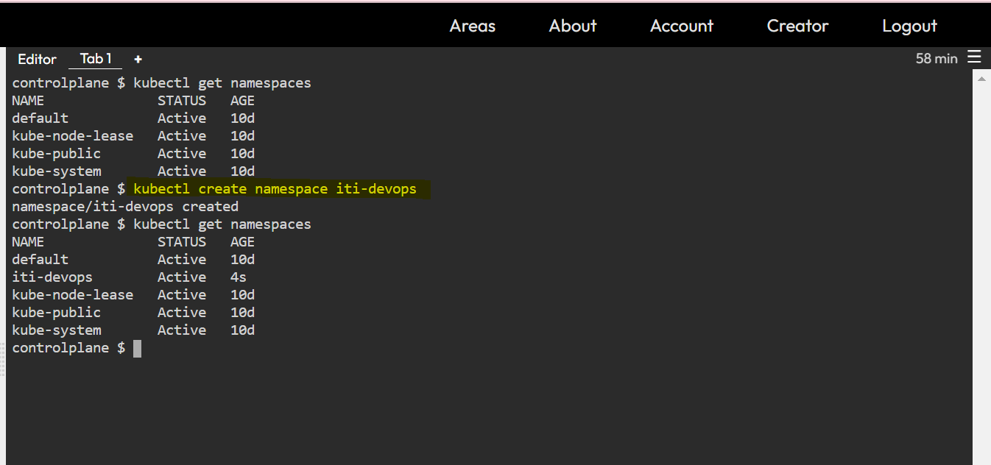

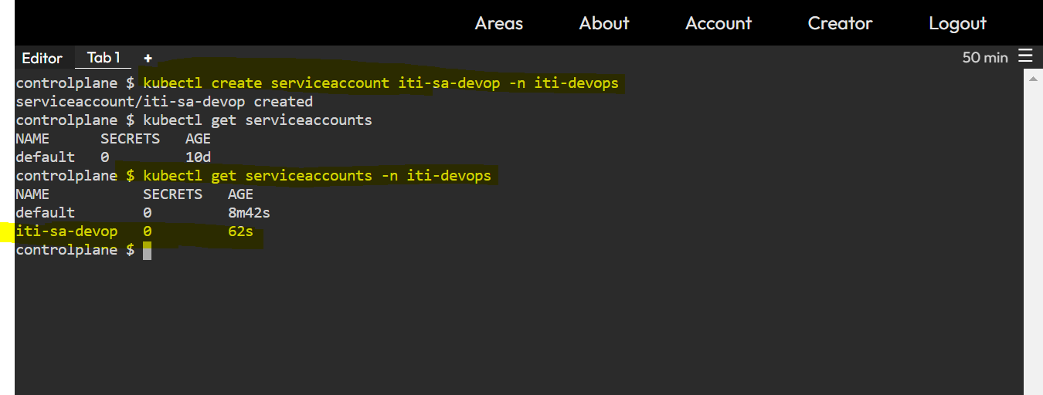

3- create a clusteRole which should be named as cluster-role-devops to grant permissions “get”,”list”,”watch”,”create”,”patch”,”update” to “configMaps”,”secrets”,”endpoints”,”nodes”,”pods”,”services”,”namespaces”,”events”,”serviceAccou nts”.

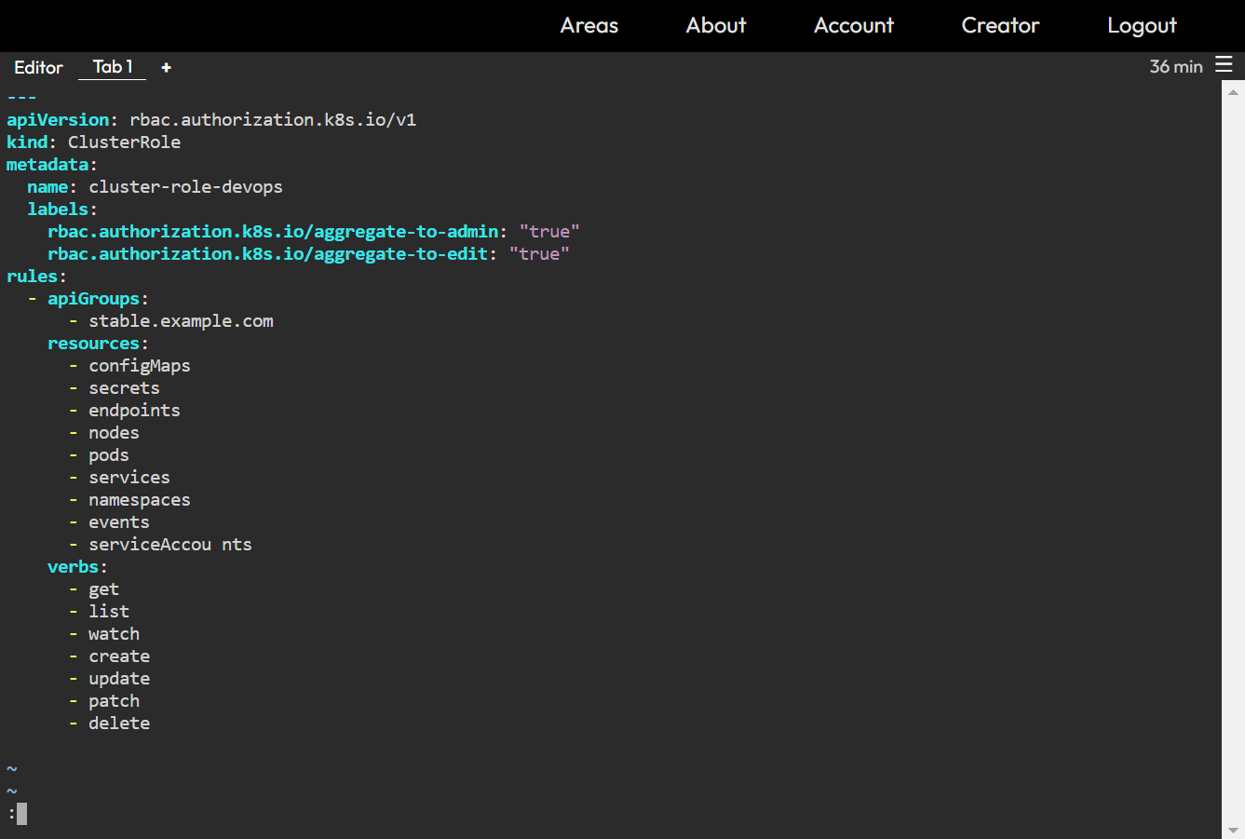

4- create a ClusterRoleBinding which should be named as cluster-role-binding-devops under the same namespace. Define roleRef apiGroup should be rbac.authorization.k8s.io . Kind should be ClusterRole, name should be cluster-role-devops and subjects kind should be ServiceAccount: name should be iti-sadevops and namespace should be iti-devops

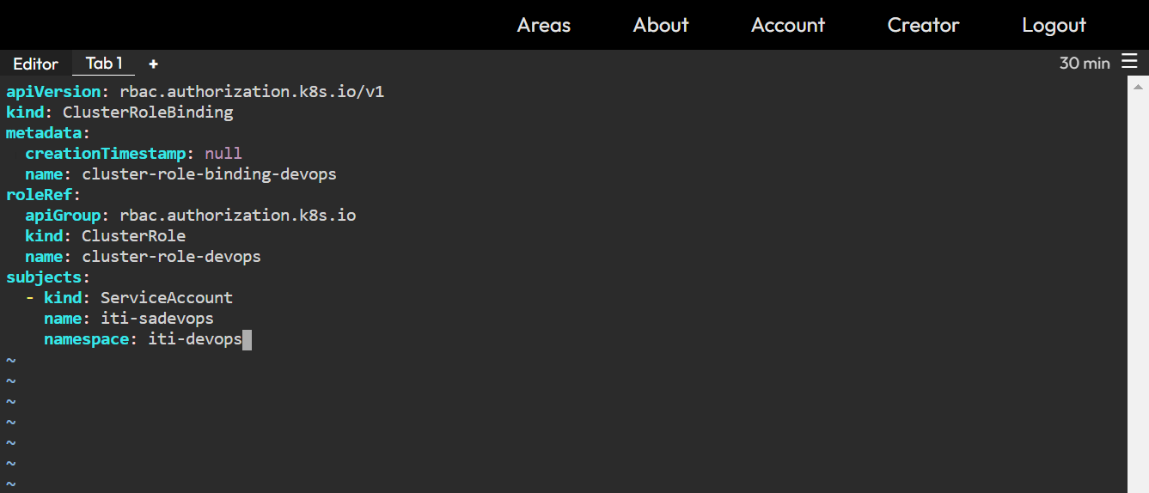

5- What is the difference between statefulSets and deployments?

A StatefulSet is a Kubernetes resource object that manages a set of pods with unique identities. By assigning a persistent ID that is maintained even if the pod is rescheduled, a StatefulSet helps maintain the uniqueness and ordering of pods. With unique pod identifiers, administrators can efficiently attach cluster volumes to new pods across failures.

A Deployment is a Kubernetes resource object that provides declarative updates for pods that encapsulate application containers. A Deployment represents a number of identical pods without unique IDs, while specifying the pods’ desired state and attributes. Deployments are typically used to autoscale the number of pod replicas, perform controlled rollouts for application code, and perform rollbacks when necessary.

6- Set up Ingress on Minikube with the NGINX Ingress Controller play around with paths , you can create more than 2 deployments if you like

