LAB2:

1-How do I trigger a Prometheus alert?

->make dir rules.yml to target ec2 or any target and then send alert

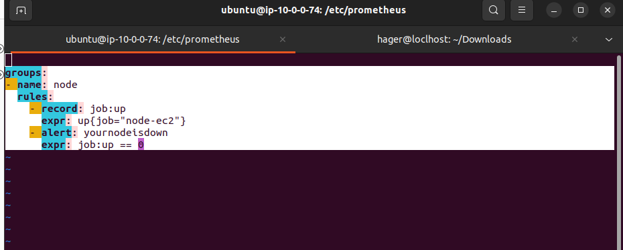
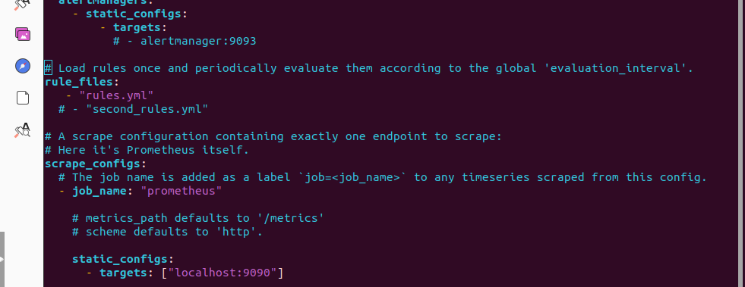
2-What is the difference between node exporter and mysql exporter ?

About mysql exporter :
Since databases are such a critical resource that downtime can cause significant financial and reputation losses, monitoring is a must. The MySQL exporter is required to monitor and expose MySQL metrics. It queries MySQL, scraps the data, and exposes the metrics to a Kubernetes service endpoint that can further be scrapped by Prometheus to ingest the time series data. For monitoring MySQL, an external Prometheus exporter can be used, which is maintained by the Prometheus Community.

About node exporter :
The Prometheus Node Exporter is an open-source time-series monitoring and alerting system for cloud-native environments, including Kubernetes, hosted by the Cloud Native Computing Foundation (CNCF) on GitHub. It can collect and store node-level metrics as time-series data, recording information with a timestamp. It can also collect and record labels, which are optional key-value pairs.

3-what is the maximum retention period to save data in Prometheus and how to increase it ?

By default the retention is configured to 15 days. The amounts of data stored on disk depends on retention — higher retention means more data on disk. The lowest supported retention in Prometheus is 2 hours (2h). Such a retention could be useful when configuring remote storage for Prometheus

higher retention means more data on disk. To increaseit

4-What are the different PromQL data types available in Prometheus Expression language?

PromQL uses three data types: scalars, range vectors, and instant vectors. It also uses strings, but only as literals. This intro will provide basic PromQL examples and concepts to understand as you get used to Prometheus queries.

5-How To calculate the average request duration over the last 5 minutes from a histogram ?

To calculate the average request duration during the last 5 minutes from a histogram or summary called http_request_duration_seconds , use the following …

rate(http_request_duration_seconds_sum[5m])
/
rate(http_request_duration_seconds_count[5m])

6-What is Thanos Prometheus?

Thanos is a set of components that can be composed into a highly available Prometheus setup with long term storage capabilities. Its main goals are operation simplicity and retaining of Prometheus's reliability properties.

7-what is promtool and how i can use it ?

promtool - Tooling for the Prometheus monitoring system …
Prometheus is typically used to collect numeric metrics from services that run 24/7 and allow metric data to be accessed via HTTP endpoints. This can be done manually or with various client libraries. Prometheus exposes data using a simple format, with a new line for each metric, separated with line feed characters

8-What types of Monitoring can be done via Grafana?
Logs. powered by Grafana Loki.
- Grafana. for visualization.
- Traces. powered by Grafana Tempo.
- Metrics. powered by Grafana Mimir and Prometheus.
- Plugins. Connect Grafana to data sources, apps, and more.
- Incident Response & Management. with Grafana Alerting, Grafana Incident, and Grafana OnCall.
- Performance testing. ...
- Grafana Cloud.

9-Can we see different Servers CPU comparison in Grafana yes

