BACKEND:

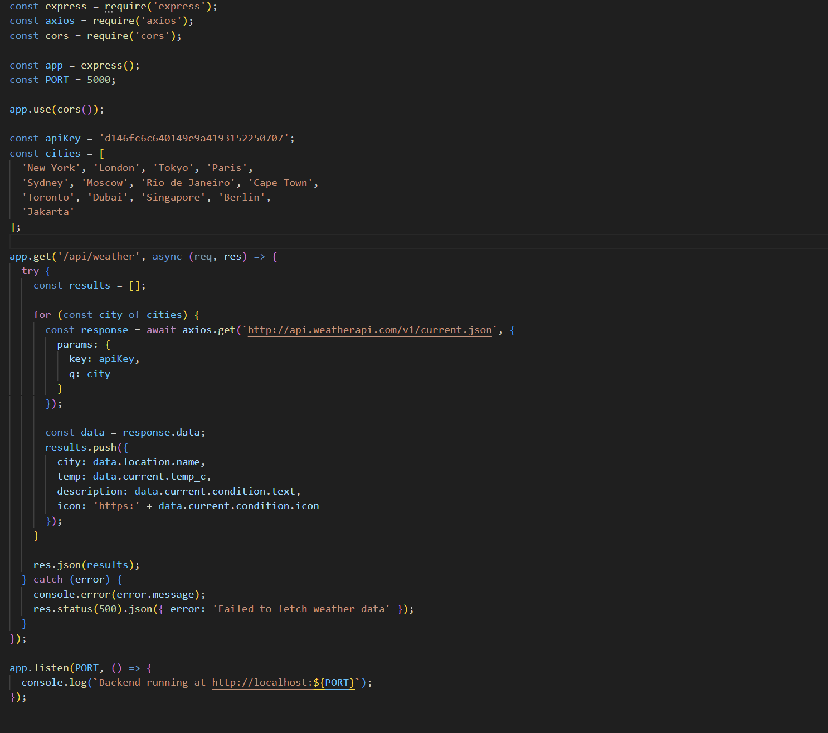

FRONTEND:

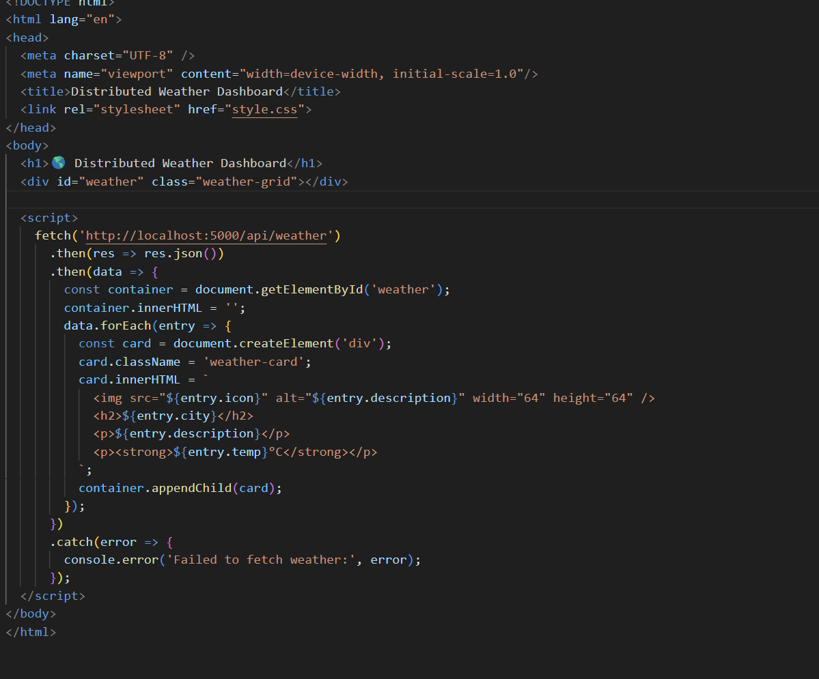

Step by step explanation on how to deploy the application:

1. Put API Key for the data from [WeatherAPI.com](http://weatherapi.com) in the backend.
2. Put name of cities that I want to show data from in the backend.
3. Run the docker with the terminal on the folder opened by using “docker-compose up --build”