Introduction & context
A Receiver Operating Characteristic is a way to visualize and quantify how good a (binary) classifier/test can perform. In World War II, people (called receiver operators) stared at radar screens trying to determine if that fuzzy blip on the screen was an approaching enemy aircraft, or just something else (perhaps a large bird, or maybe just noise). The idea was of course, to determine true positives ( actual threats) as opposed to mistakenly reporting a non-existent threat, that is, a false positive. Over time, an operator could be judged on the combination of making the right call ( there is an actual threat and she says so) versus making a false call ( there was no threat but she said there was)– hence a receiver operating characteristic. In this case the binary classifier was a person. Nowadays the classifier (test) is most likely to be a deployed algorithm making automated classification decisions. This ability of being able to classify, to categorize, is a fundamental human capability that enables us to correctly classify another person as friend or not ( of course, this may actually be a score/probability somewhere between a yes or a no, where that other person is sort-of a friend)!
Classifying binary classifiers
The general notation in this classification area of analysis treats the presence of something of interest as a positive, while the uninteresting (background) case is considered a negative. For example, if I am testing for a disease, I would consider the presence of the disease as my positive and not this disease as my negative. The idea of a test is to determine which of these is actually the case. Of course, my test might be wrong, in which case I am faced with deciding how good my test is at detecting this particular disease. This leads to four cases as shown in the table below, called a confusion matrix since the off diagonals are erroneous/confusing calls:
TP true positive - means my test correctly classified a person as having the disease when they actually did. (back to the radar operator – she says enemy incoming and it actually is an enemy)
FP false positive - means my test incorrectly classified a person as having the disease when they actually didn’t. (Back to the radar operator – she said it was an incoming enemy but actually wasn’t)
TN true negative - means the classifier says no disease and there actually is no disease. (the radar operator says the blip wasn’t an approaching enemy and she was right )
FN false negative - the test says no disease but there actually is. ( the radar operator says no enemy approaching when there actually is)
Of course, you can see that some test errors are more critical than others, depends on the situation.
Confusion matrix
 | Disease ( actually) + | NO Disease (actually) -
Test says Yes + | TP (true positive) | FP (false positive)
Test says No - | FN (false negative) | TN (true negative)
Marginal totals | Actual number of diseased= P | Actual number not diseased =N | Total subjects tested
Alternative descriptions in the literature
The above matrix is also called a confusion matrix as the off diagonals show how the test messes up. This is also called a contingency table.
tp rate true positive rate is also called the hit rate or recall ( note this is TP/all positives)
fp rate false positive rate is also called the false alarm rate
precision is also called the positive predictive value

A few parameter calculations
tp rate = TP/(TP + FN) // this is the true positives over all the actual total positives (P)
fp rate = FP/(FP + TN) // this is the false positives over all the actual total negatives (N)

accuracy = (TP + TN) /(P + N) Total // the number correctly classified out of the total
precision = TP/(TP + FP) // correctly gets the positives over all the positives

ROC Space
Graphing the performance of a classifier ( human or otherwise) can be done by plotting the fp rate on the X axis, against the tp rate on the Y axis. The result is called the Receiver Operating Curve. This plots the trade offs between benefits ( true positives) and costs ( false positives).

One kind of classifier) : Discrete classifier
There are two kinds of classifiers that I will consider. The discrete classifier gives me one class label, yes /no, positive/negative, enemy/no enemy per instance. That means I am only going to get one confusion matrix and I can characterize it as a single point in ROC space. Just suppose I have the following test confusion matrix. I am testing a population of 100 people and I know the actual features (of course the test doesn’t!) , the actual diseased and not diseased among this group. Lets calc a few parameters on this test and see how good it is.
 | Disease actual + | No disease actually -
Test says Yes + | 70 | 10
Test says No - | 5 | 15
 | 75 ( actually diseased | 25 (Actually no disease) | Total instances = 100

Accuracy = (TP + TN)/Total = (70 + 15 )/100 = 85% // correct predictions/total
Precision = TP / (TP + FP) = 70 / ( 70 + 10) = 87.5%//correct positives/positives
fp rate = 10/(10 + 15) = 40%
tp rate = 70/(70 + 5) = 93%
So, for a discrete test, the diagram below shows where this test would be positioned (A). If I devised another test ( which would change the numbers in the confusion matrix) I would get another point in ROC space, say at (0.6, 0.80). This new test is not as good as the previous since points to the northwest of a pair are better in general. Why??
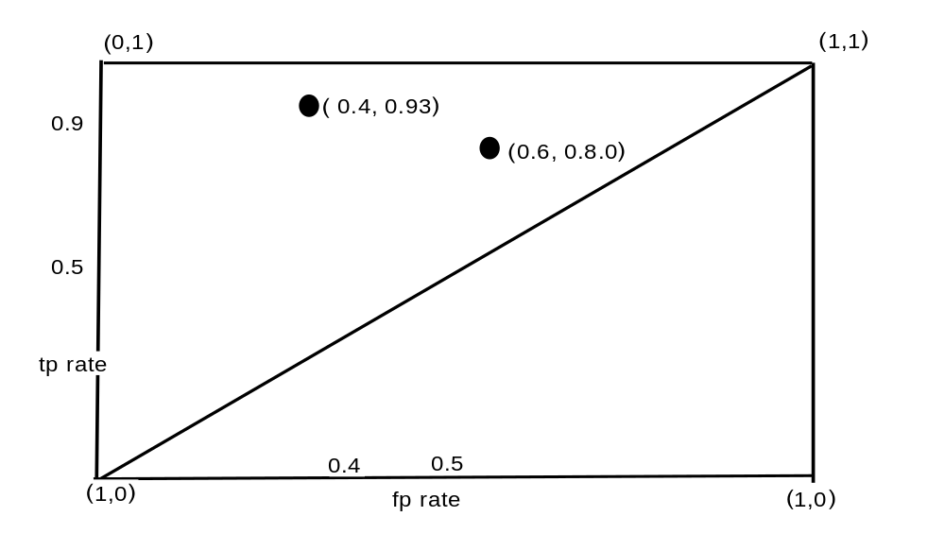

A Scoring classifier: Scoring/ Ranking classifier – says the degree/probability/score to which an instance is stated to be a class member
***(In order to evaluate a scoring classifier, the plan is to break it up into a set of discrete classifiers as in Type A above, based on thresholds, as you will see below).
Many classifiers return a classification probability for an instance, rather than a Yes or No . For example, a logistic regression will return a probability for each instance it classifies rather than a definite Yes or No. This means that if I test a person for a disease, I don’t get back a Yes or No from the test, but rather a test probability that he has the disease. So what do I say if the classifier returns a 0.95 probability of having the disease? Would I classify this person as diseased? That case is pretty clear and I would say Yes. What if the test says 0.6 probability of having the disease though, do I say still Yes?
This is not an academic exercise since if I were the responsible health care professional and the test says a 0.6 possibility of rabies, do I give a painful and expensive injection with side effects or not? Or, I am monitoring a critical cybersecurity test that comes up with a 0.6 probability of an ongoing attack – do I shut down the network? There is no evading these kinds of decisions.
The key insight here is that a scoring classifiers performance can be analyzed as a sequence of discrete classifiers as described above. I will set various thresholds to turn it into a sequence of discrete classifiers. Setting the threshold at various values will result in multiple confusion matrices, one for each threshold!! Then, for each of these discrete confusion matrices, I can calculate its’ various parameters such as fp-rate and tp-rate. This means that for each threshold I can get a (fp-rate, tp-rate ) pair ( from that specific discrete classifier) that I can plot. This plot is the ROC curve.

A calculated example
Ok, lets do one of these scoring/ranking tests and plot its’ ROC curve. I will use a test data set devised by one of the authors of the Data Science for Business text, Tom Fawcett. The assumption here is that the actual true positives are known ( indicated by a p) while the true negatives are known and indicated by an n. ( Of course the test doesn’t know this)! The test assigned a probability to each instance that is shown as a decimal in the Score column. Note that the test predicted that the third instance was 70% likely to be a p, whereas, it actually was an n. The question is: how can I assess the performance of this classifier/test versus some other classifier test that I may devise later?

Instance # | (actual) Class | (test) Score | Instance # | (actual) Class | (test) Score
1 | p | 0.9 | 11 | p | .4
2 | p | 0.8 | 12 | n | .39
3 | n | .7 | 13 | p | .38
4 | p | .6 | 14 | n | .37
5 | p | .55 | 15 | n | .36
6 | p | .54 | 16 | n | .35
7 | n | .53 | 17 | p | .34
8 | n | .52 | 18 | n | .33
9 | p | .51 | 19 | p | .30
10 | n | .505 | 20 | n | .1

Calculating the fp, tp and accuracy for each threshold.
This comes down to saying: I am going to set a cutoff probability that, above which I am going to say I accept everything is a positive and below which I am going to say everything is a negative. So if I said 90% is my threshold, then every instance with a probability of 90% or above would be considered as positive ( has the disease or is an incoming enemy). Below 90% I consider every instance with this probability to not have the disease ( not an incoming enemy). Obviously I can be wrong with persons having 90% probability of having the disease, NOT having the disease or NOT an incoming enemy.
The assumption here is that wherever I set the threshold, I will consider all instances above that threshold to be positives and all instances below that threshold to be negatives ( regardless of their actual class). This procedure will allow me to determine, for that particular threshold, how well the test performs with respect to its (fp-rate, tp-rate, accuracy).

Procedure:
A. * first analyze every instance classified as above the cutoff to be a positive. But, to what extent is that actually true?
So check each instance above the cutoff - is it actually true? then this goes into the TP bucket. BUT, if an instance is not actually true, then this goes into the FP False Positive bucket
B. I declared that everything below the cutoff is to be considered negative, but to what extent is that actually true? So I look below the cutoff value and if I see a p, then that is a FN, false negative. If I see an n, then that is a TN, true negative.

Setting the threshold at 0.9 → (0, 0.1)
(this says the test will characterize all the instances above the 0.9 probability mark as positives while all instances below 0.9 are to be counted as negatives.What is the confusion matrix now?
Be careful: I look at all the instances at 0.9 and above. Are there ay True Positives? Yes there is one, so TP = 1
tp rate = TP/ ( TP + FN) which means divide 1/( 1 + all the other actual positives in the sample, which is 9. So, tp-rate = 1/(1 + 9) = 0.1
Are there any False Positives above 0.9, No. so, FP = 0

1. TP = true positives = 1, tp-rate = TP/all the positives in the whole sample = 1/ 10 = 0.1
2. FP = false positives = 0, fp-rate = FP/all the negatives in the whole sample = 0/10 = 0.0
(fp-rate, tp-rate) = (0.0, 0.1) the first point of the ROC curve
3. Accuracy = correct predictions/total =(1 + 10 )/ 20 = 11/20
that is, at this threshold, the TP prediction is 1, while all the rest of the negatives are correctly characterized as negative, of which there are 10.
The above parameters are actually all I need to plot one ROC point, but I will go ahead and calc a few other parameters.
4. FP = 0 since I only considered one instance and it was characterizes as positive.
5. Precision = 1

Setting the threshold at 0.8 → (0, 0.2)
1. TP = true positives = 2, tp-rate = TP/all the positives in the whole sample = 2/ 10 = 0.2
2. FP = false positives = 0, fp-rate = FP/all the negatives in the whole sample = 0/10 = 0.0
(fp-rate, tp-rate) = (0.0, 0.2) the second point of the ROC curve
3. Accuracy = correct predictions/total =(2 + 10 )/ 20 = 12/20
that is, at this threshold, the TP prediction is 2, while all the rest of the negatives are correctly characterized as negative, of which there are 10.
5. Precision = 1

Setting the threshold at 0.54 → (0.1, 0.5)
1. TP = true positives = 5, tp-rate = TP/all the positives in the whole sample = 5/ 10 = 0.5
2. FP = false positives = 1, fp-rate = FP/all the negatives in the whole sample = 4/10 = 0.1
(fp-rate, tp-rate) = (0.1, 0.5) the third point of the ROC curve
3. Accuracy = correct predictions/total =(5 + 9)/ 20 = 70%
that is, at this threshold, the TP = 5, while all the rest of the negatives are correctly characterized as negative, of which there are 9.

Setting the threshold at 0.505 → (0.4, 0.6)
1. TP = true positives = 6, tp-rate = TP/all the positives in the whole sample = 6/ 10 = 0.6
2. FP = false positives = 4, fp-rate = FP/all the negatives in the whole sample = 4/10 = 0.4
(fp-rate, tp-rate) = (0.4, 0.6) the fourth point of the ROC curve
3. Accuracy = correct predictions/total =(6 + 6 )/ 20 = 12/20
that is, at this threshold, the TP prediction is 6, while all the rest of the negatives are correctly characterized as negative, of which there are 10.

Plotting this ROC curve
The matrix of values are as follows:
Threshold | (fp rate, tp rate)
0.9 | (0 , 0.1)
0.8 | ( 0, 0.2)
0.54 | (0.1, 0.5)
0.505 | (0.4, 0.6)

References
Wikipedia https://en.wikipedia.org/wiki/Receiver_operating_characteristic

