Foundation Charter of Brecon/Brecknock Collegiate Church

T.N.A., C66/709

As described in L&P XVI from Harley 1249:

<https://babel.hathitrust.org/cgi/pt?id=pst.000023992443&view=1up&seq=1>

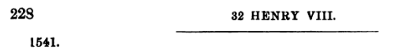

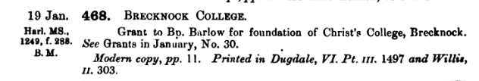

NOTE ON PRINTINGS: The text first appears in Willis’ Mitred Abbies vol II, pp. 303-309 (online here: <https://play.google.com/books/reader?id=o25bAAAAQAAJ&hl=en&pg=GBS.PA303>). Willis does not cite his source, but it cannot be the Patent Roll, C66, because he includes the full salutation and C66 begins with an abbreviated form; likewise the “footer” information is fuller in Willis than in C66. The Willis text is explicitly cited as the source for John Stevens, *The History of the antient abbeys, monasteries, hospitals, cathedral and collegiate churches. Being two additional volumes to Sir William…* (London, 1722-23), vol. II, Appendix doc. 464 (online through PittCat as digitized by Gale, go to vol. II image 652). This in turn is the cited source for Theophilus Jones’ *A History of the County of Brecknock* Vol. II (Brecknock, 1809), Appendix doc. IX (at <https://play.google.com/books/reader?id=Zoc1AQAAMAAJ&hl=en&pg=GBS.PT34>). At least someone in the chapter was paying attention, since N.L.W., SDCh/B/24 (unpag.) heads this text “An extract from the 5d Volume of Jones’s History of the County of Brecknock – Appendix no IX 821- to 825 inclusive. No 464 in Stephens’s Appendix to contin: of Dugd. Mon:). But the earliest MS copies (aside from C66) – the St John’s Cambridge MS; SDCh/B/23; and, I think, BL Harley 1249 – are earlier than Jones. The scribe of one or other of them, whoever first appended it to the St David’s statutes, may have had the surviving Letter Patent; or may have transcribed it from Willis or Stephens; or may have had an independent (and now lost) transcript of the original, just as Willis may have had (in fact, probably did, since his travel was limited and his correspondence was extensive).

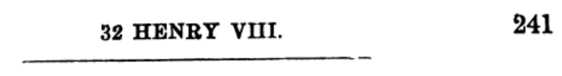

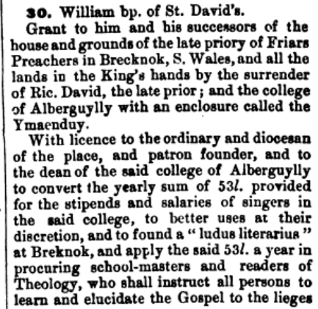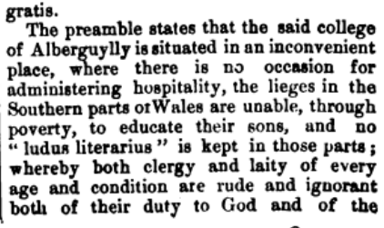

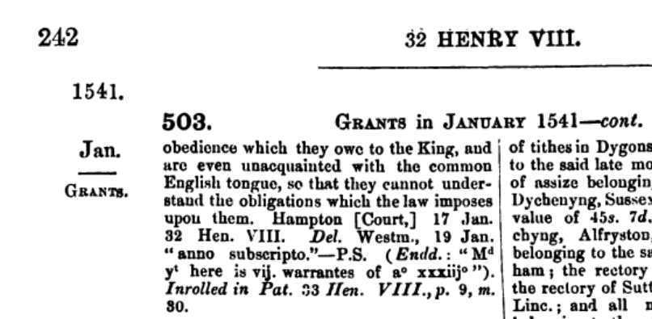

On the former friary buildings thus transferred, see

<https://cadwpublic-api.azurewebsites.net/reports/listedbuilding/FullReport?lang=&id=6826> (chapel) and <https://cadwpublic-api.azurewebsites.net/reports/listedbuilding/FullReport?lang=&id=6827> (other buildings).

How exactly did this text come to be included in the statute books? It clearly was not an original part of H6280 as it was not issued until maybe 20 years after 6280 was written. Nor was it a part in Marmaduke Middleton’s day, I think, to judge from his note at the beginning of 6280 counting the leaves then in the volume. It is **not** in the 1685 copy (SDCh/B/21), **nor** the ante 1719 copy (SDCh/B/22), but it **is** in SDCh/B/23 pp. 175-81, the St John’s copy pp. 255-65, SDCh/B/24 (not foliated, but last nine photographs in my file), SDCh/B/25 pp. 269-78. A note in Thomas Baker’s hand on p. 255 of the St John’s copy says “Subsequentes Literae Patentes aliunde desumuntur, non occurrunt in Libro Statutorum Meneven:” (The following Letters Patent are drawn from elsewhere; they do not occur in the Book of Statutes of St Davids). The text of the letter patent may have come from the original letter, not now surviving, but it could have come instead from a transcript from the patent roll; the difference in the opening formula, abbreviated in the patent roll but given in full in the copies, may reflect copying from the original letter patent, but it could also reflect a copyist looking at the patent roll, recognizing that the salutation was abbreviated, and supplying what he knew the full form ought to have been.

Baker also said that the St John’s copy of the statutes themselves was taken from the original, which he describes as old and in bad shape – see his note in St John’s copy f. iir – which must mean H6280, as the 1685 copy would not have looked like an “original or most antient authentic copy… wasted with age” just a few decades later. (NB Baker died 1740 – see ODNB – so the damage to the earlier mss must have been before then.) If Baker is correct and the St John’s copy was taken directly from H6280 (which may or may not be the case), then SDCh/B/23 was presumably copied in turn from the St John’s copy. These two MSS are in very similar but not identical hands – no doubt they are of very similar date; see note at beginning of SDCh/B/23 dating it to *ante* 1748, at which time H6280 was already lost to the Chapter and they did not know where it had gone.

Orthography: C66 scribe typically uses medial –c- that is indistinguishable from –t- (or uses c in lieu of t) in the usual places expected in mediaeval Latin, e.g. eciam/etiam. These have been distinguished into c and t according to the classical expectations, as the scribe of St J did. However, the St J scribe also restored all classical –ae- diphthongs where C66 uses only –e-; these have not been re-classicized in the following transcription, being kept as –e-. The short –i- of C66 has been retained while the St J scribe uses long –j- in consonantal cases.

Marginal note (left margin of patent roll): ????? Episcopo meneven’ de ????? sibi et successoribus

Rex omnibus ad quos & c’. Salutem.[1] Cum collegium de Aberguylly[2] in loco inidoneo existit ubi nulla occasio hospitalitatis

aliis per viros dicti collegii administrande datur ad commodum et utilitatem subditorum nostrorum in locis dicto collegio adiacentibus

ad grave dampnum dictorum ligeorum[3] nostrorum / Cumque etiam domus sive Prioratus[4] fratrem predicatorum in oppido nostro de Brechnok[5]

in australibus partibus Wallie cum omnibus et omnimodis mesuagiis terris et tenementis bonis rebus necessariis et implementis ad dictum ~

nuper Prioratum spectantibus in manibus et possessione nostris iam existunt vel existere deberent pretextu[6] doni concessionis ac sursum

redditionis Ricardi Davidi nuper Prioris et conventus[7] eiusdem nuper Prioratus nobis inde facte virtute cuius nos in iure ~

corone nostre anglie de dicto nuper Prioratu mesuagiis[8] terris[9] tenementis ac ceteris omnibus et singulis premissis seisiti[10] sumus in dominico ~

nostro ut de feodo / Cumque etiam subditi et ligei nostri in dictis partibus australibus Wallie conmorantes[11] summa egestata ~ ~

oppressi filios suos in bonis literis educare non possunt et in dictis partibus australibus Wallie nullus ludus literarius habetur per

quod non solum et clerici et laici omnis etatis et conditionis rudes et ignari redduntur tam sui officii erga deum quam debite ~

sue obediencie erga[12] nos sed etiam lingue vulgaris anglie[13] minime periti sic quod statuta nostra in huiusmodi casu ~

edita et provisa observare nequeunt / Et quod debuerunt et tenentur facere secundum formam et effectum dictorum statutorum intelligere ~

non possunt propter ignorantiam dicte lingue anglicane / Cumque etiam in dicto collegio de Aberguylly[14] pro cantatoribus ~

in eodem collegio stipendia atque salaria ad summam quinquaginta trium librarum sterlingorum annuarum attingentia providentur

Que quidem summa quinquaginta trium librarum in meliores usus potest disponi utpote in adolescentibus et aliis Iuvenibus

in bonis literis instruend’ et cotidiana[15] lectura per aliquem virum pium et eruditum dictanda unde possunt[16] veritatem callere et

quid deo et Regi faciendum foret sacius possunt[17] intelligere in maximum commodum totius populi nostri ibidem[18] commoraturi sicut

per relacionem dilecti nobis in christo Willelmi Episcopi[19] Menevensis plenius ac planius accepimus / Nos igitur volentes ex intima ~

charitate nostra qua erga deum et cunctum populum nostrum gerimus congruum remedium in hac parte providere et in multos meliores ~

usus quam nunc disponuntur[20] convertere et transmutare[21] clare percipientes quod premissa omnia et singula melius disponi possunt

volentesque multum statum[22] subditorum nostrorum melius consulere de gratia nostra speciali ac ex certa sciencia et mero motu nostris

dedimus concessimus et confirmavimus ac per presentes damus concedimus et confirmamus prefato Willelmo nunc Episcopo totam illam[23]

domum sive Prioratum fratrum predicatorum ac totum solum et fundum precinctum et ambitum dicti nuper Prioratus ac omnia ~

edificia terras et tenementa redditus reversiones et servicia mesuagia[24] sola funda proficua[25] commoditates[26] advantagia et hereditamenta

quecumque dicto nuper Prioratui quoquo modo[27] spectantia sive pertinentia acetiam[28] omnia catalla res hustilmenta[29] ~

necessaria et implementa in dicto nuper Prioratu tempore dissolutionis eiusdem vel unquam postea existencia vel ad eundem

nuper Prioratum aliqualiter spectantia vel pertinentia cuiuscumque[30] generis vel speciei fuerint ac in tam amplis modo et

forma prout dictus Ricardus[31] David ultimus Prior dicte[32] nuper domus fratrum predicatorum vel aliquis predecessorum predicti Ricardi ~

David nuper Prioris eiusdem nuper domus sive Prioratus dicti nuper Prioris ac[33] terras et tenementa solum fundum edificia ac ~

cetera hereditamenta quecumque[34] bona et[35] catalla res hustilmenta implementa et necessaria dicto nuper Prioratui[36] spectantia

vel aliquo modo pertinentia ac reversionem dicti nuper Prioratus et ceterorum premissorum quorumcumque[37] / acetiam[38] dedimus et ~

concessimus et de gratia nostra speciali certa scientia et mero motu nostris damus et concedimus eidem nunc Episcopo et successoribus ~

suis totum ius nostrum statum titulum clameum[39] possessionem interesse et demand’[40] que nos in predicto nuper Prioratu sive ~

domo fratrum predicatorum ac ceteris premissis cum pertinentiis ac in reversione dicti nuper Prioratus sive domus fratrum predicatorum ~

ac ceterorum premissorom cum omnibus et singulis suis pertinentiis universis ac in manibus et possessione nostris iam existentibus habemus seu ~

quovismodo infuturum[41] habere poterimus aut heredes vel successores nostri habere aut[42] clamare debent aut poterunt ~ ~

quovismodo infuturum[43] iure titulo materia vel causa quibuscumque[44] iuxta omnem iuris effectum ac omnia et omnimodas libertates

et franchesias iura et iurisdictiones quecumque dict’ nuper Prioratui terris et tenamentis[45] vel ceteris hereditamentis quibuscumque[46]

[NEXT MEMBRANE] sive alicui inde parcelle[47] quoquo modo[48] spectantia vel pertinentia adeo plene[49] et integre prout antedictus Ricardus David nuper Prior ~

Prioratus predicti aut aliquis predecessorum suorum[50] Priorum dicti nuper Prioratus sive domus predicatorum in iure illius Prioratus

dictam nuper domum sive Prioratum fratrum predicatorum ea vel predicta bona et catalla res necessaria vel implementa predicta vel ~

aliquam partem inde unquam habuerunt tenuerunt vel gavisi fuerunt[51] habuit tenuit aut gavisus fuit aut habere tenere seu ~

gaudere debuerunt[52] vel deberent debuit sive deberet et adeo plene et integre prout ea omnia et singula ad manus

nostras[53] racione et pretextu dissolucionis dicti nuper Prioratus[54] sive domus devenerunt seu devenire debuerunt vel deberent

ac alio modo quocumque[55] in manibus nostris iam existunt seu existere debent vel deberent / habendum[56] tenendum et gaudendum ~

predictam domum sive predictum nuper Prioratum solum fundum et precinctum eiusdem ac omnia et singula edificia dicti nuper Prioratus

ac[57] omnia mesuagia[58] terras et tenementa redditus reversiones et servitia commoditates et proficua ac cetera hereditamenta quecumque[59] bona ~

catalla res hustillamenta[60] implementa et necessaria quecumque[61] ac cetera omnia et singula premissa superius expressa et specificata

cum suis iuribus et pertinentiis universis unacum[62] omnibus et omnimodis proficuis emolumentis et commoditatibus quibuscumque[63] ad dictum nuper

Prioratum spectantibus vel pertinentibus prefato Willelmo nunc Episcopo menevensis et successoribus suis imperpetuum / Tenendum de nobis ~~

heredibus et successoribus nostris per fidelitatem tantum pro omni servicio et exactione quacumque[64] / Et ulterius ex speciali gratia nostra certa

scientia et mero[65] motu nostris damus et per presentes concedimus prefato nunc Episcopo menevensis et successoribus suis omnia[66] et ~~

omnimodas exitus reventiones[67] et proficua predicti nuper Prioratus sive domus fratrum predicatorum ac ceterorum omnium et singulorum ~

premissorum a tempore dissolutionis dicti nuper Prioratus sive domus hucusque[68] et semper postea emergentia et provenientia habendum et

percipiendum dictum nuper Prioratum terras et tenamenta ac cetera hereditamenta redditus reversiones et proficua[69] revensiones et servicia[70] ac omnia et

singula premissa cum pertinentiis eidem nunc Episcopo et successoribus suis ex dono nostro absque[71] compoto seu aliquo alio proinde nobis ~

heredibus vel successoribus nostris quoquo modo[72] reddendo solvendo vel faciendo / Et ulterius ex speciali gratia nostra certa sciencia et ~~

mero motu nostris volumus et concedimus ac per presentes damus et concedimus[73] pro nobis heredibus et successoribus nostris[74] prefato Willelmo nunc Episcopo

Menevensis et successoribus suis dictum Collegium de Alberguylly[75] ac dictum nuper Prioratum ac unam clausuram terre que dicitur le-

Close[76] ymaendny[77] ac omnia terras et tenementa redditus reversiones et servitia mesugia[78] sola funda proficua commoditates advantagia et

hereditamenta quecumque[79] dicto Collegio atque dicto nuper Prioratui et eorum cuilibet aliquo tempore quoquo modo[80] spectantia sive

pertinentia acetiam[81] volumus et per presentes concedimus prefato nunc Episcopo quod habeat has literas nostras patentes sub magno ~

sigillo nostro anglie debito modo factas et sigillatas / absque fine vel feodo magno vel parvo in hanaperio nostro seu alibi ad ~

usum nostrum quoquo modo[82] reddendum solvendum vel faciendum Eo quod expressa mentis de certitudine aut valore premissorum aut

de aliis donis sive[83] concessionibus per nos vel aliquem pregenitorum nostrorum prefato nunc Episcopo ante hec tempora factis in presentibus

minime facta existit aut aliquibus statutis actu ordinatione provisione sive restrictione in contrarium factis editis ordinatis sive

provisis aut alia aliqua[84] re causa vel materia quacumque[85] in aliquo non obstante / Insuper[86] noveritis quod nos de gratia nostra speciali ~

certa scientia et mero motu nostris[87] volumus et concedimus ac per presentes licentiam facultatem potestatem et auctoritatem ordinario

ac loci illius diocesano et patrono fundatori ac Decano dicti Collegii de Alberguylly[88] damus quod ipsi possunt absque ~~~

aliquibus impetitione vel perturbatione nostri heredum aut succesorum nostrorum vicecomitum Iusticiariorum Escaetorum[89] Officiariorum aut Ministrorum ~

nostrorum quorumcumque[90] libere et impune dictas annuas quinquaginta tres libras pro stipendio dictorum Cantatorum ut premittitur assignatas

expendendum in meliorem usum secundum eorum sanas[91] discretiones committendum Et quod ipsi libere et impune valeant quendam ~

ludum literarium[92] erigere et fundare apud Brechnoke[93] predict’ ac ipsas quinquaginta tres libras annuas ad sustentationem ~

quorumdam[94] proborum hominum videlicet eruditi ludi magistri et pedagogi lectoris Theologie Concianatoris qui apud Breknoki[95] ~

predict’ omnibus personis doceri volentibus in bonis literis erudiant ac sanctum Evangelium cunctis ligeis et fidelibus nostris ibidem ~

pure et sincere gratis et libere[96] elucidabunt secundum ordinationes et statuta in ea parte per dictum Diocesanum et loci illius ordinarium

ac[97] fundatorem Collegii predicti de tempore in tempus edenda et constitutenda libere et impune absque impetitione nostri heredum aut[98] ~

successorum nostrorum Iusticiariorum Ministrorum aut[99] Officiariorum quorumcumque[100] aliquibus statutis[101] actubus[102] ordinatione vel provisionibus[103] incontrarium

factis editis aut provisis non obstantibus Et absque aliquo ab ipsis pueris vel eorum parentibus pro educatione predictorum adolescentium

[104]capiendo vel clamando / acetiam de gratia nostra speciali certa[105] scientia et mero motu nostris volumus et concedimus per presentes quod ~

(Start: 9th photo of C66 line 13; St J p. 262 at top.)

1. This is the engrosser’s abbreviation, not the full salutation that would have appeared on the issued letter patent. That language is copied out in full in the St John’s copy, p. 255:

   Henricus Octavus Dei Gratia Angliae et Frantiae [sic] Rex fidei defensor Dominus Hiberniae et in Terra supremum Ecclesiae Caput. Omnibus Ad quos praesentes Literae pervenerint Salutem.
2. St Johns: Abergwilly. This might have been spelled correctly on the warrant or draft but the engrosser migrated the third minim of the w rightward and joined it with a long i/j to make a y. Also, here in the patent roll, it is not clear whether the word is to be understood as beginning “Alb” or “Ab”: an additional ascender *may* be part of the formation of a capital A, but I have not been able to find examples of a similarly formed capital A in other palaeography books.
3. St J: ligiorum. Def from Latham: ligeus or ligius, liege subject.
4. Throughout, Prioratus is declined as fourth declension masculine. However, this is not particularly clear in C66, since while –us may be abbreviated with 9, other endings are often reduced to ’. These endings are spelled out in St J.
5. St J: Brechnock
6. St J: pʌrætextu
7. Throughout, conventus is declined as fourth declension masculine. However, this is not particularly clear in C66, since while –us may be abbreviated with 9, other endings are often reduced to ’. These endings are spelled out in St J.
8. St J: messuagiis
9. St J: adds “et” here
10. Thus in both C 66 and St J. Latham does not give quite this form, but it relates to giving of seisin (p. 430).
11. C 66 conm-, St J comm-
12. St J: ergo
13. St J: Anglie was omitted originally but inserted with a carat in what looks to be Thomas Baker’s hand; so he must have compared this MS with one of the others that did contain this text (not H6280 or 1685 copy), or perhaps with C66 itself.
14. St J: Abergwylly
15. St J: quotidiana
16. St J: possint
17. St J: possint
18. St J: begin p. 257
19. St J margin (diff. hand, prob. saec. xviii, not Baker’s): “Barlow”
20. St J: disponuntur altered to disponantur by added stroke closing the loop of the u at top.
21. St J *om.* et transmutare
22. St J statum; C66 statm
23. C66: totum illum (error from treating domum as masc.: it is fem.; or from focusing on prioratum, which *is* masc.); totam illam in St J.
24. St J: messuagia
25. proficua: neuter plural, profits (Latham, p. 375, proficuum, s. v. profectio)
26. St J: comoditates
27. St J: quoquomodo
28. C66: aceciam; St J: Ac etiam. Aceciam doesn’t show up in my classical dictionary, nor Latham, nor Niermeyer, nor Enigma, but a quick Google search shows it in a lot of charters, in contexts similar to this (e.g. Oliver’s *Lives of the Bishops of Exeter* in the text of an Elizabethan royal grant, so used in saec. xvi in the Chancery office).
29. catalla res hustilmenta: chattels, utensils/household items
30. St J: cujuscunque
31. St J: Richardus (et similiter elsewhere)
32. C66 dicti; St J dictae (domus being fem.)
33. C66 priorat’; St J Prior~ ac
34. St J: quaecunque
35. et *om.* St J
36. C66: prioratus
37. St J: quorumcunque
38. C66: aceciam; St J: Ac etiam.
39. For def. and discussion see <http://ducange.enc.sorbonne.fr/CLAMEUM>
40. not expanded in St J either; work out what this should be
41. St J: in futurum
42. St J: seu
43. St J: in futurum
44. St J: quibuscunque
45. C66: tēntis; St J te-[line break]mentis
46. St J: quibuscunque
47. Parcella, -e: parcel (of land). Latham.
48. St J: quoquomodo
49. St J: plane, with e (Baker’s hand?) superscribed above the a
50. St J *add* nuper
51. gavisi fuerunt: from gaudeo, gaudere, gavisus sum; in medieval Latin forms of fui may substitute for forms of sum to make a pluperfect passive verb (see Keith Sidwell, *Reading Medieval Latin*, p. 362 at 4a). Hence this means “they had enjoyed”.
52. C66: ink blot obscures u after deb
53. C66: Hastily-drawn maniculus in left margin points to this word
54. St J: beginning of p. 259
55. St J: quocunque
56. St J: *add* et
57. C66: in the left margin adjacent to this word is what appears to be a small symbol consisting of four dots arranged in a diamond pattern
58. St J: messuagia
59. St J: quaecunque
60. St J: hustil-[line break]menta
61. St J: quaecunque
62. St J: una cum
63. St J: quibuscunque
64. St J: quacunque
65. St J: mero written twice, the second instance scratched out
66. St J: omnes (check grammar: which would be correct?)
67. Latham p 406: returns, revenues (from reventio)
68. Enigma/Whittaker: “hucusque ADVERB: thus far, to this point, up to this time; hitherto; to this extent” (huc + usque)
69. St J: servitia
70. St J: proficua
71. St J: beginning of p. 260
72. St J: quoquomodo
73. St J *om.* ac per presentes damus et concedimus
74. St J adds: ~~quoquomodo reddendo solvent ac per presents Damus et C~~oncedimus pro nobis haeredibus et successoribus nostris
75. St J: Abergwylly
76. St J: Le Close
77. St J: y maen duy [check this with someone who knows ecclesiastical Welsh!]
78. St J: messuagia
79. St J: quaecunque
80. St J: quoquomodo
81. St J: Ac etiam
82. St J: quoquomodo
83. St J: seu
84. St J: aliqua alia
85. St J: quacunque
86. St J: In super
87. St J: p. 261
88. St J: Abergwylly
89. St J: Eschaetorum
90. St J: quorumcunque
91. St J *om*. sanas
92. C66: literarius
93. St J: Brechnocke
94. St J: quorundam
95. St J: Brechnock’
96. St J *add* ~~ellucid~~
97. St J: et
98. St J: et
99. St J: et
100. St J: quorumqunque [sic], though the stroke turning the c into a q may be a slip of the pen rather than an intended change in spelling.
101. St J: statuto (which makes sense in Latin?)
102. St J: actu (which makes sense in Latin?)
103. St J: provisione (which makes sense in Latin?)
104. C66 left margin: · · ·
105. St J: p. 262