Reproducible Research With Stata
E. F. Haghish
This document summarizes the examples of the workshop. I have organized the examples in separate files and render them in a single document to provide an example of how a large document can be produced dynamically by calling smaller chunks of code.
haghish@imada.sdu.de

Workshop Examples
This document includes some of the examples of the workshop. I have organized them in separate do files and the dynamic document will include all of the examples.

Help
If you need help about working with MarkDoc package, probably the best place to begin is the MarkDoc GitHub Wiki, which is the package manual. If you have questions, post them on and I get back to you shortly.
Hellow World

. display "hello world"

Header
sthing will appear

Header 2

Header 3

Header 4

Header 5

Part 2
This is a text paragraph. Text can be italic or italic. Also, it can be Bold or Bold.
"the text paragraph can be indented for - typically -quoting "
- This is item 1
- Item 2
- item 3
- This is another item
- quite file I hope
  - sublist item 1
  - sublist 2
    - subsublist 1
    - item
    - sth
    - sth
  - continue with sublist
- continue with the list

Numbered list
- numbered item 1
- item 2
  - subitem 1
  - subitem 2
    - subsub item
  - sth
- back to item
Using the "---" sign will add a line in the document

Breaking the line
Add 2 or more spaces at the end of the line to break it without starting
a new
paragraph

Adding links
This is a link to MarkDoc's GitHub Manual https://github.com/haghish/MarkDoc/wiki
You can also change the hypertext e.g. MarDoc's Manual

. sysuse auto, clear //load auto dataset
(1978 Automobile Data)

. summarize

Variable | Obs Mean Std. Dev. Min Max
-------------+---------------------------------------------------------
make | 0
price | 74 6165.257 2949.496 3291 15906
mpg | 74 21.2973 5.785503 12 41
rep78 | 69 3.405797 .9899323 1 5
headroom | 74 2.993243 .8459948 1.5 5
-------------+---------------------------------------------------------
trunk | 74 13.75676 4.277404 5 23
weight | 74 3019.459 777.1936 1760 4840
length | 74 187.9324 22.26634 142 233
turn | 74 39.64865 4.399354 31 51
displacement | 74 197.2973 91.83722 79 425
-------------+---------------------------------------------------------
gear_ratio | 74 3.014865 .4562871 2.19 3.89
foreign | 74 .2972973 .4601885 0 1

. histogram price
(bin=8, start=3291, width=1576.875)

. graph export price_hist.png, replace width(300)
(file price_hist.png written in PNG format)

Including a figure
Next, I include the histogram of the Price variable using the histogram command and the price variable.

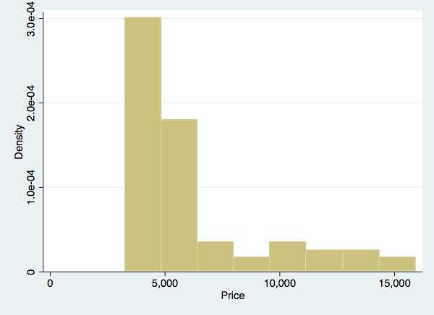
Figure 1. Histogram of the price variable
. histogram mpg
(bin=8, start=12, width=3.625)

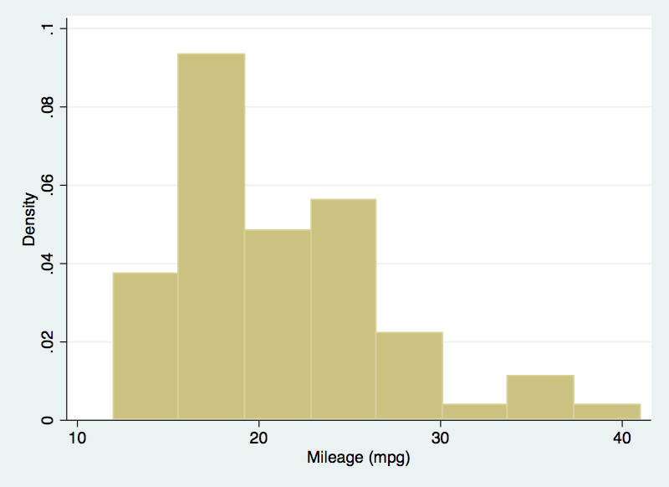
Figure 2. Histogram of the mpg variable

Writing dynamic text
use the txt command to interpret values of macros and scalars:
. summarize price

Variable | Obs Mean Std. Dev. Min Max
-------------+---------------------------------------------------------
price | 74 6165.257 2949.496 3291 15906

. return list

scalars:
r(N) = 74
r(sum_w) = 74
r(mean) = 6165.256756756757
r(Var) = 8699525.974268788
r(sd) = 2949.495884768919
r(min) = 3291
r(max) = 15906
r(sum) = 456229

The number of subject is 74 subjects in the darta set.

creating table
Optopns | Discription
markup(str) | specifies the markup language that is used for documentation
title(str) | displays the table description
width(int) | specifies the width of the table in HTML and LaTeX
height(int) | specifies the height of the table in HTML and LaTeX
center | aligns the table to the center of the document in HTML and LaTeX
left | aligns the table to the left of the document
--
size | material | color
9 | leather | brown
10 | hemp canvas | natural
11 | glass tran | sparent
Mathematical notations ======================+
You can use markdoc to:
- write inline notations (i.e. in the text paragraphs)
- on a separate line
For example, $$ will appear inline whereas

willbe on another line.

Writing mathematical notations
The text paragraph can include mathematical notations. For example, this formula will be displayed within the text paragraph, whereas this next formula will be placed on a separate line:

Use a single "$" sign for writing inline mathematical notations. For example, would be rendered inline with the text paragraph. Use double dollar signs "$$" for placing the notations on a separate lines:

- Since the notations appear in comments, they will not be interpreted by Stata as global macros.
- Place a backslash before the "$" if you are using them in the document, but not for rendering mathematical notations. The backslash will not appear in the dynamic document.
- You can also write dynamic mathematical notations using the txt command.
. local a = 10

Note that when you write inline mathematical notations, there should be NO SPACE between the dollar sign and the notation. However, if you are placing your notations on a separate line, there should be no problem.

Data preparation
- clear the data from Stata
- laod the auto dataset
. clear

. sysuse auto
(1978 Automobile Data)

Summarize the data
. summarize

Variable | Obs Mean Std. Dev. Min Max
-------------+---------------------------------------------------------
make | 0
price | 74 6165.257 2949.496 3291 15906
mpg | 74 21.2973 5.785503 12 41
rep78 | 69 3.405797 .9899323 1 5
headroom | 74 2.993243 .8459948 1.5 5
-------------+---------------------------------------------------------
trunk | 74 13.75676 4.277404 5 23
weight | 74 3019.459 777.1936 1760 4840
length | 74 187.9324 22.26634 142 233
turn | 74 39.64865 4.399354 31 51
displacement | 74 197.2973 91.83722 79 425
-------------+---------------------------------------------------------
gear_ratio | 74 3.014865 .4562871 2.19 3.89
foreign | 74 .2972973 .4601885 0 1

. histogram price
(bin=8, start=3291, width=1576.875)

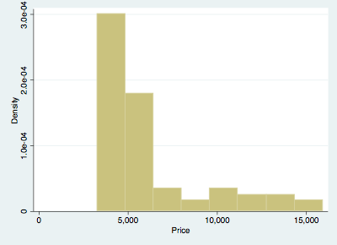
Histogram of the price variable

Dealining with the returned values
Use the return list command to list the returned values. Most of the estimations are stored in a matrix. Therefore, we copy the matrix and use it to extract the values dynamically.
. regress price mpg foreign

Source | SS df MS Number of obs = 74
-------------+---------------------------------- F(2, 71) = 14.07
Model | 180261702 2 90130850.8 Prob > F = 0.0000
Residual | 454803695 71 6405685.84 R-squared = 0.2838
-------------+---------------------------------- Adj R-squared = 0.2637
Total | 635065396 73 8699525.97 Root MSE = 2530.9

------------------------------------------------------------------------------
price | Coef. Std. Err. t P>|t| [95% Conf. Interval]
-------------+----------------------------------------------------------------
mpg | -294.1955 55.69172 -5.28 0.000 -405.2417 -183.1494
foreign | 1767.292 700.158 2.52 0.014 371.2169 3163.368
_cons | 11905.42 1158.634 10.28 0.000 9595.164 14215.67
------------------------------------------------------------------------------

return the rclass objects
. return list

scalars:
r(level) = 95

matrices:
r(table) : 9 x 3

. mat A = r(table)

. mat list A

A[9,3]
mpg foreign _cons
b -294.19553 1767.2922 11905.415
se 55.691719 700.15797 1158.6345
t -5.2825724 2.5241336 10.275385
pvalue 1.333e-06 .01383634 1.085e-15
ll -405.24167 371.2169 9595.1638
ul -183.1494 3163.3676 14215.667
df 71 71 71
crit 1.9939434 1.9939434 1.9939434
eform 0 0 0

Stata returns the estimations in the eclass
. ereturn list

scalars:
e(N) = 74
e(df_m) = 2
e(df_r) = 71
e(F) = 14.07044507869964
e(r2) = .2838474630671753
e(rmse) = 2530.945641206649
e(mss) = 180261701.570873
e(rss) = 454803694.5507485
e(r2_a) = .2636741521676592
e(ll) = -683.3599714095877
e(ll_0) = -695.7128688987767
e(rank) = 3

macros:
e(cmdline) : "regress price mpg foreign"
e(title) : "Linear regression"
e(marginsok) : "XB default"
e(vce) : "ols"
e(depvar) : "price"
e(cmd) : "regress"
e(properties) : "b V"
e(predict) : "regres_p"
e(estat_cmd) : "regress_estat"

matrices:
e(b) : 1 x 3
e(V) : 3 x 3

functions:
e(sample)

. mat B = e(b)

. mat list B

B[1,3]
mpg foreign _cons
y1 -294.19553 1767.2922 11905.415

Creating the dynamic table
In the workshop the following question came up. How can we use the returned values from Stata and create a dynamic table.
We are trying to create a dynamic table that includes the variables and . We need to get the stored values from returned matrices in Stata in the following procedure:
- save the Stata matrix with a new name
- extract the scalars of interest
- get the name of the columns of the matrix
  - parse the names of each column
  - change the /_const name to
- use the tbl command to generate the dynamic table.
. scalar scal1 = A[1,1]

. scalar scal2 = A[1,2]

. scalar scal3 = A[1,3]

. local colnms: coln A

. di "`colnms'"
mpg foreign _cons

. tokenize "`colnms'"

. display "`1' `2' `3'"
mpg foreign _cons

. local n = 1

. while "`1'" != "" {
. if "`1'" == "_cons" {
. local m`n' "$\\beta_0$"
. }
. else {
. local m`n' `1'
. }
. local n = `n' + 1
. macro shift
. }

. display "`m1' `m2' `m3'"
mpg foreign $\\beta_0$
mpg | foreign
-294.20 | 1767.29 | 11905.42

