Problem 1

1. E-R diagram

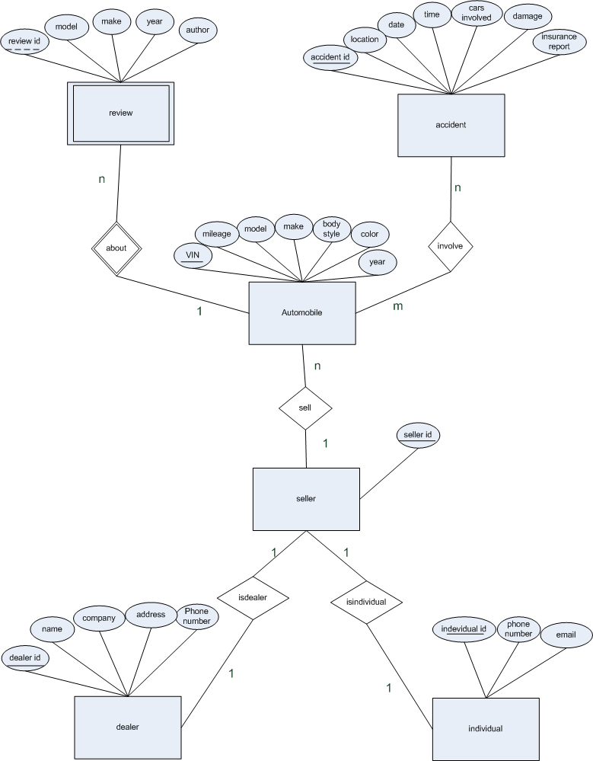

1. List the keys

|  |  |  |
| --- | --- | --- |
|  | Primary keys | Candidate keys |
| automobile | VIN | VIN |
| seller | Seller id | Seller id |
| Dealer | Dealer id | Dealer |
| Individual | Individual id | Individual id |
| Accident | Accident id | Accident id |
| Review | Review id | Review id |

Weak entities: review

Discriminators: review id

Cardinalities: listed in the er diagram

1. Tables

Automobile (VIN, mileage, model, make, body style, color, year)

Review (review id, model, make, year, author)

About (VIN, review id)

Accident (accident id, location, date, time, cars involved, damage, insurance report)

Involve (VIN, accident id)

Seller (seller id)

Sell (VIN, seller id)

Dealer (dealer id, name, company, address, phone number)

Isdealer (seller id, dealer id)

Individual (individual id, phone number, email)

Isindividual (seller id, individual id)

|  |  |  |
| --- | --- | --- |
|  | Primary keys | Candidate keys |
| automobile | VIN | VIN |
| seller | Seller id | Seller id |
| Dealer | Dealer id | Dealer |
| Individual | Individual id | Individual id |
| Accident | Accident id | Accident id |
| Review | Review id | Review id |
| About | VIN, review id | VIN, review id |
| Involve | VIN, accident id | VIN, accident id |
| Isdealer | seller id, dealer id | seller id, dealer id |
| Isindividual | seller id, individual id | seller id, individual id |
| Sell | VIN, seller id | VIN, seller id |

Problem 2

1. ER diagram

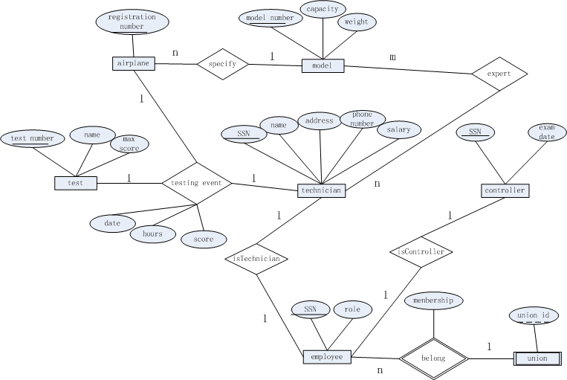

1. Tables and SQL

Airplane (registration number)

CREATE TABLE Airplane

( registration number CHAR(11),

PRIMARY KEY (registration number))

Model (model number, capacity, weight )

CREATE TABLE Model

(model number CHAR(11),

Capacity INTEGER,

Weight INTEGER,

PRIMARY KEY (model number))

Specify (registration number, model number)

CREATE TABLE Specify

(registration number CHAR(11),

model number CHAR(11),

PRIMARY KEY (registration number, model number),

FOREIGN KEY (registration number) REFERENCES Airplane,

FOREIGN KEY (model number) REFERENCES Model

)

Technician (SSN, name, address, phone number, salary)

CREATE TABLE technician

(SSN CHAR(11),

Name CHAR(11),

address CHAR(11),

phone number CHAR(11),

salary REAL,

PRIMARY KEY (SSN))

Expert (SSN, model number)

CREATE TABLE Expert

(SSN CHAR(11),

model number CHAR(11),

PRIMARY KEY (SSN, model number),

FOREIGN KEY (SSN) REFERENCES Technician,

FOREIGN KEY (model number) REFERENCES Model

)

Test (test number, name, max score)

CREATE TABLE Test

(test number CHAR(11),

Name CHAR(11),

Max score REAL,

PRIMARY KEY (test number))

Testing event (registration number, test number, SSN, date, hours, score)

CREATE TABLE testing event

(registration number CHAR(11),

test number CHAR(11),

SSN CHAR(11),

Date DATE,

Hours INTEGER,

Score REAL,

PRIMARY KEY (registration number, test number, SSN),

FOREIGN KEY (registration number) REFERENCES Airplane,

FOREIGN KEY (test number) REFERENCES Test,

FOREIGN KEY (SSN) REFERENCES Technician

)

Employee (SSN, role)

CREATE TABLE Employee

(SSN CHAR(11),

role CHAR(11),

PRIMARY KEY (SSN))

Controller (SSN, exam date)

CREATE TABLE Controller

(SSN CHAR(11),

Exam date CHAR(11),

PRIMARY KEY (SSN))

isTechnician (SSN1, SSN2)

CREATE TABLE isTechnician

(SSN1 CHAR(11),

SSN2 CHAR(11),

PRIMARY KEY (SSN1, SSN2),

FOREIGN KEY (SSN1) REFERENCES employee,

FOREIGN KEY (SSN2) REFERENCES technician

)

isController (SSN1, SSN2)

CREATE TABLE isController

(SSN1 CHAR(11),

SSN2 CHAR(11),

PRIMARY KEY (SSN1, SSN2),

FOREIGN KEY (SSN1) REFERENCES employee,

FOREIGN KEY (SSN2) REFERENCES Controller

)

Union (union id)

CREATE TABLE Union

(union id CHAR(11),

PRIMARY KEY (union id))

belong (SSN, union id, membership)

CREATE TABLE belong

(SSN CHAR(11),

Union id CHAR(11),

membership CHAR(11),

PRIMARY KEY (SSN, union id),

FOREIGN KEY (SSN) REFERENCES employee,

FOREIGN KEY (union id) REFERENCES union

)

Problem 3

1）

2）

3）

4）







5）



Problem 4

1)



2)



3)



4)

