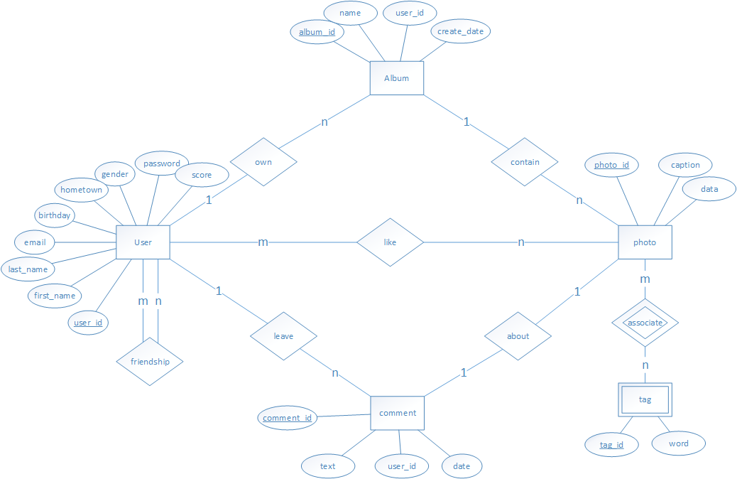

CREATE TABLE user(

user_id INTEGER,

first_name CHAR(20),

last_name CHAR(20),

email CHAR(40),

birthday Date,

hometown CHAR(40),

gender CHAR(20),

password CHAR(20),

score INTEGER,

PRIMARY KEY (user_id)

);

CREATE TABLE friendship (

user_id1 INTEGER,

user_id2 INTEGER,

PRIMARY KEY (user_id1,user_id2),

FOREIGN KEY (user_id1) REFERENCES user(user_id),

FOREIGN KEY (user_id2) REFERENCES user(user_id)

);

CREATE TABLE album (

album_id INTEGER,

name CHAR(20),

user_id INTEGER,

create_date Date,

PRIMARY KEY (album_id),

FOREIGN KEY (user_id) REFERENCES user(user_id)

);

CREATE TABLE own (

user_id INTEGER,

album_id INTEGER,

PRIMARY KEY (user_id, album_id),

FOREIGN KEY (user_id) REFERENCES user(user_id),

FOREIGN KEY (album_id) REFERENCES album(album_id));

CREATE TABLE photo (

photo_id INTEGER,

caption CHAR(20),

date Date,

PRIMARY KEY (photo_id)

);

CREATE TABLE contain (

album_id INTEGER,

photo_id INTEGER,

PRIMARY KEY (album_id, photo_id),

FOREIGN KEY (album_id) REFERENCES album(album_id),

FOREIGN KEY (photo_id) REFERENCES photo(photo_id));

CREATE TABLE tag (

tag_id INTEGER,

word CHAR(20),

PRIMARY KEY (tag_id)

);

CREATE TABLE associate (

photo_id INTEGER,

tag_id INTEGER,

PRIMARY KEY (photo_id, tag_id),

FOREIGN KEY (photo_id) REFERENCES photo(photo_id),

FOREIGN KEY (tag_id) REFERENCES tag(tag_id));

CREATE TABLE comment (

comment_id INTEGER,

text CHAR(200),

user_id INTEGER,

date Date,

PRIMARY KEY (comment_id),

FOREIGN KEY (user_id) REFERENCES user(user_id)

);

CREATE TABLE about (

photo_id INTEGER,

comment_id INTEGER,

PRIMARY KEY (photo_id, comment_id),

FOREIGN KEY (photo_id) REFERENCES photo(photo_id),

FOREIGN KEY (comment_id) REFERENCES comment(comment_id));

CREATE TABLE leave (

user_id INTEGER,

comment_id INTEGER,

PRIMARY KEY (user_id, comment_id),

FOREIGN KEY (user_id) REFERENCES user(user_id),

FOREIGN KEY (comment_id) REFERENCES comment(comment_id));