CPSC1520 – JavaScript 5 Exercise: Arrays and Loops

# Introduction

Arrays are essential data structures that are used not only in JavaScript but essentially every programming language. In this exercise you will be: filtering a list of items based on the platform selected, adding a video game to “my favourites” if the video game item in the “classics” section is clicked, and removing the video game item from the “my favourites” section.

# Exercise Step 1: Filter The List

1. You are given a form that listens to submit events. Create a function named “filterGames” that accepts one parameter. Call this function in the “videoGameForm” event handler passing the “platform” variable as the argument.
2. In the “filterGames” function, use the “forEach” method on the “allGameListItems” to loop over each element. You are essentially going to show the list items which are the same as the platform argument you passed in previous step (i.e. you will check for equality).
   1. If the element includes (you can use .includes() string function on the innerText of the element) remove the “hidden-item” class (defined in the main.css file) from the list item.
   2. Otherwise, add the “hidden-item” class to the to the element.
3. If you select different values in the select, you should see other video game platforms (other than the one you have selected) filtered out. Once your output looks like the picture below, then move to the second step. Selecting “switch” from the dropdown should look like below:

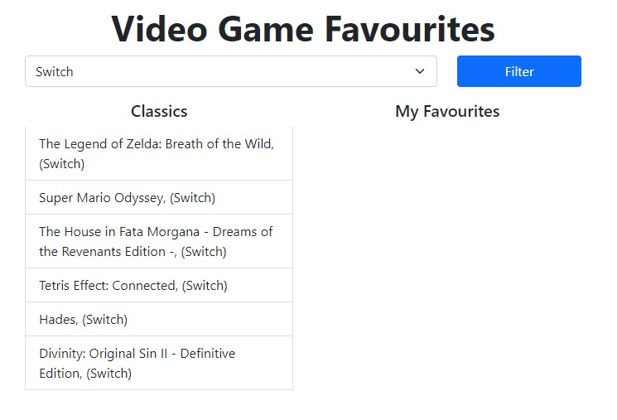

# Exercise Step 2: Add to Favourites

1. You are given an event listener on the “allGames” list that listens to click events. Create a function named “addToFavouriteGames” that accepts one parameter named “game”. Within the event handler, call the function “addToFavouriteGames” passing the game as the argument. 2. In the “addToFavouriteGames” function, push() the new argument value game on to the array “myGames”. Note: If you log out the array to the console you should see all of the items you’ve clicked.

1. Create a new function named “renderFavouriteList” that takes no parameters. You’ll do a couple of things in this function:
   1. Set the innerHTML of “myGamesList” to an empty string (i.e. '').
   2. Loop through the array “myGames” either with the forEach method. In each iteration you will add the HTML for a list item (this is given in the JavaScript file) to the innerHTML of “myGamesList”. Note: you’ll need to continuously add to the innerHTML so you might want to use the “+=” operator
2. Call your new function “renderFavouriteList” in the “addToFavouriteGames” function after you have pushed the new game to the “myGames” array.
3. If you filter the values to “Nintendo 64” and you click on the games “GoldenEye 007” and “Super Mario 64” you should see the following:

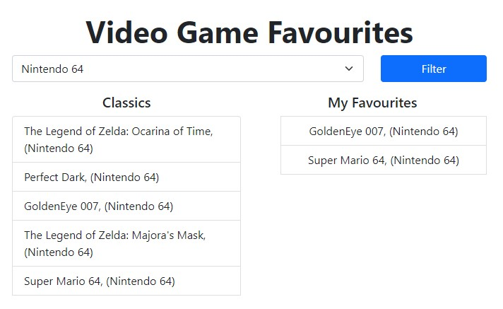

Once you see the above then you can proceed to the next step.

# Exercise Step 3: Remove From Favourites

1. You are given an event listener on the “myGameList” list that listens to click events. Create a function named “removeFromFavouriteGames” that accepts one parameter named “game”.
2. In the “removeFromFavouriteGames” function we’re going to remove the game from the “myGames” list. You’ll do this by:
   1. Getting the index of the game selected by calling the method “indexOf” with the argument “game” on the list “myGames”; assign this value to a variable (you can name it index as that seems like a good name for the index)
   2. On the “myGames” array, call the method “splice” with the two arguments: the index selected above first, and 1 as the second argument (effectively removing the element).
   3. As the last step in this function, call the “renderFavouritesList” function.
3. To test this do the following:
   1. If you filter the values to “Nintendo 64” and you click on the games “GoldenEye 007” and “Super Mario 64” you should see the following (based on the previous step)



* 1. If you click on “Golden Eye” you should see the following:

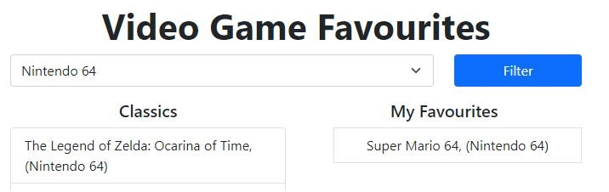

# Submission

Upload your finished lab to Netlify.

Create a GitHub repository for your lab.

Submit the Netlify and GitHub URLs to Moodle.