EE431, Lab3

Professor Tina Smilkstein

Austin Ma

My submitted q: how do you check for routing settings?

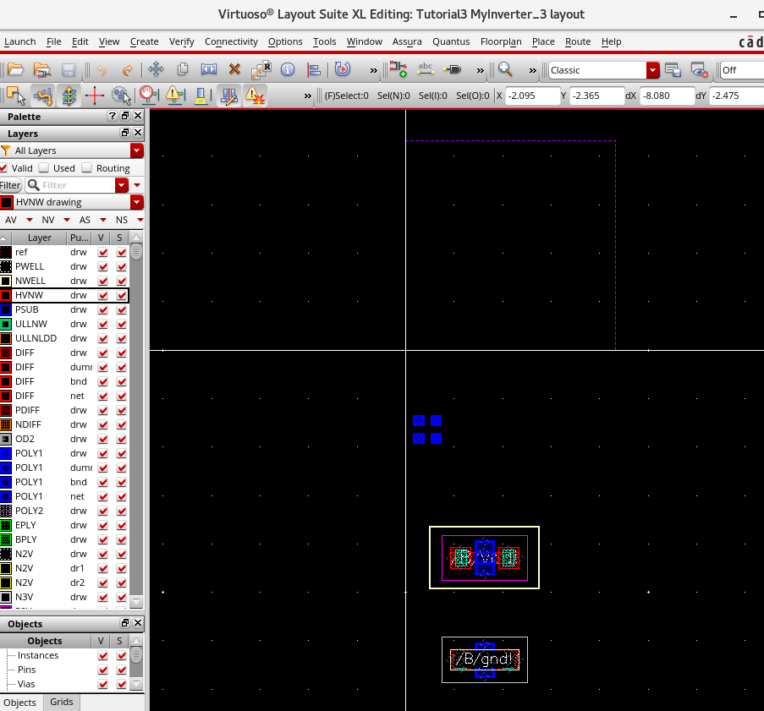

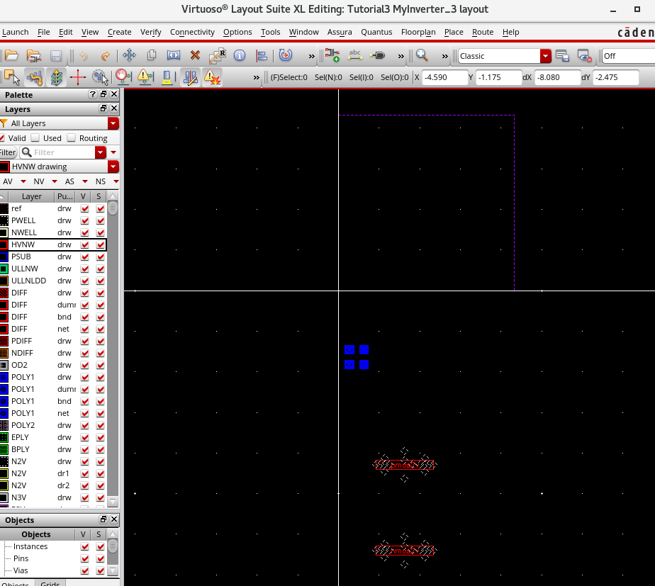

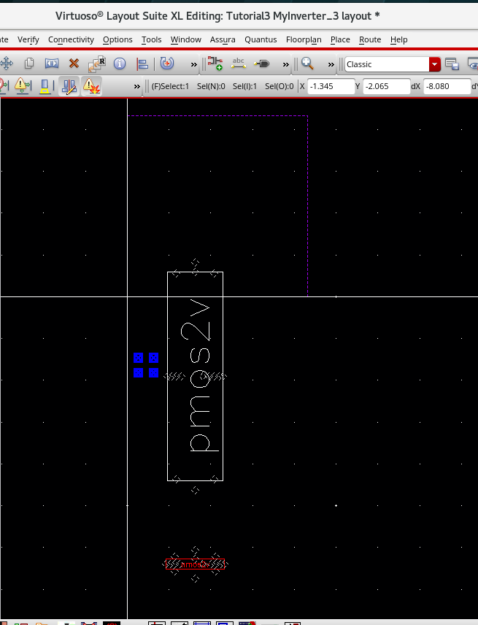

Weird 5um request for temporary parameter of width of a transistor?

