

Course Title: | Computer Organization and Architecture
Course Number: | COE608
Semester/Year (e.g.F2016) | W2021

Instructor: | Nagi Mekhiel

Assignment/Lab Number: | 2
Assignment/Lab Title: | Program Counter and Register Set Design

Submission Date : | Feb. 6, 2021
Due Date: | Feb 6.2021

Student  LAST Name | Student  FIRST Name | Student Number | Section | Signature*
Chen | Rick | 500909131 | 08 | 

*By signing above you attest that you have contributed to this written lab report and confirm that all work you have contributed to this lab report is your own work. Any suspicion of copying or plagiarism in this work will result in an investigation of Academic Misconduct and may result in a “0” on the work, an “F” in the course, or possibly more severe penalties, as well as a Disciplinary Notice on your academic record under the Student Code of Academic Conduct, which can be found online at: http://www.ryerson.ca/senate/current/pol60.pdf

Objective:
The objective of this lab is to implement the Register Set and 32-bit Program Counter that are required for the 32 bit CPU on Quartus then do the functional & timing simulation for further understanding how these two works.

Design and Implementation:
The figure below is the block diagram for a n-bit register. The register only passes the data from input to output when load and clock are high, and saves the data until clear is high or the load and clock is on again so the old one will be replaced.
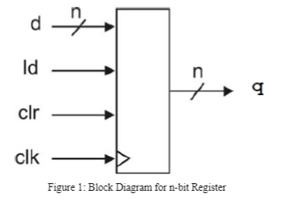

The figures below show a 32-bit program counter. The 32-bit register in the program counter takes the input from the multiplexer if the increment is low and passes to the output if the load and clock are high. If the increment is high, then the multiplexer will passes (q+4) from the adder to the register.
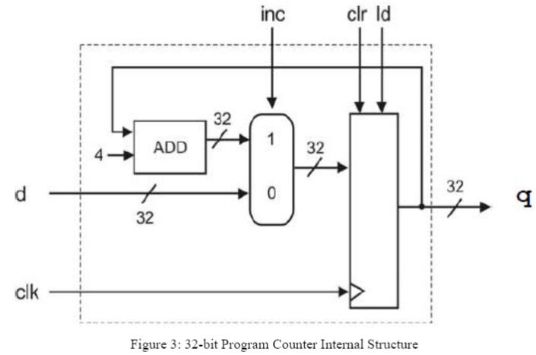
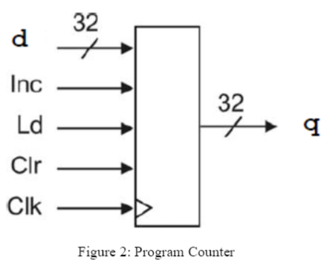

Result and Conclusion:
- Register1
  - functional simulation
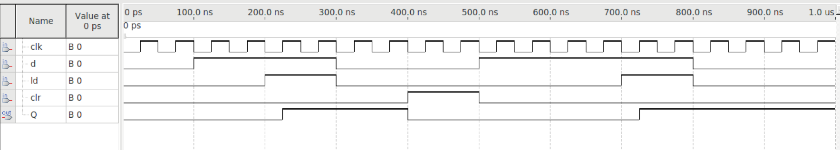
  - Timing simulation
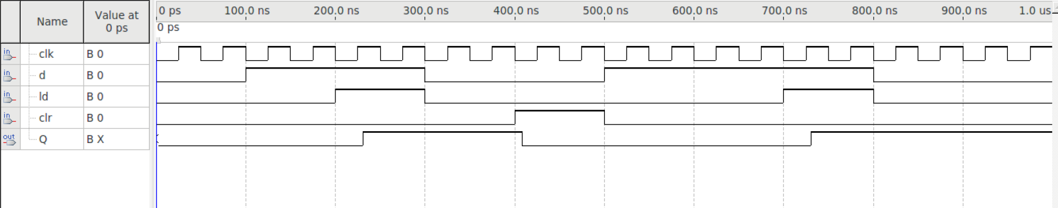
- Register32
  - Functional simulation
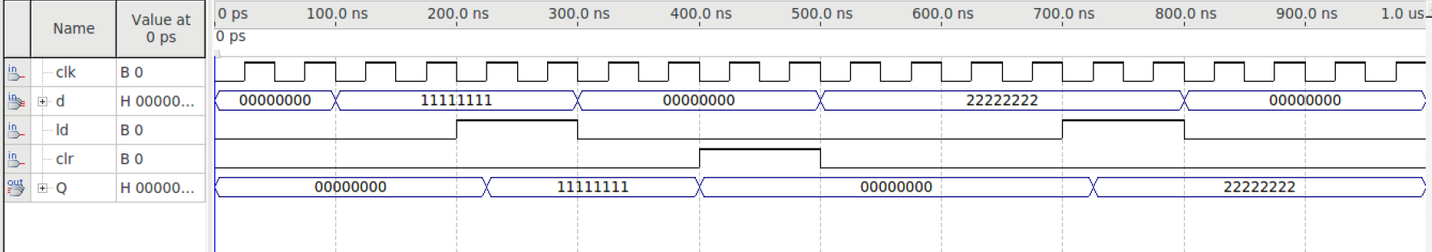
  - Timing simulation
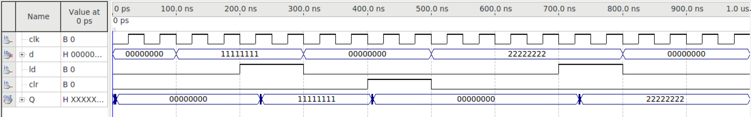
- PC counter
  - Functional simulation
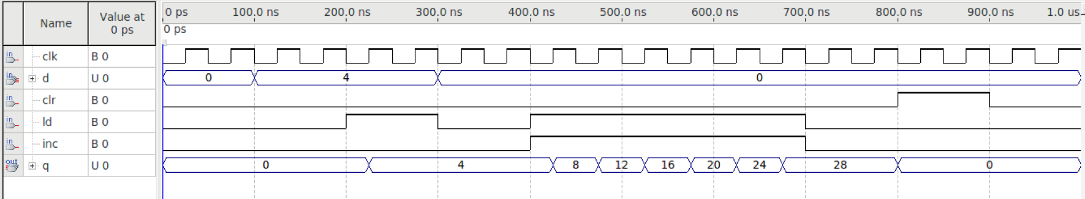
  - Timing simulation
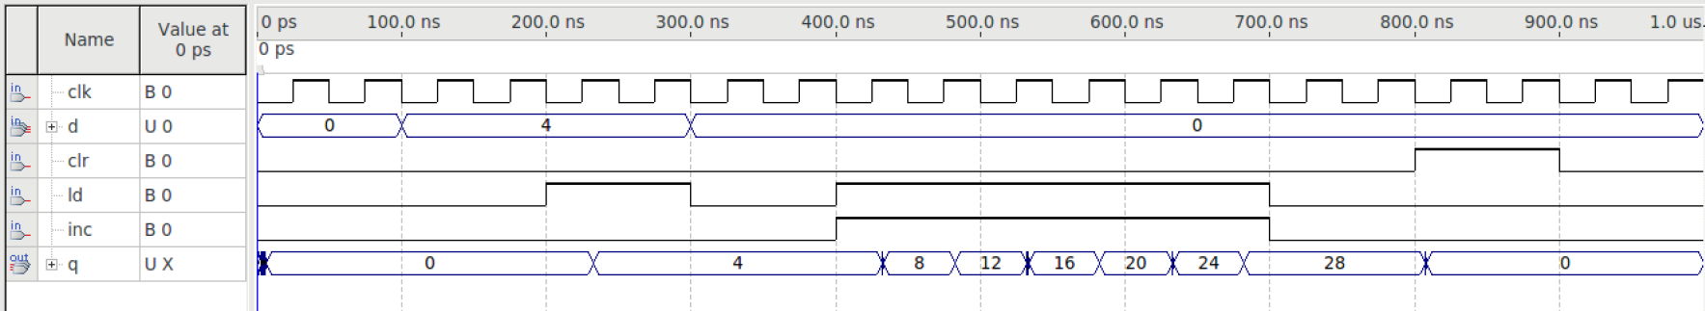

Appendix:
- Register1
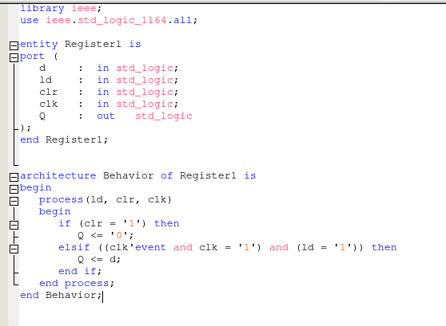
- Register32
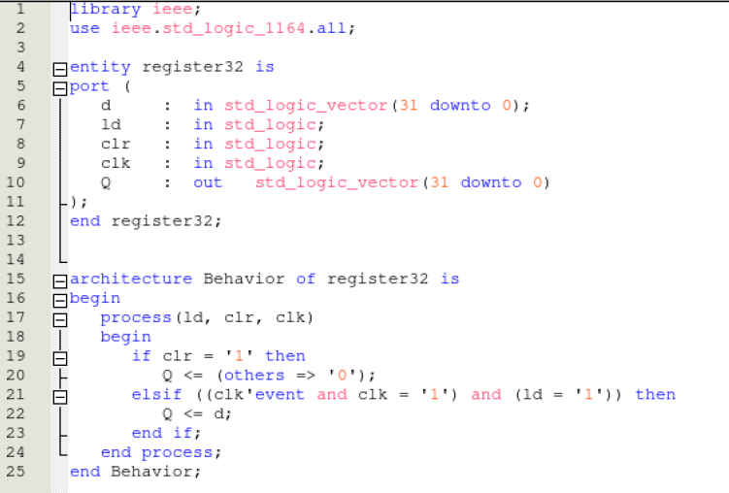
- PC
  - Pc.vhd
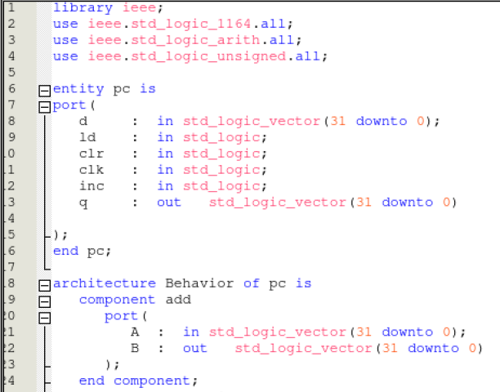
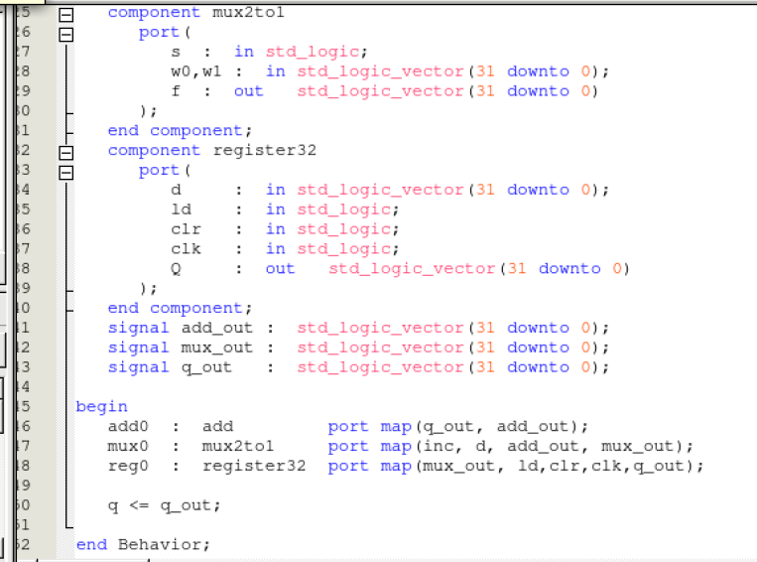
  - add.vhd
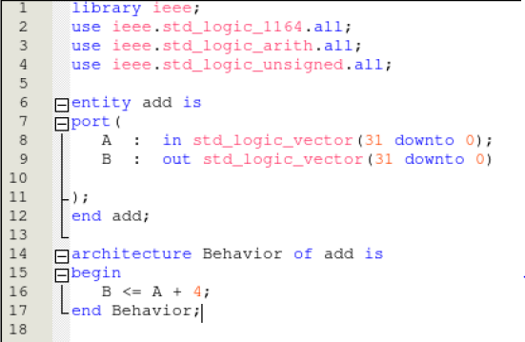
  - mux2to1.vhd
