

Course Title: | Computer Organization and Architecture
Course Number: | COE608
Semester/Year (e.g.F2016) | W2021

Instructor: | Nagi Mekhiel

Assignment/Lab Number: | 3
Assignment/Lab Title: | 32-bit ALU Design

Submission Date : | Feb. 13. 2021
Due Date: | Feb. 13.2021

Student  LAST Name | Student  FIRST Name | Student Number | Section | Signature*
Chen | Rick | 500909131 | 08 | 

*By signing above you attest that you have contributed to this written lab report and confirm that all work you have contributed to this lab report is your own work. Any suspicion of copying or plagiarism in this work will result in an investigation of Academic Misconduct and may result in a “0” on the work, an “F” in the course, or possibly more severe penalties, as well as a Disciplinary Notice on your academic record under the Student Code of Academic Conduct, which can be found online at: http://www.ryerson.ca/senate/current/pol60.pdf
Objective:
The objective of this lab is to implement a 32- bit ALU that is able to perform 6 operations, and then test it out with functional and timing simulation.

Design and Implementation:
The figure 1 below is a 32- bit Arithmetic Logic Unit and figure 2 shows the internal structure of a 2-bit ALU. The ALU takes 3 inputs, a,b and ALU_Op, and generates 3 outputs, result, zero and carry out. The outputs depend on the operation that is shown in the table below. For any operations that are not shown in the table such as “011” and “111” will pass input b and a to the result and set carry out to 0 for both of them.
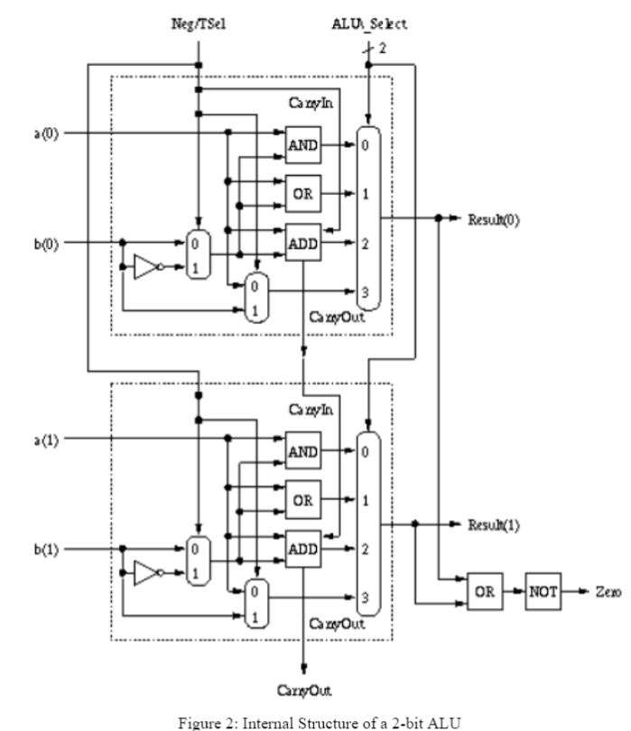
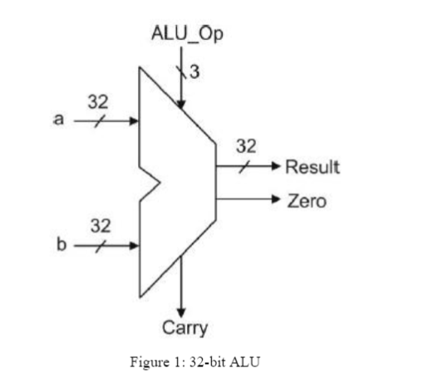
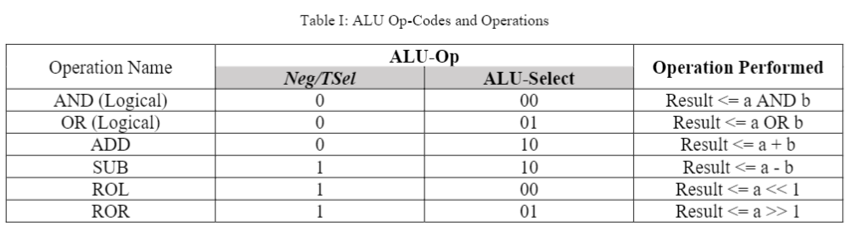

Result and Conclusion:

Simulations:
fulladd:
Functional simulation:
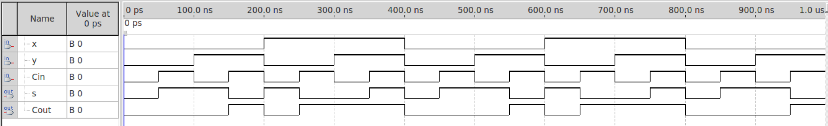
Timing simulation:
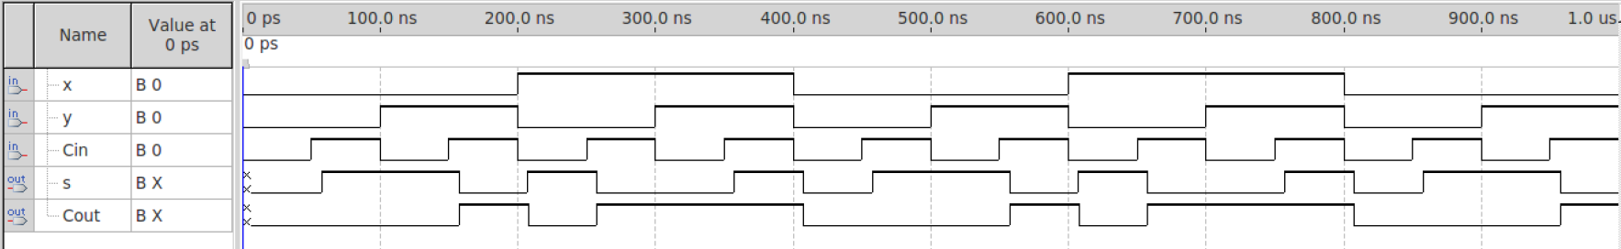

adder4:
Functional simulation:
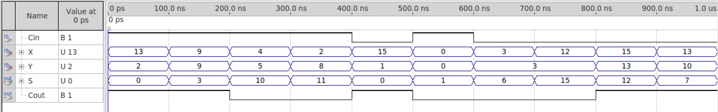
Timing simulation:
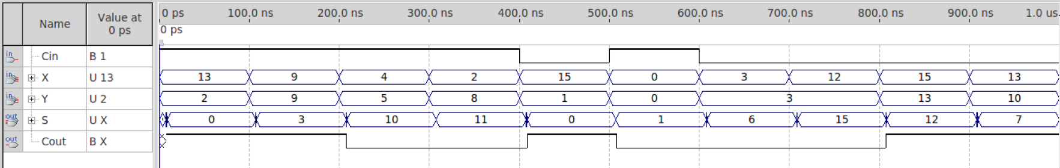

adder16:
Functional simulation:
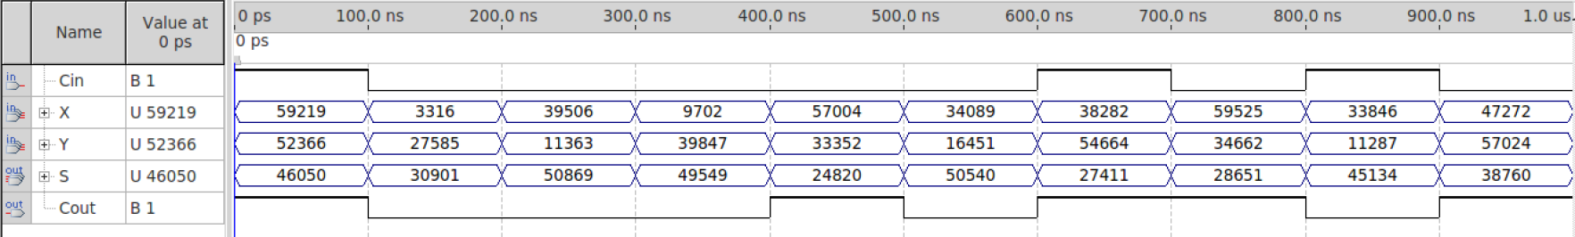
Timing simulation:
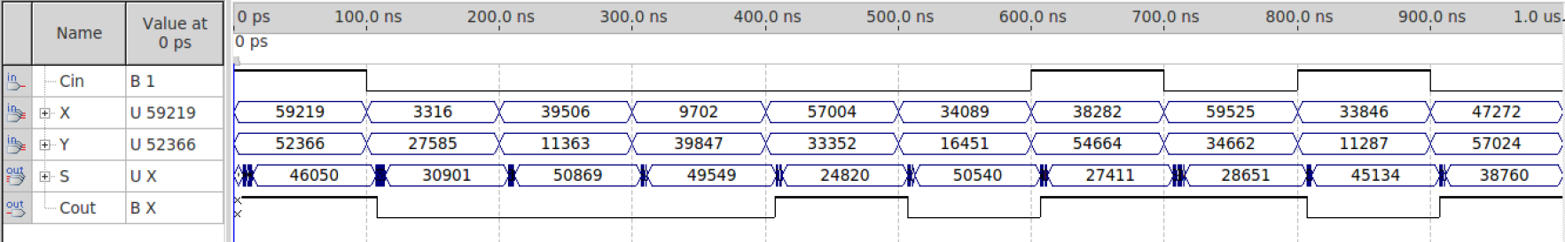
adder32:
Functional simulation:
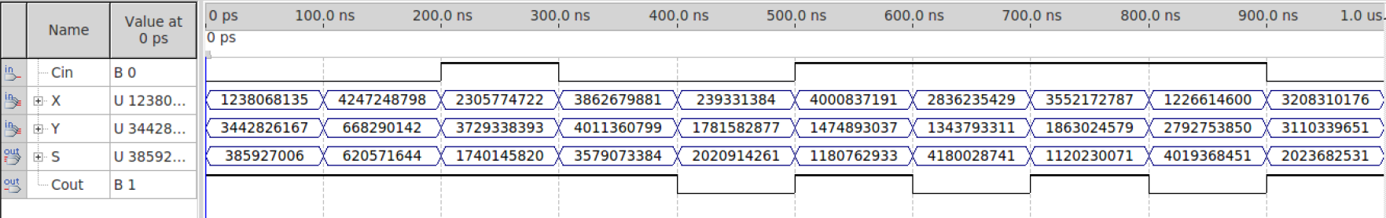
Timing simulation:
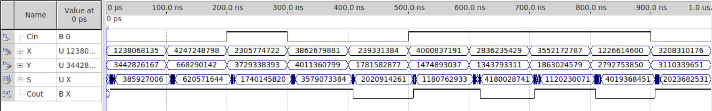

ALU:
functional simulation:
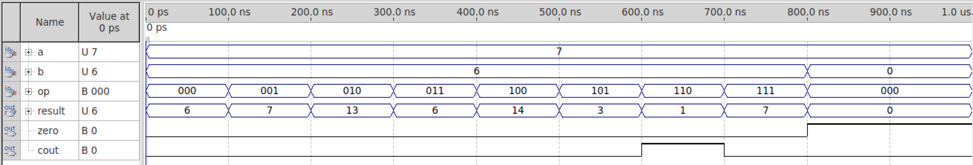
Timing simulation:
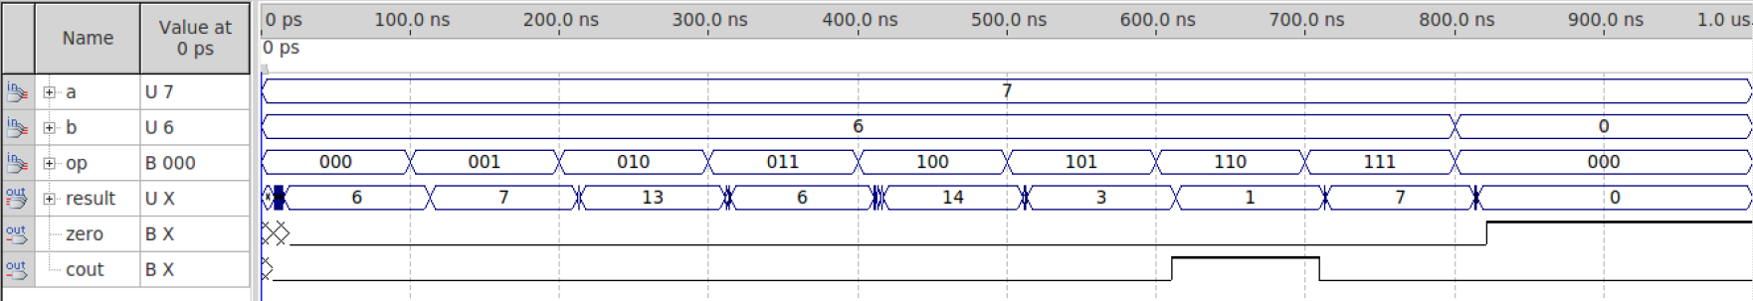

conclusion:

As we can see in the figures below, it takes around 20 ns for the system to stabilize in the AND operation. 18 ns for OR operation, 19 ns for ADD operation and so on. Within all the operations, the left logical shift operation is the one that takes most of the time. The ROL takes around 22 ns due to the reason that the system has to read every bit in the input and then logical shift left by one bit. The system also has to read the most significant bit of the input since after shift left by one bit, that extract bit is the carry out.

Appendix:

fulladd:
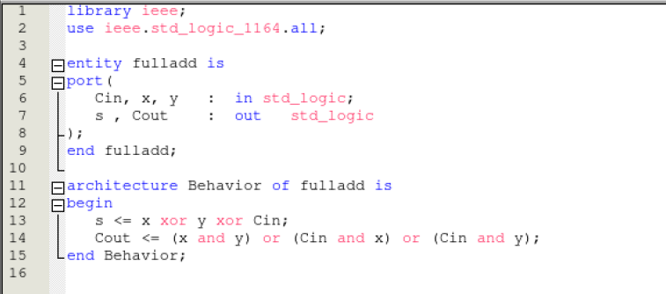

adder4:
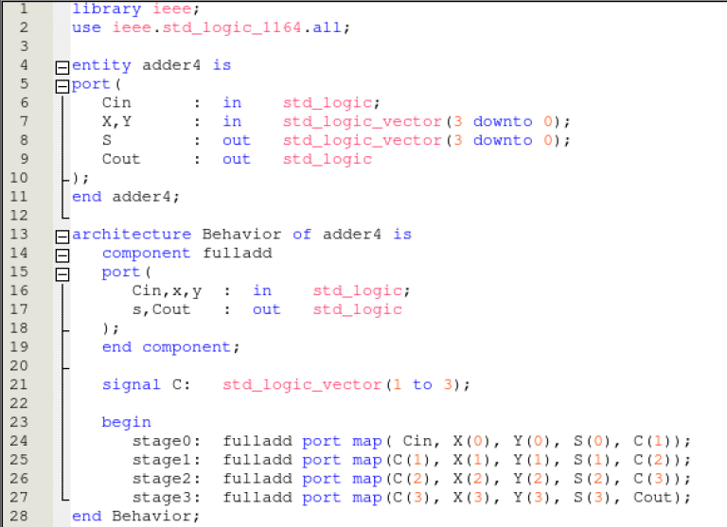

adder16:
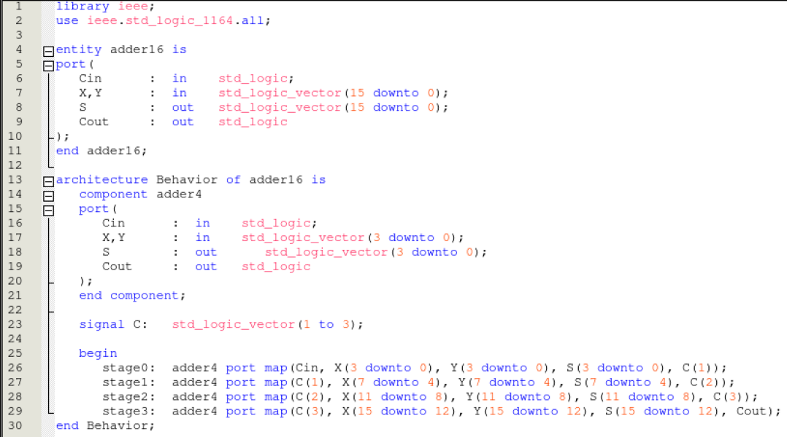

adder32:
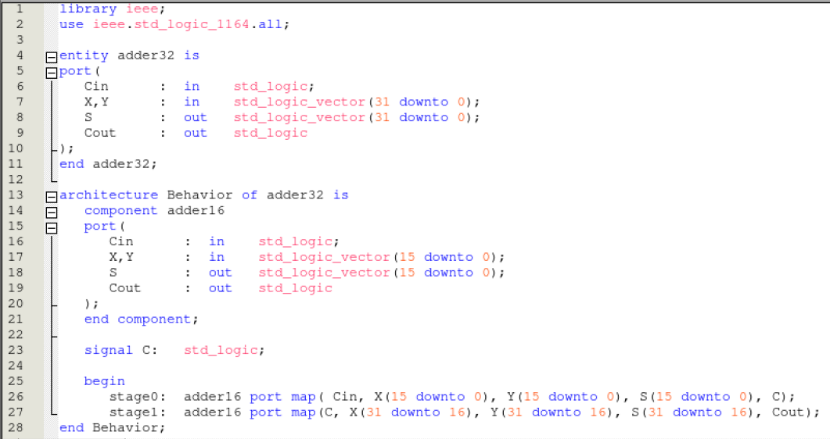

ALU:
