

Course Title: | Computer Organization and Architecture
Course Number: | COE608
Semester/Year (e.g.F2016) | W2021

Instructor: | Nagi Mekhiel

Assignment/Lab Number: | 4a
Assignment/Lab Title: | Data Memory Module

Submission Date : | Feb. 27. 2021
Due Date: | Feb. 27.2021

Student  LAST Name | Student  FIRST Name | Student Number | Section | Signature*
Chen | Rick | 500909131 | 08 | 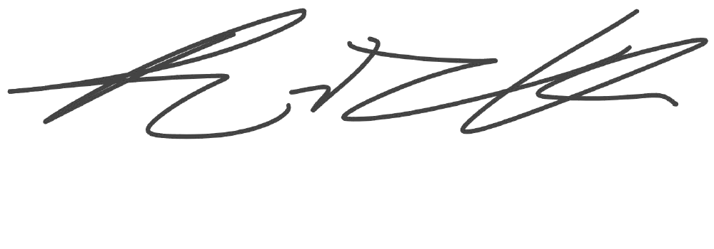

*By signing above you attest that you have contributed to this written lab report and confirm that all work you have contributed to this lab report is your own work. Any suspicion of copying or plagiarism in this work will result in an investigation of Academic Misconduct and may result in a “0” on the work, an “F” in the course, or possibly more severe penalties, as well as a Disciplinary Notice on your academic record under the Student Code of Academic Conduct, which can be found online at: http://www.ryerson.ca/senate/current/pol60.pdf
Objective:
The objective of this lab is to implement and simulate a simple memory unit that has the functions of reading and writing the data within a single clock cycle.

Design and Implementation:
The figure 1 below is a 256-words x 32-bit Data Memory Unit. The memory unit takes 5 inputs, addr, clk, data_in, en, and wen, and generates 1 output, data_out. The functions of the memory unit are shown in Table I below. When wen and en are 1, the memory unit writes the data_in into the given address of memory at the falling edge of the clock. When en is 1 and wen is 0, the memory unit reads the data stored in the given address and outputs that to data_out at the falling edge of the clock.
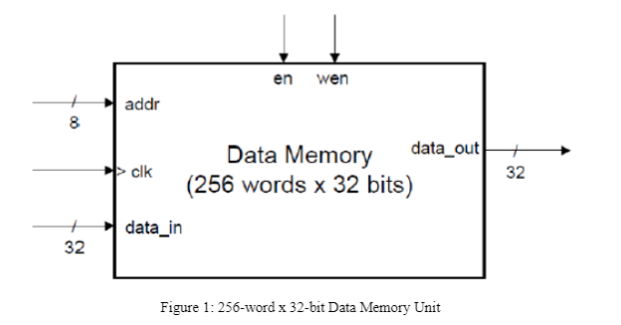

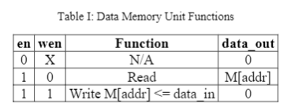

Result and Conclusion:

Simulations:
functional simulation:
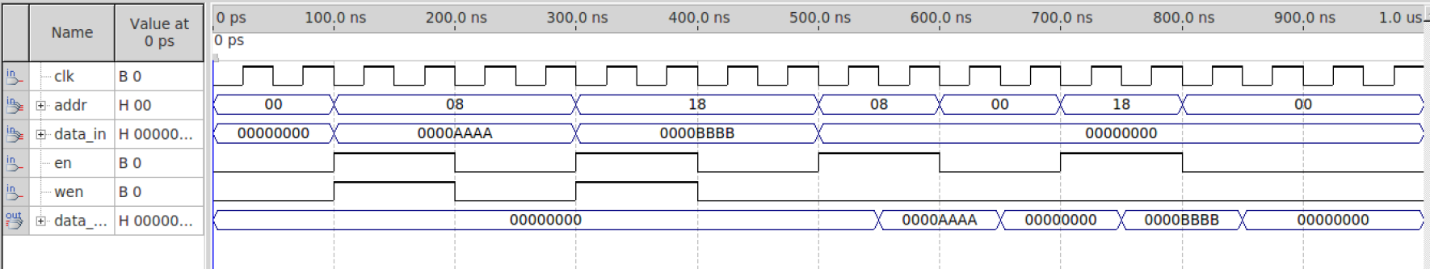

timing simulation:
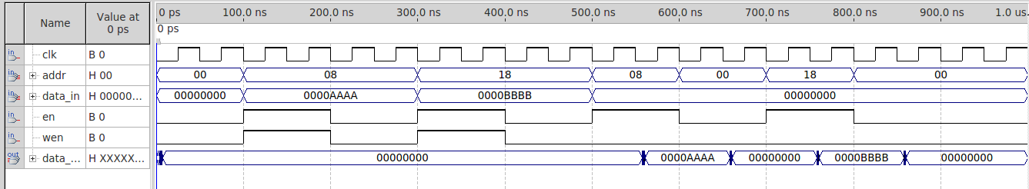

conclusion:

.As we can see in Clock to Output Times, at the falling edge of clock, the maximum time it takes data_out to rise is 10.625 ns and 10.538 ns for fall. The worst case of delay is equal to the average of both values which is 10.5815 ns.
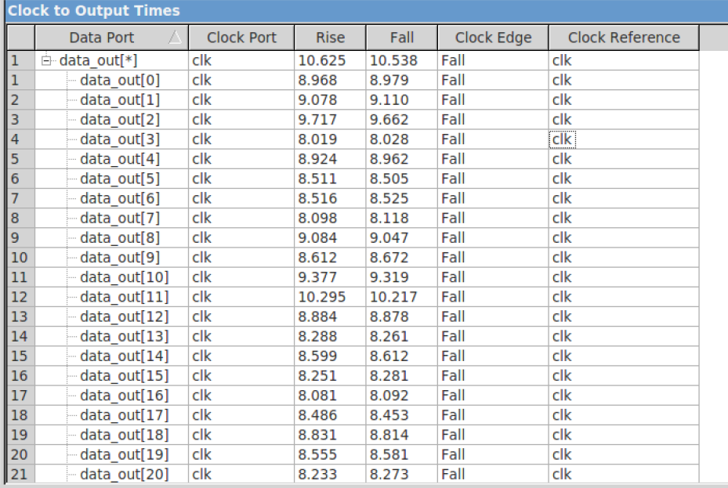
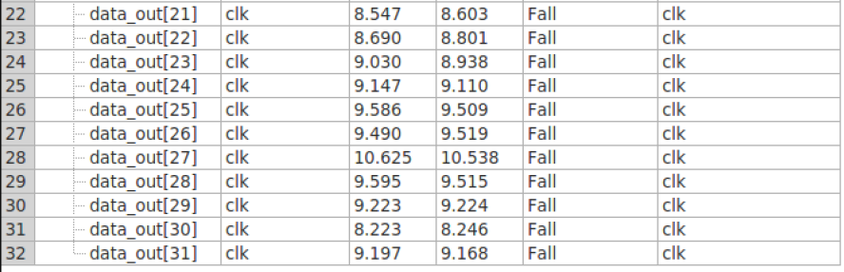

Reference:
1.Quartus II Handbook available at the course web and Altera webpag

Appendix:
