

Course Title: | Computer Organization and Architecture
Course Number: | COE608
Semester/Year (e.g.F2016) | W2021

Instructor: | Nagi Mekhiel

Assignment/Lab Number: | 6
Assignment/Lab Title: | The Complete CPU (Overall Project)

Submission Date : | April,10. 2021
Due Date: | April, 10.2021

Student  LAST Name | Student  FIRST Name | Student Number | Section | Signature*
Chen | Rick | 500909131 | 08 | 

*By signing above you attest that you have contributed to this written lab report and confirm that all work you have contributed to this lab report is your own work. Any suspicion of copying or plagiarism in this work will result in an investigation of Academic Misconduct and may result in a “0” on the work, an “F” in the course, or possibly more severe penalties, as well as a Disciplinary Notice on your academic record under the Student Code of Academic Conduct, which can be found online at: http://www.ryerson.ca/senate/current/pol60.pdf
Objective:
The objective of this lab is to implement a CPU by combining the data-path and control unit we designed in lab4 and lab5 with the reset circuit. Then by generating the waveforms to help us understand the functionality and double check the result.

Design and Implementation:
The complete CPU is a combination of data-path, control unit and reset circuit. The data-path and control unit are the one we have implemented in the previous labs. The reset circuit here is to set CLR_PC and ENABLE_PD depends on the value of RESET. At the rising edge of Clk, if RESET is high, the reset circuit will tell the data-path to clear the PC and set the enable off for the control unit, vice versa.

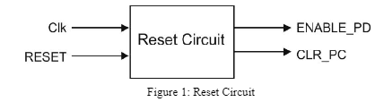

Result and Conclusion:

reset_circuit:
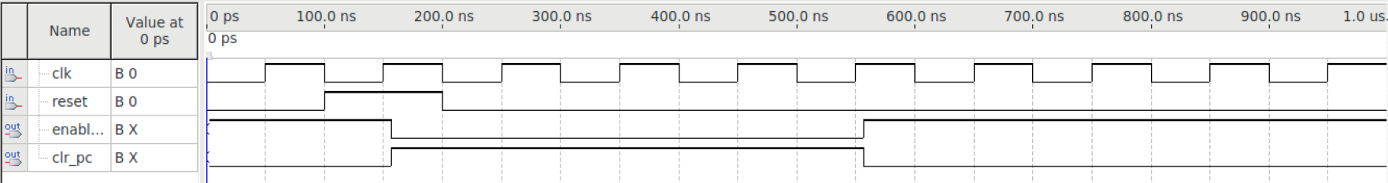

cpu_test_sim:
LDAI,STB.CLRB,LDB:
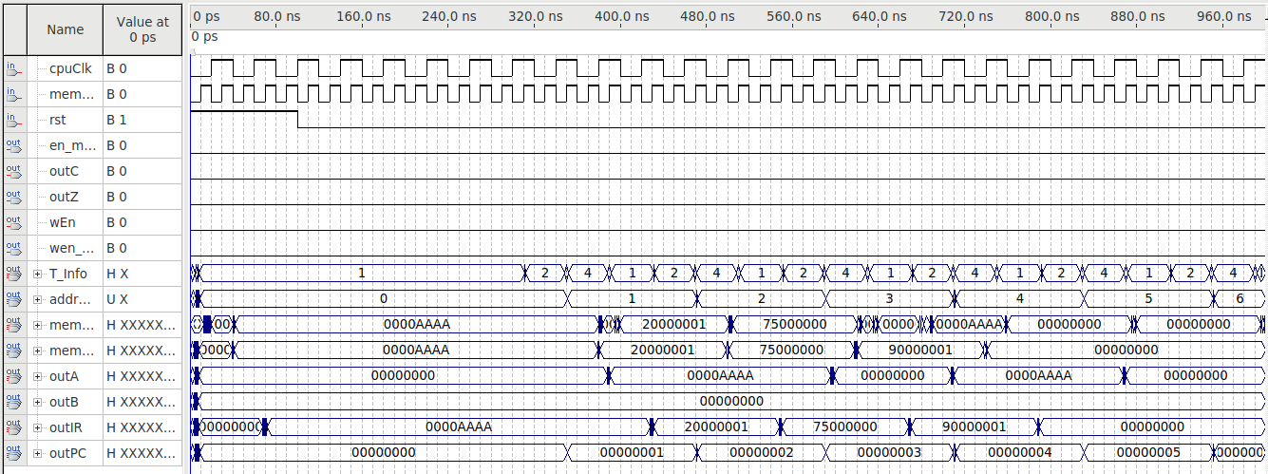

LDBI,STB,CLRB,LDB:
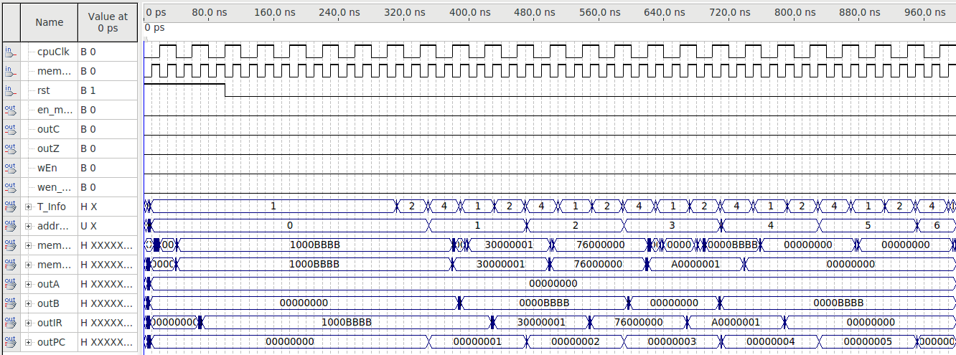

LUI:
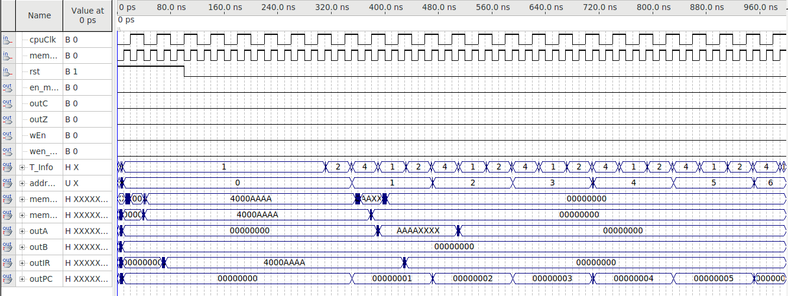

JMP:
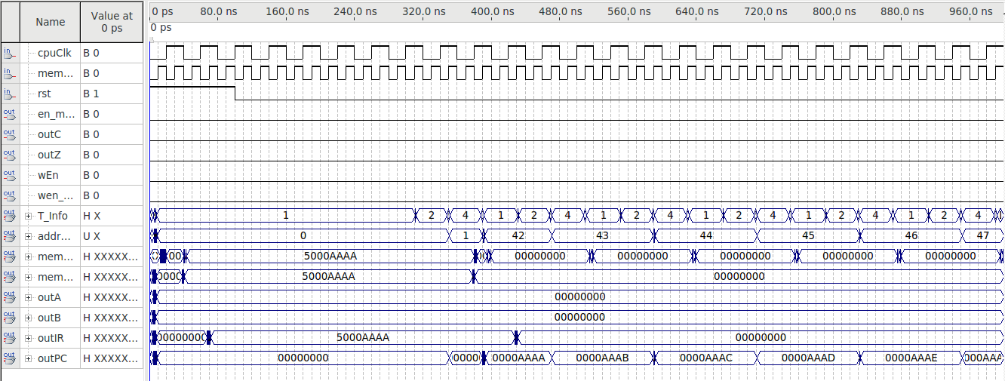

ANDI: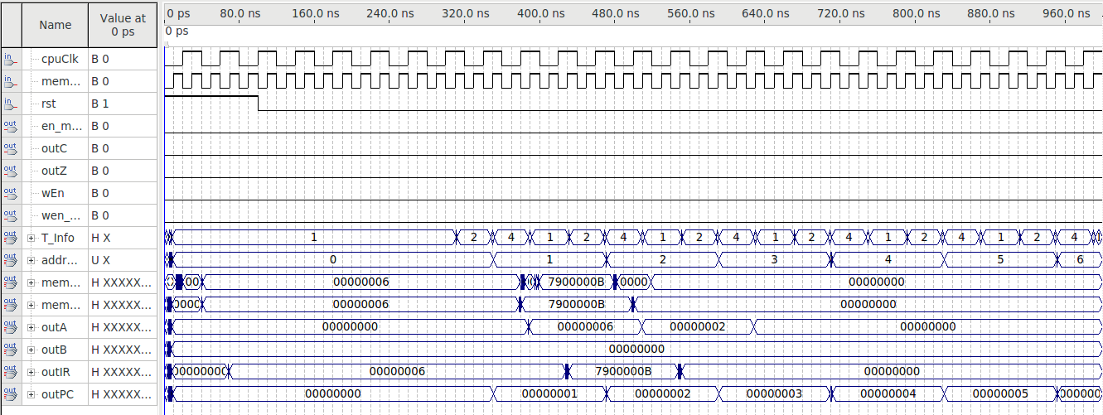

ADDI:
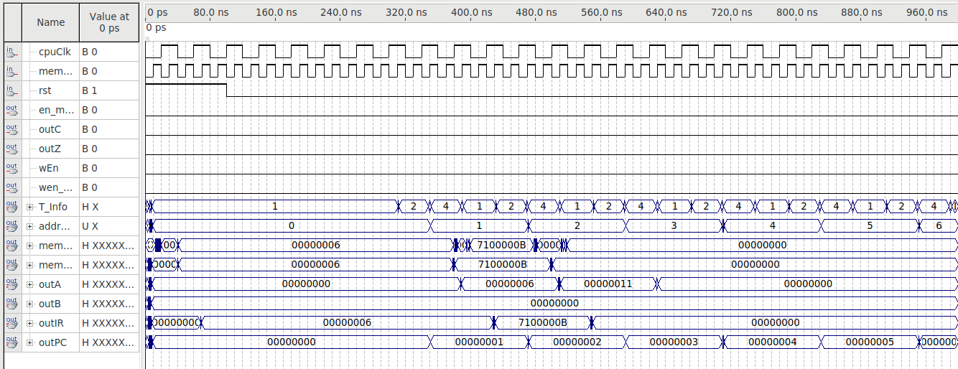

ORI:
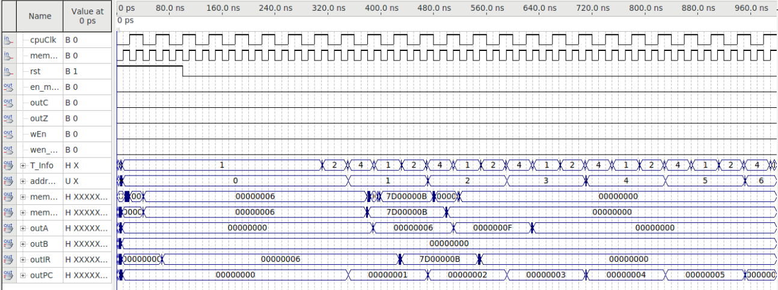

ADD:
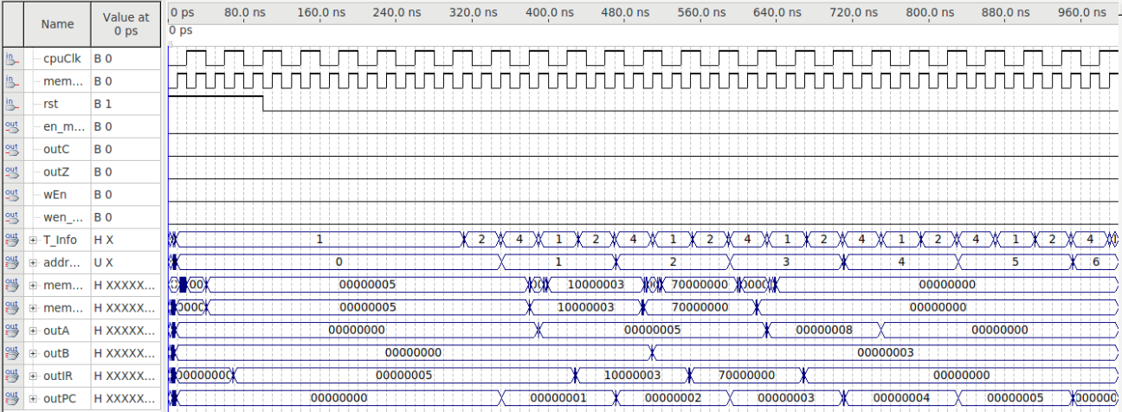

SUB:
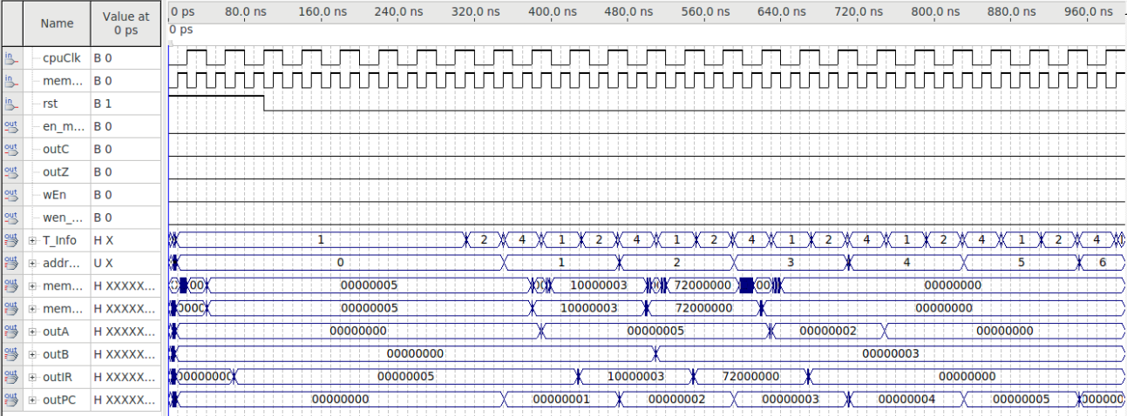

DECA:
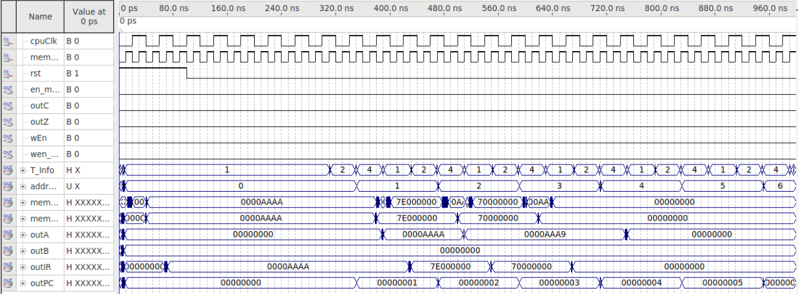

INCA:
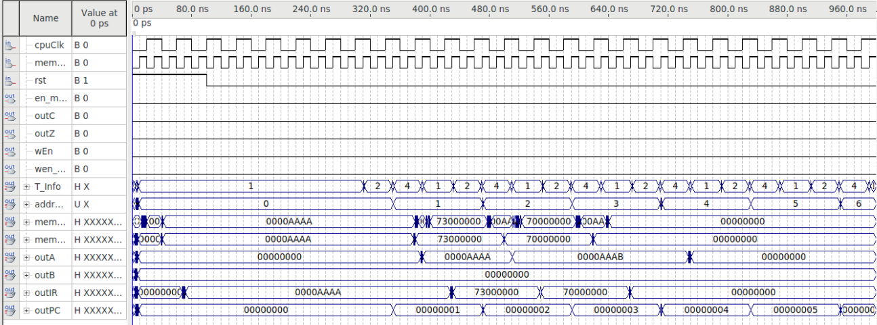

ROL:
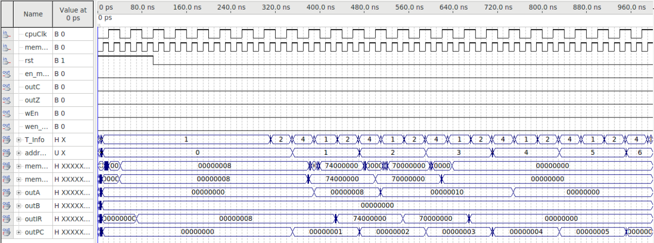

ROR:
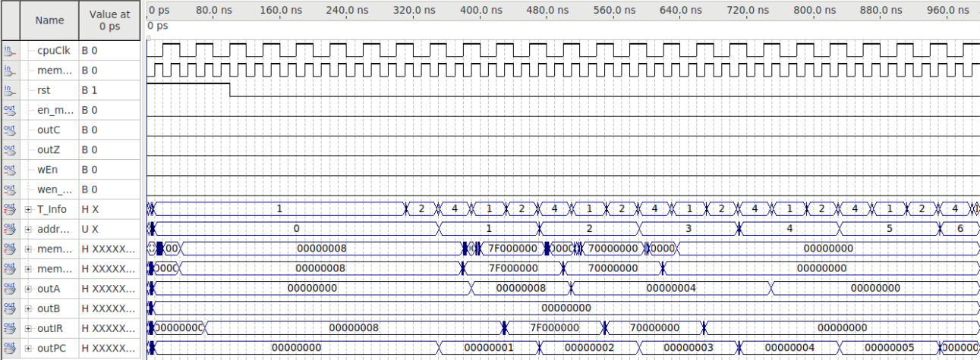

BEQ:
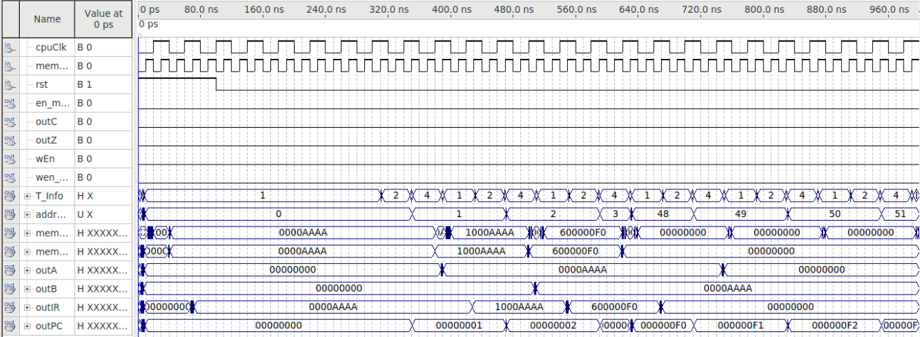

BNE:
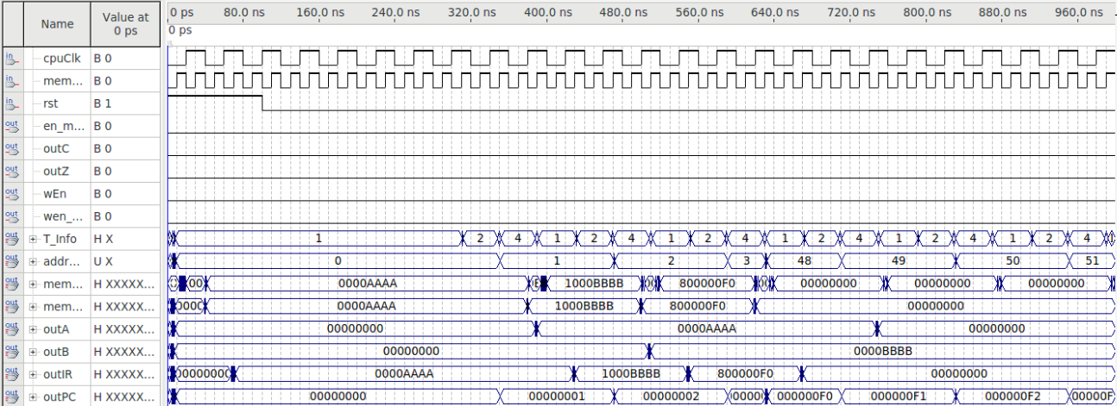

Reference:
1.Quartus II Handbook available at the course web and Altera webpag
2. COE608 Lab6_Manual_W2021
3. COE608 Lab6_Tutorial_W2021

Appendix:

reset_circuit.vhdl :
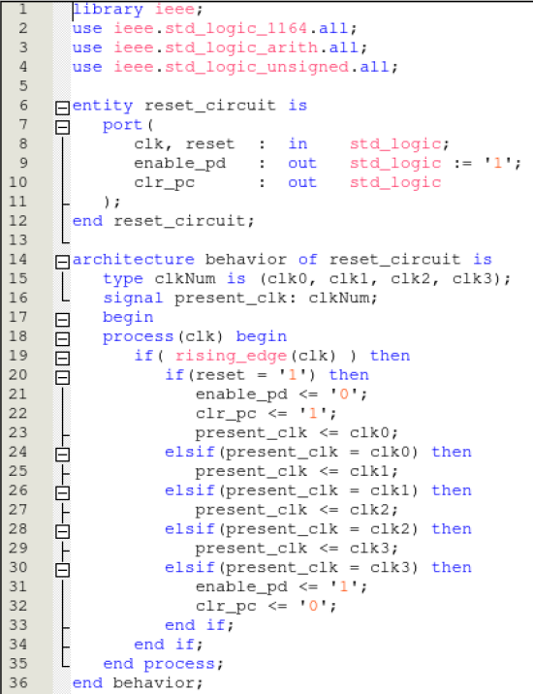

cpu1.vhdl :
