

Course Title: | Digital Systems Engineering
Course Number: | COE 758
Semester/Year (e.g.F2016) | F2021

Instructor: | Lev Kirischian

Assignment/Lab Number: | 1
Assignment/Lab Title: | Memory Hierarchy: Cache Controller

Submission Date : | 2021-10-29
Due Date: | 2021-10-29

Student  LAST Name | Student  FIRST Name | Student Number | Section | Signature*
Chen | Rick | 500909131 | 02 | 
Tilayof | David | 500679922 | 02 | David Tilayof
*By signing above you attest that you have contributed to this written lab report and confirm that all work you have contributed to this lab report is your own work. Any suspicion of copying or plagiarism in this work will result in an investigation of Academic Misconduct and may result in a “0” on the work, an “F” in the course, or possibly more severe penalties, as well as a Disciplinary Notice on your academic record under the Student Code of Academic Conduct, which can be found online at: http://www.ryerson.ca/senate/current/pol60.pdf

Abstract

Modern computers make use of multiple types of memory in order to operate quickly and efficiently while keeping costs as low as possible. The different types of memory being used in this case are Static Random Access Memory (SRAM) and Synchronous Dynamic Random Access Memory (SDRAM). SRAM is fast but more expensive so it is generally used in situations that require a small amount of fast memory such as the cache. SDRAM on the other hand is slower but less expensive so it is more suited to situations where storage capacity is more important than speed. Memory is organized into a hierarchy in order to help facilitate the different use cases for the different types of memory. In these hierarchies the fast memory such as the SRAM in the cache is located closest to the CPU and slower memory such as the SDRAM in the main memory is located further away. Controllers such as the cache controller are what allow the CPU and the different memory modules to communicate with one another. In this project we will design and implement a simple cache controller. Our objective in this project is to learn what a cache controller does and how it interacts with the SRAM and SDRAM controller. Additionally we hope to gain experience designing and implementing custom logic controllers. Finally, we are also aiming to learn what we can about VHDL coding within the Xilinx ISE CAD environment.

Introduction

In this project our aim is to design and implement a simple cache controller. The cache controller is the point of contact for communication between the CPU, the cache memory, and the main memory controller. When the CPU wants to perform a read or write it must first send an instruction to the cache controller specifying whether a read or write is being requested as well as the address where the action should be performed. The cache controller then uses these instructions along with internally stored indicators such as dirty and valid bits in order to determine how to proceed. After the instructions are processed by the cache controller it then sends further instructions to either the cache memory or the main memory controller. The CPU in this project has been provided and will send a premade set of instructions to the cache controller. The cache controller will be designed to operate as a finite state machine that can send different instructions to the cache memory and main memory controller depending on the situation. The cache memory will be simulated using BRAM memory in the Xilinx ISE. Finally the main memory controller will be simulated using VHDL code. Once all the components are complete we will measure the performance of our cache controller by evaluating the timings for each process.

System Specifications

CPU:
Functional Specifications:
- Monitor RDY signal
- Generate read and write transactions to various addresses for the cache controller to perform when RDY signal is asserted.
- Once the transaction signals are stable the CPU asserts the CS signal to indicate instructions are ready.
- Repeat this process.

Technical Specifications:
- The CPU Block is synchronized with the cache controller via a clock.
- The external RDY signal is asserted.
- An address is set on the address bus after the external RDY signal is asserted.
- The wr_rd signal is set low (0) for read transactions or high (1) for write transactions after the external RDY signal is asserted.
- If a write transaction is being performed data is set on the DOUT port after the external RDY signal is asserted.
- After all transaction signals are ready the CS signal is asserted for 4 clock cycles.

SDRAM Controller:
Functional Specifications:
- Performs read and write requests from the cache controller.
- When a write signal is received the SDRAM controller records the data sent to the DIN input to the address sent to the address bus.
- When a read signal is received the SDRAM controller sends the data from the address sent to the address bus to the DOUT output.
- Once the signals are stable the SDRAM controller asserts the MEMSTRB signal.
- Repeat steps 32 times for the full block to be complete.

Technical Specifications:
- The SDRAM Controller Block is synchronized with the cache controller via a clock.
- Receives address from incoming ADD port.
- Receives WR_RD signal which indicates read operation if signal is low and write operation if signal is high.
- If the WR_RD signal is low then the data found at the given address is sent to the DOUT port.
- If the WR_RD signal is high then the data from the DIN port is sent to the given address.
- After signals are stable MEMSTRB is asserted for one clock cycle.
- Repeat all steps until the full block is complete.

SRAM:
Functional Specifications:
- Stores and sends data to the CPU or SDRAM controller for the cache controller.

Technical Specifications:
- The SRAM Block is synchronized with the cache controller via a clock.
- Receives address from incoming ADD port.
- Receives WEN signal which indicates read operation if signal is low and write operation if signal is high.
- If the WEN signal is low then the data found at the given address is sent to DOUT port after the next rising edge of the clock.
- If the WEN signal is high then the data from the DIN port is written at the given address after the next rising edge of the clock.

Cache Controller:
Functional Specifications:
- Receives read and write transactions from the CPU.
- Determine whether the given address of the transaction is located in the cache or SDRAM.
- Depending on the location of the given address and WR_RD signal the cache controller can either read from or write to the cache memory, fetch data blocks from the main memory, or write data blocks to the main memory.
- Then indicators such as the tag, valid, and dirty bits are recorded to describe the status of each block in the cache memory.

Technical Specifications:
- The cache controller is synchronized with the rest of the system via a clock.
- The external CS signal is asserted for 4 clock cycles.
- Receives address from Address port and WR_RD signal.
- Write to cache:
  - Incoming WR_RD signal is set to high.
  - Given address is found to be in cache memory.
  - Index and offset portion of the address are passed to SRAM as the write address of the incoming data.
  - WR_RD signal is passed to SRAM as WEN.
  - Dirty and valid bits associated with the target block are set to 1.
- Read from cache:
  - Incoming WR_RD signal is set to low.
  - Given address is found to be in cache memory.
  - Index and offset portion of the address are passed to SRAM.
  - WR_RD signal is passed to SRAM as WEN.
- Read/Write to/from SDRAM and dirty bit = 0:
  - WR_RD signal is received from the CPU.
  - Given address is found to be in SDRAM.
  - Dirty bit for the index of the given address is checked and found to be 0.
  - Address is passed to the SDRAM memory controller with the offset portion set to 00000.
  - WR_RD signal is passed to the SDRAM controller.
  - MEMSTRB is asserted for one clock cycle
  - Incoming data from SDRAM is passed to cache SRAM.
  - Offset is incremented and previous two steps are repeated until the entire block is loaded into cache SRAM.
  - Tag register is updated with tag value from CPU address and valid bit is set to 1.
  - Read or write operation to or from cache is performed as previously outlined.
- Read/Write to/from SDRAM and dirty bit = 1:
  - WR_RD signal is received from the CPU.
  - Given address is found to be in SDRAM.
  - Dirty bit for the index of the given address is checked and found to be 1.
  - Address is passed to the SDRAM memory controller with an offset portion set to 00000.
  - WR_RD signal is passed to the SDRAM controller.
  - MEMSTRB is asserted for one clock cycle
  - Outgoing data from SRAM is passed to SDRAM.
  - Offset is incremented and previous two steps are repeated until the entire block is loaded into SDRAM.
  - Dirty bit is set to 0.
  - Steps from Read/Write to/from SDRAM and dirty bit = 0 are performed.
  - Read or write operation to or from cache is performed as previously outlined.

Device Design
- Symbols
The CPU can read or write depending on the request. The 3 input signals of the CPU are clock, ready indicator and 8-bit data in. The output signals are 16-bit address word, read and write indicator, chip selector and 8-bit data out. The 16 bits address word can be divided into 3 components, tag, offset and index.
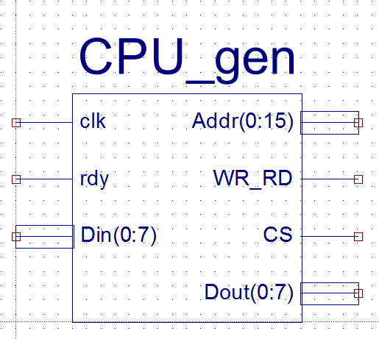
Figure1. CPU_gen
The cache controller is designed to read or write to cache memory, fetch whole data blocks from the main memory, or write out blocks to the main memory. Based on the given signals, the cache controller will decide to take which action. The cache controller interface consists of 4 inputs and 8 outputs. The input signals are clock, 16-bit address word, read and write indicator, and chip selector. The outputs are: a ready indicator, 16-bit address to SDRAM, read and write an indicator to SDRAM, memory strobe, dirty bit, valid bit, 7-bit address to SRAM, and write enable signal.
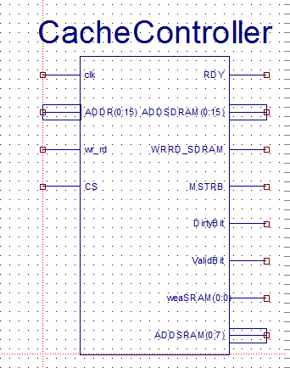
Figure 2. Cache controller
The SDRAM controller responds to block read and write requests from the cache controller. The SDRAM controller interface consists of 5 inputs and 1 output signal. The input signals are clock, 16-bit address word, read and write indicator, memory strobe, and 8-bit data in. The only output signal is 7-bit data out.
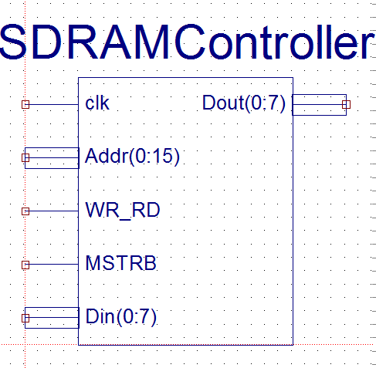
Figure 3. SDRAM Controller
The SRAM is used to implement the local memory for the cache and the interface consists of 4 inputs and 1 output signal. The input signals are clock, 7-bit address, write enable, and 8-bit data in. The output signal is one 8-bit data out.
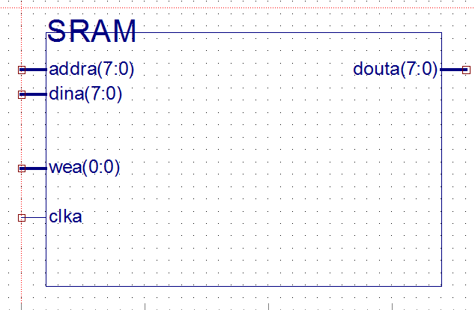
Figure 4. SRAM Controller

- Block diagram

The figure below shows the block diagram of the complete structure of the cache system. The system contains a cache controller, CPU, SDRAM controller, and local SRAM block. The cache is the intermediate between CPU and SDRAM controller and itself is a combination of cache controller and SRAM block.

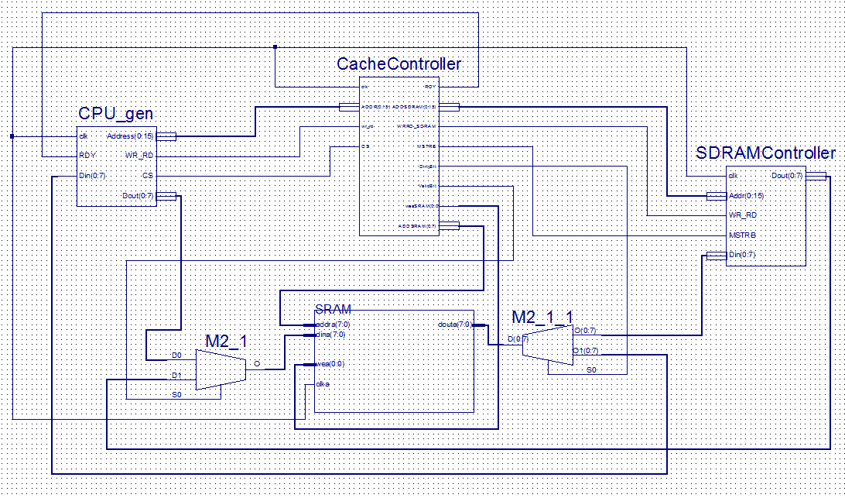
Figure 5. Block diagram

- State diagrams

The state diagram below shows the states of the system. Starting from state0, the cache controller is in an idle state. When CS = 1, the cache controller enters the state1 which initializes the signals and checks the hit and miss. Next, depending on the value of Vbit, Dbit, and memory tag, it may enter one of the states(states3, state2, and state4). During state4, write data from SRAM into SDRAM. In state3, the data is loaded from SDRAM into SRAM. In state2, depending on the WR_RD, either write data from CPU to SRAM or read SRAM data out at CPU.
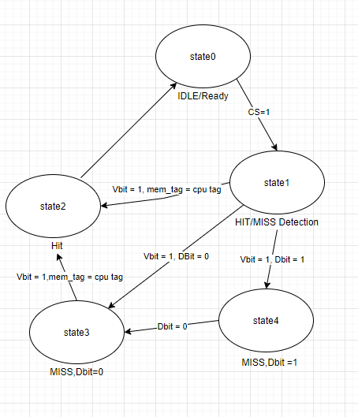
Figure6. State Diagram

- Process diagram

The figure below shows the processes of the system. If the value of the memory tag equals the CPU tag, and the valid bit is equal to 1 then it is the HIT or else MISS. If HIT, depending on the value of the read and write indicator, the system will either read data from SRAM or send data from CPU to SRAM. If MISS and dirty bit is equal to 1, the data will be written back into SDRAM and set the dirty bit equal to 0. If MISS and dirty bit equals to 0, the data will be loaded from SDRAM into SRAM and then set memory tag equals to CPU tag.
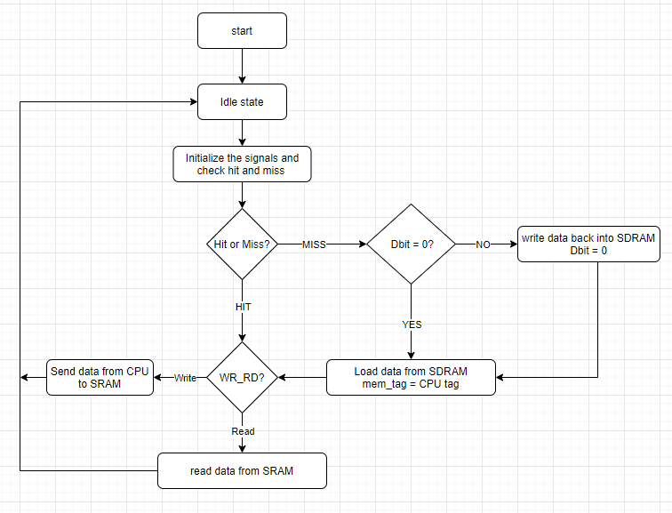
Figure7. Process Diagram

- Timing diagram
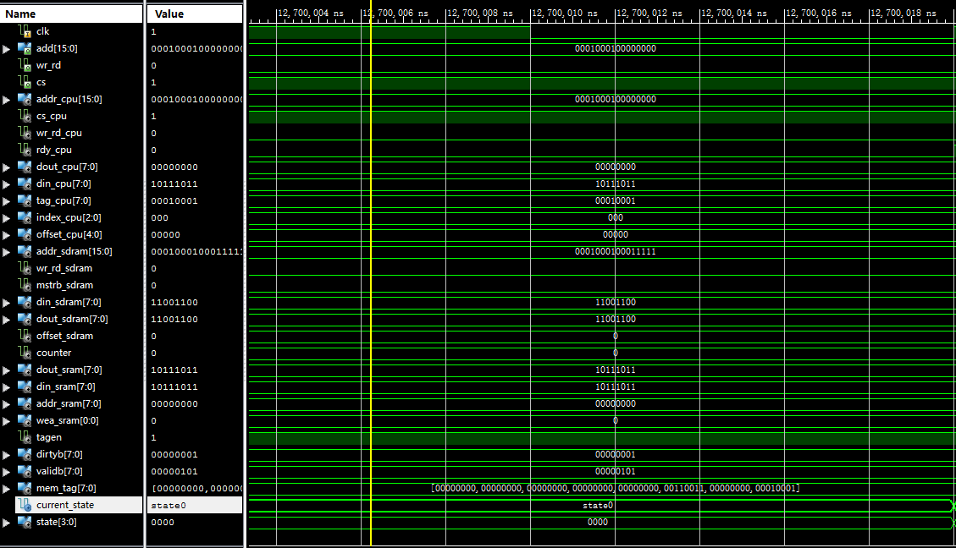
Figure8. State0, Idle/Ready State

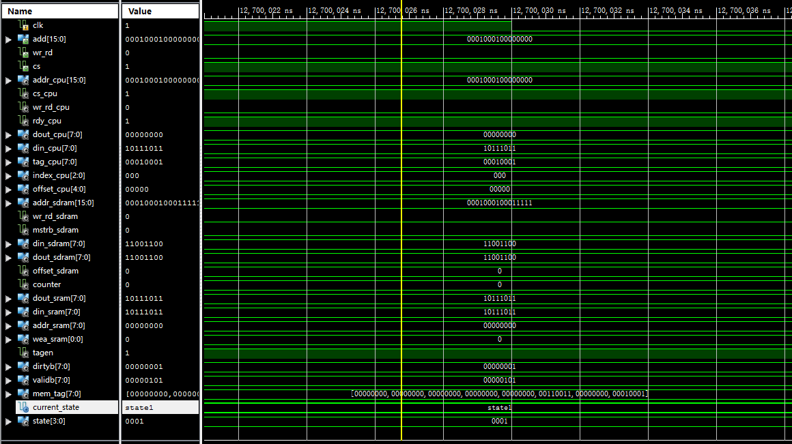
Figure9. State1, Hit Miss Detection
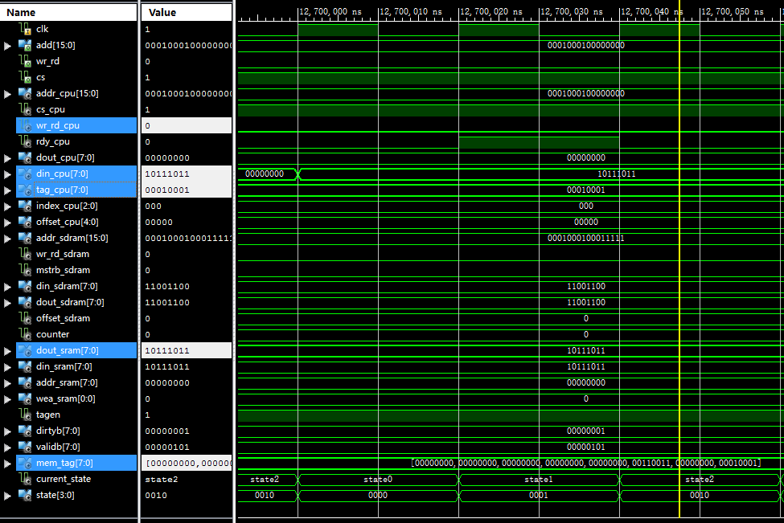
Figure10. State2, Hit, read

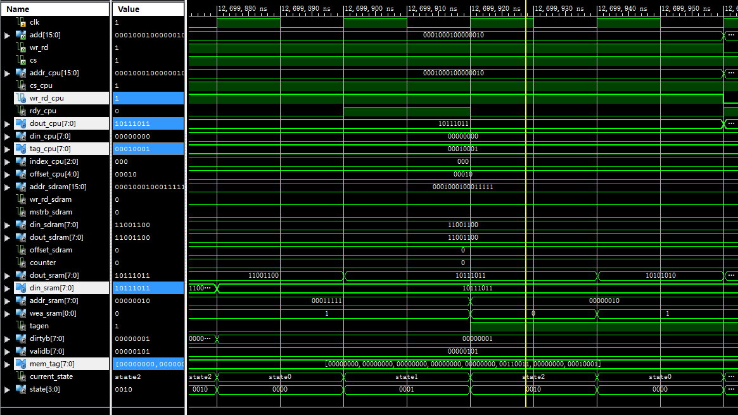
Figure11. State2, Hit and write

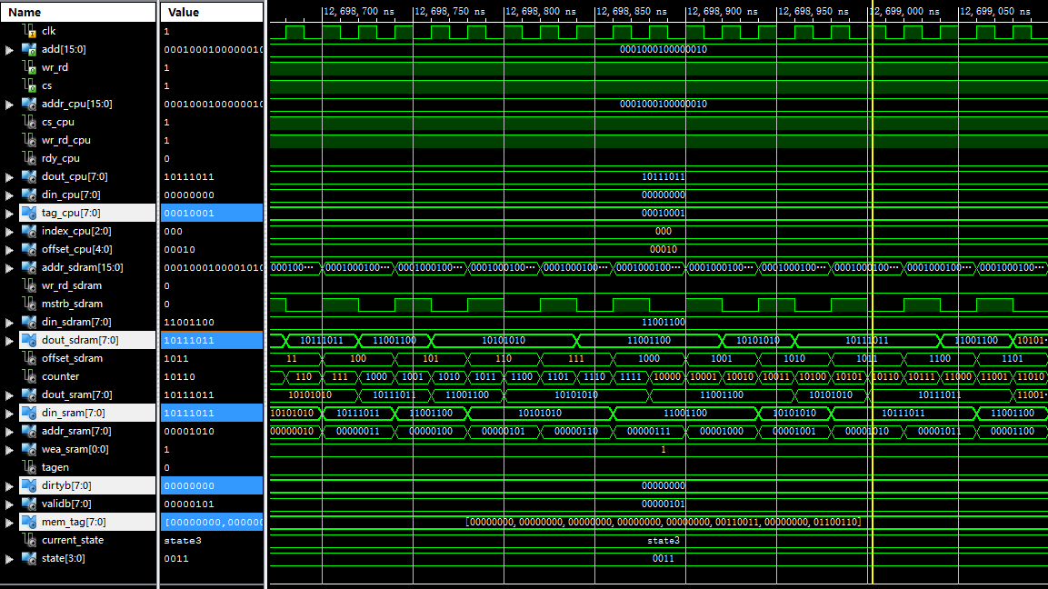
Figure12. State3, Miss, Dbit = 0
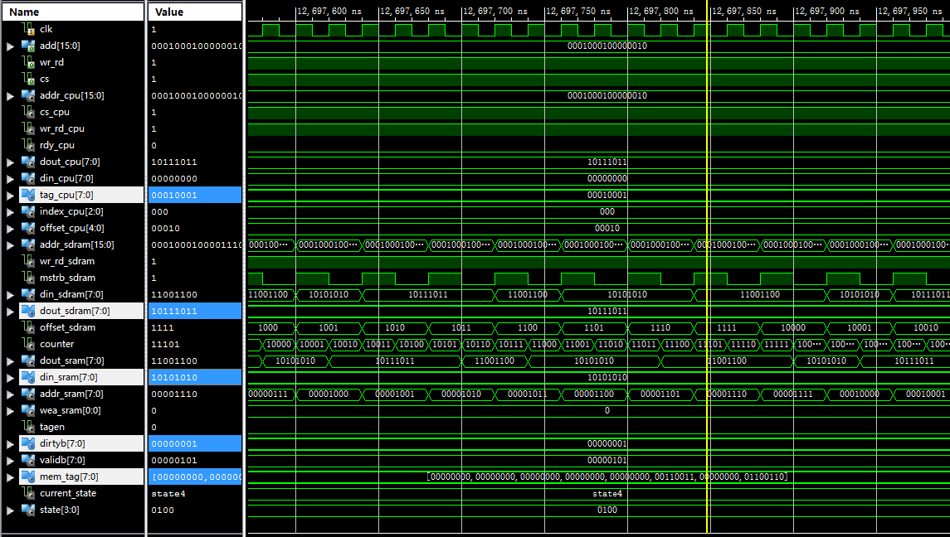
Figure13. State4, Miss and Dbit = 1

Results

N | Cache performance parameter | Time in nS
1 | Hit/ Miss determination time | 20 nS
2 | Data access time | 20 nS
3 | Block replacement time | 1280 nS
4 | Hit time (case 1 and 2) | 60 nS
5 | Miss penalty for Case 3 (when D-bit = 0) | 1340 nS
6 | Miss penalty for Case 4 (when D-bit = 1) | 2640 nS
Table1. Cache performance table

In the table above, the hit/miss determination time is 20 nS which is the time spent in state1, the hit/miss detection. The data access time is the time spent in state2, the state reads the data from SRAM to CPU or writes the data from CPU to SRAM depending on the read and write indicator. The block replacement time is the time required to write a block to SDRAM or SRAM. The time for 1 memstrb is 40 ns and a total of 32 cycles, therefore, 1280 nS in total. The hit time is the total time that is spent in idle state + hit/miss detection state + Hit, read and write data state. The miss penalty for Case 3 is the total time that is spent in state0 + state1 + state3, where SRAM loads data from SDRAM. The miss penalty for case 4 is the time spent in state0 + state1 + state 3 and 4, where SRAM writes the old data back into SDRAM and loads the new data with a different tag from SDRAM.

As we can see from the table above, with the cache system, the time to read or write the data is significantly reduced. When it is hit, to read or write the data only takes up to 60 nS. However, it requires 1300 nS for reading and 2600 nS for writing & reading from SDRAM. The performance of the hit is 22 times greater than miss, D = 0, and 44 times greater than miss, D = 1. Therefore, to read or write from the cache is much faster than to read and write to the memory.

Conclusion

In this project we accomplished our goals of gaining experience with VHDL coding as well as designing and implementing a simple cache controller that was able to handle read and write requests from a CPU. The cache controller was designed as an FSM with five states and was able to successfully perform all four of the behavioural cases expected of it. The results measured when testing the cache controller demonstrated the usefulness of implementing a memory hierarchy. As seen from the results the time taken for cases 1 and 2 was significantly shorter than the time taken for case 3 or 4. Using a cache controller allows us to make use of both the high speed of SRAM memory as well as the low cost of SDRAM memory. As a result the cache controller enables us to design computers that are capable of high speeds while still still being affordable.

References

- COE758 – Digital Systems Engineering - Ryerson University. (n.d.). Retrieved October 29, 2021, from https://www.ee.ryerson.ca/~lkirisch/ele758/labs/Cache%20Project%5b12-09-10%5d.pdf.
- Coe-758. Ryerson University - Lev Kirischian - COE758. (n.d.). Retrieved October 29, 2021, from https://www.ee.ryerson.ca/~lkirisch/coe758/handouts.htm.
Appendix

CacheController.vhd
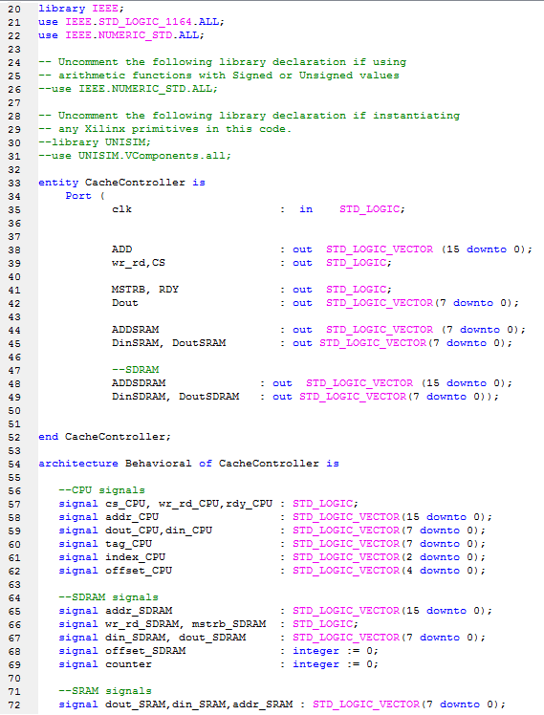
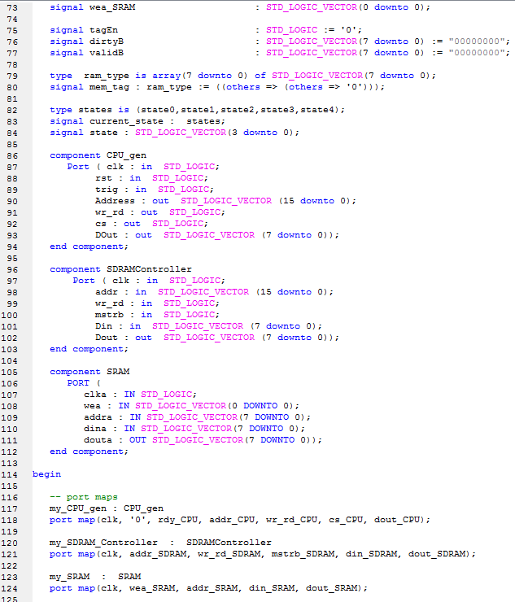
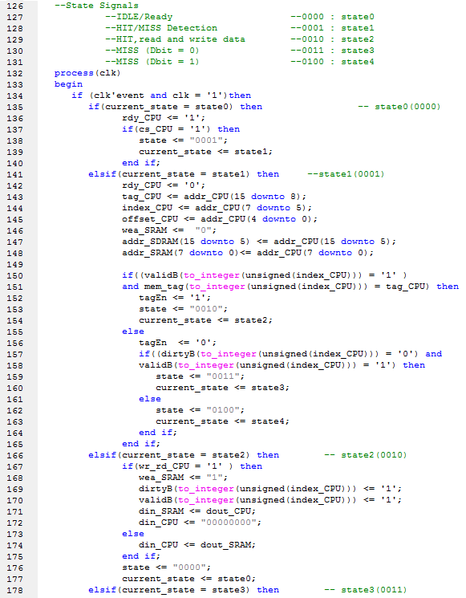
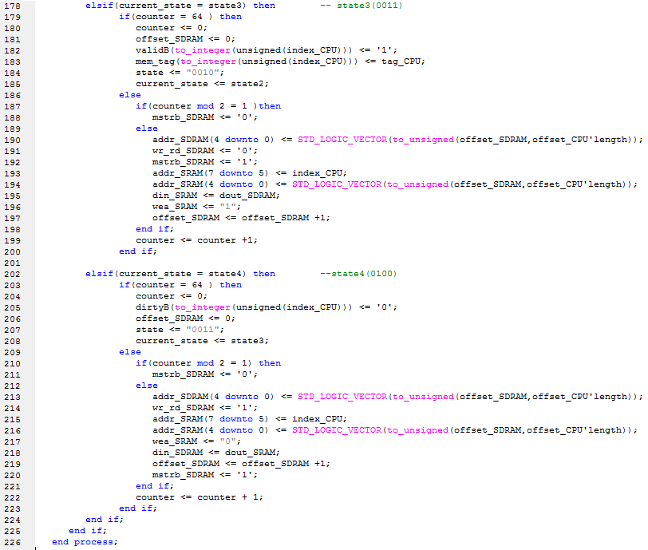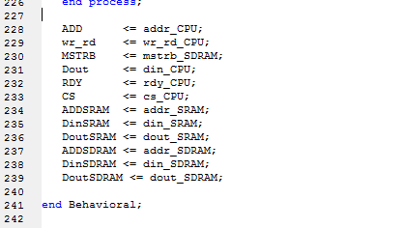

SDRAMController.vhd
