檔名記得加上學號

Name: 陳璽文

Student ID: 4108056041

* **Please show both the result of *find* and your program to prove the correctness. (refer to p.16 of the slide)**
* **Without the result of *find*, get no score.**

1. (35%) Snapshot of searching ‘*passwd*’ at root directory

* Your program

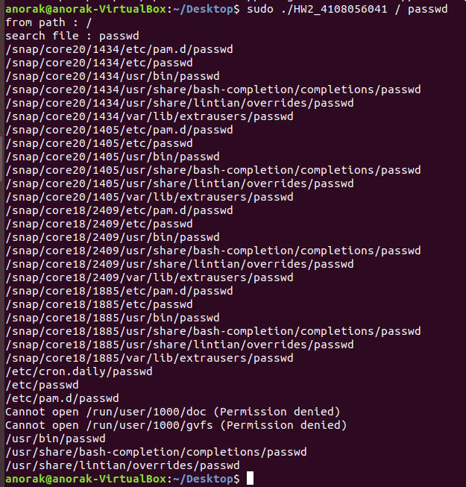

* By *find*

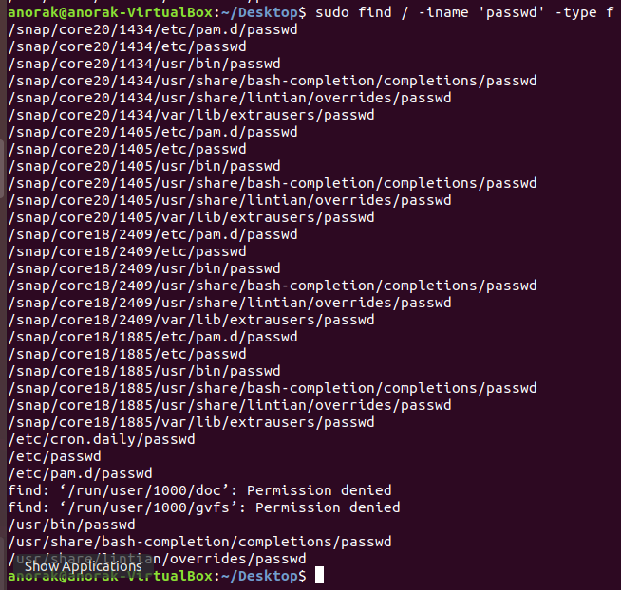

1. (35%) Snapshot of searching ‘*passwd’* at default directory (current directory)
   * Your program

**桌面上的檔案及目錄**



**假設找不存在的檔案**

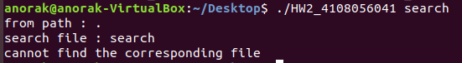

**找存在的檔案**

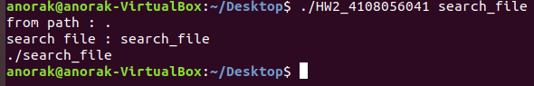

* By *find*



1. (30%) Briefly describe your design.

**Main()內**

負責判斷參數有沒有包含指定路徑，並分別處理

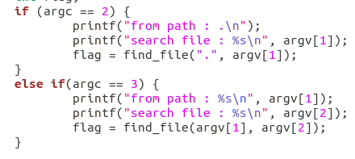

或是找不到目標檔案，則回傳

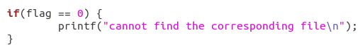

**Find_file()內**

變數ct負責記錄找到幾個目標檔案。

負責記錄路徑名稱

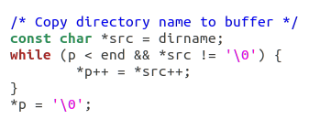

找到檔案的話，進一步判斷是不是目標檔案

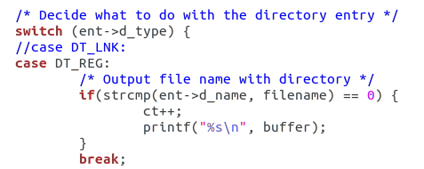

找到目錄的話，只要不是”.”或”..”，就進入並呼叫find_file()

