陳璽文4108056041

1.

Write a program “printid.c” with the authority of superuser to print the real user ID and the effective user ID

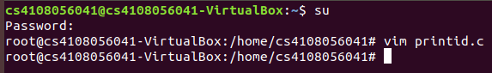

Create a new user

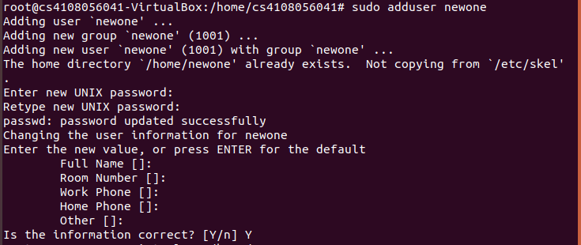

Add the setuid attribute



Change to the new user



Execute the “printid” to print the real user ID and the effective user ID

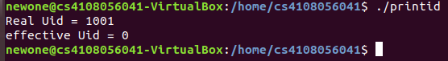

RESULT:

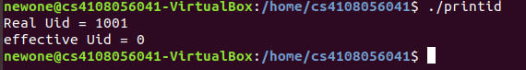

2.1

Execute **changefile** with the authority “root”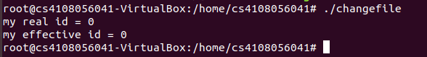

Switch to another user and execute **changefile**

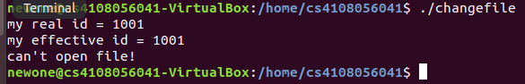

2.2

By setting changefile with a SUID attribute:

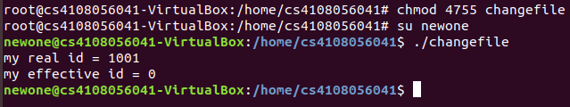

Modify SourceCode.c with seteuid() function:

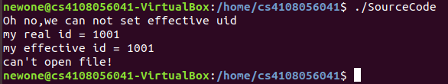

原因:

若不是superuser, seteuid()的參數就只能放real id 和saved id。