UNIVERSITY OF ENGINEERING AND Technology (LAHORE)



TOPIC: USAGE OF MOBILE PHONE.

GROUP MEMBERS:
- HUMA IMAM (2025-GA-25)
- ABDUL HADI (2025-GA-51)
- MUHAMMAD FAIZAN (2025-GA-11)
- MUHAMMAD ABDUALLAH (2025-GA-10)
- ABDUL REHMAN (2025-GA-46)

INSTRUCTOR NAME:
- Ms . Ramsha Khalid.

Table of Contents
ABSTRACTION 1
INTRODUCTION 2
EARLY HISTORY 3
EVOLUTION OF MOBILE PHONE 4
ROLE OF MOBILE PHONE ON YOUTH LIFE 5
HOW MOBILE PHONE AFFECT ON THE ACADAMIC PERFORMANCE 6
- POSITIVE IMPACT OF MOBILE PHONE ON ACADAMIC PERFORMANCE
- NEGATIVE IMPACT OF MOBILE PHONE ON ACADAMIC PERFORMANCE
- BELANCINGTHE EFFECT FOR BETTER OUTCOME
IMPACT ON THE SOCIETY…………………………………………………………………………………………………7
EFFECT ON MENTAL HEALTH AND CYBER BULLYING…………………………………………………………...8
IMPACT OF MOBILE PHONE ……………………………………………………………………………………………...9
- IMPACT ON CONNECTION SPEED
- IMPACT ON SOCIAL ISOLATION
REFERENCES…………………………………………………………………………………………………………………10
CONCLUSION…………………………………………………………………………………………………………………11

ABSTACTION:

The purpose of this study is to investigate “USEAGE OF MOBILE PHONE”. Data collection was done by doing a survey on google form. We got 38 responses on the survey, in which there are 20 men and 18 women between the age of 15 to 27 that were chosen by the group members using convenient and purposive chosen. The findings show that most respondents would rather use their mobile phones to fulfill their needs than for communication or social media. They observe mannerisms as well and discover that they greatly influence their cultural patterns. In addition, viewers think that Pakistanis are primarily to blame for the current fashions for use of mobile phone. The results also show that mobile phones have an impact on the language, attire, festivals, way of life, music, and eating practices of the local populace. It also changes our way of communication, way of priorities, way of study methods. Keywords (Mobile phone, lifestyle, youth).

INTRODUCTION:

Mobile phones have evolved from basic communication devices to multifunctional tools integrating calls, texting, internet access, apps, cameras, and payment systems. Globally, over 5 billion people use mobile phones, with smartphones dominating due to features like social media, e-commerce, and productivity apps. Usage spans personal communication, entertainment, education, and business, driven by affordable devices and expanding 4G/5G networks.
In Pakistan, mobile phone penetration is high, with about 85-90% of the population (around 220 million people) owning at least one mobile device, according to recent reports from the Pakistan Telecommunication Authority (PTA). Key aspects include:
- Communication and Connectivity: Mobiles are primary for voice calls and SMS, especially in rural areas where landlines are scarce. With over 180 million active SIMs, services from operators like Jazz, Telenor, and Zong enable widespread access.
- Internet and Digital Services: About 70% of users access the internet via mobiles, fueling social media (e.g., Facebook, WhatsApp), online shopping, and streaming. Mobile banking apps like Easypaisa and JazzCash have over 50 million users, facilitating transactions in a cash-heavy economy.
- Demographics and Trends: Urban youth (ages 18-35) lead in smartphone adoption for gaming and social apps, while rural users rely on basic phones for essentials. Challenges include data affordability and digital literacy, but initiatives like government subsidies and 5G rollouts are bridging gaps.
- Economic Impact: The telecom sector contributes ~2% to GDP, with mobiles boosting e-commerce, remote work, and education during events like the COVID-19 pandemic.
By 2030, mobile phone usage in Pakistan is expected to grow significantly, potentially reaching 95% penetration, driven by technological advancements and economic development.
- Demographic Shifts: Younger generations (under 30) will dominate, with smartphone ownership rising to 80% as devices become cheaper. Rural adoption will surge due to improved infrastructure, targeting underserved areas.
- Usage Evolution: Increased reliance on 5G for high-speed internet will boost digital services like telemedicine, online education, and fintech, with mobile payments potentially handling 50% of transactions.
- Challenges and Opportunities: While affordability and cybersecurity concerns may slow growth, government policies (e.g., Digital Pakistan initiative) and rising incomes could accelerate adoption, making mobiles central to daily life for over 250 million users.

EARLY HISTORY:

You know, the story of mobile phones really kicks off back in the 1940s when engineers at Motorola dreamed up this clunky thing called a car phone—it was

basically, a suitcase-sized radio strapped to your vehicle, weighing a ton and costing a fortune. Fast-forward to 1973, and you've got Martin Cooper, this guy from Motorola, making the first handheld call on a brick-like device that weighed over two pounds. It was revolutionary, but back then, mobiles were mostly for emergencies or big-shot businessmen cruising around in their cars, chatting on the go without needing a wired phone booth. By the 1980s, with the rise of 1G networks, these gadgets started shrinking and getting cheaper, letting everyday folks use them for quick calls or texts while out and about. I remember hearing stories from my grandparents about how owning one felt like having a superpower—it freed people from being tied to home phones and opened a whole new world of instant connection, even if the reception was spotty and batteries died in a flash. It was the start of something huge, paving the way for the smartphones we can't live without today.
You'd be surprised how quickly mobile phones went from novelty to necessity in those early years. Starting with analog systems in the 1980s, like the AMPS network in the US, phones began popping up everywhere, but they were bulky and had terrible range—drop a call mid-conversation and you'd be out of luck. By the early 1990s, digital tech started creeping in, improving clarity and security, which made them more reliable for business use, like stock traders or journalists reporting from the field. Usage evolved too; what started as a tool for the elite turned into something families shared, with kids begging to borrow them for quick calls home. I remember growing up hearing about how these devices bridged gaps in rural areas, where landlines were nonexistent, allowing farmers to check market prices or call for help during storms. It wasn't perfect—roaming charges were insane, and coverage was spotty—but it laid the groundwork for the explosion of texting and apps later. Honestly, without those clunky beginnings, we might not have the seamless connectivity we take for granted now.

Evolution of Mobile Phones:

A mobile phone is a device that can make and receive phone calls over a radio link while traveling throughout a large geographic region. It is also referred to as a cellular phone, cell phone, or hand phone. It accomplishes this by making a connection to a cellular network that a mobile phone provider has set up, giving it access to the public phone network. The first functional cell phone model was installed at a base station in New York by Dr. Martin Cooper, who is regarded as the founder of the cell phone. In 1973, Mr. Cooper and Motorola brought the Motorola Dyna-Tac phone technology to New York for public demonstration. Timeline from1977 to 1979 Testing of public mobile phones started , initially in Chicago and then in other US cities. Japan then enrolled in the testing program.

The 1980s introduced 1G (first-generation) analog networks, enabling voice calls with devices like the Motorola DynaTAC (1983), which cost $4,000 and offered 30 minutes of talk time. Usage was limited to business professionals and the wealthy due to high costs and poor battery life. The 1990s brought 2G digital networks, adding texting (SMS) and better security, with phones like Nokia's 3310 becoming popular for their durability. 3G (early 2000s) introduced mobile internet, enabling basic web browsing and email, while 4G (2010s) boosted speeds for video calls and apps, transforming phones into multimedia hubs.
Smartphones emerged in the late 2000s with Apple's iPhone (2007) and Android devices, integrating touchscreens, cameras, GPS, and app ecosystems. This shifted usage from calls to social media, gaming, and productivity. 5G networks (2019 onward) enable ultra-fast speeds for streaming, virtual reality, and IoT connectivity. Today, phones are multi- functional, with AI features, foldable screens, and sustainability focus. Future evolution may include 6G for holographic calls and advanced AI integration, driven by global demand for seamless connectivity. In regions like Pakistan, this has boosted digital inclusion, with over 180 million users relying on mobiles for banking and education.

ROLE OF MOBILE PHONE ON YOUTH LIFE:
You know, when it comes to education, mobile phones have been a game changer for young people, especially in areas where schools might not have the best resources. I remember back in my school days, we'd struggle with outdated textbooks, but now kids can just pull out their phones and access free online courses or apps like Khan Academy for math help or Duolingo for languages. In Pakistan, with so many youth in rural spots, mobiles bridge that gap—think about how a teenager can watch educational videos during a power outage or join virtual study groups on Telegram. It's democratized learning, giving everyone a shot at knowledge without needing fancy libraries. But hey, it's not without its downsides; I've seen how easy it is to get sidetracked by notifications during homework, turning a quick study session into hours of mindless scrolling. Still, if used right, it's like having a personal tutor in your pocket, helping youth build skills for jobs that didn't even exist when I was their age.
On the social side, mobiles have turned friendships and relationships upside down for the younger crowd. It's amazing how quick Snapchat or Instagram DM can keep you in the loop with pals across town or even countries, fostering these global connections that make the world feel smaller. For youth in Pakistan, where family ties are huge, phones let them balance that with hanging out virtually with friends, sharing laughs over funny videos or planning meetups. But let's be real, it's also sparked some drama—I've heard stories of teens feeling left out because of online cliques or the pressure to post the perfect selfie to fit in. It can boost confidence for some, like starting a blog or YouTube channel, but for others, it's led to that dreaded FOMO (fear of missing out), making real-life interactions feel less exciting. As someone who's watched this unfolding, it's clear mobiles amplify both the good and bad in social dynamics, teaching youth about empathy and boundaries in ways we never had to worry about.
Looking ahead, the role of mobiles in young people is only going to evolve, and it's got me thinking about the future. With all the AI and VR stuff coming in, phones could become tools for immersive learning or virtual hangouts, helping young people explore careers in tech or creative fields without leaving home. In Pakistan, where economic opportunities are growing, mobiles are already empowering youth to freelance on platforms like Upwork or sell handmade crafts online. Yet, there's this nagging worry about addiction—I've seen kids glued to screens, impacting sleep and physical health, or even falling prey to misinformation on social media. It's up to us adults to guide them, teaching digital literacy so they can harness the power without the burnout. Honestly, mobiles are shaping a generation that's more connected and innovative, but with a bit of wisdom, they could lead to a brighter, more balanced world for everyone.

HOW MOBILE PHONE AFFECT ON THE ACADAMIC PERFORMANCE:
- POSITIVE IMPACT OF MOBILE PHONE ON THE ACADAMIC PERFORMANCE:

You know, mobile phones can be a real boost for students' academic performance if they're used wisely, and I've seen it firsthand with own kids. For starters, they give instant access to a ton of educational resources—like apps such as E-books for classes or Khan Academy for video lessons—that make studying way more interactive and fun than flipping through dusty textbooks. In places like Pakistan, where not every school has the latest tech, mobiles help bridge that gap; a teenager can download free PDFs of textbooks or join online forums for homework help during a blackout. It's empowering, right? Plus, with features like voice notes or reminders, phones keep students organized, reminding them of deadlines or even recording lectures for later review. I've noticed how this kind of tech turns passive learning into something proactive, helping kids grasp complex topics faster and even encouraging self-paced study. Overall, when guided properly, mobiles aren't just distractions, they're tools that can level the playing field and spark genuine interest in learning.

- NEGATIVE IMPACT OF MOBILE PHONE ON THE ACADAMIC PERFORMANCE:

On the flip side, though, mobile phones can really mess with a student's focus and grades, and it's something I've worried about a lot as a parent. The constant buzz of notifications from social media or games pulls kids away from their studies, turning a quick break into hours of scrolling through TikTok or chatting on WhatsApp. I remember my niece struggling with her exams because she'd stay up late texting friends instead of sleeping, leading to tired mornings and poor concentration in class. In Pakistan, where academic pressure is high, this distraction factor is even worse kids might skip reading assignments to binge-watch YouTube, or worse, get involved in cyberbullying that affects their mental state and schoolwork. Studies show it can lower attention spans and increase procrastination, making it harder to retain information or complete assignments on time. Honestly, it's like having a mini-entertainment center in your pocket that's always tempting you away from the books, and without some self-control or parental rules, it can tank academic performance big time.

- BALANCING THE EFFECT FOR BETTER ACADAMIC OUTCOME:

Looking at it all, the impact of mobile phones on academic performance is a mixed bag, and it's up to us to find that sweet spot. I've talked to teachers who say that while phones enable cheating or off-task behavior, they also allow for collaborative learning, like group projects via shared docs on Google Drive. In Pakistan, with its growing digital divide, mobiles can uplift rural students by connecting them to virtual tutors, but only if families set boundaries—like no-phone zones during study time or apps that block distractions. It's about teaching digital literacy early, so kids learn to use phones as allies rather than enemies to their education. From what I've observed, students who manage their screen time tend to perform better, balancing online tools with real-world focus. Ultimately, mobiles are here to stay, and with the right mindset, they can enhance rather than hinder academic success—it's all about moderation and smart habits.

IMPROVE OUR SOCIETY:

Mobile phones have become an essential part of modern society, transforming the way people communicate, work, and access information. What was once a simple tool for making calls has now evolved into a multifunctional device that connects people across the globe instantly. Through mobile phones, individuals can send messages, share photos and videos, and participate in social networks, fostering a sense of global community and connectivity.
One of the most impactful benefits is enhanced communication. Mobile phones allow people to stay connected across vast distances, fostering stronger relationships among families, friends, and communities. This connectivity also supports emergency response systems, enabling quicker coordination during natural disasters or crises.
In education, mobile phones have opened new opportunities for learning. Students can use their phones to research topics, access online classes, and collaborate with peers on academic projects. Educational apps and e-books make learning more interactive and accessible, especially for those living in remote areas. However, excessive use of mobile phones can also distract students from their studies and reduce face-to-face interaction. Mobile phones provide access to online learning platforms, educational apps, and digital libraries. Students in remote or underserved areas can now access quality resources and participate in virtual classrooms, helping bridge the educational divide.
From an economic perspective, mobile phones have created new industries and job opportunities. Mobile banking, online shopping, and app-based services have made transactions faster and more convenient, boosting business efficiency. Small businesses can now reach customers worldwide through mobile marketing and social media platforms, contributing to economic growth and digital inclusion.

EFFECT ON THE MENTAL HEALTH AND CYBER BULLYING:

Mobile phones have become such an important part of our daily lives that it’s hard to imagine a day without them. While they help us stay connected and make life more convenient, their constant use can have a serious impact on our mental health. Many people, especially teenagers, spend hours scrolling through social media, comparing themselves to others, and chasing likes or comments. This can lead to feelings of anxiety, low self-esteem, and even depression. The pressure to always stay online and appear “perfect” can make people feel mentally exhausted and disconnected from real life. In today’s fast-paced digital age, mobile phones have become an inseparable part of our lives. But with constant notifications, endless scrolling, and the pressure to stay “online,” many people—especially young adults—are experiencing increased levels of anxiety, depression, and sleep disturbances. Studies show that excessive screen time can disrupt sleep patterns and reduce attention span, making it harder to focus and retain information.
The survey we had done on the google form our response’s view in it and the reviews in such a way that that was most like its MENTAL HEALTH EFFECTED THE MOST.

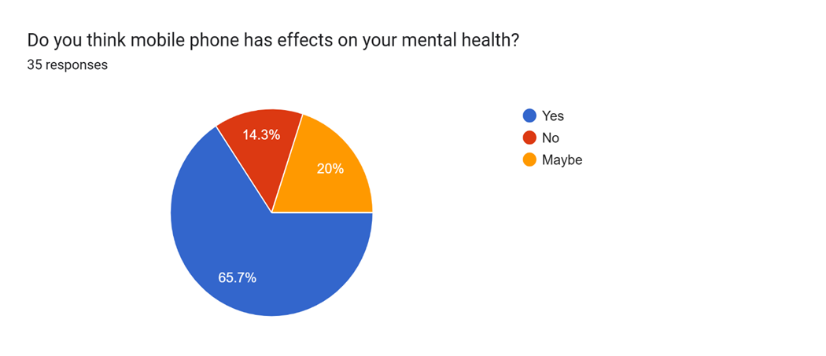

Another major issue related to mobile phone use is cyberbullying. With easy access to the internet and social media, some people use these platforms to spread hate, make fun of others, or post hurtful comments. Unlike traditional bullying, cyberbullying can happen anytime and anywhere, since the victim carries their phone with them all the time. This makes it harder to escape, and the emotional impact can be severe. Victims often feel isolated, scared, and ashamed, which can further harm their mental well-being. Although mobile phones have many benefits, it’s clear that their misuse can lead to serious emotional and psychological problems. It’s important for people to set boundaries—like limiting screen time, avoiding negative online spaces, and focusing on real-life relationships. Parents and schools also play a big role in teaching young people how to use technology responsibly and respectfully. By being more mindful of how we use our phones, we can enjoy their advantages without letting them take over our mental health.

The survey we had done on the google form our response’s view in it and the reviews in such a way that that was most like its CYBER BULLYING.

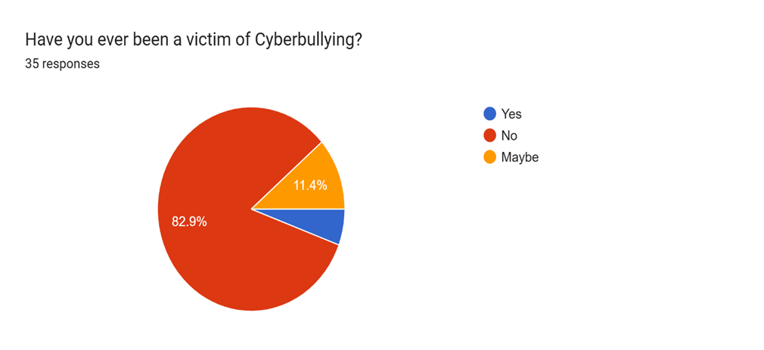

Impact of Mobile Phone:
There are two kinds of impacts of mobile phone according to our survey those are following mention below:

Impact On Connection Speed:
Mobile phones do not inherently speed up internet connections. The internet speed depends on factors like your service provider, network infrastructure (e.g., 4G, 5G, Wi-Fi 6), signal strength, and the capabilities of the device itself.
Newer phones often have more advanced wireless adapters and processors that can take advantage of faster network technologies, but the phone itself doesn't control the speed provided by your network.
When connected to a Wi-Fi network, an older phone with a slower Wi-Fi adapter might experience slower speeds than a computer with a newer adapter on the same network.

Impact on social isolation:

Mobile phones have dual role in social connection:
- Enhancing Connectivity: They help people stay connected with friends and family across geographical distances, which can reduce feelings of loneliness and isolation, especially for those with limited mobility or living in remote areas.
- Causing Isolation: Excessive or inappropriate use can lead to social isolation by displacing face-to-face interactions.
  - "Phubbing" (phone snubbing): Diverting attention to a phone during in-person conversations makes the other person feel excluded, decreases feelings of social connectedness, and reduces relationship satisfaction.
  - Reduced Quality of Interactions: Even the mere presence of a phone during meaningful conversations can lead to lower ratings of trust, perceived empathy, and overall conversation quality.
  - Preference for Virtual over Real: Many users, particularly youth, prefer communicating through social media and messaging, which can hinder the development of in-person social skills and emotional intelligence vital for strong relationships.
  - Addiction and Mental Health: Over-reliance or addiction to mobile phones has been linked to higher rates of loneliness, depression, anxiety, and general behavioral issues, as users may neglect their personal lives and real-life relationships.
The survey we have done in it the following impact in such a way that is given in the graph that is shown below:

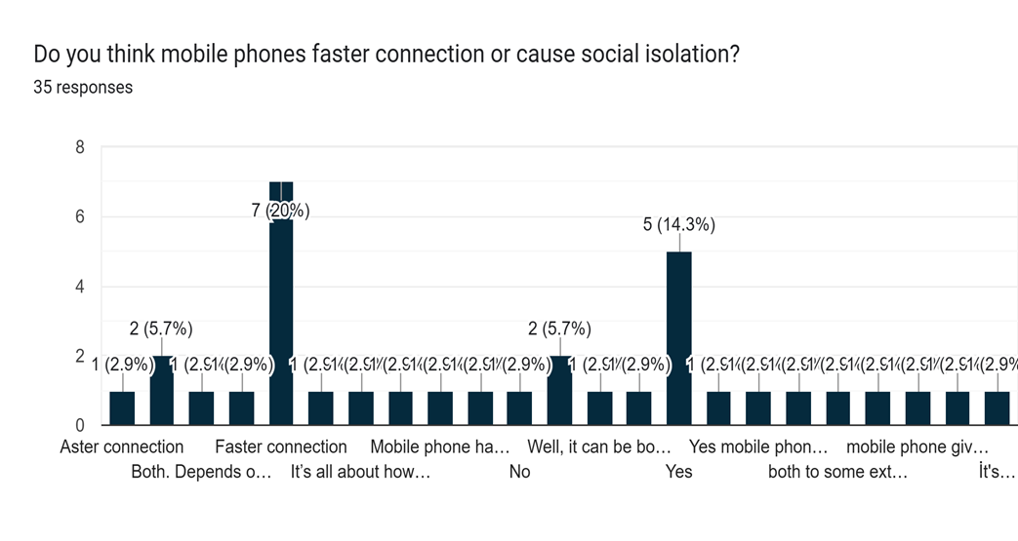

References

[1] | M. Carrier, From Smartphones to Social Media: How Technology Affects Our Brains and Behavior, Santa Barbara, California: Greenwood, 2018.
[2] | R. M. G. G. W. S. A. N. &. L. M. R. Kowalski, "Bullying in the digital age: A critical review and meta-analysis of cyberbullying research. Psychological Bulletin, 140(4), 1073–1137.," Psychological Bulletin., vol. 140, no. 4, p. 65, 2014.
[3] | D. Steinbock, The Mobile Revolution : The Making Of Mobile Services Worldwide, London: Kogan Page, 2005.
[4] | J. M. &. C. W. K. Twenge, "Associations between screen time and lower psychological well-being among children and adolescents.," Preventive Medicine, vol. 115, no. Preventive Medicine does not list a specific issue number for this publication — the article appears in the November 2018 issue of Volume 115., pp. 134-156, 2018.
[5] | A. K. P. &. N. Weinstein, "Can you connect with me now? How the presence of mobile communication technology influences face-to-face conversation quality. Journal of Social and Personal Relationships, 30(3), 237–246.," p. Journal of Social and Personal Relationships (an academic psychology journal), 23 May 2013.

CONCLUSION:

In conclusion, the usage of mobile phones has become an inseparable part of modern life, offering countless benefits that make communication, learning, and daily tasks faster and more convenient. They connect people across distances, provide immediate access to information, and support important activities like online banking, studying, and working. For many, a mobile phone is not just a device but a tool that enhances productivity and keeps life running smoothly.
However, it is equally important to recognize the challenges that come with excessive or careless use. Overdependence on mobile phones can affect focus, reduce face-to-face interaction, and even impact physical and mental well-being. Therefore, while mobile phones bring undeniable advantages, using them responsibly and in moderation is essential. Striking this balance allows us to enjoy the benefits of technology without letting it take control of our daily lives.

