**Evaluation**

A screenshot of the confusion matrix can be seen below:

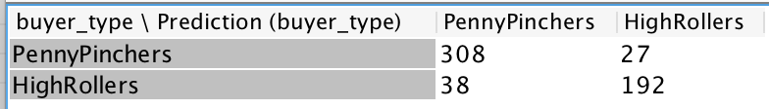

As seen in the screenshot above, the overall accuracy of the model is **88.496%**

row1, col1: 308, real label is PennyPinchers, predict label is PennyPinchers, correctly predicted

row1, col2: 27, real label is PennyPinchers, predict label is HighRollers, incorrectly predicted

row2, col1: 38 real label is HighRollers, predict label is PennyPinchers, incorrectly predicted

row2, col2: 192, real label is HighRollers, predict label is HighRollers, correctly predicted