**Analysis Conclusions**

The final KNIME workflow is shown below:

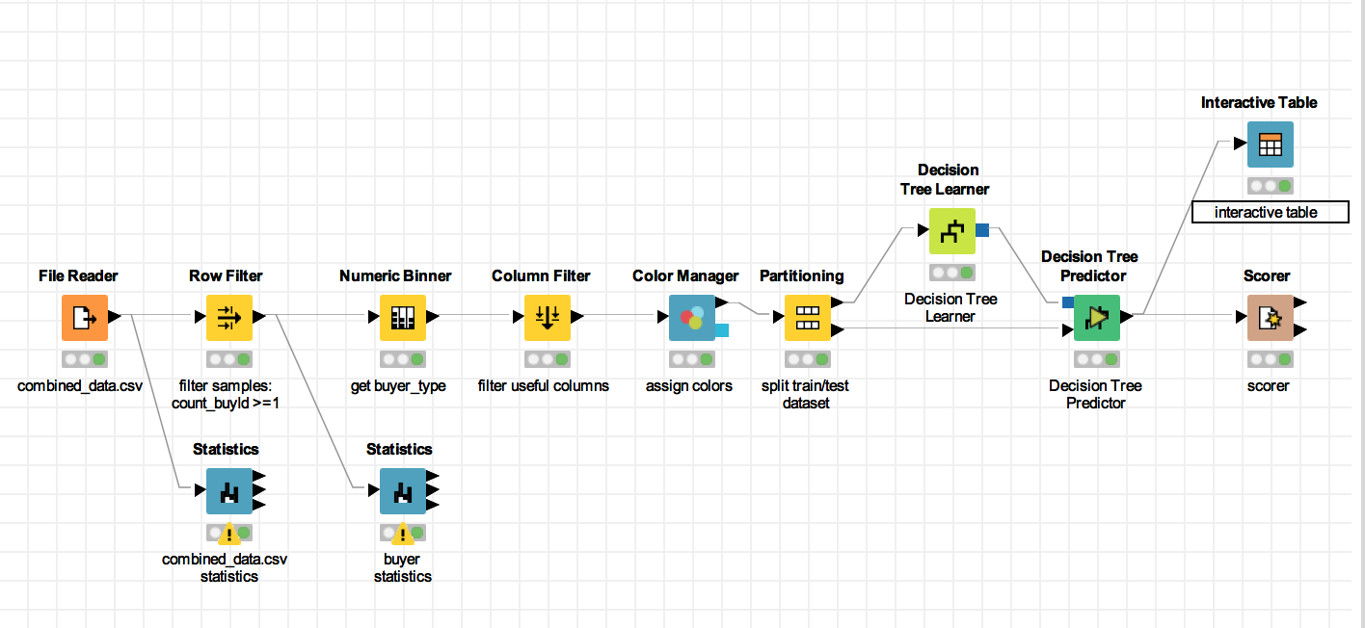

What makes a HighRoller vs. a PennyPincher?

PlatformType is a key attribute to classify users. If user use iphone, he or she high probability is a HighRoller. And if users not use iphont, he or she high probability is a PennyPicher.

|  |
| --- |
| **Specific Recommendations to Increase Revenue** |
| 1. Advertising to iphone users, to attract more new iphone users. |
| 2. Offering discount items to users who are not use iphone. |