Collection/ document/ Data

/cps|cps_test/{community uid}/cp/{cp serial}/order/{order serial}

EX:/cps_test/ 6f876708-4272-4a38-9236-2d8fa6ba0b96/cp/serial123/order/CPS16523435283889835

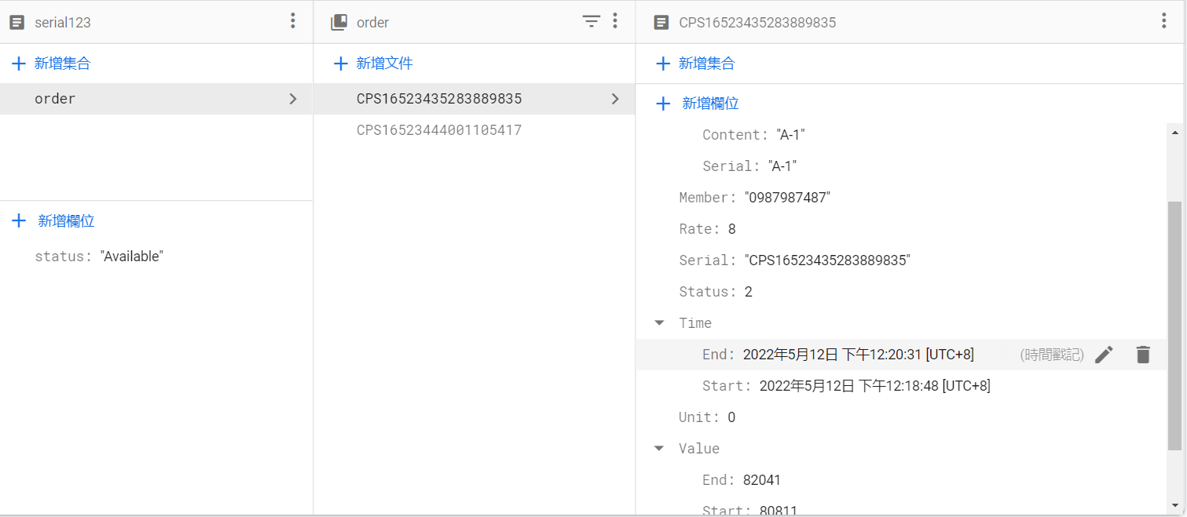

{

"Serial":"CPS16523435283889835",//訂單序號

"Status":2,//狀態 0=Charge,1=Checkout,2=End

"Cost":9.84,

"Rate":8.0,//套用費率

"Unit":0,//計價單位 0=TWD,1=USD,2=JPY,3=RMB

"cDate":"2022-05-12 16:18:48",//建立時間

"Member":"0987987487",//使用成員訊息

"Card4No":"1111",//信用卡後4碼

"Loc":{"Serial":"A-1","Conetent":"A-1"},//停車位資料

"Time":{"Start":"2022-05-12 04:18:48","End":"2022-05-12 04:20:31"},//充電時段

"Value":{"Start":80811.0,"End":82041.0,"Unit":"Wh"}//充電度數

}

更新紀錄:

20220531:

1.調整資料結構

2.須注意cDate Time.Start Time.End 資料型態變為Timestamp 不再是時間字串