|  |  |  |  |
| --- | --- | --- | --- |
| argue add | add argue information |  | **\*紅色框為必填** |
| API url:http://iparkingnet.eki.com.tw/api/argue/add | | | |
| **Method** | **POST** |  |  |
| **Content-Type** | multipart/form-data |  |  |
| **Header** | |  |  |
| **Key** |  | **Value** |  |
| **Authorization** | | Eki+空格+token | |
| **Body** | |  |  |
| **form-data** | |  |  |
| **img** | **File(jpg,png)** | image | 沒圖片不用帶 |
| **info** | json object text | argue information |  |
| Key |  | value |  |
| serial | string | order serial number | |
| type | int | argue type |  |
|  |  | 0=其他 |  |
|  |  | 1=檢舉 |  |
|  |  | 2=違法停車 |  |
|  |  | 3=態度不佳 |  |
|  |  | 4=遺留垃圾/損壞物品 |  |
|  |  | 5=環境髒亂 |  |
|  |  | 6=虛假照片 |  |
| source | int | 0=車主 |  |
|  |  | 1=地主 |  |
| text | string | 問題呈訴(長度500內) |  |
| lat | double | latitude |  |
| lng | double | longitude |  |

Sample:

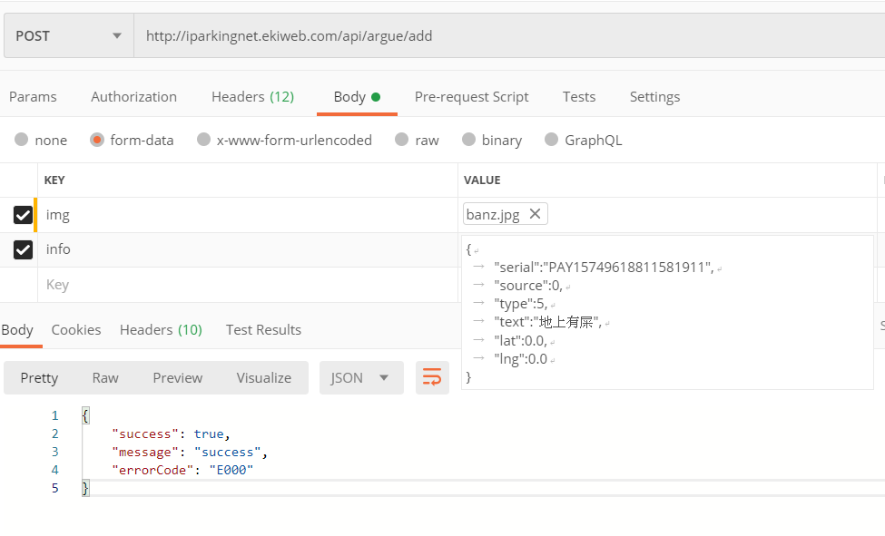

{

"serial":"PAY15749618811581911",

"source":0,

"type":5,

"text":"地上有屎",

"lat":0.0,

"lng":0.0

}

Response:

{

"success": true,

"message": "success",

"errorCode": "E000"

}