|  |  |  |  |  |
| --- | --- | --- | --- | --- |
| Manager LvInfo | 下載該地主的等級資訊 | |  | **\*紅色框為必填** |
| API url: http://iparkingnet.eki.com.tw/api/Manager/LvInfo | | | | |
| **Method** | **POST** |  | |  |
| **Header** | |  | |  |
| **Authorization** |  | Eki+空格+token | |  |
| **Response** |  |  | |  |
| info | json object |  | |  |
| ManagerLv | int | Manager level | | |
| Percent | int | Discount rate(%) | | |

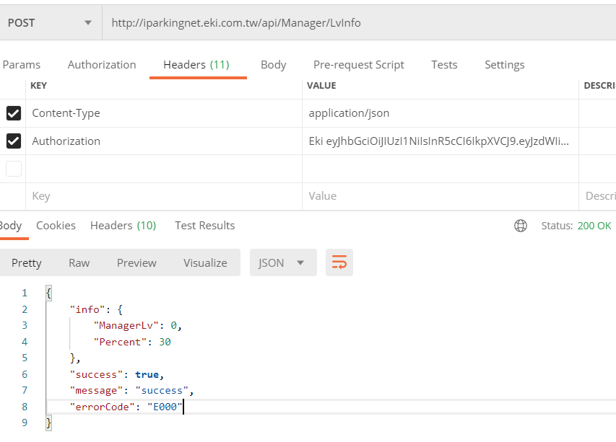

Response:

{

"info": {

"ManagerLv": 0,

"Percent": 30

},

"success": true,

"message": "success",

"errorCode": "E000"

}