|  |  |  |  |
| --- | --- | --- | --- |
| manager SetLocationImg | Set Location lmage | 目前最大上限3筆資料 | **\*紅色框為必填** |
| API url:http://iparkingnet.eki.com.tw/api/manager/SetLocationImg | | | |
| **Method** | **POST** |  |  |
| **Content-Type** | multipart/form-data |  |  |
| **Header** | |  |  |
| **Key** |  | **Value** |  |
| **Authorization** | | Eki+空格+token | |
| **Body** | |  |  |
| **form-data** | |  |  |
| **img** | **File(jpg,png)** | location image |  |
| **info** | json object text | vehicle information |  |
| Key |  | value |  |
| serNum | string | location serial number | |
| sort | int | image sorting number | |

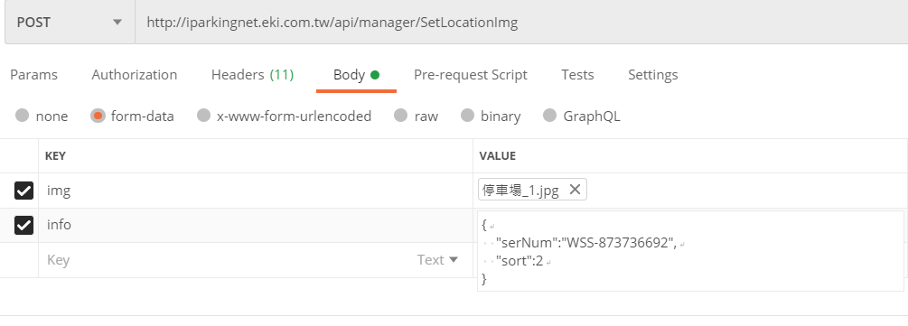

Sample:

{

"serNum":"WSS-873736692",

"sort":2//填入欲新增or修改的圖片序號

}

Response:

{

"info": [

{

"Sort": 1,

"Url": "http://iparkingnet.eki.com.tw/upload/member/8475C0E5-BA1A-47F1-B046-DA2A6C4CEEB6/202004071002073618533.jpg"

},

{

"Sort": 2,

"Url": "http://iparkingnet.eki.com.tw/upload/member/8475C0E5-BA1A-47F1-B046-DA2A6C4CEEB6/202009230427599870856.jpg"

}

],

"success": true,

"message": "success",

"errorCode": "E000"

}