|  |  |  |  |
| --- | --- | --- | --- |
| member AddVehicle | add vehicle information | 目前最大上限5筆資料 | **\*紅色框為必填** |
| API url:http://iparkingnet.eki.com.tw/api/member/AddVehicle | | | |
| **Method** | **POST** |  |  |
| **Content-Type** | multipart/form-data |  |  |
| **Header** | |  |  |
| **Key** |  | **Value** |  |
| **Authorization** | | Eki+空格+token | |
| **Body** | |  |  |
| **form-data** | |  |  |
| **img** | **File(jpg,png)** | vehicle image | 沒圖片不用帶 |
| **info** | json object text | vehicle information |  |
| Key |  | value |  |
| label | string | vehicle label |  |
| type | string | vehicle type |  |
| current | int | 0=none,1=AC,2=DC | |
| charge | int | 0=none,1=Combo2,2=CHAdeMO,3=Tesla,4=Type1CCS,5=GB/T 20234,6=SAEJ1772,7=CNS15511,8=TEC62196-2 | |
| name | string | vehicle name |  |
| number | string | vehicle serial number | |
| isDefault | boolean | vehicle is default |  |

Sample:

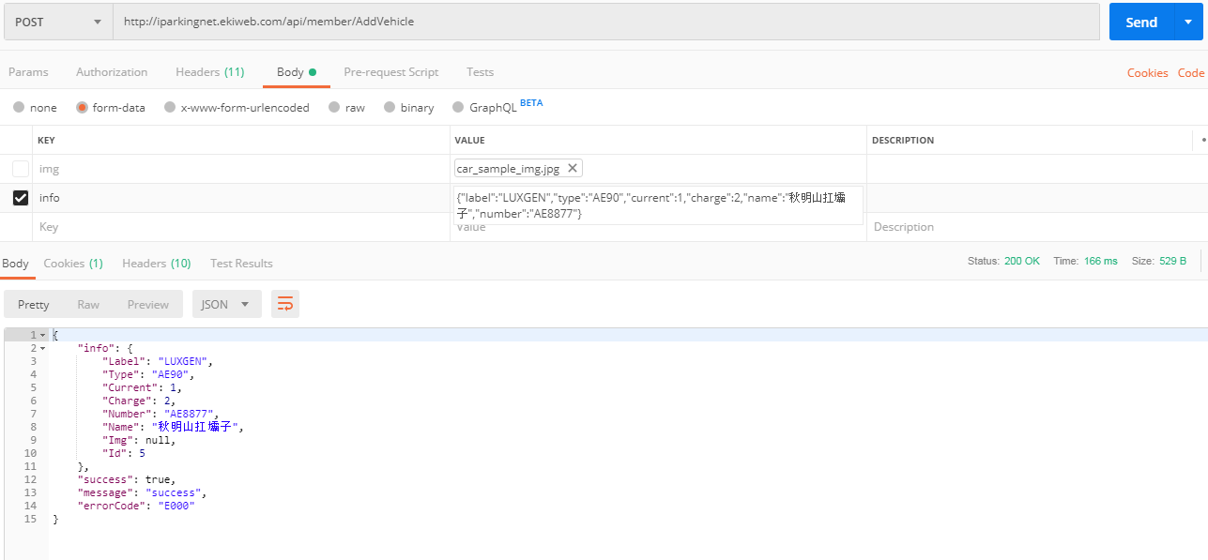

info={"label":"vehicle label","type":"vehicle type","current":1,"charge":2,"name":"vehicle name","number":"vehicle serial number","isDefault":true}

Response:

{

"info": {

"Label": "LUXGEN",

"Type": "AE90",

"Current": 1,

"Charge": 2,

"Number": "AE8877",

"Name": "秋明山扛壩子",

"Img": null,

"IsDefault": true,

"Id": 5

},

"success": true,

"message": "success",

"errorCode": "E000"

}

更新紀錄:

2020/01/08:新增isDefault紀錄是不是預設車子