Regime-Aware Early Warning for Stablecoin Depegs
Sections 3-5: Methodology, Results, and Contributions

3. Methodology and Empirical Framework

3.1 Approach
Our question has two parts. (1) Prediction: does adding the market regime make on-chain models forecast depegs better? We judge this only on data the models have never seen. (2) Relationships: does the same on-chain signal carry different risk in stressed and calm markets? We answer this by looking inside the fitted models. For both, we compare pairs of models that are identical except for the regime information, so any difference can be attributed to it.

3.2 Outcome, predictors and regime
- Outcome. Whether a coin (DAI, USDC, USDT) breaches its Phase 1 dynamic depeg band on day t+1. The band narrows for more heavily traded coins and uses only the previous month's volume, so it is known in advance. Note: the label marks every breach day, including days inside an ongoing episode, rather than only new breaches as planned. Section 4.5 therefore also evaluates the first day of each new episode.
- Predictors. Seven on-chain measures for day t (transfers, volume, unique senders and receivers, minted, burned, large-transfer volume), log-transformed.
- Regime. Our Phase 1 rule: a day is 'stressed' when at least two of three signals agree: bearish BTC, bearish ETH, and Fear & Greed below 40. It was fixed before testing and is a simple proxy for crypto-wide stress.

3.3 Models
Table 1. Model specifications
Specification | Inputs | Question
M1 (baseline) | 7 on-chain features | How well does on-chain activity alone predict depegs?
M2 (regime-aware) | M1 + stress flag (0/1) | Does the regime improve forecasts? (Part 1)
M3 (logit only) | M2 + each feature x stress | Do feature effects change under stress? (Part 2)

- Logistic regression (logit). Our main benchmark. Each feature pushes risk in one direction, so results are easy to read; in M2 the flag raises or lowers baseline risk on stressed days.
- Random forest (RF). A flexible check: 500 decision trees that learn 'if-then' rules, including thresholds and interactions we do not specify. If the regime matters in a non-linear way, the forest should find it.
Settings for both models were fixed in advance rather than tuned. With only 8 breaches in the 2022 validation months, tuning would mostly fit noise.

3.4 Evaluation design
Everything runs forward in time (Figure 1). In 2022, each month from July to November is forecast by a model trained only on earlier data. A final model is then trained on all of 2022, frozen, and used once to forecast February-April 2023. No 2023 outcome is used for anything. 2022 is dominated by the Terra collapse and 2023 by SVB, so the test asks whether lessons from one crisis carry over to a different one.
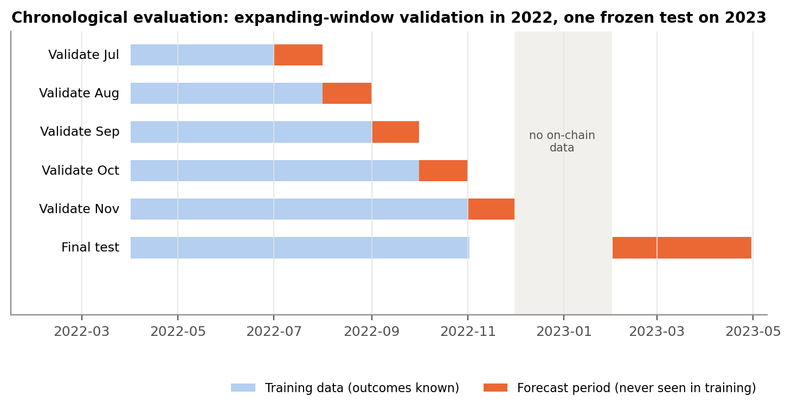
Figure 1. Forward-in-time evaluation design.
Table 2. Sample sizes
Sample | Coin-days | Breach days | Stressed days
Training (2022, Apr-Nov) | 645 | 62 | 56%
2022 validation forecasts (Jul-Nov) | 372 | 8 (all in July) | 42%
2023 test forecasts (Feb-Apr) | 267 | 49 | 3% (3 days)

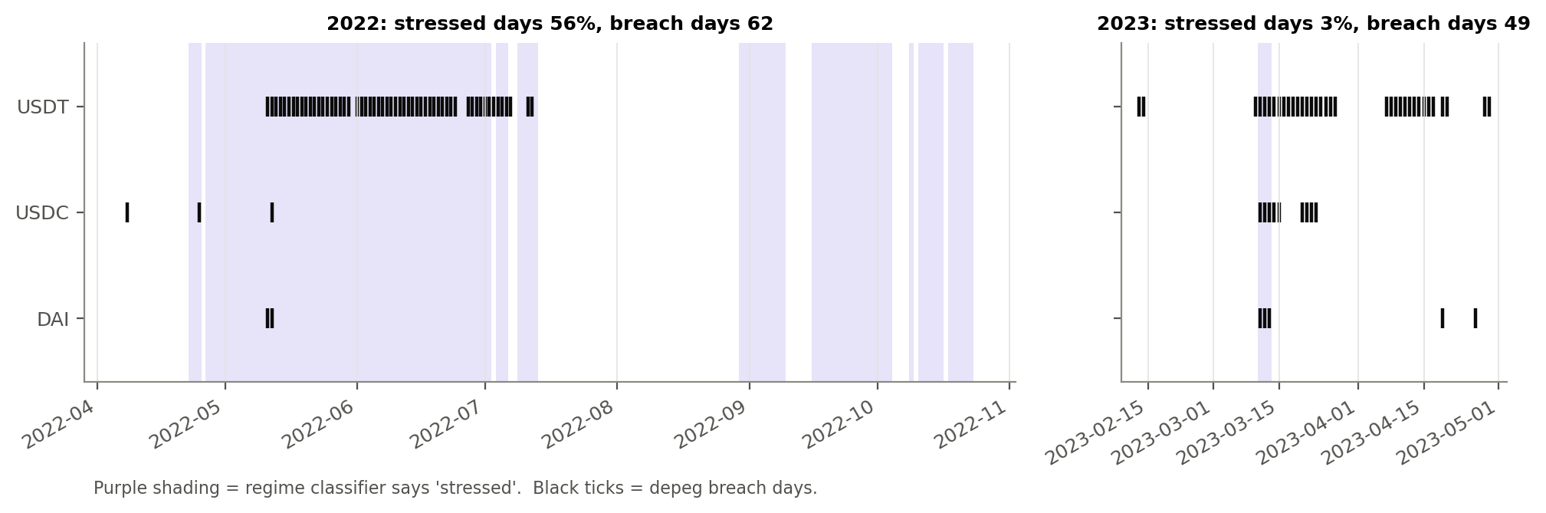
Figure 2. When the regime flag is on (purple) and when depegs happen (black). In 2022 breaches cluster in stressed periods; in 2023 the flag is on for only three days.

3.5 How we judge 'adds value'
Depegs are rare, so accuracy is misleading (always predicting 'no depeg' is about 98% accurate). We use:
- AP, average precision (main metric). How well the model ranks breach days above calm days, focusing on the rare breaches. It summarises the precision-recall curve (our PR-AUC measure). A no-skill model scores the breach rate; 1 is perfect.
- ROC-AUC. Probability that a random breach day is ranked above a random calm day (0.5 = coin flip).
- Brier score. Average squared gap between forecast probability and outcome; lower is better.
- Alerts and early warning. Precision, recall, false alarms and missed breaches using an alert cut-off fixed on 2022, plus whether each new 2023 episode was warned of in advance.
Two checks separate real gains from luck. A block bootstrap resamples forecast weeks 2,000 times to give a 95% range for M2 minus M1. A placebo test asks whether the real flag beats fake ones:
How to read the placebo p-value
Does the real flag help because of when it switches on, or would any on/off variable with long stressed spells help just as much? To check, we create 89 fake flags by sliding the real flag's history along the calendar by 30 to 646 days. Each fake has the same number and length of stressed spells, but at the wrong dates. We rerun the whole analysis with each fake.
Placebo p = (1 + number of fakes that improve the model at least as much as the real flag) / (1 + 89).
Example: for the logit in 2022, 19 of the 89 fakes improved AP as much as the real flag, so p = 20/90 = 0.22. The real flag is not special. If no fake did as well, p would be 1/90 = 0.01, meaning the real timing matters.
Rule of thumb: p of 0.05 or less is convincing; p above 0.10 means a random flag with the same pattern does about as well.

All results are predictive associations, not causal effects. We assume day-t data are available before forecasting day t+1, and check this by also using the flag from earlier days (Section 4.6).

4. Results and Interpretation

4.1 The regime flag does not reliably improve forecasts
Table 3. Out-of-sample performance without (M1) and with (M2) the regime flag
Period | Model | Spec | AP (higher better) | ROC-AUC (higher better) | Brier (lower better)
2022 validation | Logit | M1 | 0.304 | 0.958 | 0.0516
2022 validation | Logit | M2 | 0.360 | 0.945 | 0.0478
2022 validation | Random forest | M1 | 0.573 | 0.979 | 0.0380
2022 validation | Random forest | M2 | 0.644 | 0.971 | 0.0331
2023 frozen test | Logit | M1 | 0.537 | 0.826 | 0.1310
2023 frozen test | Logit | M2 | 0.564 | 0.845 | 0.1521
2023 frozen test | Random forest | M1 | 0.495 | 0.739 | 0.1317
2023 frozen test | Random forest | M2 | 0.509 | 0.753 | 0.1363

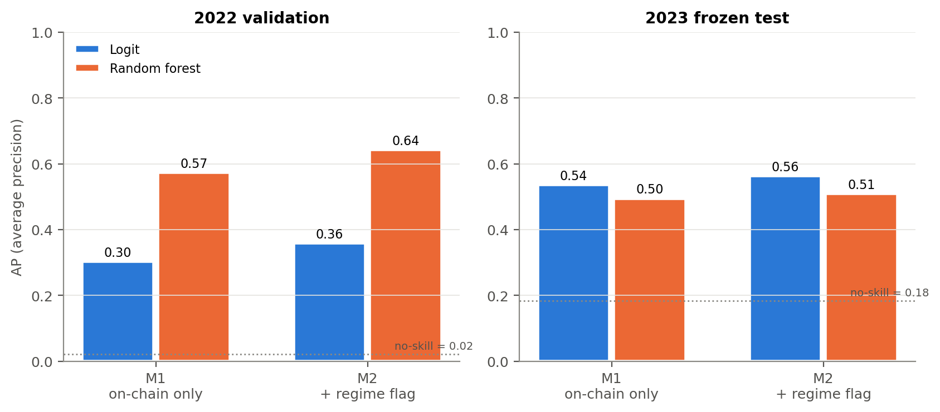
Figure 3. AP with and without the regime flag. Dotted line = no-skill level.
Table 4. Is the gain from the regime flag real?
Period | Model | Metric | Gain (M2 - M1) | 95% range | Placebo p
2022 validation | Logit | AP | +0.055 | [-0.385, +0.319] | 0.22
2022 validation | Logit | ROC-AUC | -0.013 | [-0.058, +0.056] | 0.54
2022 validation | Logit | Brier | -0.0038 | [-0.0260, +0.0201] | 0.11
2022 validation | Random forest | AP | +0.070 | [-0.176, +0.538] | 0.17
2022 validation | Random forest | ROC-AUC | -0.008 | [-0.030, +0.034] | 0.74
2022 validation | Random forest | Brier | -0.0049 | [-0.0210, +0.0111] | 0.01
2023 frozen test | Logit | AP | +0.028 | [-0.005, +0.055] | 0.11
2023 frozen test | Logit | ROC-AUC | +0.019 | [+0.002, +0.040] | 0.06
2023 frozen test | Logit | Brier | +0.0211 | [+0.0009, +0.0466] | 0.94
2023 frozen test | Random forest | AP | +0.014 | [-0.003, +0.032] | 0.16
2023 frozen test | Random forest | ROC-AUC | +0.013 | [-0.002, +0.026] | 0.63
2023 frozen test | Random forest | Brier | +0.0046 | [-0.0074, +0.0202] | 0.89
For Brier, a negative gain means M2 is better. Shaded rows: placebo p of 0.05 or less.
Adding the flag raises AP slightly in every case (Table 3), but none of these gains can be told apart from chance (Table 4). Every 95% range for AP includes zero, and 11-22% of fake flags help as much as the real one (Figure 4). Only two results pass the 0.05 bar. The forest's 2022 calibration improves (p = 0.01), and the logit's 2023 ROC-AUC rises by +0.019 (p = 0.06). With twelve comparisons, one or two such results are expected by chance. Meanwhile, 2023 calibration gets worse with the flag in both models.
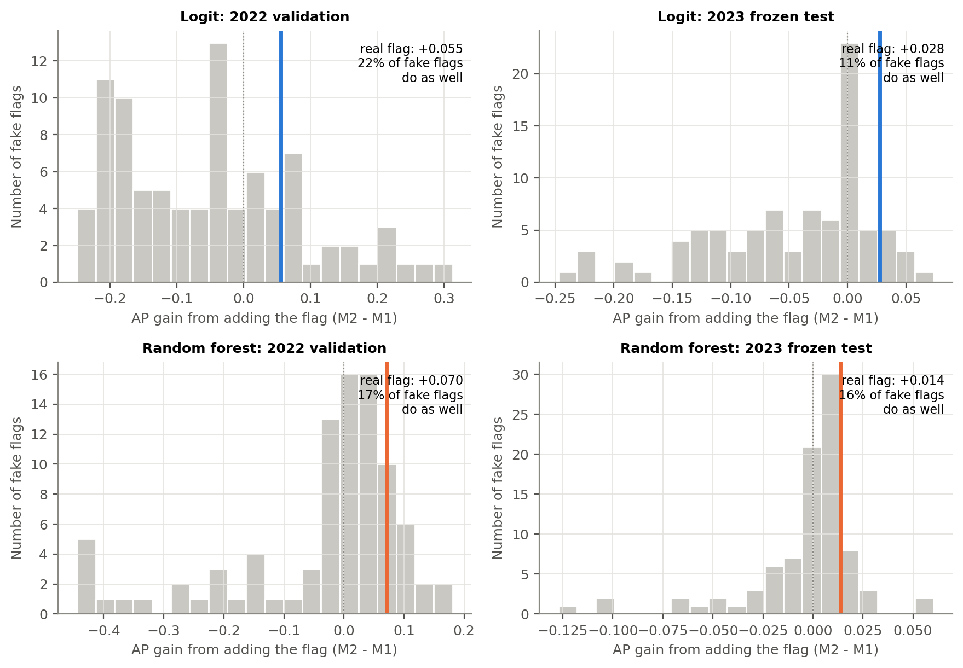
Figure 4. Real regime flag (coloured line) against 89 fake flags (grey). A genuinely informative flag would sit to the right of almost all grey bars.

4.2 Why: the flag was right, but rarely switched on
Table 5. Performance split by the regime on the forecast day
Period | Model | Regime | Coin-days | Breaches | AP M1 | AP M2 | Brier M1 | Brier M2
2022 validation | Logit | Normal | 216 | 2 | 0.212 | 0.217 | 0.0600 | 0.0174
2022 validation | Logit | Stressed | 156 | 6 | 0.815 | 0.438 | 0.0399 | 0.0900
2022 validation | Random forest | Normal | 216 | 2 | 0.542 | 0.537 | 0.0488 | 0.0194
2022 validation | Random forest | Stressed | 156 | 6 | 0.733 | 0.788 | 0.0231 | 0.0520
2023 frozen test | Logit | Normal | 258 | 40 | 0.494 | 0.498 | 0.1105 | 0.1342
2023 frozen test | Logit | Stressed | 9 | 9 |  |  | 0.7199 | 0.6669
2023 frozen test | Random forest | Normal | 258 | 40 | 0.438 | 0.441 | 0.1176 | 0.1222
2023 frozen test | Random forest | Stressed | 9 | 9 |  |  | 0.5365 | 0.5410
AP cannot be computed when every day in a group is a breach (2023 stressed days).
In 2022, 16% of stressed coin-days were breaches against 1% of normal ones, so M2 learned to raise risk under stress and lower it otherwise. In 2023 the flag was still right when on: all 9 stressed coin-days were breaches. But it was on for only three days, and 40 of the 49 breaches came on days it called normal. On those days M2 cut its forecasts (logit average 8.5% to 3.0%), which is why calibration worsens (Table 5).
Interpretation. The regime captures crypto-native stress (falling BTC/ETH, fearful sentiment), the setting of the Terra collapse. SVB was a traditional banking shock: USDC depegged because part of its reserves sat in a failing bank, while crypto markets were not in a downturn. A crypto-market regime cannot anticipate such a shock.

4.3 The SVB episode
Neither model gives USDC or DAI a high depeg probability during SVB (Figure 5). The forest peaks near 25% for USDC; the logit stays below 7%. The flag did switch on on 10 March, in time for the first USDC and DAI breach day, but it added only about 3 percentage points to their forecasts (Appendix Table A2). The regime responded, but the models had learned to give it too little weight for this kind of crisis.
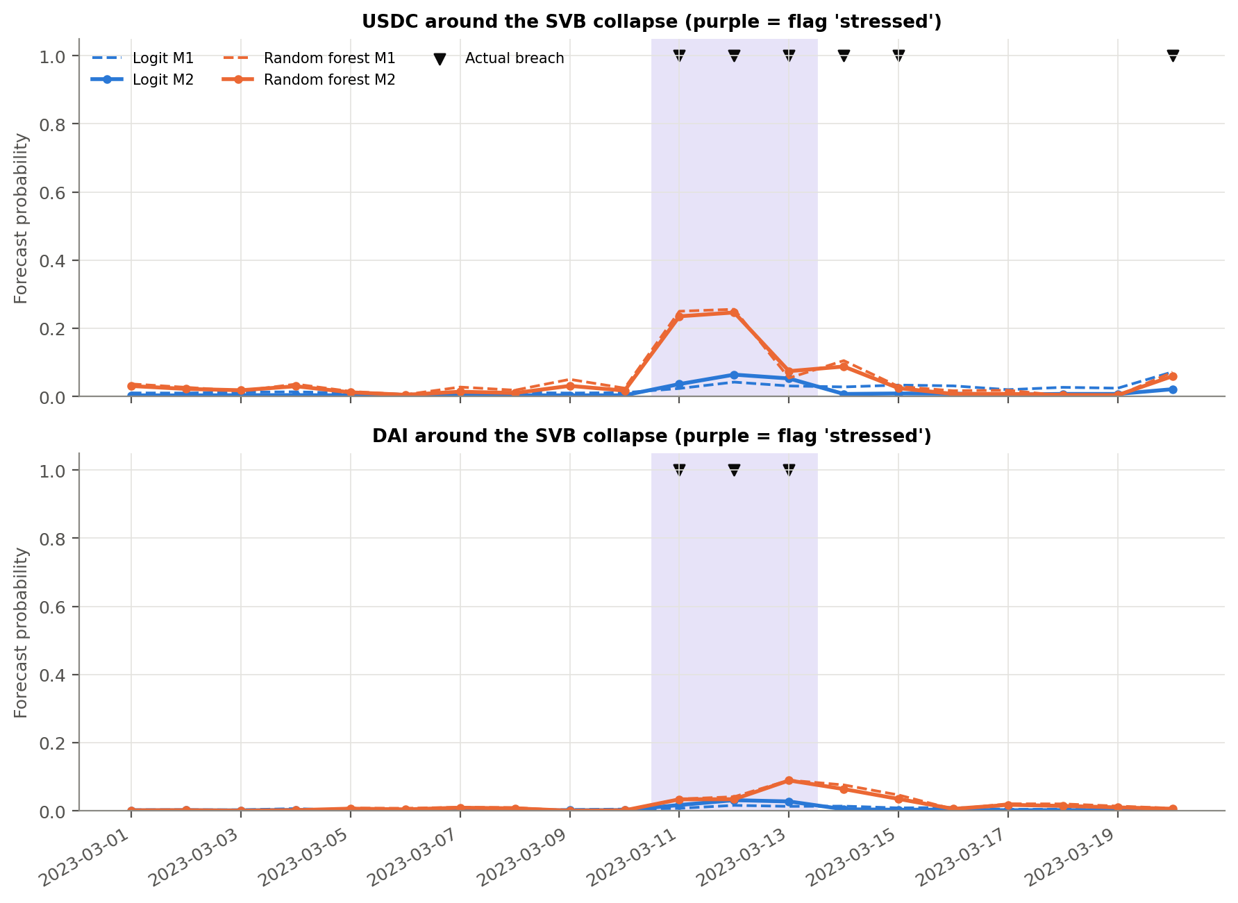
Figure 5. Forecasts for USDC and DAI around the SVB collapse. Dashed = M1, solid = M2. Triangles = actual breaches. Purple = flag 'stressed'.

4.4 On-chain relationships do change with the regime
Here the answer is yes. In the logit M3, the seven feature-by-stress terms are jointly highly significant (Wald chi-square = 59.1, p = 2.3e-10, date-clustered standard errors). In calm markets, the mix of activity matters: more transfers lowers risk, while more unique senders, receivers and minting raise it. Under stress these effects fade and volume takes over: higher on-chain volume raises risk and more large-transfer volume lowers it (Figure 6, Table 6).
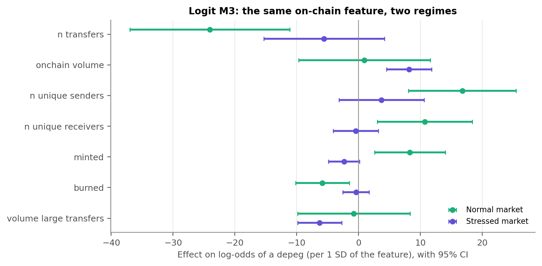
Figure 6. Logit M3: each feature's effect in normal vs stressed markets (95% intervals).
Table 6. Logit M3: effect on depeg log-odds per 1 SD of each feature (standard error)
Feature | Normal market | Stressed market | Change under stress
n transfers | -24.02 (6.60) | -5.56 (4.99) | +18.46
onchain volume | 0.97 (5.43) | 8.20 (1.87) | +7.23
n unique senders | 16.79 (4.43) | 3.73 (3.51) | -13.06
n unique receivers | 10.73 (3.92) | -0.44 (1.85) | -11.17
minted | 8.32 (2.91) | -2.33 (1.29) | -10.65
burned | -5.83 (2.21) | -0.41 (1.09) | +5.43
volume large transfers | -0.77 (4.64) | -6.27 (1.83) | -5.51
Transfers, senders and receivers move closely together, so read their effects as a group.
The forest finds the same pattern without being told to look for it. Its predicted-risk curves for each feature are not parallel between regimes (Figure 7), and they diverge more under the real flag than under fake ones (placebo p = 0.033). The difference is largest for burned, minted and unique receivers (Table 7).
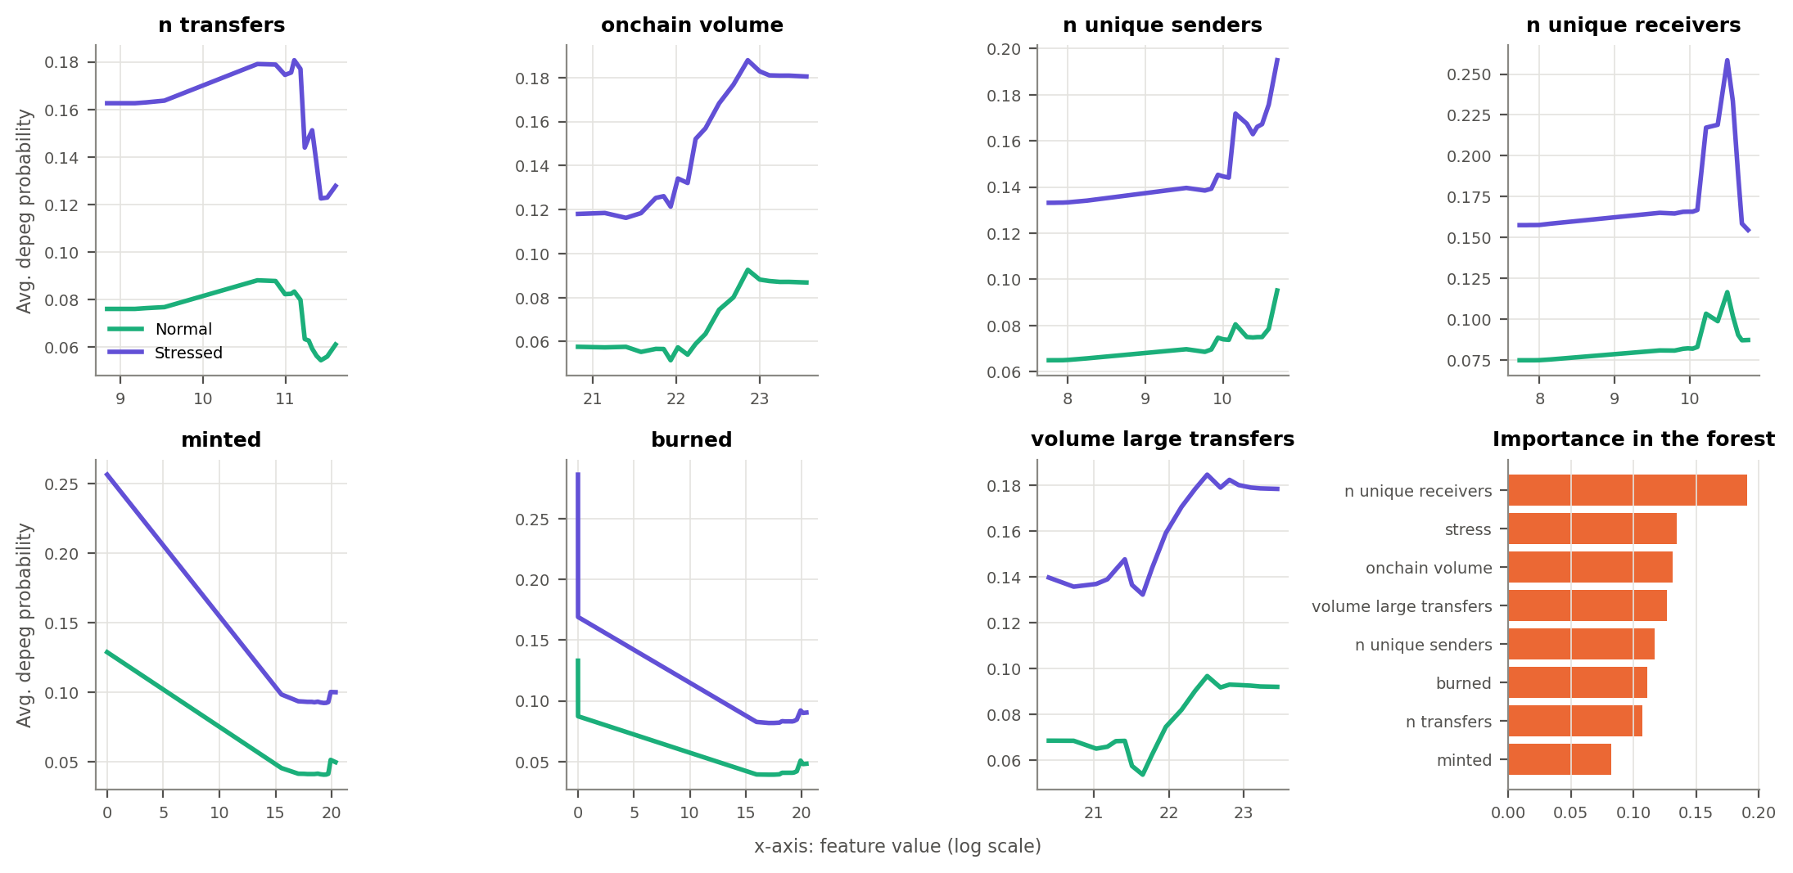
Figure 7. Random forest: predicted depeg risk as each feature varies, normal vs stressed (2022).
Table 7. Random forest: how much each feature's effect depends on the regime
Feature | Real flag | Average fake flag | Placebo p
All features combined | 0.1097 | 0.0481 | 0.033
n transfers | 0.0090 | 0.0067 | 0.222
onchain volume | 0.0142 | 0.0059 | 0.067
n unique senders | 0.0118 | 0.0061 | 0.089
n unique receivers | 0.0196 | 0.0080 | 0.044
minted | 0.0196 | 0.0066 | 0.011
burned | 0.0286 | 0.0085 | 0.011
volume large transfers | 0.0068 | 0.0062 | 0.378
0 = the regime only shifts risk up or down; larger = the feature's effect itself changes. Shaded rows: placebo p of 0.05 or less.
Interpretation. The same on-chain movement does mean different things in different markets: heavy volume looks like a run under stress but is ordinary in calm times. This supports our hypothesis and the regime-dependent logic of currency-crisis early warning (Kaminsky, Lizondo & Reinhart, 1998). But because the pattern was learned from Terra, it did not improve forecasts of the next, different crisis.

4.5 Early warning: alerts and new episodes
Table 8. 2023 alert performance, cut-offs fixed on 2022 validation
Model | Spec | Cut-off | Precision | Recall | Correct alerts | False alarms | Missed
Logit | M1 | 0.53 | 1.000 | 0.020 | 1 | 0 | 48
Logit | M2 | 0.63 | 1.000 | 0.020 | 1 | 0 | 48
Random forest | M1 | 0.57 | 0.833 | 0.204 | 10 | 2 | 39
Random forest | M2 | 0.62 | 1.000 | 0.061 | 3 | 0 | 46
Precision = share of alerts that were breaches; recall = share of 49 breaches that got an alert. 2022 results are in Appendix Table A3.
Cut-offs set on 2022 (about 0.5-0.6) were far above the probabilities the models produced in 2023, so recall fell to 2-20% (Table 8). The flag made this worse for the forest (10 breaches caught without it, 3 with it) by lowering risk on 'normal' days. In 2022 the flag had looked useful, cutting the forest's false alarms from 8 to 2.
Table 9. Every new depeg episode in 2023 and the forecast made the day before
Coin | First breach day | Regime flag | Logit M2 forecast | RF M2 forecast
DAI | 11 Mar 2023 | Stressed | 1.7% | 3.4%
DAI | 19 Apr 2023 | Normal | 0.3% | 0.7%
DAI | 26 Apr 2023 | Normal | 0.1% | 1.0%
USDC | 11 Mar 2023 | Stressed | 3.6% | 23.5%
USDC | 20 Mar 2023 | Normal | 2.1% | 6.0%
USDT | 13 Feb 2023 | Normal | 2.3% | 7.1%
USDT | 10 Mar 2023 | Normal | 8.7% | 15.6%
USDT | 07 Apr 2023 | Normal | 7.7% | 6.6%
USDT | 19 Apr 2023 | Normal | 9.8% | 10.5%
USDT | 28 Apr 2023 | Normal | 9.9% | 9.1%
No model (M1 or M2) issued an alert for any of these days or the three days before them.
Interpretation. None of the 10 new episodes in 2023 was warned of by any model, so lead time cannot be measured (Table 9). Every correct alert fell on a day after an episode had already begun. The models mainly learn that depegs persist, not when they start, partly because the label rewards spotting ongoing episodes.

4.6 Robustness
Table 10. AP gain from regime information (M2 - M1) under alternative specifications
Variant | Logit 2022 | Logit 2023 | RF 2022 | RF 2023
Main: flag from day t | +0.055 | +0.028 | +0.070 | +0.014
Flag from day t-1 | +0.155 | +0.025 | +0.199 | +0.005
Flag from day t-3 | +0.135 | +0.024 | +0.040 | +0.007
Stress score (0-3) instead of 0/1 flag | -0.080 | +0.028 | +0.071 | +0.014
Placebo p-values were computed for the main flag and the stress score; none of their AP gains has a placebo p below 0.10. Full stress-score results are in Appendix Table A4.
- Flag timing. Using the flag from one or three days earlier leaves the small 2023 gains unchanged, but the 2022 gain swings between +0.04 and +0.20. A genuine signal would not be this sensitive to timing.
- Finer regime measure. Using the number of stress signals (0-3) instead of the on/off flag does not help, and it removes the forest's one significant 2022 result.
- Model choice. The forest is better in 2022 (AP 0.57 vs 0.30 for M1) and the logit in 2023 (0.56 vs 0.51 for M2). The flexible forest fits Terra-era patterns closely and carries over less well. Neither finds dependable value in the regime, so the conclusion does not depend on the model.

5. Contributions, Limitations, and Future Directions

5.1 Contributions
- Prediction: A crypto-market regime does not reliably improve out-of-sample depeg forecasts, in linear or flexible models. This is the informative null our plan anticipated: the proxy is too crypto-centric to anticipate a crisis that starts in traditional finance.
- Relationships: On-chain signals carry different depeg risk in stressed and calm markets. Volume matters under stress; the composition of activity matters in calm markets. Pooled models (Lee, Chiu & Hsieh, 2025) average over these two relationships.
- Method: Forward-only testing across two different crises, paired baseline and regime-aware models, and a placebo test that separates genuine regime information from the benefit of any persistent on/off variable. The placebo test can be reused for any proposed stress indicator.
- Caution: Good ranking scores (ROC-AUC up to 0.85) coexisted with zero warnings for new episodes. Early-warning studies should report event-level results, not only AP or ROC-AUC.
Practical implication. For DeFi protocols and exchanges, a crypto stress flag is a useful lens for reading on-chain signals, but not a substitute for monitoring each stablecoin's reserves and banking exposure, where shocks like SVB originate.

5.2 Limitations
- Few events: 3 coins, 8 breaches in the 2022 validation months (all in July), 10 new episodes in 2023.
- Label: Counts every breach day, not only new breaches, which pushes models towards detecting persistence.
- Little regime variation: The flag is on for only 3 days in 2023, so its test rests largely on the SVB week.
- Two data sources: 2022 and 2023 on-chain data come from different providers, so part of the gap between years may reflect measurement differences.
- Assumptions: Settings were fixed rather than tuned, and data publication timing is assumed rather than verified.

5.3 Future directions
- Target new episodes: Predict the first day of each episode and measure lead time directly.
- Better stress measures: Add traditional-finance stress (VIX, bank stocks, T-bill spreads) and stablecoin-specific stress (redemption flows, liquidity-pool imbalances), possibly via a probabilistic regime model. Fix any new indicator on 2022 only and run it through the same placebo test.
- Wider sample: More stablecoins and years would allow testing by holding out one crisis at a time.
- Adaptive alerts: Re-set alert cut-offs as base rates change, since 2022 cut-offs were far too high for 2023.

Appendix: supporting tables and figures
Table A1. 2022 validation, month by month
Model | Month | Coin-days | Breaches | Stressed | AP M1 | AP M2 | Brier M1 | Brier M2
Logit | 2022-07 | 93 | 8 | 29% | 0.333 | 0.751 | 0.0884 | 0.0483
Logit | 2022-08 | 93 | 0 | 10% |  |  | 0.0654 | 0.0246
Logit | 2022-09 | 90 | 0 | 80% |  |  | 0.0345 | 0.0963
Logit | 2022-10 | 93 | 0 | 52% |  |  | 0.0190 | 0.0252
Logit | 2022-11 | 3 | 0 | 0% |  |  | 0.0077 | 0.0010
Random forest | 2022-07 | 93 | 8 | 29% | 0.621 | 0.722 | 0.0722 | 0.0439
Random forest | 2022-08 | 93 | 0 | 10% |  |  | 0.0474 | 0.0198
Random forest | 2022-09 | 90 | 0 | 80% |  |  | 0.0163 | 0.0561
Random forest | 2022-10 | 93 | 0 | 52% |  |  | 0.0145 | 0.0137
Random forest | 2022-11 | 3 | 0 | 0% |  |  | 0.0663 | 0.0185
AP is undefined in months without breaches. The flag improves Brier in July-August but worsens it in September (mostly stressed, no breaches).
Table A2. How much of each M2 forecast comes from the regime flag
Model | Period | Effect of switching flag on (pp) | Contribution on stressed days (pp) | USDC/DAI during SVB (pp)
Logit | 2022 validation | +16.0 | +16.2 | -
Logit | 2023 frozen test | +10.3 | +15.5 | +3.2
Random forest | 2022 validation | +9.2 | +9.2 | -
Random forest | 2023 frozen test | +5.6 | +11.9 | +3.1
pp = percentage points. Same fitted M2, flag forced to 0 vs 1; a model-based breakdown, not causal.
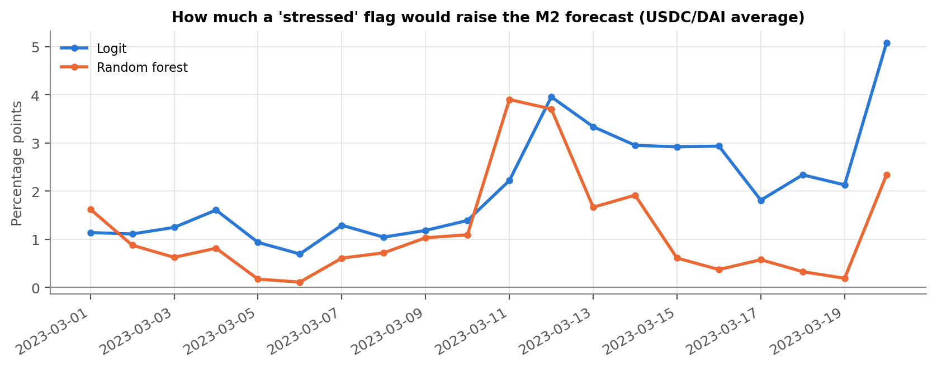
Figure A1. What a 'stressed' flag would add to the frozen M2 forecast, SVB window.
Table A3. Alert performance in both periods
Period | Model | Spec | Cut-off | Precision | Recall | F1 | Correct | False alarms | Missed
2022 validation | Logit | M1 | 0.53 | 0.333 | 0.500 | 0.400 | 4 | 8 | 4
2023 frozen test | Logit | M1 | 0.53 | 1.000 | 0.020 | 0.040 | 1 | 0 | 48
2022 validation | Logit | M2 | 0.63 | 0.444 | 0.500 | 0.471 | 4 | 5 | 4
2023 frozen test | Logit | M2 | 0.63 | 1.000 | 0.020 | 0.040 | 1 | 0 | 48
2022 validation | Random forest | M1 | 0.57 | 0.429 | 0.750 | 0.545 | 6 | 8 | 2
2023 frozen test | Random forest | M1 | 0.57 | 0.833 | 0.204 | 0.328 | 10 | 2 | 39
2022 validation | Random forest | M2 | 0.62 | 0.750 | 0.750 | 0.750 | 6 | 2 | 2
2023 frozen test | Random forest | M2 | 0.62 | 1.000 | 0.061 | 0.115 | 3 | 0 | 46
The 2022 rows are where the cut-off was chosen, so they flatter the models.
Table A4. Stress score (0-3) vs on/off flag, all metrics
Period | Model | Metric | M1 | M2 flag | M2 score | Placebo p (flag) | Placebo p (score)
2022 validation | Logit | AP | 0.304 | 0.360 | 0.224 | 0.22 | 0.49
2022 validation | Logit | ROC-AUC | 0.958 | 0.945 | 0.943 | 0.54 | 0.51
2022 validation | Logit | Brier | 0.0516 | 0.0478 | 0.0503 | 0.11 | 0.23
2023 frozen test | Logit | AP | 0.537 | 0.564 | 0.564 | 0.11 | 0.12
2023 frozen test | Logit | ROC-AUC | 0.826 | 0.845 | 0.849 | 0.06 | 0.02
2023 frozen test | Logit | Brier | 0.1310 | 0.1521 | 0.1564 | 0.94 | 0.88
2022 validation | Random forest | AP | 0.573 | 0.644 | 0.645 | 0.17 | 0.23
2022 validation | Random forest | ROC-AUC | 0.979 | 0.971 | 0.969 | 0.74 | 0.76
2022 validation | Random forest | Brier | 0.0380 | 0.0331 | 0.0324 | 0.01 | 0.09
2023 frozen test | Random forest | AP | 0.495 | 0.509 | 0.510 | 0.16 | 0.20
2023 frozen test | Random forest | ROC-AUC | 0.739 | 0.753 | 0.753 | 0.63 | 0.60
2023 frozen test | Random forest | Brier | 0.1317 | 0.1363 | 0.1365 | 0.89 | 0.84

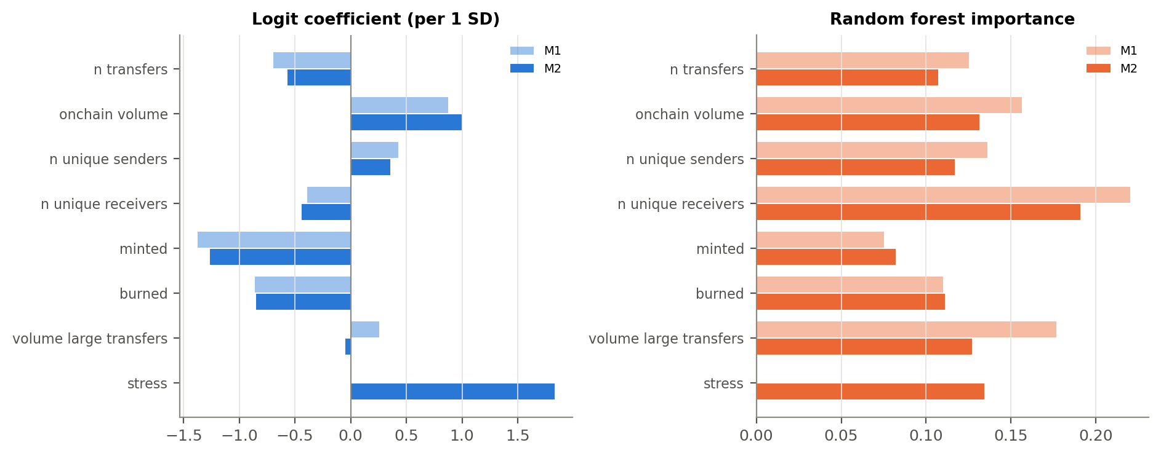
Figure A2. What each model relies on (trained on all of 2022). Lighter = M1, darker = M2.
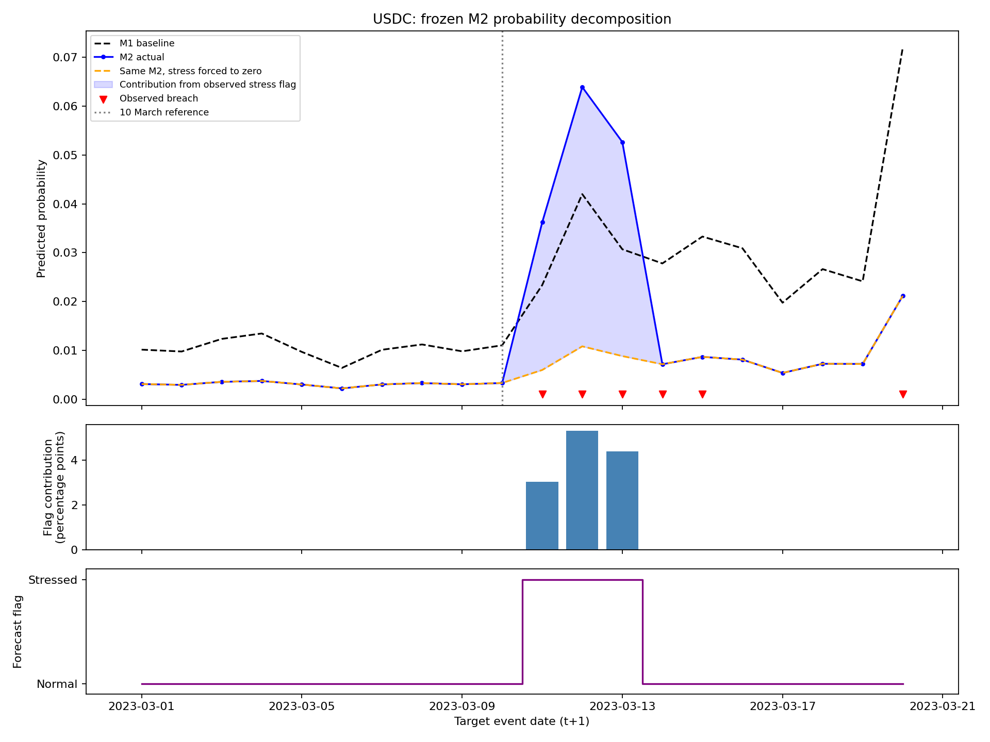
Figure A3. Logit, USDC: M2 forecast with and without the flag's contribution.
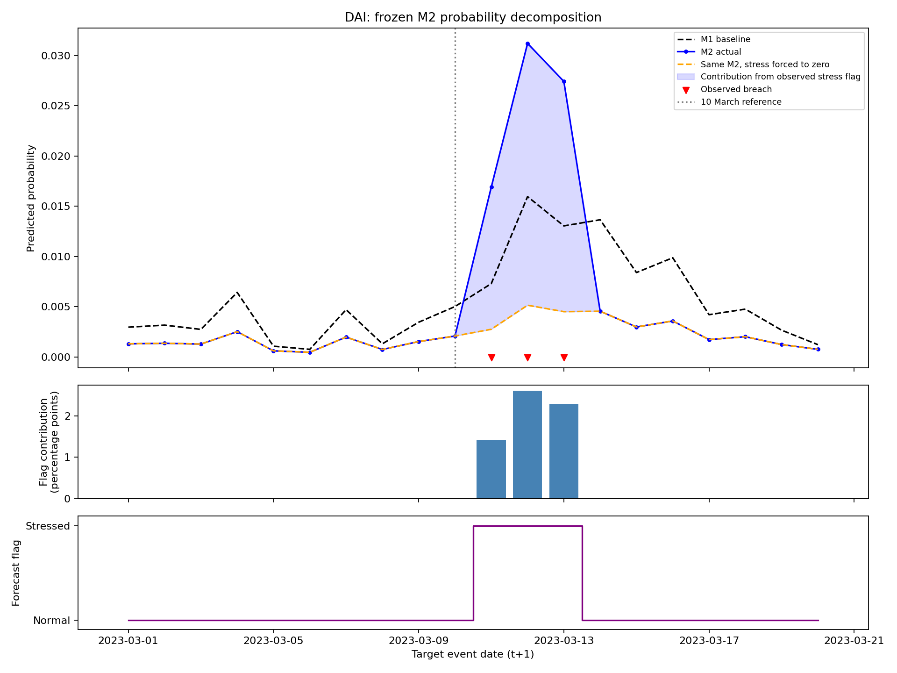
Figure A4. Logit, DAI: the same breakdown.
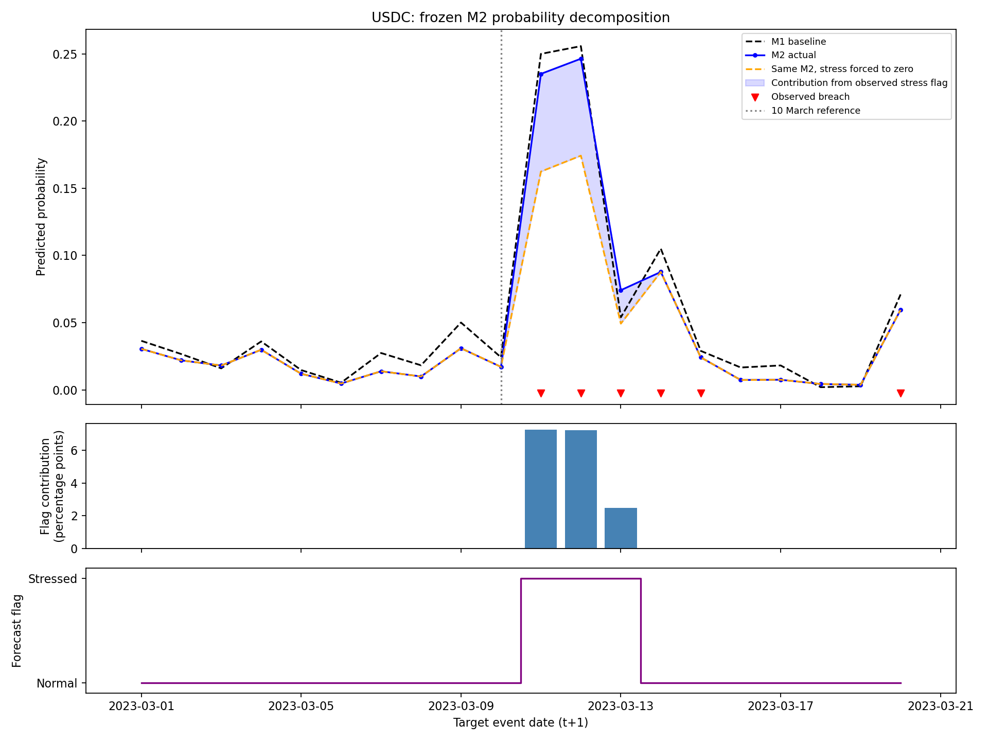
Figure A5. Random forest, USDC: M2 breakdown.
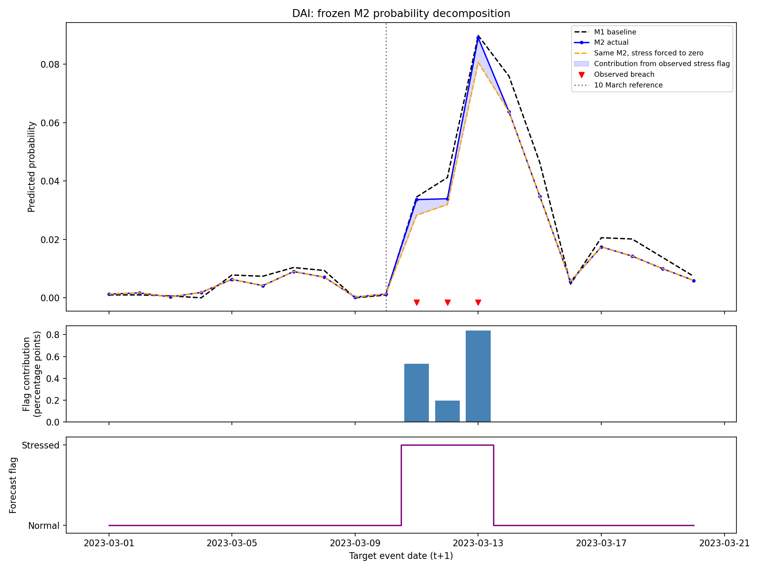
Figure A6. Random forest, DAI: M2 breakdown.
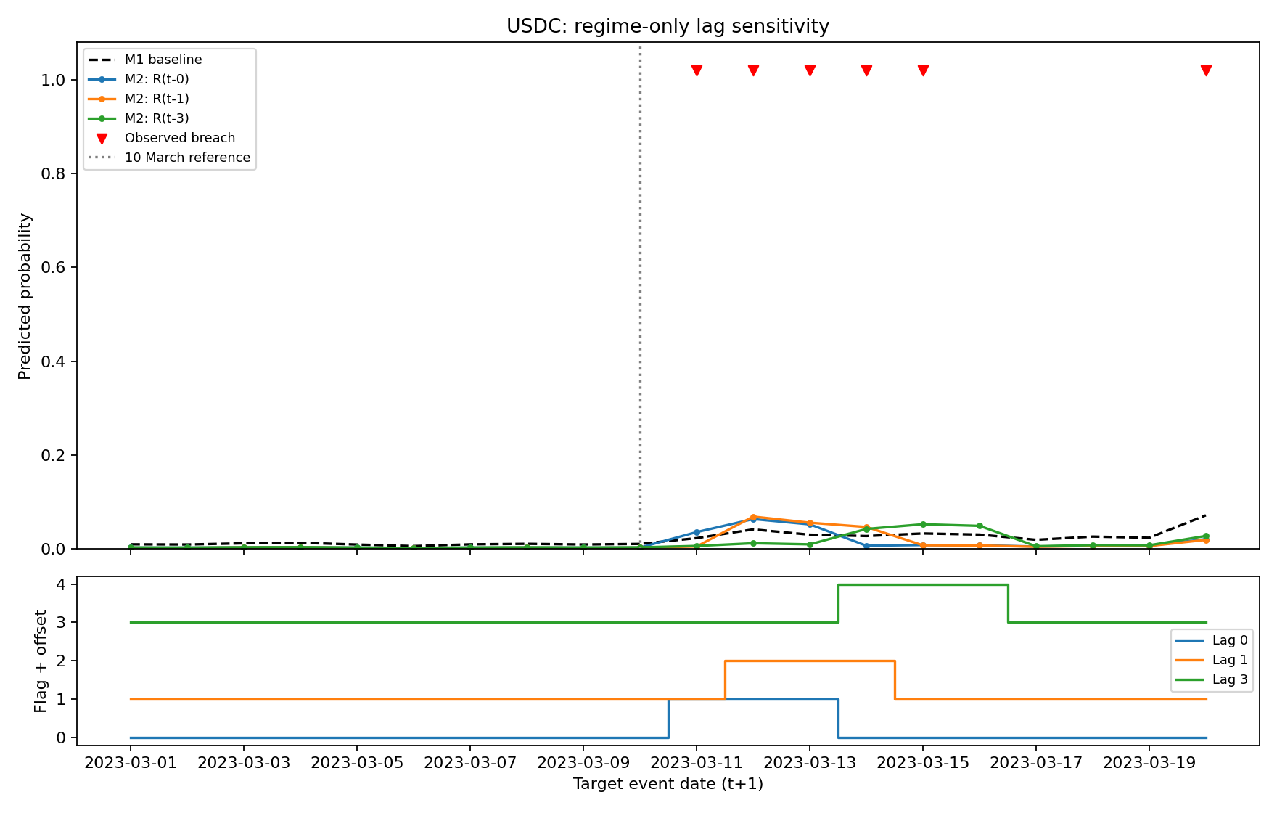
Figure A7. Logit, USDC: flag from t, t-1, t-3.
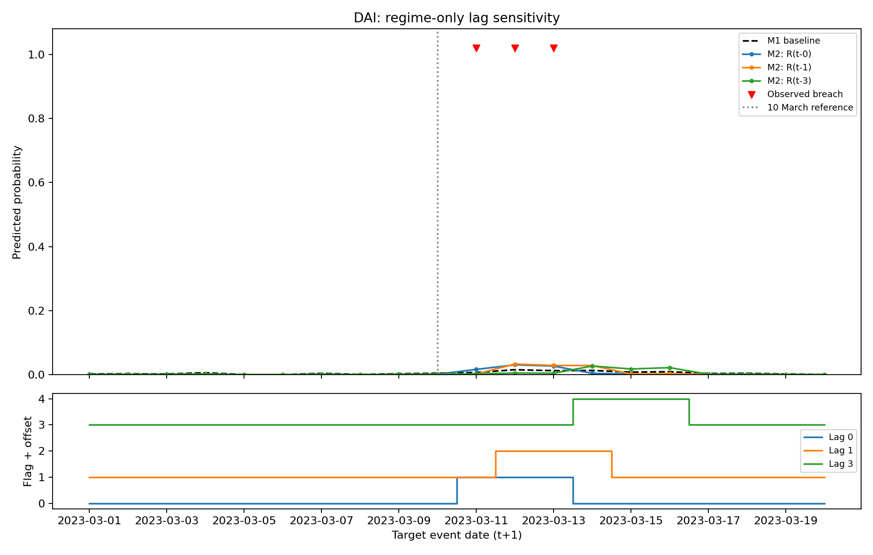
Figure A8. Logit, DAI: flag timing.
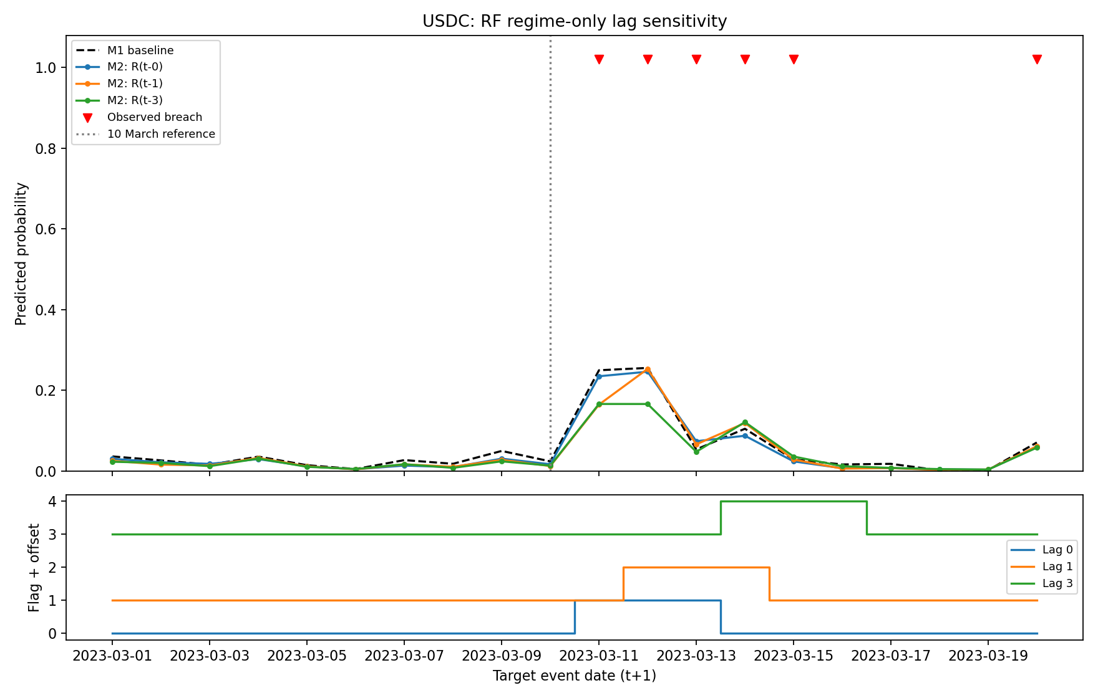
Figure A9. Random forest, USDC: flag timing.
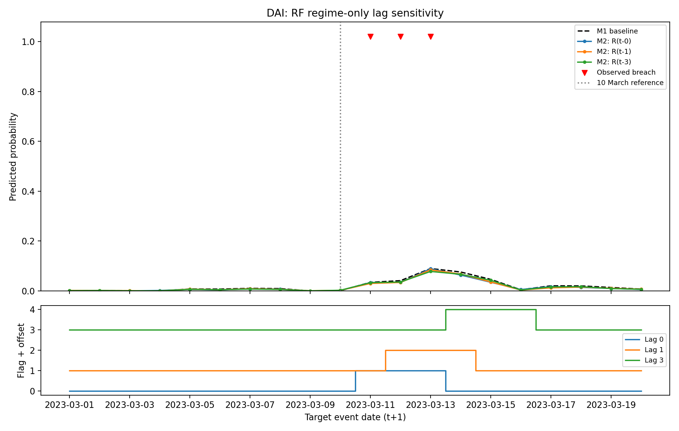
Figure A10. Random forest, DAI: flag timing.

