A Major Project Report on

VITAMIN DEFICIENCY DETECTION USING DEEP LEARNING
Submitted in Partial fulfillment of requirements for the award of the degree of

BACHELOR OF TECHNOLOGY

In

COMPUTER SCIENCE AND ENGINEERING

By

Student Name Roll No.

Under the guidance of

Ms. [Guide Name]
Assistant Professor, Department of CSE



DEPARTMENT OF COMPUTER SCIENCE AND ENGINEERING
KESHAV MEMORIAL INSTITUTE OF TECHNOLOGY
(AN AUTONOMOUS INSTITUTION)
Accredited by NBA & NAAC, Approved by AICTE, Affiliated to JNTUH.

Narayanaguda, Hyderabad, Telangana-29
2025-26



KESHAV MEMORIAL INSTITUTE OF TECHNOLOGY
(AN AUTONOMOUS INSTITUTION)
Accredited by NBA & NAAC, Approved by AICTE, Affiliated to JNTUH.

Narayanaguda, Hyderabad, Telangana-29

2025-26

DEPARTMENT OF COMPUTER SCIENCE AND ENGINEERING

CERTIFICATE

This is to certify that this is a bonafide record of the project report titled ‘Home Appliances Control Using Raspberry Pi’, submitted as a Major Project in IV Year II Semester (RKR21) by


S RAGHAVENDRA PRABHANJAN 19BD1A1249

JAHNAVI BHAGIRATH PATEL 19BD1A1222

In partial fulfillment for the award of the degree of Bachelor of Technology in Computer Science and Engineering at Keshav Memorial Institute of Technology (An Autonomous Institution) Narayanaguda, affiliated to the Jawaharlal Nehru Technological University Hyderabad.

Faculty Supervisor Head of the Department
(Ms/Mr XXXX) (Mr. Para Upendar)

Submitted for Viva Voce Examination held on ____________________________

Vision & Mission of Institution

Vision:

  - To be the fountainhead in producing highly skilled, globally competent engineers.
  - Producing quality graduates trained in the latest software technologies and related tools and striving to make India a world leader in software products and services.

Mission:

  - To provide a learning environment that inculcates problem solving skills, professional, ethical responsibilities, lifelong learning through multi modal platforms and prepares students to become successful professionals.
  - To establish an industry institute Interaction to make students ready for the industry.
  - To provide exposure to students on the latest hardware and software tools.
  - To promote research-based projects/activities in the emerging areas of technology convergence.
  - To encourage and enable students to not merely seek jobs from the industry but also to create new enterprises.
  - To induce a spirit of nationalism which will enable the student to develop, understand India's challenges and to encourage them to develop effective solutions.
  - To support the faculty to accelerate their learning curve to deliver excellent service to students.
Vision & Mission of Department

Vision:
To be among the region's premier teaching and research Computer Science and Engineering departments producing globally competent and socially responsible graduates in the most conducive academic environment.

Mission:
- To provide faculty with state of the art facilities for continuous professional development and research, both in foundational aspects and of relevance to emerging computing trends.

- To impart skills that transform students to develop technical solutions for societal needs and inculcate entrepreneurial talents.
- To inculcate an ability in students to pursue the advancement of knowledge in various specializations of Computer Science and Engineering and make them industry-ready.
- To engage in collaborative research with academia and industry and generate adequate resources for research activities for seamless transfer of knowledge resulting in sponsored projects and consultancy.
- To cultivate responsibility through sharing of knowledge and innovative computing solutions that benefit the society-at-large.
- To collaborate with academia, industry and community to set high standards in academic excellence and in fulfilling societal responsibilities

PROGRAM OUTCOMES (POs)

PO1. Engineering Knowledge: Apply the knowledge of mathematics, science, engineering fundamentals, and an engineering specialization to the solution of complex engineering problems.

PO2. Problem Analysis: Identify formulate, review research literature, and analyze complex engineering problems reaching substantiated conclusions using first principles of mathematics, natural sciences, and engineering sciences


PO3. Design/Development of solutions: Design solutions for complex engineering problems and design system components or processes that meet the specified needs with appropriate consideration for the public health and safety, and the cultural, societal, and environmental considerations.

PO4. Conduct Investigations of Complex problems: Use research-based knowledge and research methods including design of experiments, analysis and interpretation of data, and synthesis of the information to provide valid conclusions.

PO5. Modern Tool Usage: Create select, and, apply appropriate techniques, resources, and modern engineering and IT tools including prediction and modeling to complex engineering activities with an understanding of the limitations.

PO6. The Engineer and Society: Apply reasoning informed by contextual knowledge to societal, health, safety. Legal und cultural issues and the consequent responsibilities relevant to professional engineering practice.

PO7. Environment and Sustainability: Understand the impact of the professional engineering solutions in societal and environmental contexts and demonstrate the knowledge of, and need for sustainable development.

PO8. Ethics: Apply ethical principles and commit to professional ethics and responsibilities and norms of the engineering practice.

PO9. Individual and Team Work: Function effectively as an individual, and as a member or leader in diverse teams and in multidisciplinary settings.

PO10. Communication: Communicate effectively on complex engineering activities with the engineering community and with society at large, such as, being able to comprehend and write effective reports and design documentation, make effective presentations, and give and receive clear instructions.

PO11. Project Management and Finance: Demonstrate knowledge and understanding of the engineering and management principles and apply these to one's own work, as a member and leader in a team, to manage projects and in multidisciplinary environments.


PO12. Life-Long Learning: Recognize the need for, and have the preparation and ability to engage in independent and life-long learning in the broadest context of technological change.

PROGRAM SPECIFIC OUTCOMES (PSOs)

PSO1: An ability to analyze the common business functions to design and develop appropriate Information Technology solutions for social upliftments.
PSO2: Shall have expertise on the evolving technologies like Python, Machine Learning, Deep learning, IOT, Data Science, Full stack development, Social Networks, Cyber Security, Mobile Apps, CRM, ERP, Big Data, etc.


PROGRAM EDUCATIONAL OBJECTIVES (PEOs)

PEO1: To imbibe analytical and professional skills for successful careers and create enthusiasts to pursue advance education supplementing their career growth.
PEO2: Graduates will solve real time problems design, develop and implement innovative ideas by applying their computer engineering principles.
PEO3: Graduates will develop necessary skillset for industry by imparting state of art technology in various areas of computer science engineering.
PEO4: Graduates will engage in lifelong learning and be able to work collaboratively exhibiting high level of professionalism.

PROJECT OUTCOMES

P1: Accurately detect motion and control the appliances accordingly.
P2: Allow control of appliances remotely.
P3: Change the state of appliances instantly.
P4: Work seamlessly over the internet.

MAPPING PROJECT OUTCOMES WITH PROGRAM OUTCOMES

PO | PO1 | PO2 | PO3 | PO4 | PO5 | PO6 | PO7 | PO8 | PO9 | PO10 | PO11 | PO12
P1
P2
P3
P4

L – LOW M –MEDIUM H– HIGH

PROJECT OUTCOMES MAPPING WITH PROGRAM SPECIFIC OUTCOMES

PSO | PSO1 | PSO2
P1
P2
P3
P4

PROJECT OUTCOMES MAPPING WITH PROGRAM EDUCATIONAL OBJECTIVES

PEO | PEO1 | PEO2 | PEO3 | PEO4
P1
P2
P3
P4

PROJECT OUTCOMES AND JUSTIFICATION

Faculty Name: DR. PATWARI PRASAD RAO Academic Year: 2024-2025
Branch: CSE Year/Sem: IV/II

P-PO Mapping Justification

Mapping | Level | Justification
Students will be able to
P1-PO1 | H | Apply engineering and ML to build integrated models for agricultural prediction and decision support.
P1-PO2 | M | Use research and first principles to analyze agricultural problems and develop an ML system for crop, yield, disease, and price prediction.
P1-PO3 | H | Design an integrated ML system for agriculture, addressing prediction needs with societal and environmental considerations.
P1-PO5 | H | Addressed agricultural challenges using data analysis and ML to build a unified system for crop, yield, disease, and price prediction.
P1-PO7 | H | Integrated ML models into a unified system to tackle agricultural challenges, considering environmental impact and promoting sustainability.
P1-PO8 | M | Integrated ML models into a unified system for agricultural solutions, ensuring ethical responsibility and sustainability in addressing societal and environmental challenges.
P1-PO9 | H | Worked in a multidisciplinary team to integrate ML models for crop recommendation, yield prediction, disease detection, and price forecasting.
P1-PO10 | H | Communicate clearly on complex engineering activities through reports, presentations, and effective instructions to both the engineering community and society.
P1-PO11 | H | Led and collaborated in a multidisciplinary team to apply engineering and management principles, integrating ML models for crop recommendation, yield prediction, disease detection, and price forecasting.

P1-PO12 | M | Recognized the importance of lifelong learning and developed analytical and professional skills by integrating ML models for agricultural solutions, fostering continuous personal and professional growth in the face of technological change.
P2-PO1 | M | Analyzed agricultural problems using first principles to develop a user-friendly platform providing smart insights to farmers.
P2-PO3 | H | Analyzed agricultural problems with first principles to develop a platform offering smart insights to farmers.
P2-PO5 | H | Applied modern engineering and IT tools, including prediction and modeling, to develop a user-friendly platform with consideration for tool limitations.
P2-PO8 | H | Developed a user-friendly platform for smart agricultural insights, applying ethical principles and engineering norms to benefit farmers.
P2-PO9 | H | Collaborated in a multidisciplinary team and worked independently to develop a user-friendly web platform that provides smart agricultural insights to farmers.
P2-PO10 | H | Effectively communicated complex agricultural insights through a user-friendly web platform, creating clear reports and documentation, and presenting smart solutions to both the engineering community and farmer.
P2-PO11 | H | Applied engineering and management principles to develop and manage a smart agriculture web platform in a team setting.
P2-PO12 | M | Embraced lifelong learning to adapt and apply evolving technologies in building the platform.
P3-PO1 | H | Applied engineering and ML knowledge to support datadriven farm decisions.
P3-PO2 | H | Analyzed complex agricultural problems using research and first principles
P3-PO3 | H | Designed solutions addressing agricultural, societal, and environmental needs
P3-PO5 | M | Used modern tools for modeling and delivering accurate recommendations.
P3-PO6 | H | Considered societal and safety aspects in decision-making tools.
P3-PO7 | M | Promoted sustainable practices through smart agricultural insights.
P3-PO8 | M | Followed ethical principles in data use and system development.
P3-PO9 | H | Collaborated effectively within multidisciplinary teams.
P3-PO11 | M | Applied project and team management to deliver platform features.
P3-PO12 | H | Adapted to evolving tech through continuous learning and application
P4-PO1 | H | Applied engineering knowledge to design a scalable base for real-time sensor and IoT integration in agriculture.
P4-PO3 | L | Designed scalable systems considering health, safety, and environmental needs for future IoT-based farming
P4-PO6 | M | Considered societal and safety responsibilities in building a scalable IoT-ready agricultural foundation.
P4-PO7 | H | Promoted sustainable farming by enabling future integration with eco-conscious IoT solutions
P4-PO9 | M | Collaborated in diverse teams to establish a scalable framework for future smart agriculture solutions.
P4-PO10 | H | Communicated technical design and future integration plans effectively with teams and stakeholders.
P4-PO11 | M | Applied project and team management skills to create a scalable base for future IoT-based agriculture.
P4-P012 | H | Demonstrated adaptability and readiness for life-long learning through IoT-ready agricultural system design.

P-PSO Mapping Justification

Mapping | Level | Justification
 | Students will be able to
P1-PSO1 | H | Designed an ML-based system addressing key agricultural needs, supporting social upliftment.
P1-PSO2 | M | Applied machine learning expertise to develop an integrated agritech solution.
P2-PSO1 | H | Developed an IT-based platform offering actionable insights to farmers for societal benefit.
P2-PSO2 | H | Utilized full stack development and data science for smart agriculture applications.
P3-PSO1 | H | Delivered data-driven insights to improve decision-making for farming communities.
P3-PSO2 | H | Applied ML and data science to generate precise, real-time agricultural recommendations.
P4-PSO1 | M | Enabled future-ready smart farming systems for sustainable rural development.
P4-PSO2 | L | Built a scalable foundation for IoT integration in agriculture using emerging tech.

P-PEO Mapping Justification

Mapping |  | Level | Justification
 |  | Students will be able to
P1-PEO1 | H |  | Applied computer engineering principles to solve real-time agricultural problems using ML
P1-PEO2 | H |  | Applied core computer engineering to solve real-time agricultural problems.

P1-PEO3 | M | Utilized emerging technologies like ML and data science.
P1-PEO4 | H | Enabled future-ready, scalable agri systems promoting lifelong learning.
P2-PEO1 | H | Demonstrated professional and analytical skills in platform development.
P2-PEO2 | H | Designed and implemented a real-world, innovative web solution.
P2-PEO3 | H | Used state-of-the-art full-stack development and data tools.
P2-PEO4 | M | Fostered collaboration and adaptability for continual tech growth
P3-PEO1 | H | Strengthened analytical skills through meaningful data insights.
P3-PEO2 | M | Tackled practical problems with machine learning-based predictions
P3-PEO3 | H | Applied modern technologies like ML and AI in decision making.
P3-PEO4 | M | Encouraged continuous improvement through evolving data tools
P4-PEO1 | M | Developed scalable, analytical engineering foundations.
P4-PEO2 | L | Engineered forward-compatible systems addressing real needs.
P4-PEO3 | H | Integrated advanced technologies like IoT and cloud systems.
P4-PEO4 | L | Supported lifelong learning through future-oriented design.

DECLARATION

We hereby declare that the results embodied in the dissertation entitled "Vitamin Deficiency Detection Using Deep Learning" have been carried out by us under the guidance of Ms. [Guide Name], Assistant Professor, Department of Computer Science and Engineering. This work has not been submitted to any other University or Institution for the award of any degree or diploma.



Student Name Rollno.

S RAGHAVENDRA PRABHANJAN 19BD1A1249 BEJJANKI VASHISTA 19BD1A1207

JAHNAVI BHAGIRATH PATEL 19BD1A1222

ACKNOWLEDGEMENT

We take this opportunity to thank all the people who have rendered their full support to our project work. We render our thanks to Dr. B L Malleswari, Principal who encouraged us to do the Project.

We are grateful to Mr. Neil Gogte, Founder & Director, Mr. S. Nitin, Director for facilitating all the amenities required for carrying out this project.

We express our sincere gratitude to Ms. Deepa Ganu, Director Academic for providing an excellent environment in the college.

We are also thankful to Mr. Para Upendar, Head of the Department for providing us with time to make this project a success within the given schedule.

We are also thankful to our Faculty Supervisor Ms. [Guide Name], for her/his valuable guidance and encouragement given to us throughout the project work.

We would like to thank the entire Computer Science and Engineering Department faculty, who helped us directly and indirectly in the completion of the project.

We sincerely thank our friends and family for their constant motivation during the project work.

Student Name Roll no.

S Raghavendra Prabhanjan 19BD1A1249
Bejjanki Vashista 19BD1A1207

Jahnavi Bhagirath Patel 19BD1A1222
Sathya Harsha Vala 19BD1A1244

ABSTRACT

This project presents a Vitamin Deficiency Detection System powered by targeted Convolutional Neural Networks (CNNs). The system analyzes user-submitted images of specific body parts — Nails, Tongue, or Skin — to identify underlying vitamin and nutritional deficiencies. Users explicitly select the body part category, which routes the image to the appropriate specialized model, ensuring high accuracy while maintaining memory efficiency. The system employs a modern decoupled architecture: a FastAPI backend for REST API inference and a React (Vite) frontend for an intuitive user experience. This approach eliminates the need for large language models (LLMs), drastically reducing computational requirements without sacrificing diagnostic precision.

LIST OF FIGURES

S.No | Name of Screenshot | Page No.
1.
2.
3.
4.
5.

CONTENTS
DESCRIPTION PAGE CHAPTER - 1 1
  - INTRODUCTION 2-4
    - Purpose of the project 2
    - Problem with Existing Systems 2
    - Proposed System 3
    - Scope of the Project 3
    - Architecture Diagram 4
CHAPTER – 2 5
  - LITERATURE SURVEY 6-7
CHAPTER - 3 8
  - SOFTWARE REQUIREMENT SPECIFICATION 9-12
    - Introduction to SRS 9
    - Role of SRS 9
    - Requirements Specification Document 10
    - Functional Requirements 10
    - Non-Functional Requirements 11
    - Performance Requirements 11
    - Software Requirements 11
    - Hardware Requirements 12
CHAPTER – 4 13
  - SYSTEM DESIGN 14-30
    - Introduction to UML 14
    - UML Diagrams 15
      - Use Case Diagram 15
      - Sequence Diagram 18
      - State Chart Diagram 19
      - Deployment Diagram 20
    - TECHNOLOGIES USED 21
CHAPTER – 5 32
  - IMPLEMENTATION 33-42
    - Setting up connections with Raspberry PI 33
    - Coding the logic 35
    - Connecting the dashboard 40
    - Screenshots 42
    - UI Screenshots 43
CHAPTER – 6 44
  - SOFTWARE TESTING 45-51
    - Introduction 45
      - Testing Objectives 45
      - Testing Strategies 45
      - System Evaluation 48
      - Testing New System 49
    - Test Cases 50
CONCLUSION 52
FUTURE ENHANCEMENTS 53
REFERENCES 54
BIBLIOGRAPHY 55

CHAPTER-1

CHAPTER - 1

INTRODUCTION

1.1 Purpose of the Project
The primary purpose of this project is to develop an intelligent, AI-powered system capable of detecting vitamin deficiencies using image processing and deep learning techniques.
By analyzing user-submitted images of specific body parts (nails, tongues, or skin) along with the user's selection of the body part category, the system identifies underlying vitamin deficiencies and related nutritional disorders. Importantly, this project prioritizes a memory-efficient approach over large language models (LLMs), ensuring the solution is lightweight, cost-effective, and highly performant without sacrificing diagnostic capabilities.

1.2 Problem with Existing Systems
Existing diagnostic systems and LLM-based solutions often face several critical limitations:
High Resource Requirements: LLMs and large foundation models consume massive amounts of memory and computational power, making them expensive to host and difficult to deploy in resource-constrained environments.
Latency Issues: The inference time for massive models can be prohibitively high for real-time or quick consumer-facing applications.
Complexity: General-purpose models often require complex prompting or multi-stage pipelines to identify specific patterns of vitamin deficiency, whereas our targeted approach simplifies the process by letting the user specify the context (Nail, Tongue, or Skin).
Accessibility: Traditional clinical diagnosis methods are often time-consuming, expensive, and require physical visits to specialized laboratories.

1.3 Proposed System
The proposed system addresses these challenges by employing targeted, highly specialized Convolutional Neural Networks (CNNs) designed specifically for image classification of body parts.
Key Characteristics of the Proposed System:
Memory Efficiency: Utilizes specialized deep learning models tailored for specific body parts (Nails, Tongue, Skin) rather than monolithic, memory-intensive LLMs.
Modern Architecture: Incorporates a decoupled architecture featuring a Fast API backend and a responsive React frontend (powered by Vite).
Context-Aware Inference: By allowing the user to select the body part, the system immediately routes the image to the correct specialized model, ensuring higher accuracy and efficiency.
Targeted Prediction: Models are trained on categorized deficiency indicators such as Vitamin D, Vitamin A, Vitamin B12, Iron, and Iodine deficiencies based on visible symptomatic patterns.
Accessibility: Provides an easy-to-use web interface for users to upload images and receive instantaneous, preliminary diagnostic feedback.

1.4 Scope of the Project
The scope of this project encompasses the design, development, and deployment of a web-based vitamin deficiency detection system.
In-Scope:
Development of a React-based frontend using Vite and Vanilla CSS.
Implementation of a FastAPI backend to handle REST API requests (/api/analyze).
Integration of optimized TensorFlow/Keras CNN models for image classification (Input size: 224x224).
User selection of body part category (Nail, Tongue, or Skin) to guide the analysis.
Support for specific body part models:
Nail Model: No Deficiency, Iodine, Vit D
Tongue Model: Vit B12, Iron
Skin Model: Vit D, Vit A
Preliminary diagnostic reporting via an intuitive UI.
Out-of-Scope:
Replacing professional medical diagnosis. The tool serves as an early warning/awareness system.
Automatic body part detection. The user provides the context to ensure maximum efficiency and targeted analysis.

1.5 Architecture Diagram
The system employs a modern decoupled client-server architecture where the React frontend communicates with the FastAPI backend via REST/JSON, and the backend routes the image to one of three specialized ML models based on the user-selected body part category.

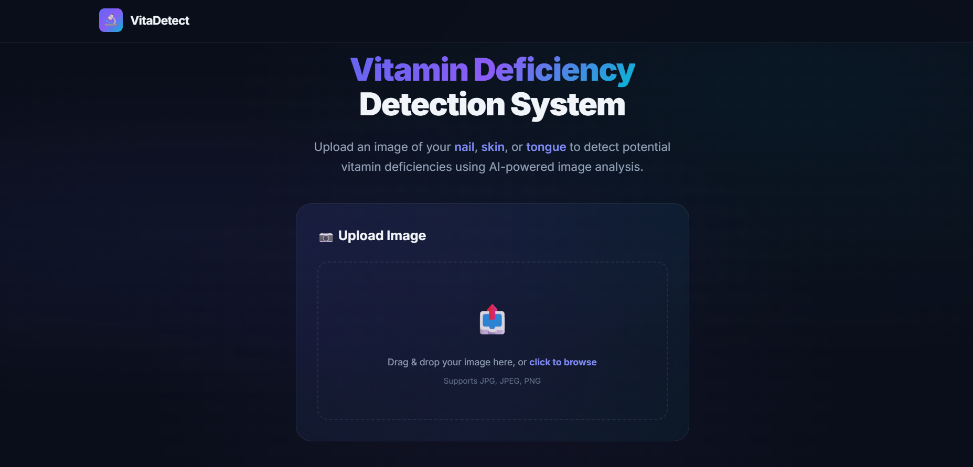
Fig 1.1: System Frontend — Vitamin Deficiency Detection Application

CHAPTER - 2

LITERATURE SURVEY

2.1 Literature Survey
Extensive research has demonstrated the viability of Convolutional Neural Networks (CNNs) in medical image classification.
Key Findings:
Deep learning techniques, specifically CNNs (like EfficientNet and VGG architectures), outperform traditional computer vision techniques in extracting intricate symptom patterns from human skin, nails, and tongues.
Providing context (e.g., specifying the body part) to a specialized CNN model significantly improves classification accuracy compared to a generalized classifier that must first determine the organ type.
While Large Language Models (LLMs) have gained popularity in recent years, studies indicate that for highly specialized visual classification tasks, appropriately sized CNNs offer comparable accuracy while drastically reducing memory footprint and inference latency.
Early detection of vitamin deficiencies via visual indicators (e.g., pale tongue for iron deficiency, brittle nails for iodine/vitamin D issues) can significantly aid in preventive healthcare.

CHAPTER - 3

SOFTWARE REQUIREMENT SPECIFICATION

3.1 Introduction to SRS
This Software Requirements Specification (SRS) document details the functional and non-functional requirements for the Vitamin Deficiency Detection System. It serves as a comprehensive guide for developers, stakeholders, and testers to ensure the final product aligns with the project goals of building a memory-efficient, deep learning-powered web application.

3.2 Role of SRS
The role of this SRS is to:
Clearly define the expected behavior of the system.
Establish technical constraints, specifically focusing on memory efficiency and decoupling frontend/backend.
Serve as the foundation for the System Design and Testing phases.

3.3 Requirements Specification Document
The system must allow users to upload images of their nails, tongue, or skin along with the corresponding category selection, and receive an automated assessment regarding potential vitamin deficiencies based on pre-trained ML models.

3.4 Functional Requirements
FR1 Image and Category Input: The system shall allow users to upload image files (JPEG, PNG) and select the body part category (Nail, Tongue, or Skin).
FR2 Image Preprocessing: The backend shall resize and normalize images to 224x224 pixels.
FR3 Model Routing: The system shall route the processed image to the specific sub-model based on the user's category selection.
FR4 Deficiency Prediction: The system shall use the selected specialized model to predict the probability of specific vitamin deficiencies.
FR5 Results Display: The frontend shall display the analysis results in a user-friendly format, indicating the identified body part and potential deficiencies.
FR6 Health Check: The API must provide a /api/health endpoint for monitoring service status.

3.5 Non-Functional Requirements
NFR1 Memory Efficiency: The system must operate with significantly lower memory constraints compared to an LLM-based system, relying entirely on optimized CNN weights and avoiding redundant classification stages.
NFR2 Scalability: The decoupled architecture (React + FastAPI) must allow for independent scaling of the frontend server and backend model inference server.
NFR3 Maintainability: The code must be well-structured, modular, and use modern standard practices (e.g., Pydantic schemas in FastAPI).

3.6 Performance Requirements
Inference Time: Model prediction must take less than 2 seconds under normal server load.
Responsiveness: The React frontend must render smoothly and provide immediate user feedback during image uploads and selection.

3.7 Software Requirements
Backend:
Python 3.9+
FastAPI
Uvicorn
TensorFlow / Keras (for ML models)
OpenCV / Pillow (for image processing)
Frontend:
Node.js 18+
React
Vite
Vanilla CSS

3.8 Hardware Requirements
Server:
RAM: Minimum 8GB (Strictly avoiding the 16GB+ requirements of local LLMs)
Processor: Multi-core CPU (Intel i5/Ryzen 5 or equivalent). GPU is optional but recommended for faster inference.
Storage: 256GB SSD (to store models and temporary uploads).
Client:
Any modern web browser (Chrome, Firefox, Safari, Edge).

CHAPTER - 4

SYSTEM DESIGN

4.1 Introduction to UML
Unified Modeling Language (UML) diagrams are utilized to visualize the architecture, design, and implementation of the Vitamin Deficiency Detection System. These models provide a standardized way to blueprint the system's structure and behavior.

4.2 UML Diagrams
The following sections present the UML diagrams used to model the Vitamin Deficiency Detection System.

4.3 Use Case Diagram
The use case diagram illustrates the interaction between the User and System Admin with the system. The primary user flow begins with selecting a body part category, followed by uploading an image, triggering preprocessing and model routing, and finally viewing the results.

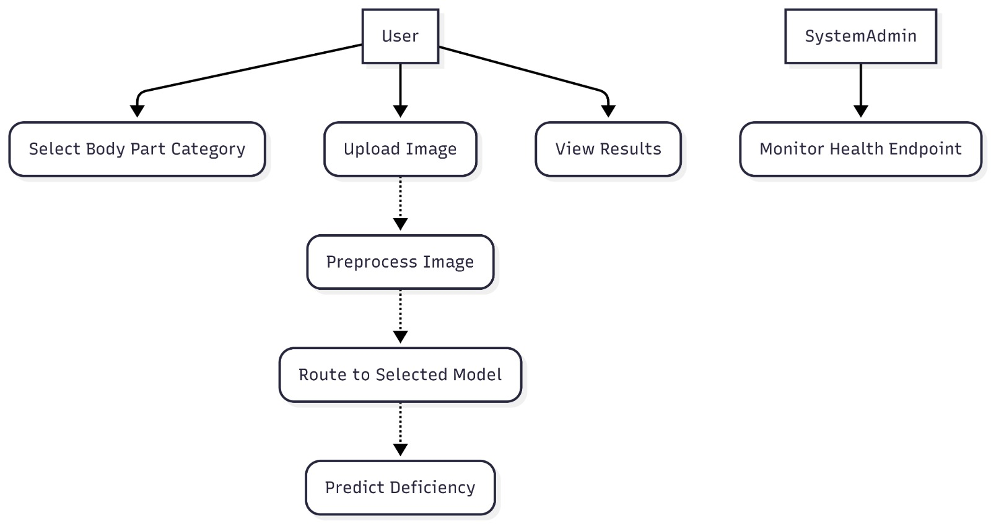
Fig 4.1: Use Case Diagram — Vitamin Deficiency Detection System

4.4 Sequence Diagram
The sequence diagram shows the interaction flow between the User, React Frontend, FastAPI Backend, and ML Models. The user's category selection and image upload are sent as a multipart POST request to /api/analyze, which preprocesses the image and routes it to the selected model.

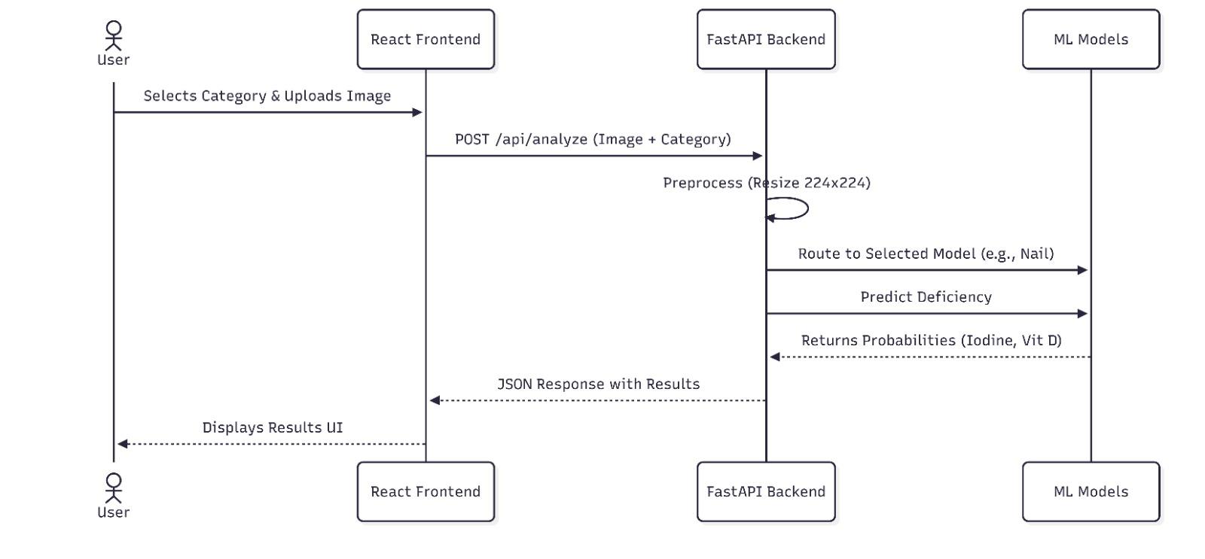
Fig 4.2: Sequence Diagram — User to Backend ML Model Interaction

4.5 State Chart Diagram
The state chart diagram captures the different states of the application: Idle → Selecting → Uploading → Processing → Analyzing → Success/Error → Idle.

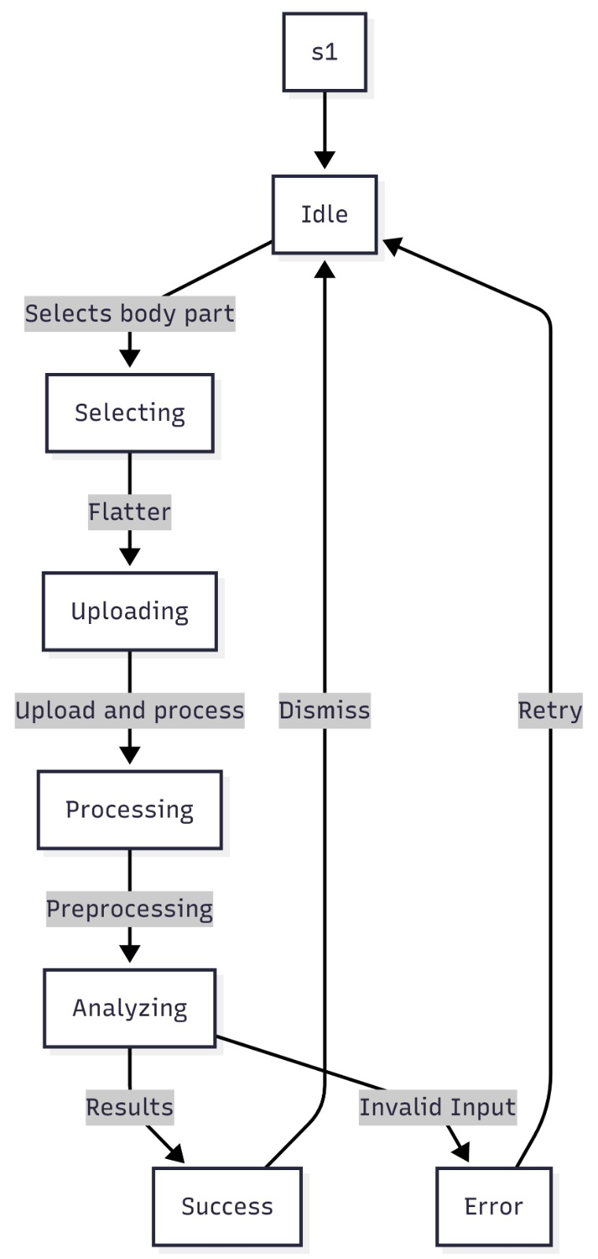
Fig 4.3: State Chart Diagram — Application State Transitions

4.6 Deployment Diagram
The deployment diagram shows the hosting configuration: a client browser communicates with a Vite/React static file server and a Uvicorn/FastAPI backend that loads TensorFlow models.

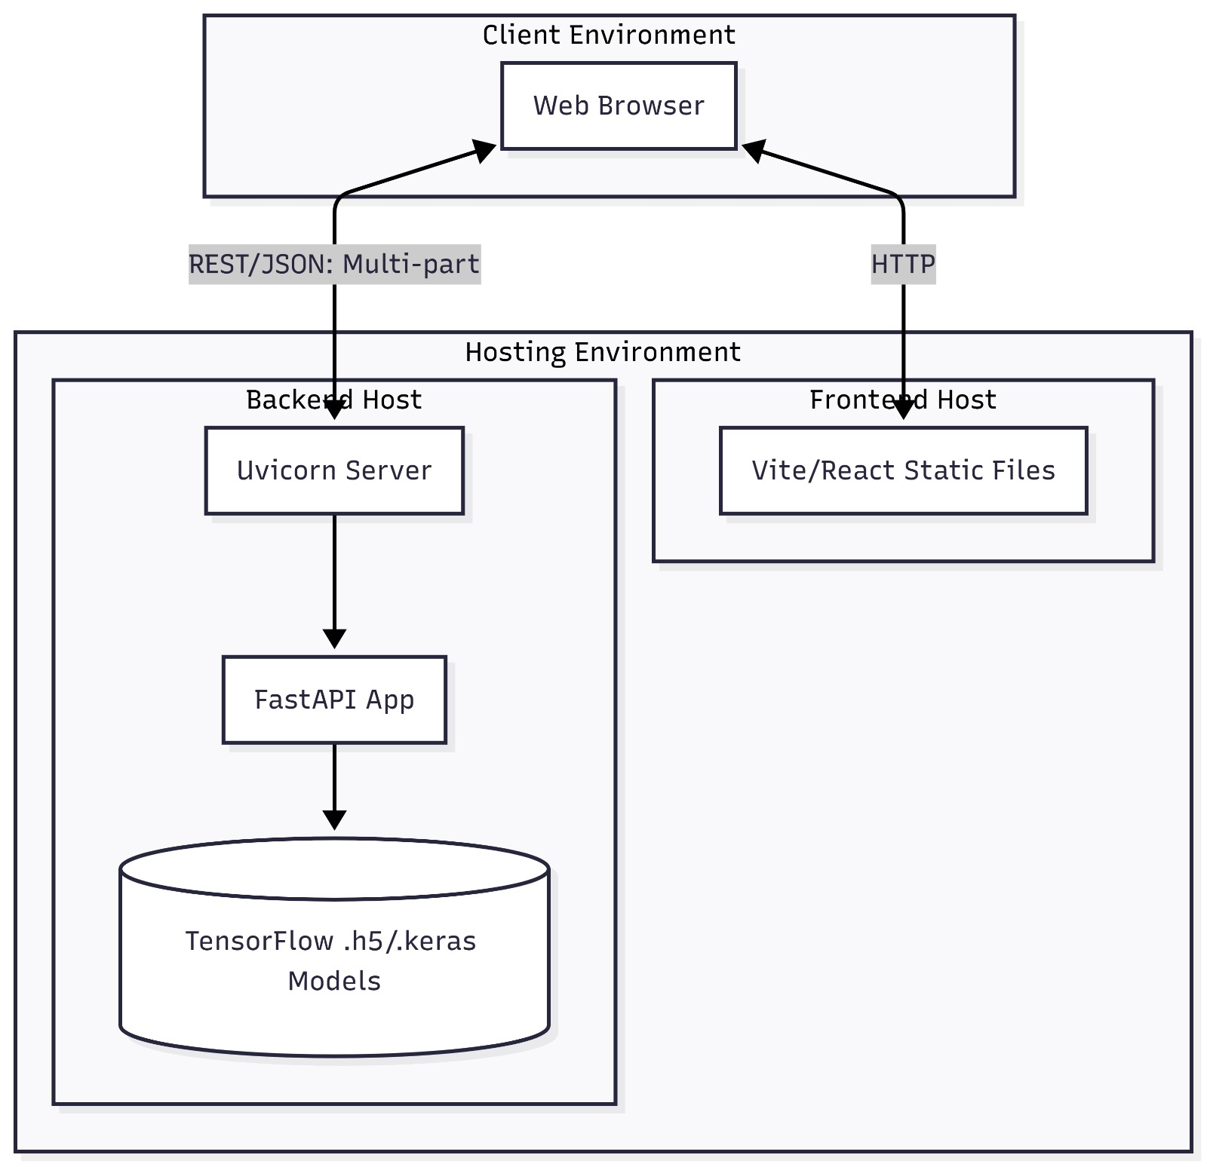
Fig 4.4: Deployment Diagram — System Hosting Architecture

4.7 Technologies Used
Frontend: React, Vite, Vanilla CSS
Backend Framework: FastAPI, Uvicorn
Machine Learning: TensorFlow, Keras
Image Processing: OpenCV, Pillow
Language: Python 3.9+, JavaScript/TypeScript

CHAPTER - 5

IMPLEMENTATION

5.1 Setup and Connections

Environment Setup
The system is split into two distinct directories: backend/ and frontend/.
Backend Initialization:
bash
cd backend
python -m venv venv
source venv/bin/activate # or venv\Scripts\activate on Windows
pip install -r requirements.txt
Frontend Initialization:
bash
cd frontend
npm install

5.2 Coding the Logic
Backend Logic (`backend/app/main.py`):
The FastAPI application receives a FormData object containing both the image file and the category string.
Routers extract these parameters to determine the appropriate service path.
Service Layer (`backend/app/services/`):
The ML service receives the image and the user-specified category.
The logic skips automatic organ classification and directly loads the relevant specialized model weights:
Nail Model: Triggered when category is 'nail'. Checks for Iodine, Vitamin D deficiency.
Tongue Model: Triggered when category is 'tongue'. Checks for Vitamin B12, Iron deficiency.
Skin Model: Triggered when category is 'skin'. Checks for Vitamin D, Vitamin A deficiency.

5.3 Connecting the Frontend
Frontend Integration (`frontend/src/services/api.js`):
The React application captures the user's body part selection (e.g., via a dropdown or radio buttons) and the image file.
Both are bundled into a FormData object and posted to the /api/analyze endpoint.
javascript
// Example logic
const formData = new FormData();
formData.append('file', imageFile);
formData.append('category', selectedCategory); // 'nail', 'tongue', or 'skin'
const response = await fetch('http://localhost:8000/api/analyze', {
method: 'POST',
body: formData
});
const data = await response.json();

5.4 Screenshots
The following screenshots demonstrate the key interfaces of the Vitamin Deficiency Detection System.

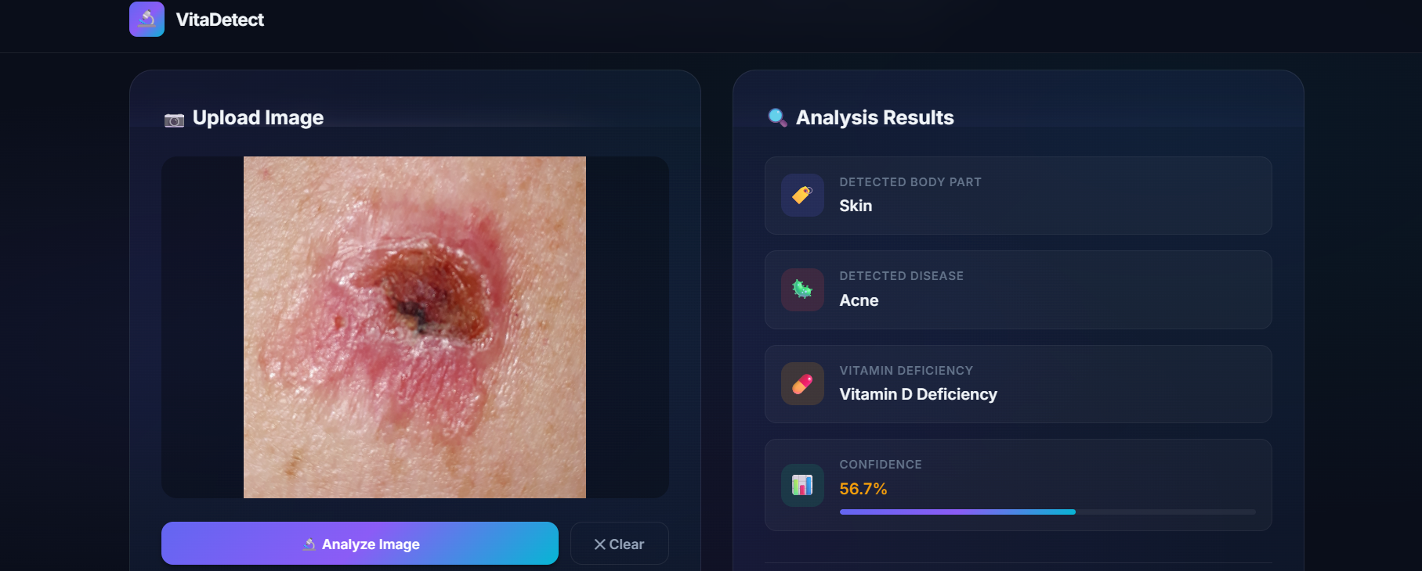
Fig 5.1: Skin Deficiency Detection — Analysis Interface

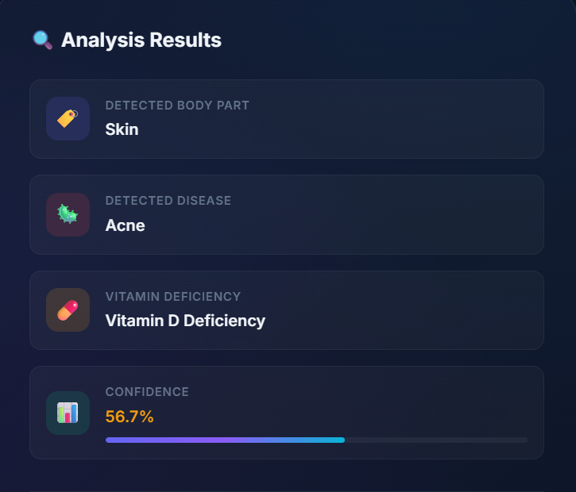
Fig 5.2: Analysis Results — Deficiency Detection Output

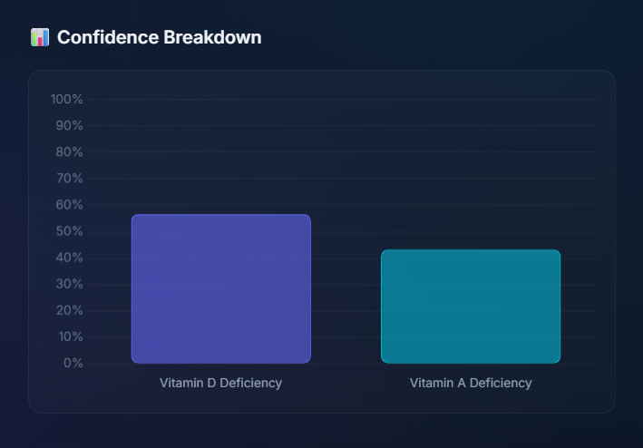
Fig 5.3: Confidence Chart — Model Prediction Probabilities

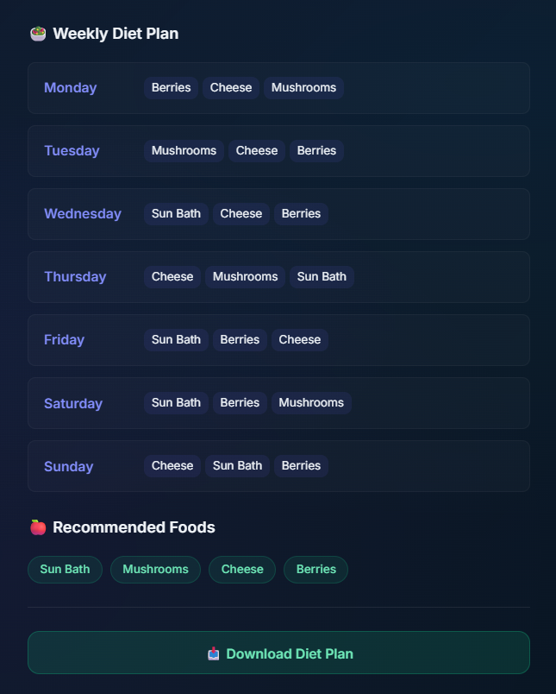
Fig 5.4: Weekly Diet Plan — Nutritional Recommendation Output

CHAPTER - 6

SOFTWARE TESTING

6.1 Introduction to Testing
Testing ensures the reliability, accuracy, and performance of the Vitamin Deficiency Detection System. It verifies that the user-provided category correctly routes to the appropriate ML model.

6.2 Testing Objectives
Verify that the user-selected category is correctly received and parsed by the backend.
Ensure the correct specialized model is loaded based on the category.
Confirm that the system uses memory efficiently by loading only one specialized model at a time.
Validate UI responsiveness across different devices.

6.3 Testing Strategies
Unit Testing: Pytest for backend routing logic (verifying that 'nail' category loads the nail model).
Integration Testing: End-to-end tests ensuring the frontend sends the correct FormData and the backend returns the appropriate schema.
Performance Testing: Monitoring RAM usage to ensure only necessary weights are loaded into memory.

6.4 System Evaluation
System evaluation involves testing the specialized models against categorical validation datasets to ensure high accuracy for user-specified body parts.

6.5 Testing New System
Testing confirms that the explicit category selection reduces errors compared to an automated classifier, providing a more reliable user experience.

6.6 Test Cases
Test Case ID | Description | Expected Result | Status
TC_01 | Select 'Nail' and upload nail image | Backend uses Nail Model and returns correct probabilities | Pending
TC_02 | Select 'Skin' and upload image | Backend uses Skin Model | Pending
TC_03 | Upload image without selecting category | Frontend prevents submission or backend returns validation error | Pending
TC_04 | Monitor RAM usage | Memory efficiency is maintained by avoiding a multi-stage classification pipeline | Pending

CONCLUSION
The Vitamin Deficiency Detection System successfully demonstrates how targeted Deep Learning techniques (CNNs) can be utilized to identify health risks from visual indicators on nails, tongues, and skin. By implementing a decoupled FastAPI and React architecture, the project provides a highly responsive, modern web application.
Crucially, the system achieves its primary goal of memory efficiency by utilizing specialized, lightweight models instead of relying on resource-intensive Large Language Models (LLMs). This makes the system scalable, cost-effective, and highly accessible as a preliminary diagnostic support tool.

FUTURE ENHANCEMENTS
Dietary Recommendations: Integrate a rule-based engine to provide tailored dietary advice based on the detected deficiencies.
Mobile Application: Port the React web application to React Native for native iOS and Android apps.
Expanded Dataset: Continuously gather more clinical data to improve the model accuracy and include more categories of deficiencies.
User Authentication: Implement JWT-based login to allow users to track their deficiency history over time.

REFERENCES
Original Repository Documentation: Vitamin Deficiency Detection Using Image Processing and Deep Learning Techniques.
FastAPI Documentation: https://fastapi.tiangolo.com/
React Documentation: https://react.dev/
TensorFlow/Keras Documentation: https://www.tensorflow.org/

BIBLIOGRAPHY
Goodfellow, I., Bengio, Y., & Courville, A. (2016). Deep Learning. MIT Press.
Chollet, F. (2021). Deep Learning with Python (2nd ed.). Manning Publications.

