RESULTS ANALYSIS REPORT
Results, statistics and teaching recommendations

This report analyses the results of 12 students from the file provided (2 assessment(s), marked out of 20). Empty cells are excluded from calculations: no grade is invented.
01 | Class overview | 12 students graded

11.81/20  Class average | 75.0 %  Success rate | 12.00/20  Median | 2.02  Standard deviation

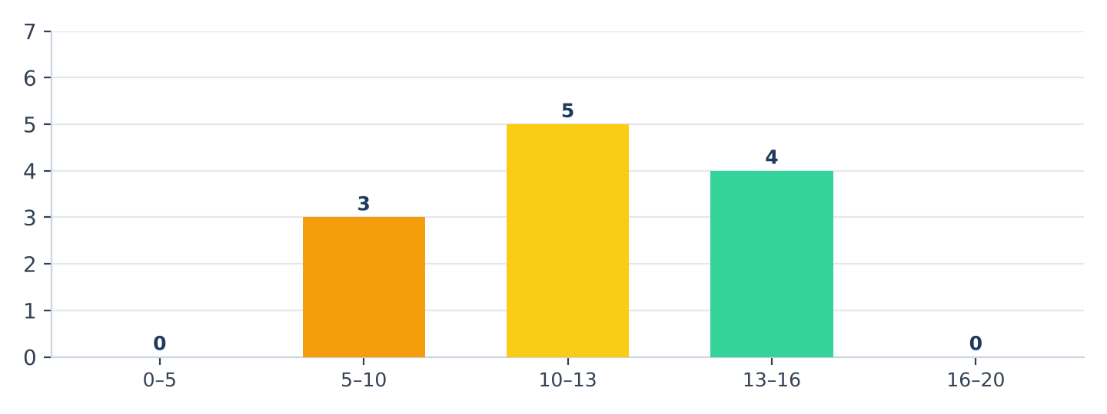  Figure 1 — students by level | 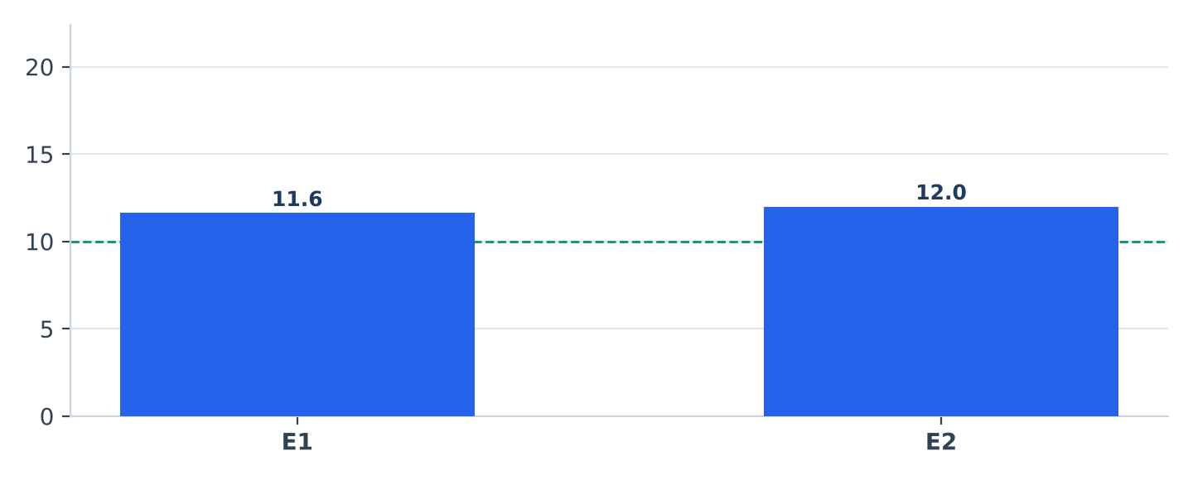  Figure 2 — class average by assessment

Distribution of students by level
Level | Range | Students | %
● Very weak | 0 – 5 | 0 | 0.0 %
● Weak | 5 – 10 | 3 | 25.0 %
● Fair | 10 – 13 | 5 | 41.7 %
● Good | 13 – 16 | 4 | 33.3 %
● Very good | 16 – 20 | 0 | 0.0 %

Reading the results
▸ The class average is 11.81/20; 75 % of students pass (9 of 12). Results range from 9.00 to 15.25.
▸ Mean 11.81 out of 20 (59.1 %), median 12.00 out of 20, standard deviation 2.02.
▸ Averages are those given in the Excel file.

02 | Assessments and students needing support | 12 students graded

Analysis of assessments
Assessment | Code | Scale | Mean | Median | Min – Max | Pass | Graded
الفرض الأول‎ | E1 | 20 | 11.62 | 11.50 | 4.5 – 18.5 | 67 % | 12
الفرض الثاني‎ | E2 | 20 | 12.00 | 12.50 | 6.0 – 17.0 | 75 % | 12

 | Strengths  “E2” is the best-performed assessment (mean 12.0/20). |  |  | Points of attention  “E1” is the weakest assessment (mean 11.6/20).

Change between the first and last assessment
Among 12 comparable students: 6 improved, 0 are stable and 6 declined. The class average moves from 11.62 to 12.00 (out of 20).

Top 5 results | Lowest 5 results
Rank | Student name | Average |  | Rank | Student name | Average
1 | مريم بنجلون‎ | 15.25 |  | 1 | خديجة الودغيري‎ | 9.00
2 | سلمى التازي‎ | 14.50 |  | 2 | رشيد الأزرق‎ | 9.25
3 | نادية الشرقاوي‎ | 14.00 |  | 3 | يوسف الإدريسي‎ | 9.75
4 | إلياس الكتاني‎ | 13.00 |  | 4 | عمر الحسني‎ | 10.00
5 | أحمد بنعلي‎ | 12.25 |  | 5 | فاطمة الزهراء العلوي‎ | 10.75

3 students needing support (average < 10/20)
No. | Student name | Average |  | No. | Student name | Average
1 | خديجة الودغيري‎ | 9.00 |  | 3 | يوسف الإدريسي‎ | 9.75
2 | رشيد الأزرق‎ | 9.25

03 | Student results and recommendations | 12 students graded

Results by student
No. | Student name | E1 | E2 | Average |  | No. | Student name | E1 | E2 | Average
1 | أحمد بنعلي‎ | 14 | 10.5 | 12.25 |  | 7 | ياسين الفاسي‎ | 15 | 8.5 | 11.75
2 | فاطمة الزهراء العلوي‎ | 8.5 | 13 | 10.75 |  | 8 | هاجر المرابط‎ | 18.5 | 6 | 12.25
3 | يوسف الإدريسي‎ | 11 | 8.5 | 9.75 |  | 9 | إلياس الكتاني‎ | 10.5 | 15.5 | 13.00
4 | مريم بنجلون‎ | 16 | 14.5 | 15.25 |  | 10 | خديجة الودغيري‎ | 6.5 | 11.5 | 9.00
5 | عمر الحسني‎ | 7.5 | 12.5 | 10.00 |  | 11 | رشيد الأزرق‎ | 4.5 | 14 | 9.25
6 | سلمى التازي‎ | 12 | 17 | 14.50 |  | 12 | نادية الشرقاوي‎ | 15.5 | 12.5 | 14.00

Attendance, participation and behaviour
▸ Behaviour: حسن‎ (7), متوسط‎ (3), جيد‎ (2).
Recommendations
▸ The pass rate is satisfactory: consolidate achievements and offer enrichment to top students.
▸ Set up targeted support for the 3 students whose average is below 10/20.
▸ The assessment “E1” had the weakest results (mean 11.6/20): revisit it in class.
▸ 6 student(s) declined between the first and last assessment: individual follow-up is advised.
▸ Schedule a new assessment to measure the effect of remediation measures.

Teacher  ……………………………… · Signature and stamp | Principal  ……………………………… · Signature and stamp

