RESULTS ANALYSIS REPORT
Learning assessment: pre-test and post-test
Arabic · الثانوية الإعدادية‎ 30 يونيو‎ · 3APIC-1 · School year 2026/2027

This report compares the results of the same test taken on two successive occasions. The test measures 6 components; each is worth 1 point (1 = achieved, 0 = not achieved), so the total is out of 6. 33 of 35 students took the pre-test and 34 took the post-test; the comparison covers the 33 students present at both.
01 | Pre-test: starting point | 33 students assessed

2.12/6  Overall mean | 35.4 %  Success rate | 2/6  Median | 10  students with no component achieved

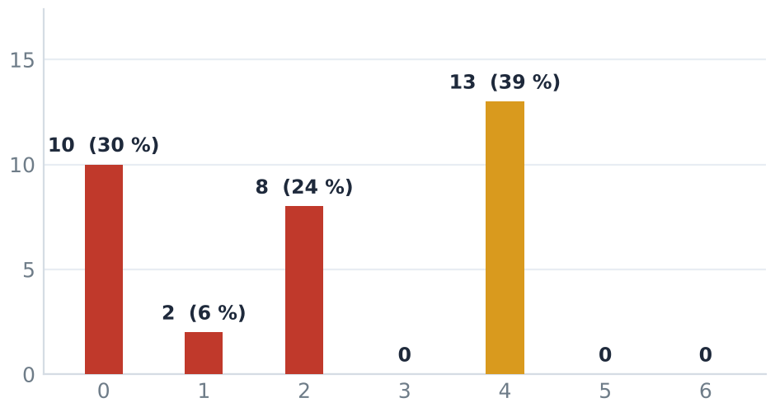  Figure 1 — components achieved out of 6 (pre-test) | 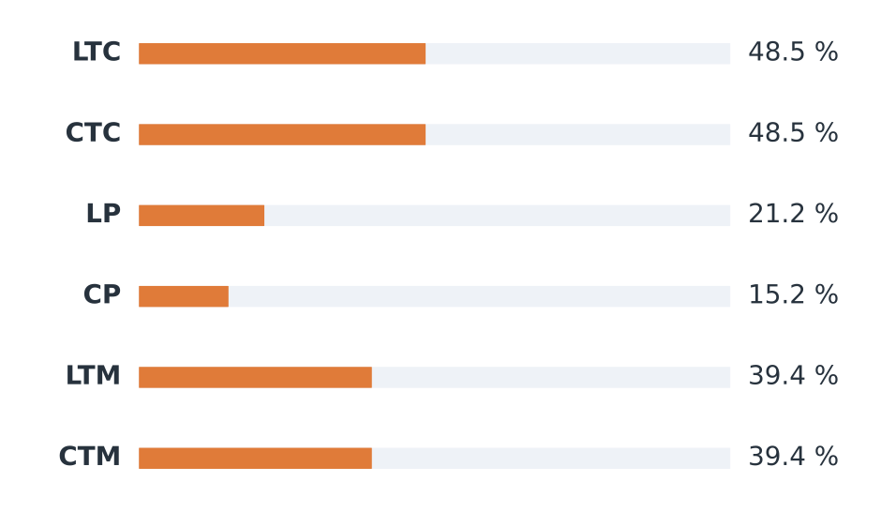  Figure 2 — success rate by component (pre-test)

Assessed components in detail
Component | Code | Passed | Rate | Level
الطلاقة على مستوى النص القصير‎ | LTC | 16/33 | 48.5 % | ● Average
الفهم على مستوى النص القصير‎ | CTC | 16/33 | 48.5 % | ● Average
الطلاقة على مستوى النص الفقرة‎ | LP | 7/33 | 21.2 % | ● Weak
الفهم على مستوى النص الفقرة‎ | CP | 5/33 | 15.2 % | ● Weak
الطلاقة على مستوى النص المتوسط‎ | LTM | 13/33 | 39.4 % | ● Average
الفهم على مستوى النص المتوسط‎ | CTM | 13/33 | 39.4 % | ● Average

Reading the results
▸ Mean 2.12 out of 6 (35.4 %), median 2 out of 6, standard deviation 1.68.
▸ Best-achieved component: CTC (48.5 %). Most fragile: CP (15.2 %).
▸ 10 student(s) with no component achieved; highest score: 4 out of 6.
Summary
The group does best on “CTC” (48.5 %) and struggles with “CP” (15.2 %); this is where progress will be decided.

02 | Post-test: effect of the support | 34 students assessed

2.82/6  Overall mean | 47.1 %  Success rate | 4/6  Median | 6  students with no component achieved

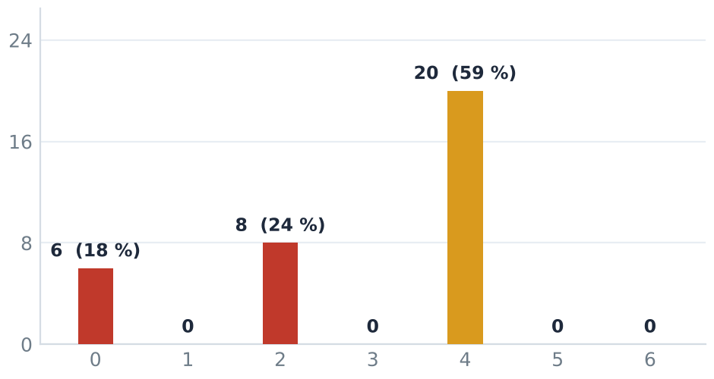  Figure 3 — components achieved out of 6 (post-test) | 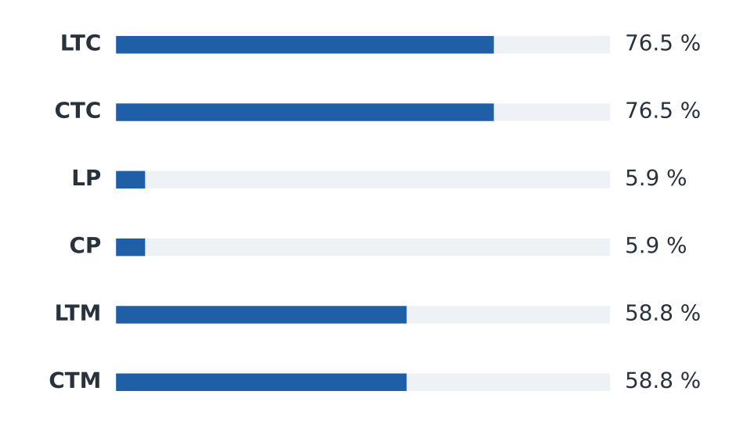  Figure 4 — success rate by component (post-test)

Assessed components in detail
Component | Code | Passed | Rate | Level
الطلاقة على مستوى النص القصير‎ | LTC | 26/34 | 76.5 % | ● Satisfactory
الفهم على مستوى النص القصير‎ | CTC | 26/34 | 76.5 % | ● Satisfactory
الطلاقة على مستوى النص الفقرة‎ | LP | 2/34 | 5.9 % | ● Weak
الفهم على مستوى النص الفقرة‎ | CP | 2/34 | 5.9 % | ● Weak
الطلاقة على مستوى النص المتوسط‎ | LTM | 20/34 | 58.8 % | ● Satisfactory
الفهم على مستوى النص المتوسط‎ | CTM | 20/34 | 58.8 % | ● Satisfactory

Reading the results
▸ Mean 2.82 out of 6 (47.1 %), median 4 out of 6, standard deviation 1.54.
▸ Best-achieved component: CTC (76.5 %). Most fragile: LP (5.9 %).
▸ 6 student(s) with no component achieved; highest score: 4 out of 6.
Mastery levels
Level | Criterion (components achieved) | Pre | Post | Change
● Weak | 0 to 2 | 20 (60.6 %) | 14 (41.2 %) | -6
● Average | 3 to 4 | 13 (39.4 %) | 20 (58.8 %) | +7
● Satisfactory | 5 to 6 | 0 (0.0 %) | 0 (0.0 %) | =

 | Strengths  “CTC” is the strongest component (76.5 %). |  |  | Points of attention  “LP” remains the most fragile (5.9 %); 6 student(s) achieved no component.

03 | Comparison of the two tests | 33 students present at both tests

Indicator | Pre | Post | Change
Students compared | 33 | 33 | =
Mean (out of 6) | 2.12 | 2.79 | +0.67
Success rate | 35.4 % | 46.5 % | +11.1 pts
Median | 2 | 4 | +2
Standard deviation | 1.68 | 1.55 | -0.13
Students at 0 / 6 | 10 | 6 | -4

Note: a positive change means the student gained components; the group's mean change is 0.67 point(s) out of 6.
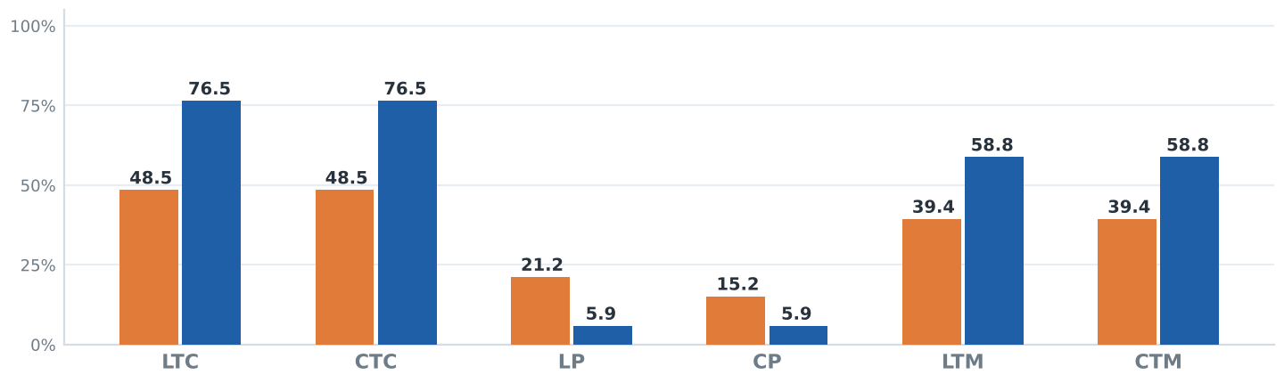
Figure 5 — change in success rates between the two tests

Individual progress of 33 students  ▸ Mean change: 0.67 point(s) out of 6, i.e. 11.1 percentage points.  ▸ 10 students improved, 20 stayed the same and 3 declined (out of 33 compared).  ▸ Largest rise: “LTC” (+28 pts); smallest change: “LP” (-15 pts). | 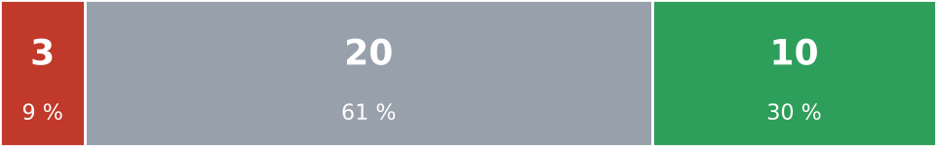  Figure 6 — students by change in score  ■ Decline ■ No change ■ Improvement

15 students needing focused support
including 1 absent · post-test score 2 out of 6 or below
No. | Student name | Pre → post | Priority |  | No. | Student name | Pre → post | Priority
1 | بتاك ياسمين‎ | 0 → 0 | Priority |  | 9 | خليل ايمان‎ | 1 → 2 | Support
2 | دحو ياسين‎ | 0 → 0 | Priority |  | 10 | انفلوس حمزة‎ | 2 → 2 | Support
3 | راشيد كمال‎ | 0 → 0 | Priority |  | 11 | بلال معاذ‎ | 2 → 2 | Support
4 | عيلا لطيفة‎ | 0 → 0 | Priority |  | 12 | زهواتي آية‎ | 2 → 2 | Support
5 | كبدون نعيمة‎ | 2 → 0 | Priority |  | 13 | هڭـ اميرة‎ | 2 → 2 | Support
6 | وخير زكرياء‎ | 2 → 0 | Priority |  | 14 | مرواد محمد‎ | 4 → 2 | Priority
7 | ابكشو عمر‎ | 0 → 2 | Support |  | 15 | العمراني فيصل‎ | – → – | Absent
8 | احراد زكرياء‎ | 0 → 2 | Support

