**Schema:**

**CREATE USER TABLE:**

CREATE TABLE USER (

UID INT NOT NULL AUTO_INCREMENT,

GENDER VARCHAR(6),

EMAIL VARCHAR(40) UNIQUE,

PASSWORD VARCHAR(40) NOT NULL,

DOB DATE,

HOMETOWN VARCHAR(40),

FNAME VARCHAR(40) NOT NULL,

LNAME VARCHAR(40) NOT NULL,

PRIMARY KEY (UID)

);

**CREATE FRIENDSHIP TABLE:**

CREATE TABLE FRIENDSHIP(

UID1 INT NOT NULL,

UID2 INT NOT NULL,

PRIMARY KEY(UID1, UID2),

FOREIGN KEY (UID1) REFERENCES USER(UID) ON DELETE CASCADE,

FOREIGN KEY (UID2) REFERENCES USER(UID) ON DELETE CASCADE

);

**CREATE Album TABLE:**

CREATE TABLE ALBUM(

AID INT NOT NULL AUTO_INCREMENT,

NAME VARCHAR(40) NOT NULL,

DOC TIMESTAMP NOT NULL,

UID INT NOT NULL,

PRIMARY KEY (AID),

FOREIGN KEY (UID) REFERENCES USER(UID) ON DELETE CASCADE

);

**CREATE Photo TABLE:**

CREATE TABLE PHOTO(

PID INT NOT NULL AUTO_INCREMENT,

CAPTION VARCHAR(200),

DATA BLOB NOT NULL,

AID INT NOT NULL,

PRIMARY KEY (PID),

FOREIGN KEY (AID) REFERENCES ALBUM(AID) ON DELETE CASCADE

);

**CREATE Comment TABLE:**

CREATE TABLE COMMENT(

CID INT NOT NULL AUTO_INCREMENT,

CONTENT VARCHAR(200) NOT NULL,

DOC TIMESTAMP NOT NULL,

UID INT NOT NULL,

PID INT NOT NULL,

PRIMARY KEY (CID),

FOREIGN KEY (UID) REFERENCES USER(UID) ON DELETE CASCADE,

FOREIGN KEY (PID) REFERENCES PHOTO(PID) ON DELETE CASCADE

);

**CREATE THE LIKETABLE:**

CREATE TABLE LIKETABLE(

UID INT NOT NULL,

PID INT NOT NULL,

DOC TIMESTAMP NOT NULL,

PRIMARY KEY (UID, PID),

FOREIGN KEY (UID) REFERENCES USER(UID) ON DELETE CASCADE,

FOREIGN KEY (PID) REFERENCES PHOTO(PID) ON DELETE CASCADE

);

**CREATE Tag TABLE:**

CREATE TABLE TAG(

HASHTAG VARCHAR(40) NOT NULL,

PRIMARY KEY (HASHTAG)

);

**CREATE Associate Table:**

CREATE TABLE ASSOCIATE(

PID INT NOT NULL,

HASHTAG VARCHAR(40) NOT NULL,

PRIMARY KEY (PID, HASHTAG),

FOREIGN KEY (HASHTAG) REFERENCES TAG(HASHTAG) ON DELETE CASCADE,

FOREIGN KEY (PID) REFERENCES PHOTO(PID) ON DELETE CASCADE

**ER Diagram:**

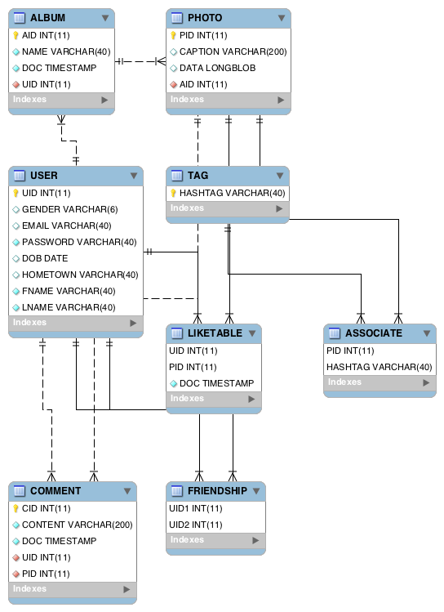

**Functionality:**

**Homepage and User Activity:**

The picture below is our homepage, it can show the top active users of all users. Also, you can implement several functions from this homepage, and detailed functionality will be introduced later.

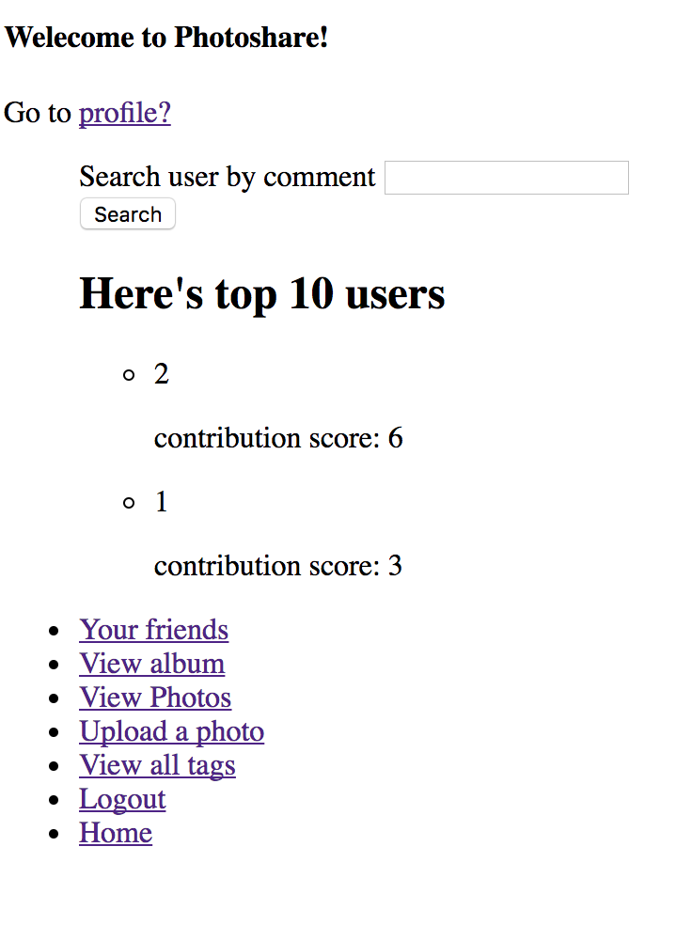

**Register:**

Fill required information to become a registered user.

If email does not been register before:



If the email has been registered, it will return:

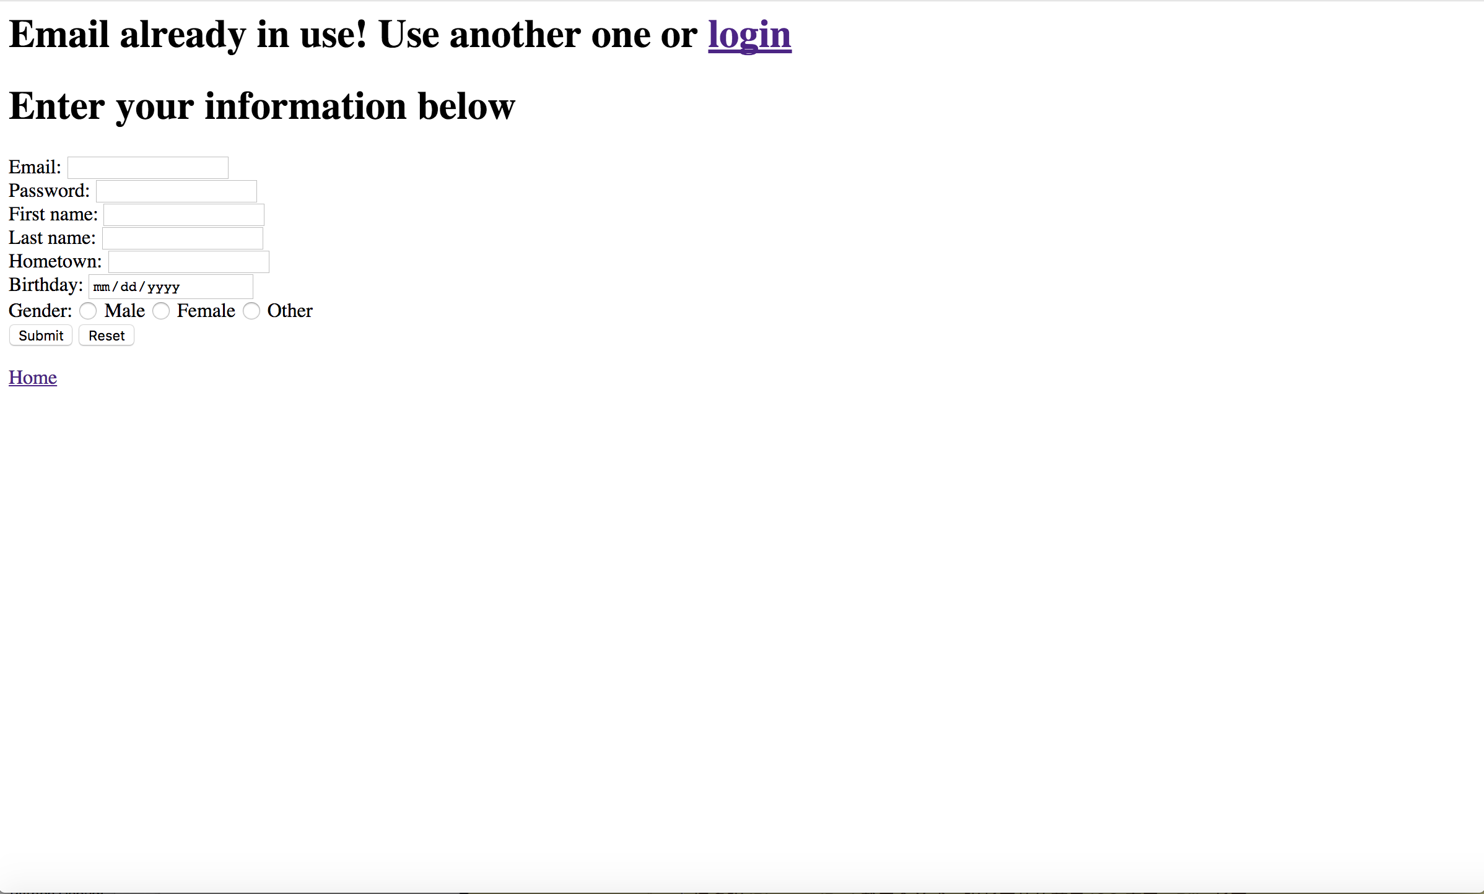

**Login:**

We can login in an exist user.



After login successfully,

If we type wrong information,



**Listing Friends:**

After we click “Your Friends” Button, all you friends information will be listed.



**Add Friends and Friend Recommendation:**

We want to add more friends, click “Add other friends”. It will have some recommendation. For example, because Joe is friend of Amy which is a friend of user, and not friend of user. And if we want to add Joe as friend, click “Add” below information of Joe.

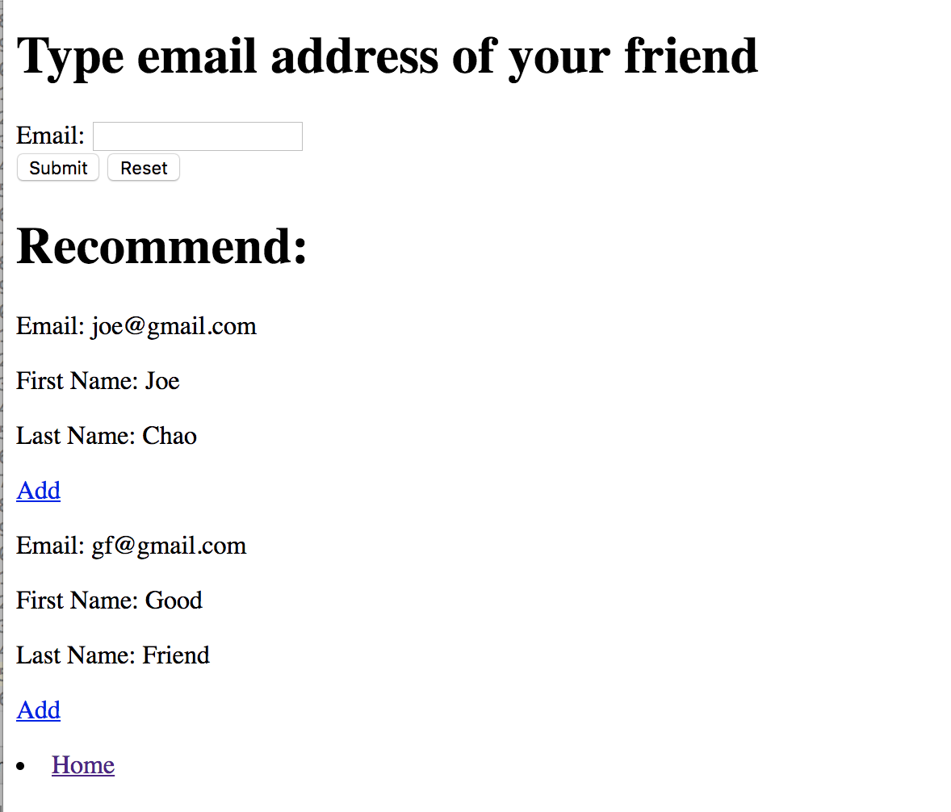

If we add Joe, we will back to friend list, and Joe will become our new friend.

 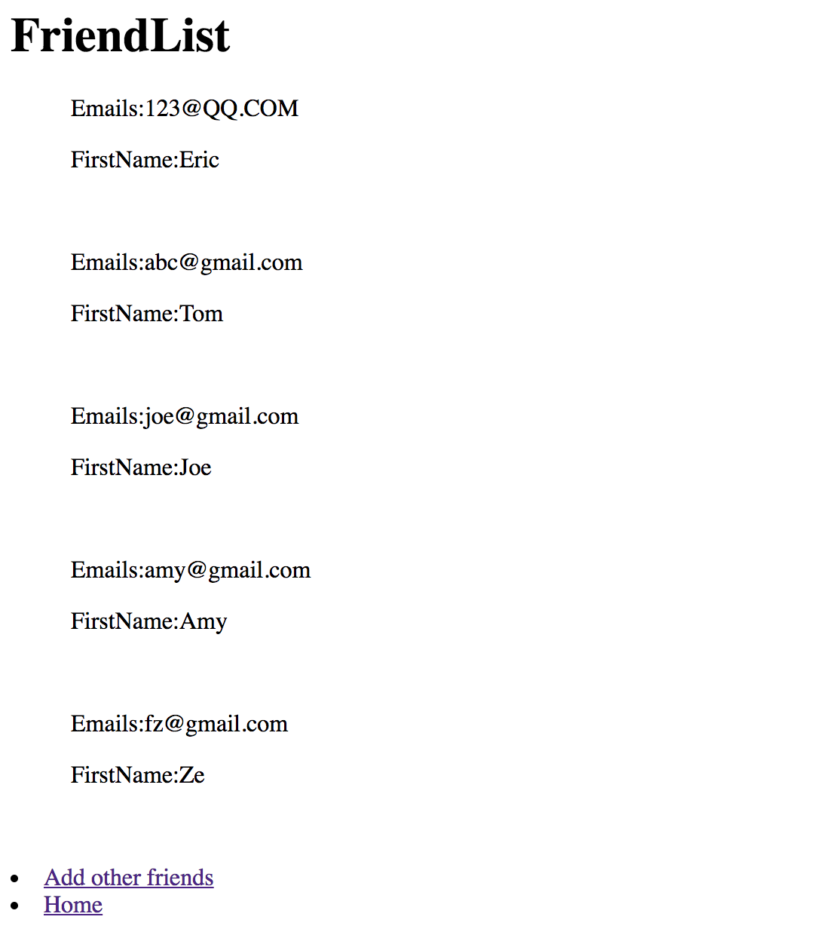

We can find a user by email and add as friend.

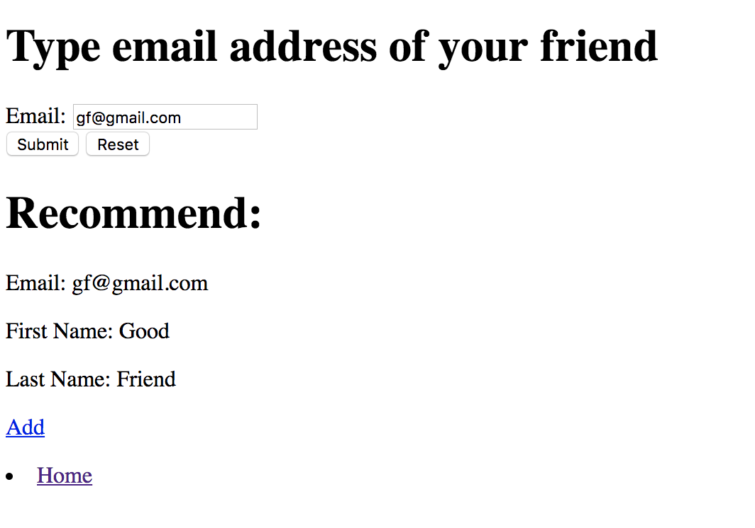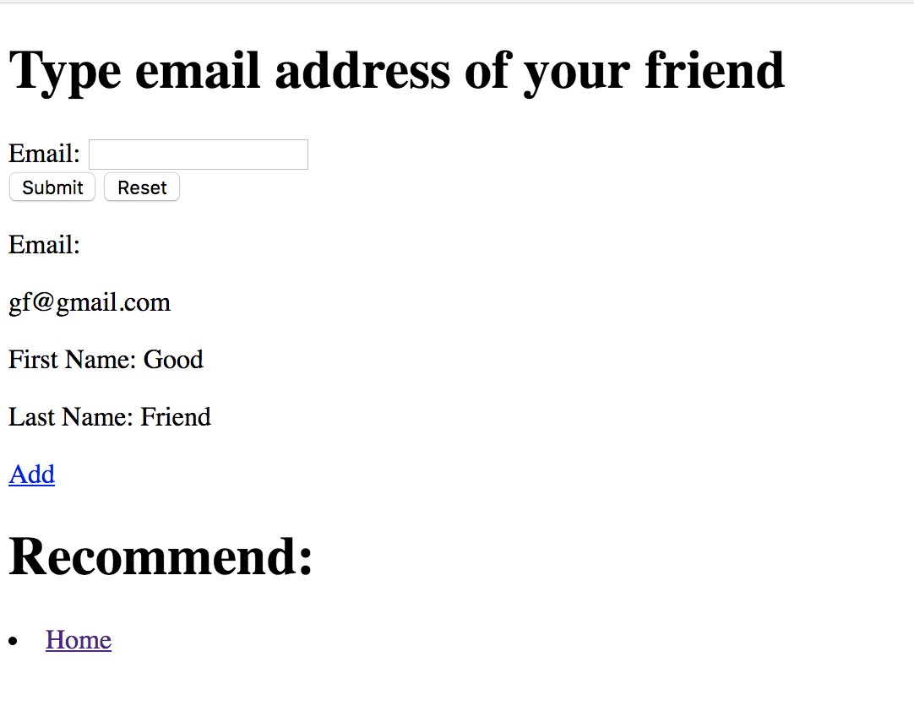

After clicking “Add”, we will also come back to friend list, and Good is friend of user now.

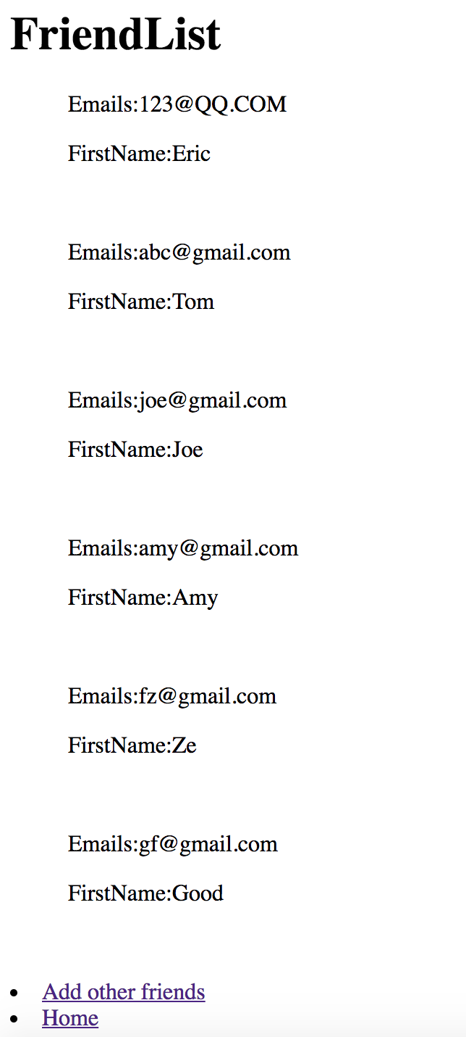



**Browse Albums:**

We can view all albums by clicking “View album” button. All albums will be listed.

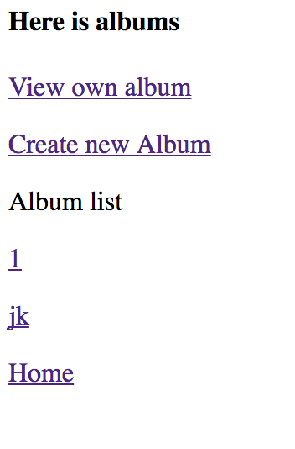

If we click on “View own album”, we can only see the album that belongs to current user. We can modify and delete album by choosing album. Notice that we can only modify an album a time, but can delete many albums one time.

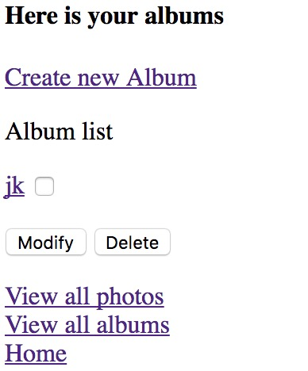

**Browse Photos and Leaving Comments and Like Functionality:**

We can click “ View Photos” to see all photos. We see caption of photo, comment it and use like functionality. All the photos are public and can be views by all visitor. One can leave comment whether that log in or not. But only register user can like photo. Anyone can view comment and who liked photo by click comment or like button

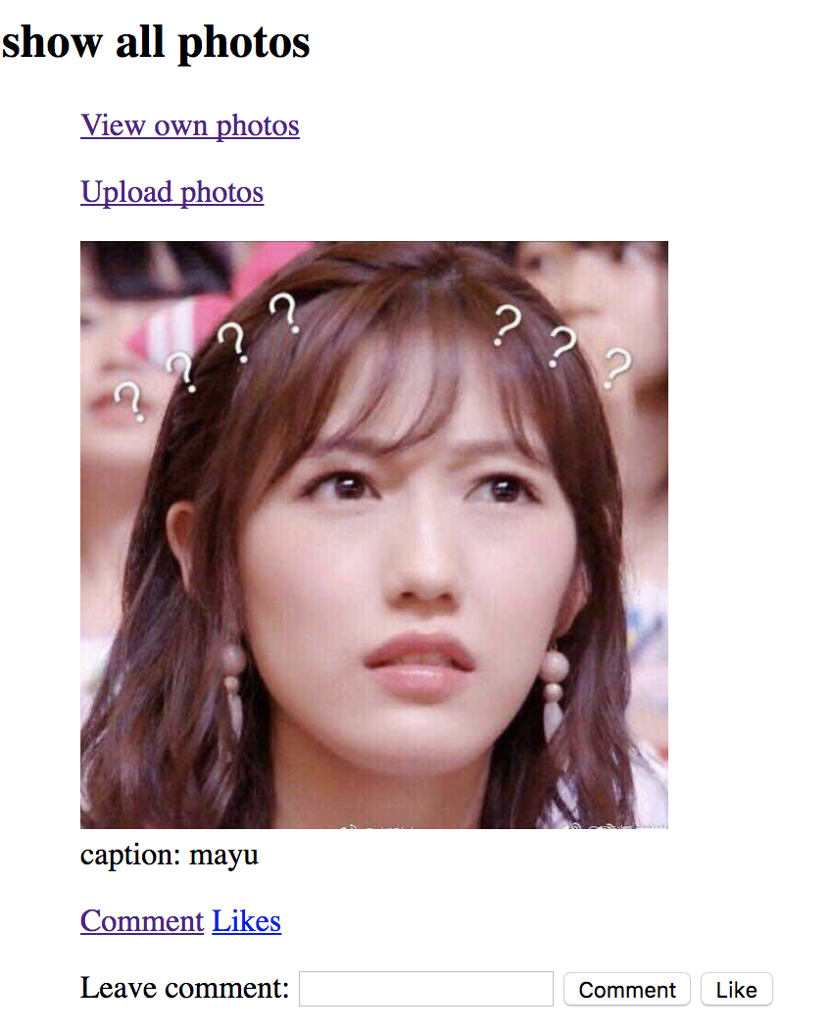

after click comment or click likes, we can see all user name that like this photo and how many likes this photo has:

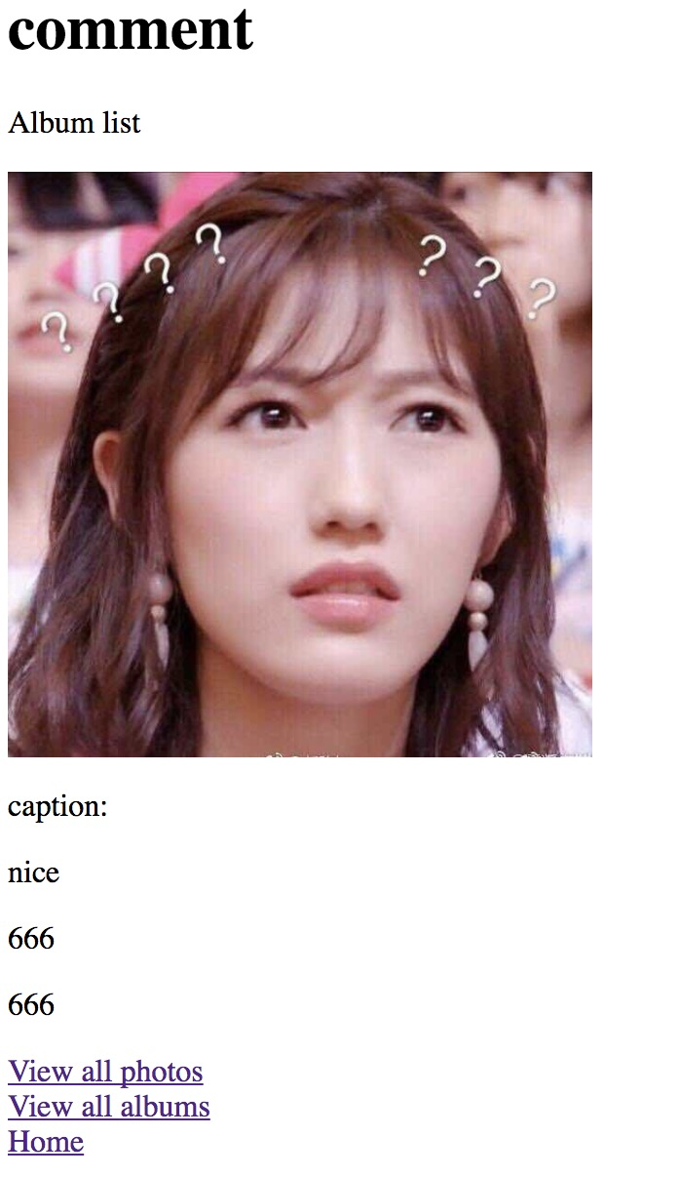 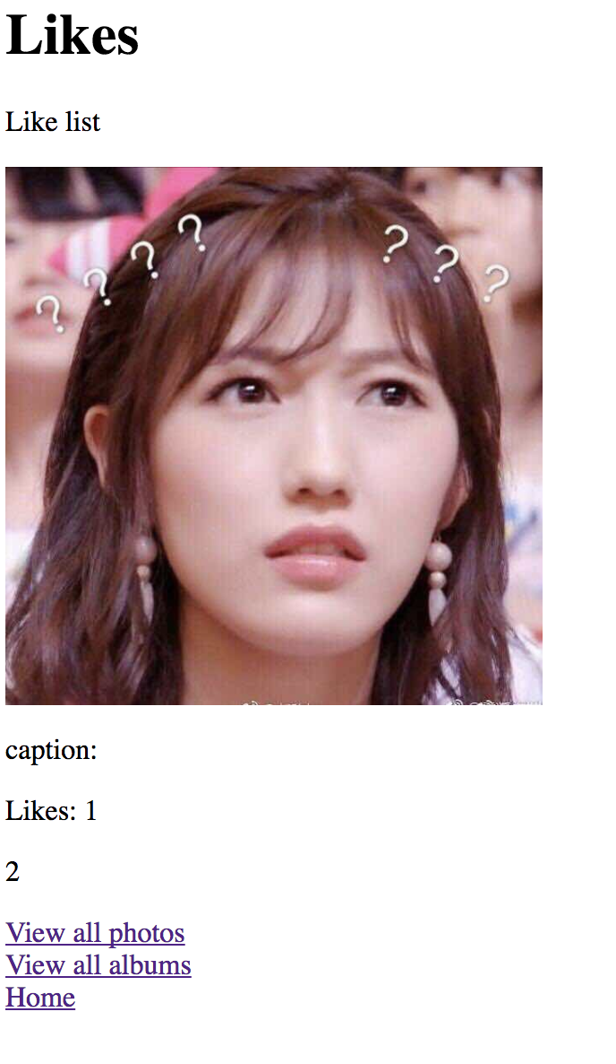

**Create Album:**

Users can create album.

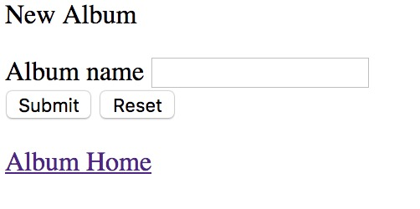

**Upload Photos:**

The upload webpage. User has to login before upload a photo. User can upload photo and type caption of photo. Also, user can assign multiple tag to photo. The tag should enter as a format, which begin with # and separate by blank space. Also, user can choose which album to upload but user can only upload photo to his own albums.

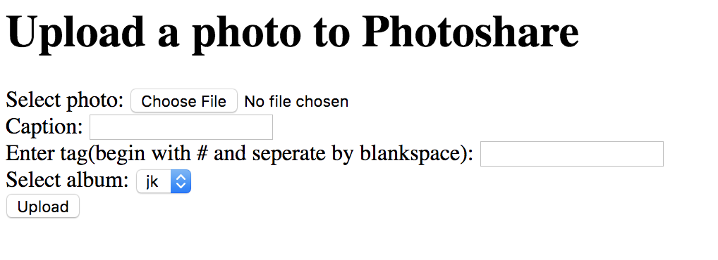

User can view their own photo if they login. They can delete and modify their own photo.

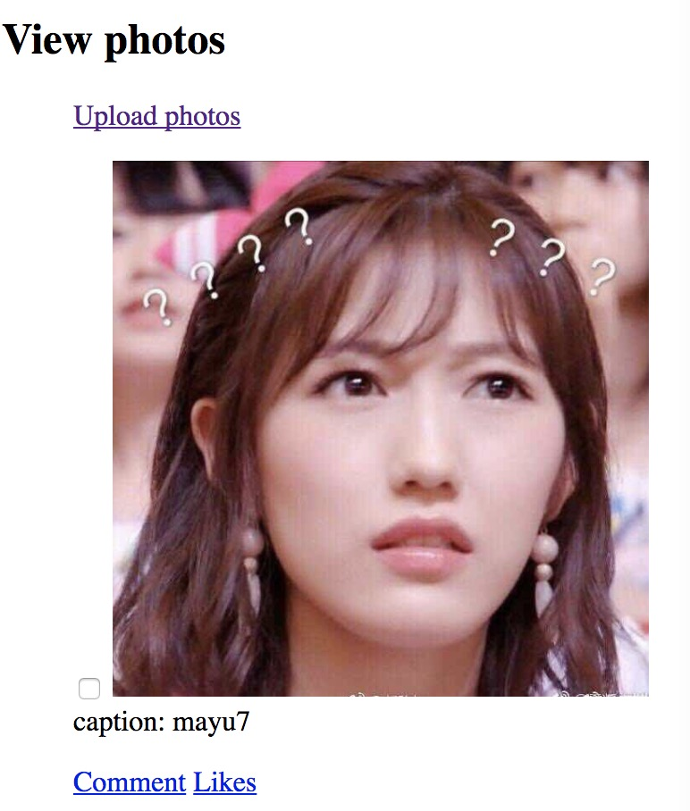

**View My Photos by Tag Name:**

**Registered user can view his own tag.**

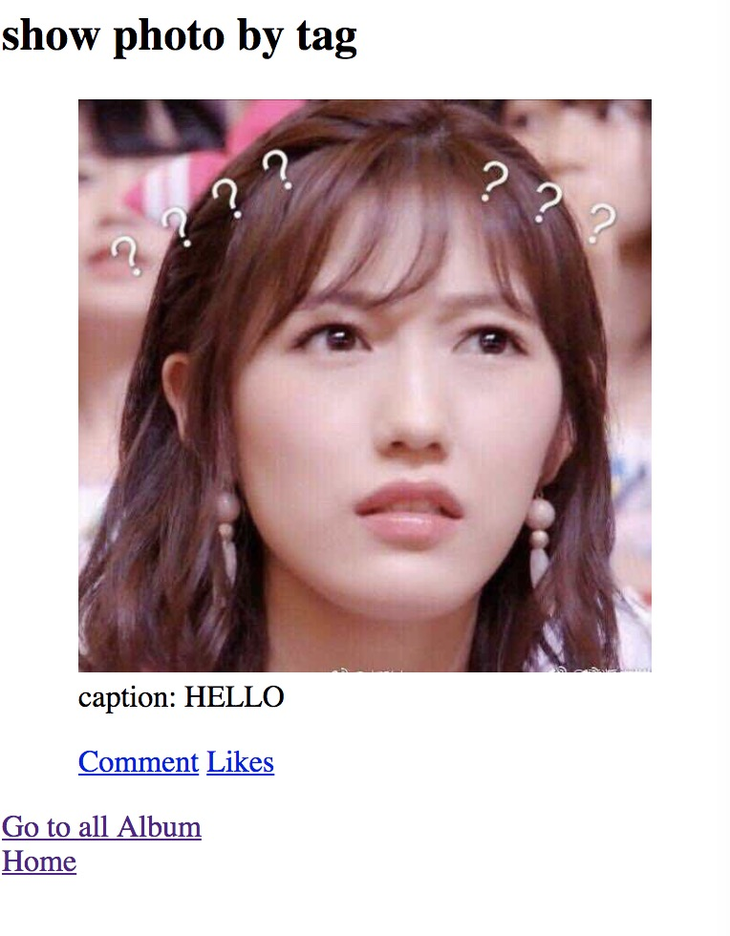

**View All Photos by Tag Name and View Most Popular Tag:**

Visitor can view all tag and find photo related to tag name. All tag should begin with #. The tag page also display 5 most popular tag that used by most photos. Also, we can search a photo by tag.

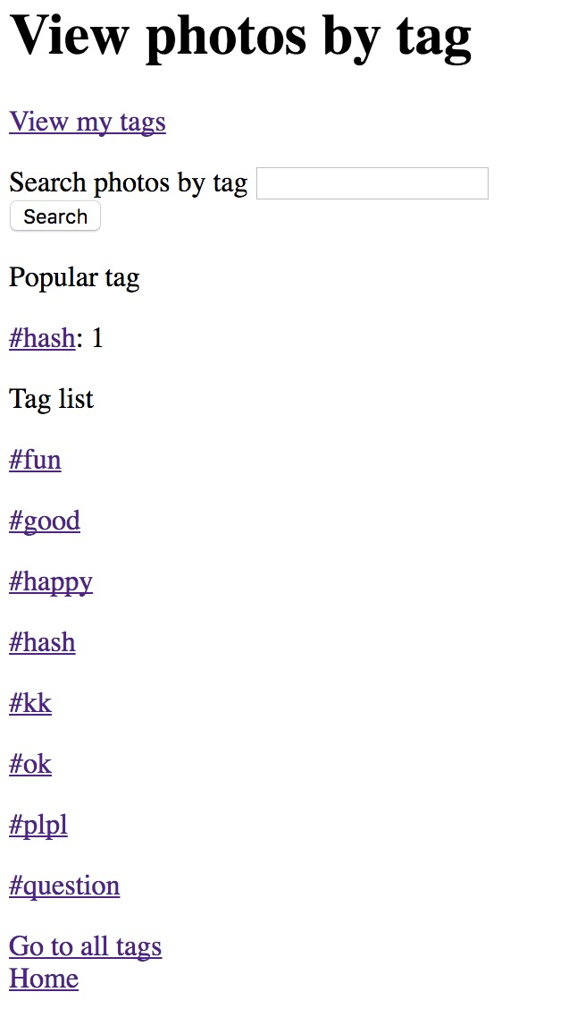

**Photo Search:**

Also, we can search a photo by tag

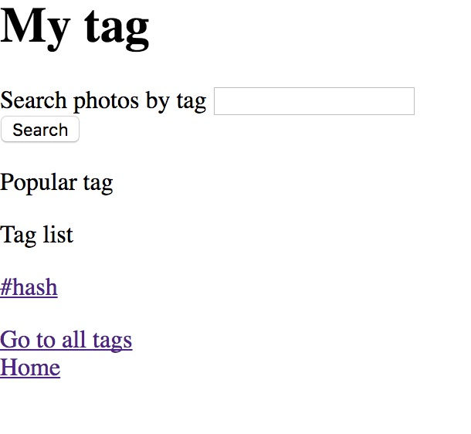

**Search on Comments:**

User can search comment to get user name and the number of comments.

