ex35_더해보기

1. 게임의 지도를 그려보고, 그 게임에서 이동하는 방법도 그려 보세요.

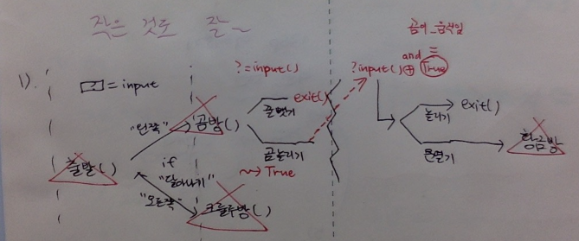

2. Correct any typo or bug in the script.

There I made none of it.

3. Annotate functions that you can’t get grasp.

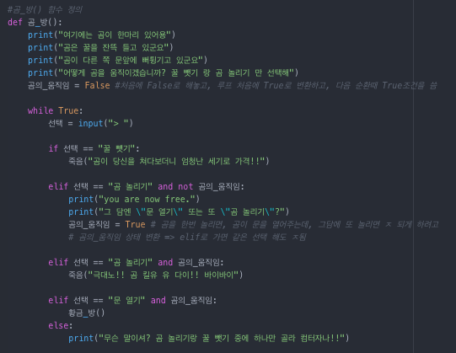

I intuitively didn’t catch what is going on in the bear_room(). I annotated what each parts are doing.

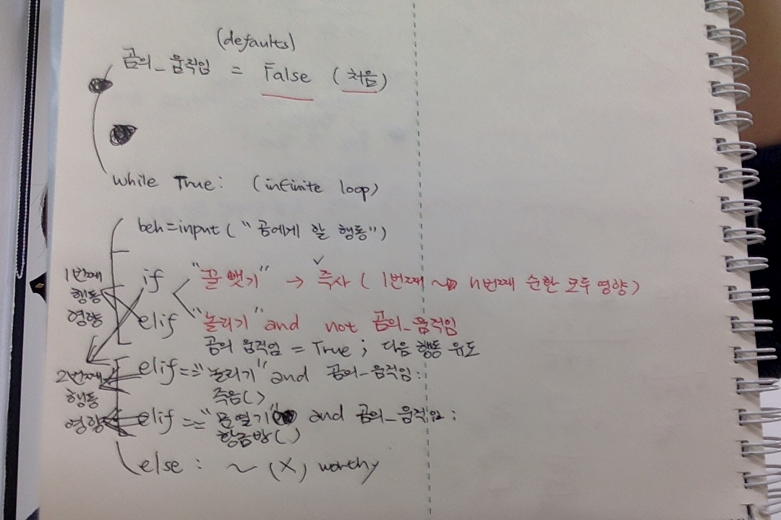

While loop starts with while True: which indicates that if the exit is not made in the function the block will be executed over and over again. However, the block in the if sents and elif sents make it impossible to stay in the while True: for more than 2user input

chance. It is either you die and exit or go to the goldenroom, which is represented as calling golden_room(), the function.

4. Expand the game width and simplify it when it is necessary.

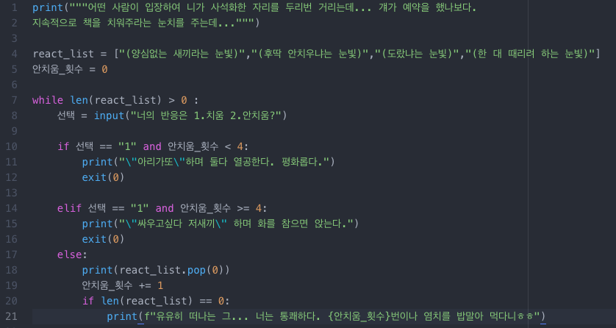

I made script using while, bool exp. and if structure to make a story-lined game on privatizing school library. It uses int assigned to a variable to control the varied reactions from the one who is making the claim for me to get off my stuffs from the desk that he reserved.

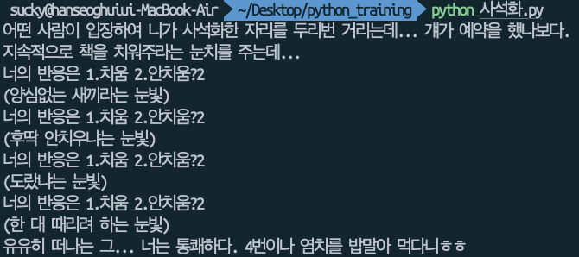

And as soon as the targeted number of his reaction runs out, he leave and the loop stops.

used “and” cond. in the bool-exp.

5. golden_room() function receives the user_input number in a erroneous way. Which bugs might occur if it’s written so? how could we fix it?

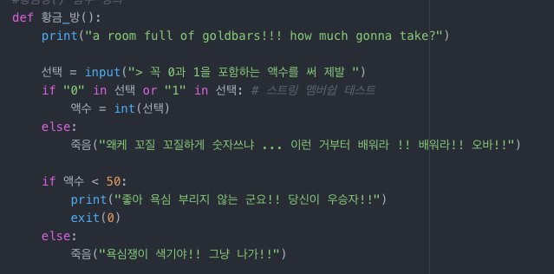

=> if user puts the input that includes chars other than number the int() function returns error. Therfore, extracting only int()-convertible chars is necessary. ex). user might input 50$. We need reg_exp to extract only number and later convert it into integer with that func.

# reg_exp