机器环境安装
本项目所有服务，均使用docker方式部署。机器环境以centos7为准。
提供以下步骤安装，供参考

机器列表
机器IP | 配置 | 用户
94.191.83.120 | 4核8G | Root
106.55.250.100 | 2核4G | Root
106.55.248.74 | 2核4G | Root
106.55.249.133 | 2核4G | Root
106.55.152.41 | 4核8G | Root
106.52.62.38 | 4核8G | Root
106.53.195.121 | 2核4G | Root
106.55.246.66 | 2核4G | Root
106.55.248.7 | 2核4G | Root

机器部署情况
机器ip | 部署方式 | 部署内容 | 描述
94.191.83.120 | Docker | mysql-master-pro-master | 产品模块主db
94.191.83.120 | Docker | mysql-master-pro-slave | 产品模块从db
94.191.83.120 | Docker | mysql-master3309 | 订单模块主db
94.191.83.120 | Docker | mysql-slave3310 | 订单模块从db
94.191.83.120 | Docker | mongo | Mongodb
94.191.83.120 | Docker | Zookeeper | Zookeeper
94.191.83.120 | Docker | Rabbitmq | Rabbitmq
94.191.83.120 | Docker | fastdfs | fastdfs
94.191.83.120 | Docker | mysql-master | 未分库之前的主db
94.191.83.120 | Docker | mysql-slave | 未分库之前的从db
94.191.83.120 | Jar | Jenkins | Jenkins
94.191.83.120 | 源码安装 | Mycat | Mycat

机器ip | 部署方式 | 部署内容 | 描述
106.55.250.100 | Docker | mall-account | mall-account
106.55.250.100 | Docker | mall-config | mall-config
106.55.250.100 | Docker | mall-admin | mall-admin
106.55.250.100 | Docker | mall-dashboard | mall-dashboard

机器ip | 部署方式 | 部署内容 | 描述
106.55.248.74 | Docker | mall-product-service | mall-product-service
106.55.248.74 | Docker | mall-pay | mall-pay
106.55.248.74 | Docker | mall-order-service | mall-order-service
106.55.248.74 | Docker | mall-kill | mall-kill

机器ip | 部署方式 | 部署内容 | 描述
106.55.249.133 | Docker | mall-account | mall-account
106.55.249.133 | Docker | mall-config | mall-config
106.55.249.133 | Docker | mall-eureka | mall-eureka

机器ip | 部署方式 | 部署内容 | 描述
106.55.152.41 | Docker | mall-web-order | mall-web-order
106.55.152.41 | Docker | kill-mysql-master | 秒杀模块主db
106.55.152.41 | Docker | kill-mysql-slave | 秒杀模块从db
106.55.152.41 | Docker | mysql-master | 用户模块主db
106.55.152.41 | Docker | mysql-slave | 用户模块从db
106.55.152.41 | Docker | nginx | nginx

机器ip | 部署方式 | 部署内容 | 描述
106.52.62.38 | Docker | mall-web-order | mall-web-order
106.52.62.38 | Docker | kafka-manager | Kafka管理
106.52.62.38 | Docker | es | es
106.52.62.38 | Docker | elasticsearch-head | es数据展示
106.52.62.38 | Docker | kafka | kafka
106.52.62.38 | Docker | Zookeeper | Zookeeper
106.52.62.38 | Docker | config | seata数据库配置
106.52.62.38 | Docker | fastdfs | fastdfs
106.52.62.38 | Docker | redis | redis
106.52.62.38 | jar | zipkin | 微服务链路追踪
106.52.62.38 | 源码安装 | Seata | 分布式事务

机器ip | 部署方式 | 部署内容 | 描述
106.53.195.121 | Docker | mall-product-service | mall-product-service
106.53.195.121 | Docker | mall-pay | mall-pay
106.53.195.121 | Docker | mall-order-service | mall-order-service
106.53.195.121 | Docker | mall-kill | mall-kill

机器ip | 部署方式 | 部署内容 | 描述
106.55.246.66 | Docker | mall-zuul | mall-zuul
106.55.246.66 | Docker | mall-web-mng | mall-web-mng
106.55.246.66 | Docker | mall-user-service | mall-user-service

机器ip | 部署方式 | 部署内容 | 描述
106.55.248.7 | Docker | mall-zuul | mall-zuul
106.55.248.7 | Docker | mall-web-mng | mall-web-mng
106.55.248.7 | Docker | mall-user-service | mall-user-service

约定项目域名
域名用的是阿里云的域名，域名解析指向了nginx所在的服务器地址
域名：http://mi.xiangxueketang.cn

jdk与maven安装
项目需要自动打包部署，因此需要配置jdk与maven
安装jdk
yum install java-1.8.0-openjdk.x86_64
安装maven
安装maven
sudo yum install -y yum-utils
yum-config-manager --add-repo http://repos.fedorapeople.org/repos/dchen/apache-maven/epel-apache-maven.repo
yum install -y apache-maven
配置maven仓库为阿里云
<mirror>
<id>nexus-aliyun</id>
<mirrorOf>central</mirrorOf>
<name>Nexus aliyun</name>
<url>http://maven.aliyun.com/nexus/content/groups/public</url>
</mirror>

docker安装
  - sudo yum install -y yum-utils device-mapper-persistent-data lvm2
  - sudo yum-config-manager --add-repo https://mirrors.aliyun.com/docker-ce/linux/centos/docker-ce.repo
  - sudo yum install docker-ce
配置docker加速器（注册阿里云加速更快）、容器网段、镜像仓库
vi /etc/docker/daemon.json
{
"bip":"172.18.6.1/24",
"registry-mirrors":[" https://kzorq22x.mirror.aliyuncs.com"],
"insecure-registries":["192.168.244.10:5000"]
}
配置后重启docker服务：
systemctl daemon-reload
systemctl restart docker

docker-compose安装
sudo curl -L https://github.com/docker/compose/releases/download/1.17.1/docker-compose-`uname -s`-`uname -m` > /usr/local/bin/docker-compose
sudo chmod +x /usr/local/bin/docker-compose

docker仓库服务
Docker镜像仓库用的是腾讯云的仓库

登录仓库
docker login -u 2181935941@qq.com xiangxueman-docker.pkg.coding.net

推送镜像
- 给本地镜像打标签
docker tag tag1 xiangxueman-docker.pkg.coding.net/enjoy-mi/mi-images/mall-zuul:1.0
- 推送您的 docker 镜像
docker push xiangxueman-docker.pkg.coding.net/enjoy-mi/mi-images/mall-zuul:1.0

拉取镜像
docker pull xiangxueman-docker.pkg.coding.net/enjoy-mi/mi-images/mall-zuul:1.0

docker挂载目录约定。
数据目录：/docker-data
日志目录：/docker-log

项目环境搭建

zk搭建
docker run -d \
> -p 2181:2181 \
> -v /home/zookeeper/data/:/data/ \
> --name=zookeeper \
> --privileged zookeeper:3.4.9

redis搭建
docker run -d --name redis -p 6379:6379 redis --requirepass "123456"

mysql主从搭建

创建mysql主从库配置目录
mkdir -p /docker-data/mysql/master/conf
mkdir -p /docker-data/mysql/slave/conf

在/docker-data/mysql/master/conf下，创建my.cnf配置文件
[client]
port=3306
default-character-set=utf8
[mysql]
default-character-set=utf8
[mysqld]
character_set_server=utf8
sql_mode=NO_ENGINE_SUBSTITUTION,STRICT_TRANS_TABLES
# 配置大小写不敏感
lower_case_table_names=1
## 同一局域网内注意要唯一
server-id=100
## 开启二进制日志功能（关键）
log-bin=mysql-bin

在/docker-data/mysql/slave/conf下，创建my.cnf配置文件
[client]
port=3306
default-character-set=utf8
[mysql]
default-character-set=utf8
[mysqld]
character_set_server=utf8
sql_mode=NO_ENGINE_SUBSTITUTION,STRICT_TRANS_TABLES
# 配置大小写不敏感
lower_case_table_names=1
## 同一局域网内注意要唯一
server-id=101

使用docker-compose来管理mysql主从库，

在/docker-data/mysql下创建docker-compose.yaml：
vi docker-compose.yaml
version: '3'
services:
mysql-slave:
image: mysql:5.7
depends_on:
- mysql-master
links:
- mysql-master
volumes:
- /docker-data/mysql/slave/data:/var/lib/mysql
- /docker-data/mysql/slave/conf:/etc/mysql
- /docker-data/mysql/slave/log:/var/log/mysql
ports:
- "3308:3306"
restart: always
environment:
MYSQL_ROOT_PASSWORD: root
container_name: mysql-slave
mysql-master:
image: mysql:5.7
volumes:
- /docker-data/mysql/master/data:/var/lib/mysql
- /docker-data/mysql/master/conf:/etc/mysql
- /docker-data/mysql/master/log:/var/log/mysql
ports:
- "3307:3306"
restart: always
environment:
MYSQL_ROOT_PASSWORD: root
container_name: mysql-master

启动compose来启动mysql
docker-compose up -d

主数据库配置，连接主库并创建数据同步用户
CREATE USER 'slave'@'%' IDENTIFIED BY '123456';
GRANT REPLICATION SLAVE, REPLICATION CLIENT ON *.* TO 'slave'@'%';

SHOW MASTER STATUS ;

从数据库配置，连接从库配置从库同步连接（指定连接的ip/port/user/passwd以及上图中show master status命令得到的file和position值）
CHANGE MASTER TO MASTER_HOST='192.168.244.10',MASTER_PORT=3307,MASTER_USER='slave',MASTER_PASSWORD='123456',MASTER_LOG_FILE='mysql-bin.000003',MASTER_LOG_POS=609;
#启动同步进程
START SLAVE;

测试结果状态
主库查询进程：SHOW PROCESSLIST
从库查询进程：SHOW PROCESSLIST

mongodb搭建
docker run -d --name mongo -p 27017:27017 -v /docker-data/mongo:/data/db mongo

fastdfs图片服务
创建fastdfs容器服务
docker run --add-host fastdfs.net:192.168.244.10 --name fastdfs --net=host -e TRACKER_ENABLE=1 -e NGINX_PORT=8181 -v /docker-data/fastdfs:/storage/fastdfs -it mypjb/fastdfs
并进入容器内修改mod_fastdfs配置，vi /usr/local/nginx/modules/fastdfs/src/mod_fastdfs.conf
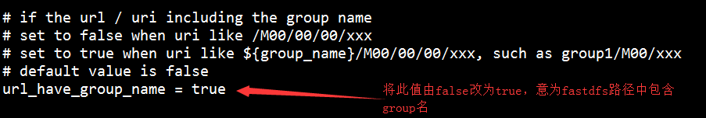
修改tracker_server地址
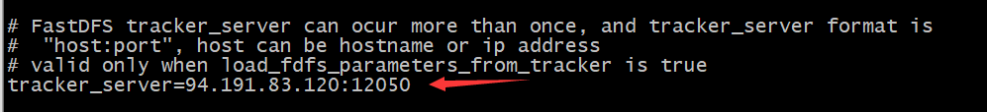
修改nginx配置，vi /usr/local/nginx/conf/nginx.conf
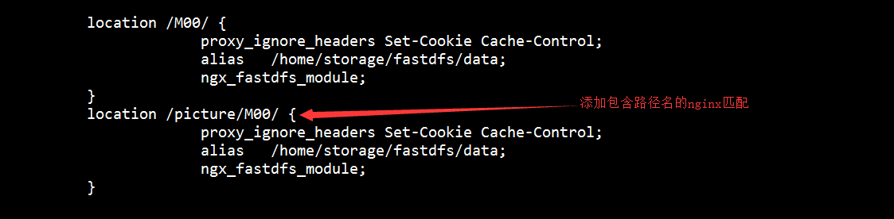
重启nginx服务，nginx -s reload
退出容器（ctrl + Q）

rabbitMQ服务
docker run -d --name mq -p 5672:5672 -p 15672:15672 -v /docker-data/rabbitmq:/var/lib/rabbitmq -e RABBITMQ_DEFAULT_USER=admin -e RABBITMQ_DEFAULT_PASS=admin rabbitmq:3.7.14-management

nginx服务
创建nginx命令：

docker run -ti -p 80:80 --name nginx --privileged -d -v /home/docker-data/nginx/nginx.conf:/etc/nginx/nginx.conf -v /home/docker-data/nginx/error.log:/etc/nginx/log/error.log -v /home/docker-data/nginx/server/:/etc/nginx/conf.d/ -v /home/docker-data/nginx/web/:/root/web/ --privileged=true nginx

各微服务的nginx配置
vi mi.conf
upstream zuul {
#weigth参数表示权值，权值越高被分配到的几率越大
#本机上的Squid开启3128端口
server 106.55.246.66:8193;
server 106.55.248.7:8193;
}
upstream mall {
#weigth参数表示权值，权值越高被分配到的几率越大
#本机上的Squid开启3128端口
#server 106.55.152.41:8186;
server 106.52.62.38:8186;
}

upstream mallmng {
#weigth参数表示权值，权值越高被分配到的几率越大
#本机上的Squid开启3128端口
server 106.55.248.7:8185;
server 106.55.246.66:8185;
}
upstream mallcallback {
#weigth参数表示权值，权值越高被分配到的几率越大
#本机上的Squid开启3128端口
server 106.55.248.74:8188;
server 106.53.195.121:8188;
}
upstream mallaccount {
#weigth参数表示权值，权值越高被分配到的几率越大
#本机上的Squid开启3128端口
#server 106.55.250.100:8180;
#server 106.55.249.133:8180;
server 106.52.62.38:8180;
}

server {
listen 80;
server_name mi.xiangxueketang.cn;
location /mall/api {
proxy_pass http://zuul;
proxy_set_header Host $host:$server_port;
}

location /mall {
alias /root/web/mall/static/;
index index.php index.html index.htm;
}
location /mall/static {
alias /root/web/mall/static/static/;
expires 30d;
}
#location /mall/static/css {
# alias /root/web/mall/static/static/css;
# expires 30d;
#}
#location /mall/static/img {
# alias /root/web/mall/static/static/img;
# expires 30d;
#}
location /mall-mng/api {
proxy_pass http://zuul;
}
location /mall-mng {
alias /root/web/mall-mng/static/;
index index.php index.html index.htm;
}
location /mall-mng/static {
alias /root/web/mall-mng/static/static/;
expires 30d;
}
location ~ /picture/M00{
proxy_pass http://94.191.83.120:8181;
}
location /wx {
proxy_pass http://mallcallback;
}
location /mall-account/api {
proxy_pass http://zuul;
}
location /mall-account {
alias /root/web/mall-account/static/;
index index.php index.html index.htm;
}
location /mall-account/scripts {
alias /root/web/mall-account/static/scripts/;
expires 30d;
}

}

vi nginx.conf
#运行用户
user root;
#启动进程,通常设置成和cpu的数量相等
worker_processes 4;

#全局错误日志及PID文件
error_log /var/log/nginx/error.log;
pid /var/run/nginx.pid;

#工作模式及连接数上限
events {
use epoll; #epoll是多路复用IO(I/O Multiplexing)中的一种方式,但是仅用于linux2.6以上内核,可以大大提高nginx的性能
worker_connections 1024;#单个后台worker process进程的最大并发链接数
# multi_accept on;
}

#设定http服务器，利用它的反向代理功能提供负载均衡支持
http {
#设定mime类型,类型由mime.type文件定义
include /etc/nginx/mime.types;
default_type application/octet-stream;
#设定日志格式
access_log /var/log/nginx/access.log;

#sendfile 指令指定 nginx 是否调用 sendfile 函数（zero copy 方式）来输出文件，对于普通应用，
#必须设为 on,如果用来进行下载等应用磁盘IO重负载应用，可设置为 off，以平衡磁盘与网络I/O处理速度，降低系统的uptime.
sendfile on;
#tcp_nopush on;

#连接超时时间
#keepalive_timeout 0;
keepalive_timeout 65;
tcp_nodelay on;

#开启gzip压缩
gzip on;
gzip_disable "MSIE [1-6]\.(?!.*SV1)";

#设定请求缓冲
client_header_buffer_size 1k;
large_client_header_buffers 4 4k;

include /etc/nginx/conf.d/*.conf;
include /etc/nginx/sites-enabled/*;

#设定负载均衡的服务器列表
# upstream mysvr {
#weigth参数表示权值，权值越高被分配到的几率越大
#本机上的Squid开启3128端口
# server 192.168.8.1:3128 weight=5;
# server 192.168.8.2:80 weight=1;
# server 192.168.8.3:80 weight=6;
# }

# server {
#侦听80端口
# listen 80;
#定义使用www.xx.com访问
# server_name 106.55.152.41;

#设定本虚拟主机的访问日志
#access_log logs/www.xx.com.access.log main;

#默认请求
# location / {
# root /root; #定义服务器的默认网站根目录位置
# index index.php index.html index.htm; #定义首页索引文件的名称
#
# fastcgi_pass www.xx.com;
#fastcgi_param SCRIPT_FILENAME $document_root/$fastcgi_script_name;
#include /etc/nginx/fastcgi_params;
# }

# 定义错误提示页面
# error_page 500 502 503 504 /50x.html;
# location = /50x.html {
# root /root;
# }

#静态文件，nginx自己处理
# location ~ ^/(images|javascript|js|css|flash|media|static)/ {
# root /var/www/virtual/htdocs;
#过期30天，静态文件不怎么更新，过期可以设大一点，如果频繁更新，则可以设置得小一点。
# expires 30d;
# }
#PHP 脚本请求全部转发到 FastCGI处理. 使用FastCGI默认配置.
#location ~ \.php$ {
# root /root;
# fastcgi_pass 127.0.0.1:9000;
# fastcgi_index index.php;
# fastcgi_param SCRIPT_FILENAME /home/www/www$fastcgi_script_name;
# include fastcgi_params;
#}
#设定查看Nginx状态的地址
# location /NginxStatus {
# stub_status on;
# access_log on;
# auth_basic "NginxStatus";
# auth_basic_user_file conf/htpasswd;
# }
#禁止访问 .htxxx 文件
# location ~ /\.ht {
# deny all;
# }

# }
}

seata数据库
docker run --name config -p 3309:3306 --privileged=true -ti -e MYSQL_ROOT_PASSWORD=123456 -e MYSQL_DATABASE=config -e MYSQL_USER=user -e MYSQL_PASSWORD=pass -v /home/docker-data/mysql/seata/conf/:/etc/mysql/conf.d -v /home/docker-data/mysql/seata/data/:/var/lib/mysql -v /home/docker-data/mysql/seata/logs/:/var/log/mysql -d mysql:5.7

apm部署

A、zookeeper安装
docker run -d \
> -p 2181:2181 \
> -v /home/zookeeper/data/:/data/ \
> --name=zookeeper \
> --privileged zookeeper:3.4.9

B、kafka安装
docker run -d --name kafka --publish 9092:9092 --link zookeeper --env KAFKA_ZOOKEEPER_CONNECT=zookeeper:2181 --env KAFKA_ADVERTISED_HOST_NAME=106.52.62.38 --env KAFKA_ADVERTISED_PORT=9092 --volume /etc/localtime:/etc/localtime wurstmeister/kafka:latest

C、es安装
docker run -e ES_JAVA_OPTS="-Xms2g -Xmx2g"
-d --name es -p 9200:9200 -p 9300:9300 -e "discovery.type=single-node" docker.elastic.co/elasticsearch/elasticsearch:5.6.4
修改es的启动内存，默认启动内存是2G，如果不修改启动不久就会停掉容器
vi config/jvm.options
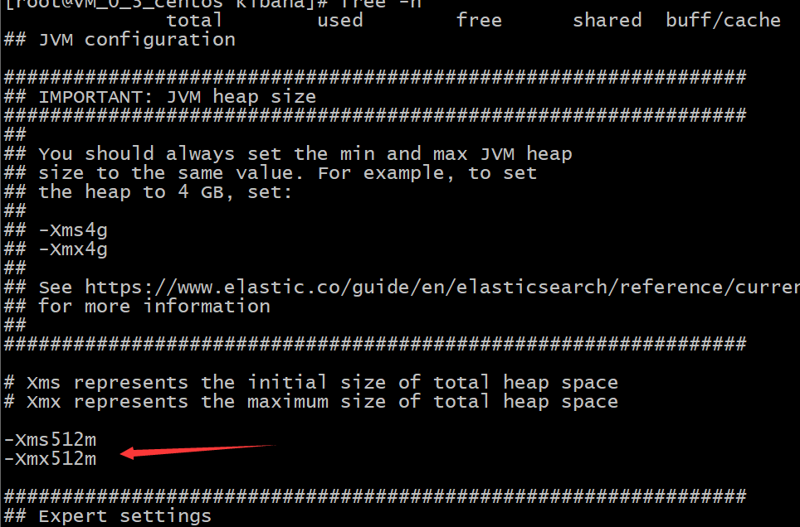

修改elasticsearch的配置文件，加入跨域配置
进入es容器
docker exec -it es /bin/bash
修改配置文件
vi config/elasticsearch.yml
加入如下配置
http.cors.enabled: true
http.cors.allow-origin: "*"
xpack.security.enabled: false

重启es
docker restart es

D、es head安装
docker run -d -p 9100:9100 docker.io/mobz/elasticsearch-head:5

E、Kafka manager安装
docker run -itd --name=kafka-manager -p 9000:9000 -e ZK_HOSTS="106.52.62.38:2181" sheepkiller/kafka-manager

配置详情
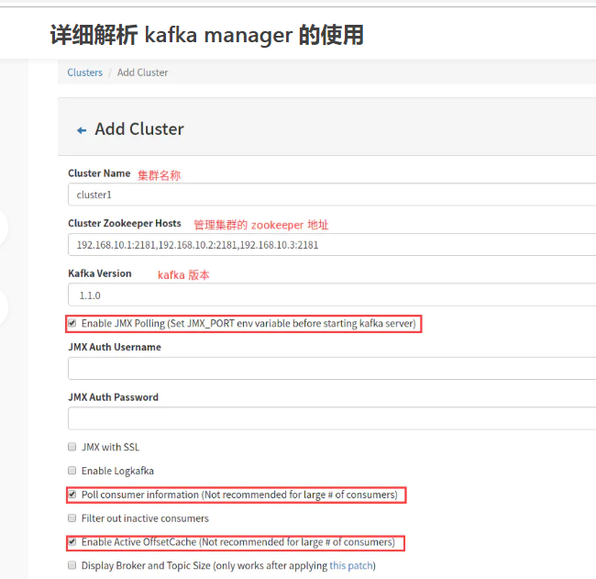

F、zipkin安装
下载zipkin
wget -O zipkin.jar 'https://search.maven.org/remote_content?g=io.zipkin.java&a=zipkin-server&v=LATEST&c=exec'
启动zipkin
nohup java -DKAFKA_ZOOKEEPER=106.52.62.38:2181 -DKAFKA_BOOTSTRAP_SERVERS=106.52.62.38:9092 -DSTORAGE_TYPE=elasticsearch -DES_HOSTS=http://106.52.62.38:9200 -jar zipkin.jar &

Mycat部署
Mycat下载
wget https://github.com/MyCATApache/Mycat-Server/releases/download/Mycat-server-1675-release/Mycat-server-1.6.7.5-release-20200422133810-linux.tar.gz

解压
tar -zxvf Mycat-server-1.6.7.5-release-20200422133810-linux.tar.gz

启动
./mycat start

项目代码部署
项目代码，统一使用docker方式部署。
项目打包部署统一在linux环境下进行（请确保机器环境中装好了jdk/maven/docker）

项目代码托管在腾讯云，地址为：
https://e.coding.net/xiangxueman/enjoy-mi.git

后续代码的CI和CD，持续集成和持续部署都是通过Jenkins来完成的，Jenkins项目一览图
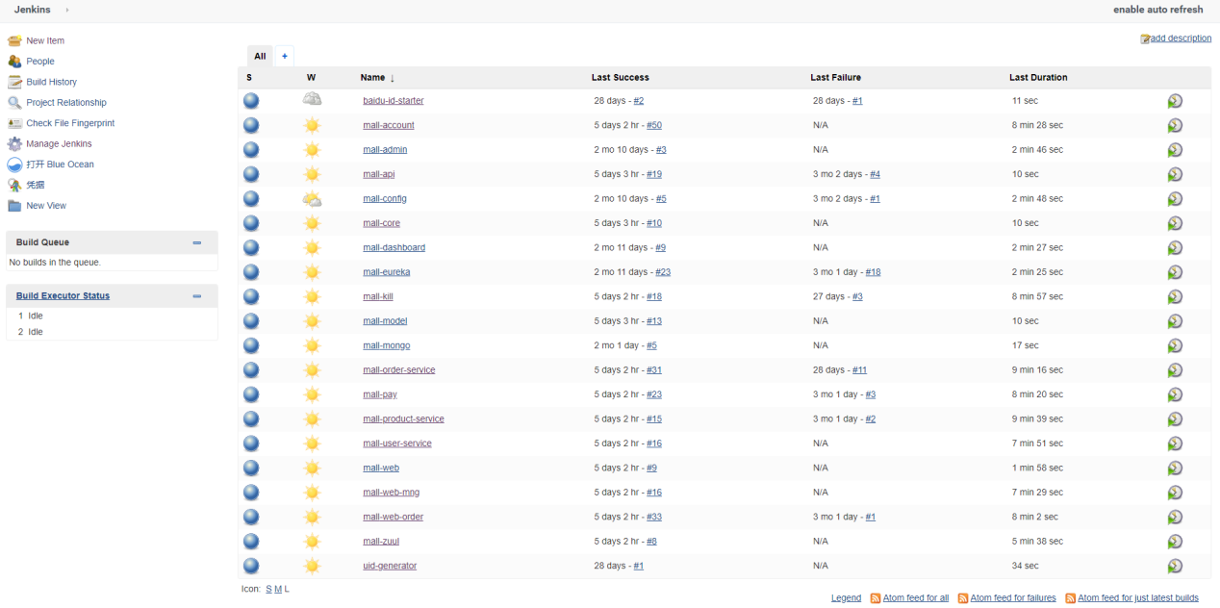

mall-account
Jenkins中的配置内容如下：
Git地址
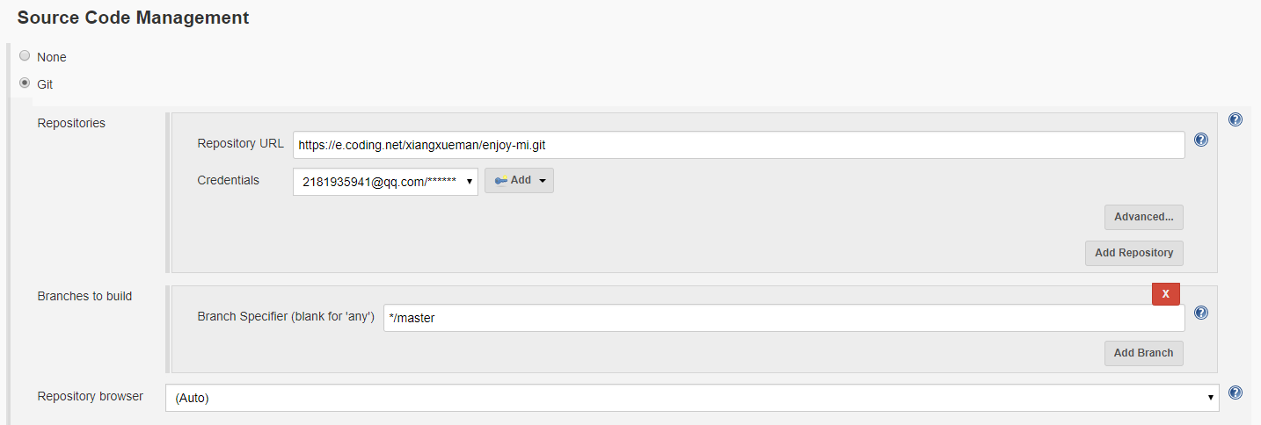

打包指令
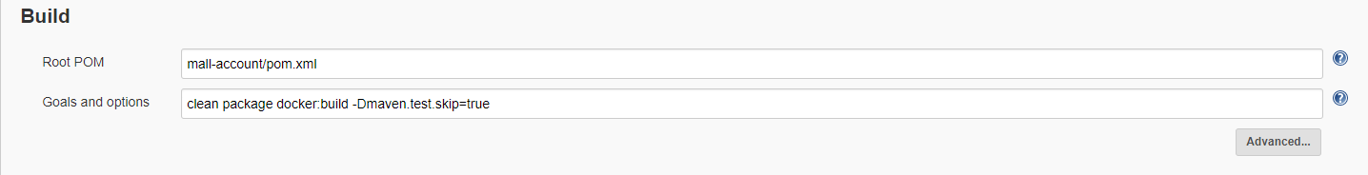

执行 shell，把镜像push到镜像仓库
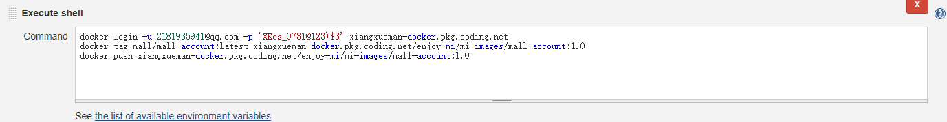
docker login -u 2181935941@qq.com -p 'XKcs_0731@123)$3' xiangxueman-docker.pkg.coding.net
docker tag mall/mall-account:latest xiangxueman-docker.pkg.coding.net/enjoy-mi/mi-images/mall-account:1.0
docker push xiangxueman-docker.pkg.coding.net/enjoy-mi/mi-images/mall-account:1.0

远程部署
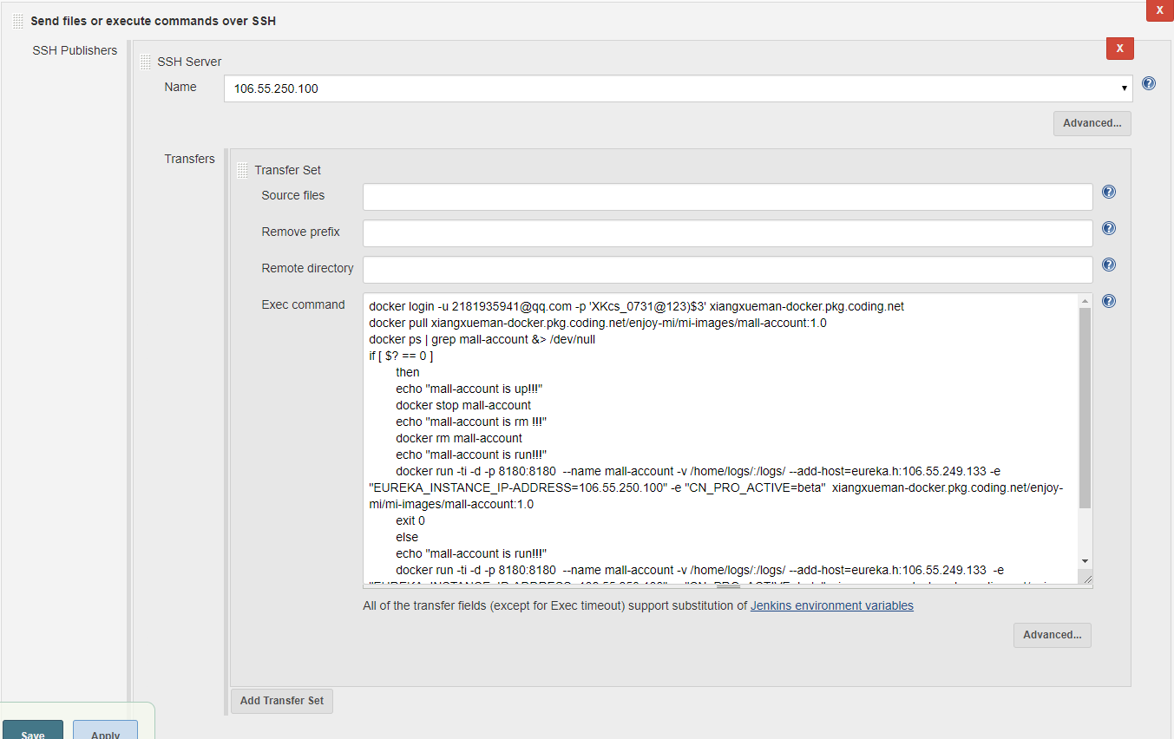
脚本
- 先登录到镜像仓库
- 从镜像仓库pull镜像
- 判断主机中该镜像对应的容器是否启动
- 如果启动了则关闭容器，删除容器，然后再根据下载的镜像启动容器
- 如果没有启动则直接根据下载的镜像启动容器
docker login -u 2181935941@qq.com -p 'XKcs_0731@123)$3' xiangxueman-docker.pkg.coding.net
docker pull xiangxueman-docker.pkg.coding.net/enjoy-mi/mi-images/mall-account:1.0
docker ps | grep mall-account &> /dev/null
if [ $? == 0 ]
then
echo "mall-account is up!!!"
docker stop mall-account
echo "mall-account is rm !!!"
docker rm mall-account
echo "mall-account is run!!!"
docker run -ti -d -p 8180:8180 --name mall-account -v /home/logs/:/logs/ --add-host=eureka.h:106.55.249.133 -e "EUREKA_INSTANCE_IP-ADDRESS=106.55.250.100" -e "CN_PRO_ACTIVE=beta" xiangxueman-docker.pkg.coding.net/enjoy-mi/mi-images/mall-account:1.0
exit 0
else
echo "mall-account is run!!!"
docker run -ti -d -p 8180:8180 --name mall-account -v /home/logs/:/logs/ --add-host=eureka.h:106.55.249.133 -e "EUREKA_INSTANCE_IP-ADDRESS=106.55.250.100" -e "CN_PRO_ACTIVE=beta" xiangxueman-docker.pkg.coding.net/enjoy-mi/mi-images/mall-account:1.0
exit 0
fi

mall-admin
项目构建
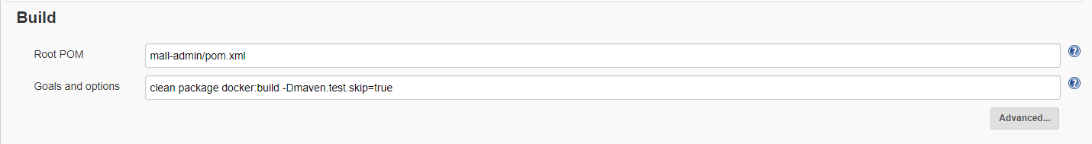
Push镜像到镜像仓库
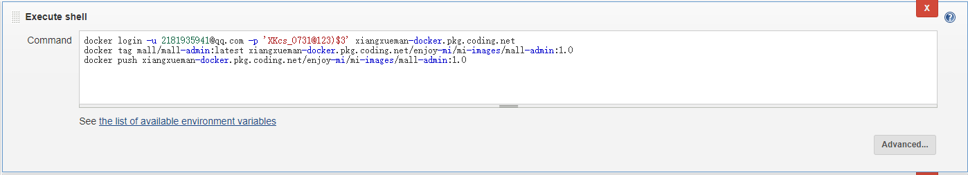
docker login -u 2181935941@qq.com -p 'XKcs_0731@123)$3' xiangxueman-docker.pkg.coding.net
docker tag mall/mall-admin:latest xiangxueman-docker.pkg.coding.net/enjoy-mi/mi-images/mall-admin:1.0
docker push xiangxueman-docker.pkg.coding.net/enjoy-mi/mi-images/mall-admin:1.0
远程发布
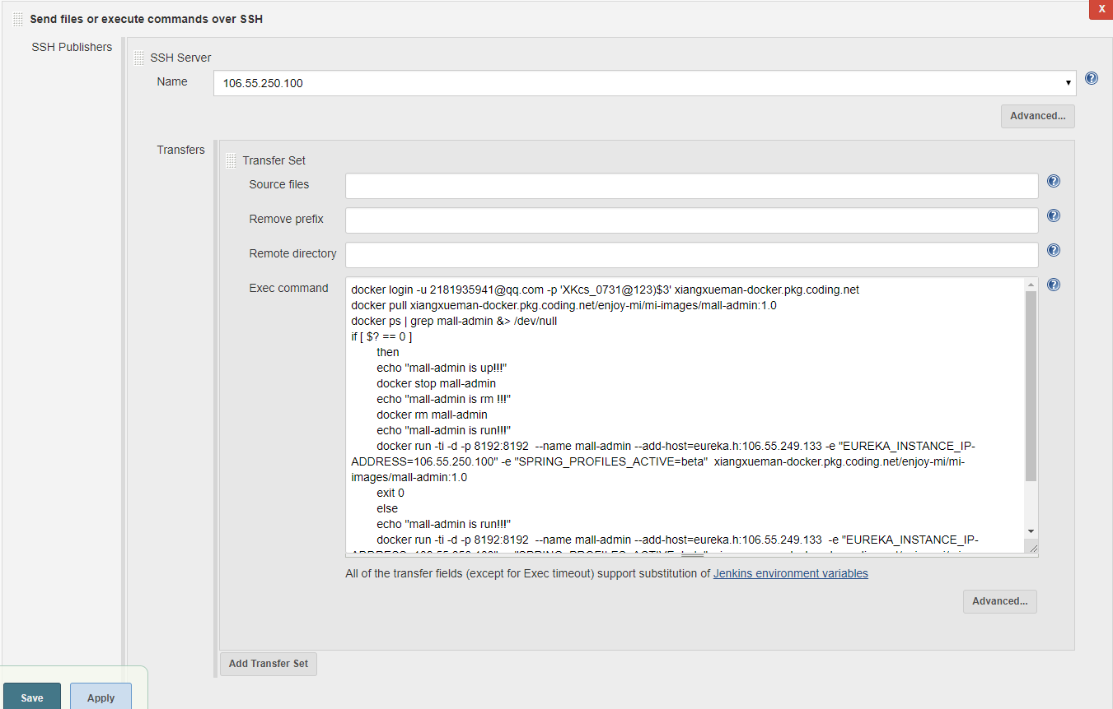
执行脚本
docker login -u 2181935941@qq.com -p 'XKcs_0731@123)$3' xiangxueman-docker.pkg.coding.net
docker pull xiangxueman-docker.pkg.coding.net/enjoy-mi/mi-images/mall-admin:1.0
docker ps | grep mall-admin &> /dev/null
if [ $? == 0 ]
then
echo "mall-admin is up!!!"
docker stop mall-admin
echo "mall-admin is rm !!!"
docker rm mall-admin
echo "mall-admin is run!!!"
docker run -ti -d -p 8192:8192 --name mall-admin --add-host=eureka.h:106.55.249.133 -e "EUREKA_INSTANCE_IP-ADDRESS=106.55.250.100" -e "SPRING_PROFILES_ACTIVE=beta" xiangxueman-docker.pkg.coding.net/enjoy-mi/mi-images/mall-admin:1.0
exit 0
else
echo "mall-admin is run!!!"
docker run -ti -d -p 8192:8192 --name mall-admin --add-host=eureka.h:106.55.249.133 -e "EUREKA_INSTANCE_IP-ADDRESS=106.55.250.100" -e "SPRING_PROFILES_ACTIVE=beta" xiangxueman-docker.pkg.coding.net/enjoy-mi/mi-images/mall-admin:1.0
exit 0
fi

mall-config
项目构建
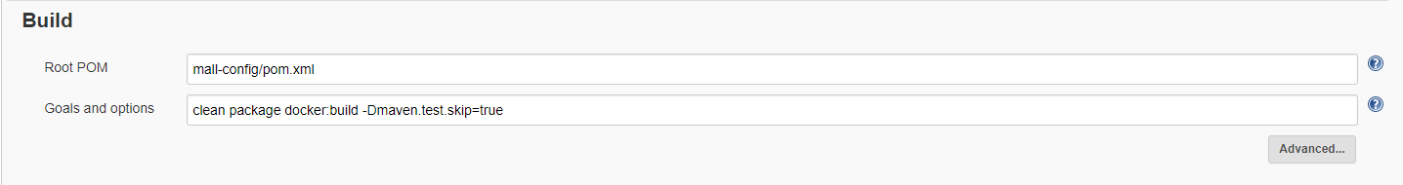

Push镜像到镜像仓库
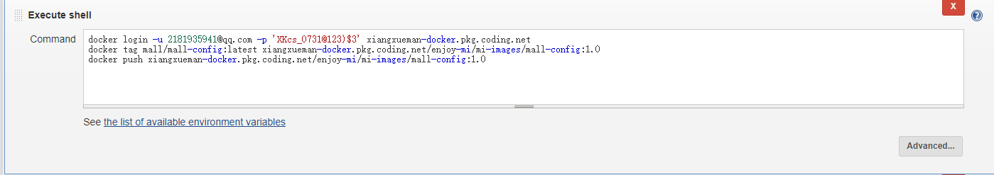
docker login -u 2181935941@qq.com -p 'XKcs_0731@123)$3' xiangxueman-docker.pkg.coding.net
docker tag mall/mall-config:latest xiangxueman-docker.pkg.coding.net/enjoy-mi/mi-images/mall-config:1.0
docker push xiangxueman-docker.pkg.coding.net/enjoy-mi/mi-images/mall-config:1.0

远程发布
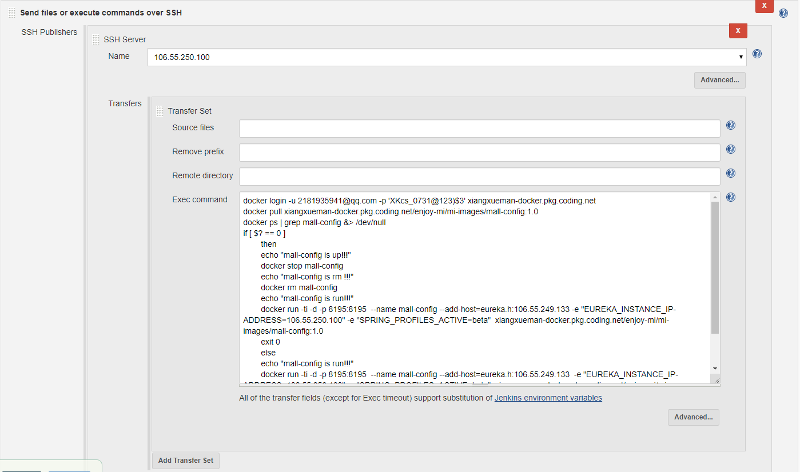
执行脚本
docker login -u 2181935941@qq.com -p 'XKcs_0731@123)$3' xiangxueman-docker.pkg.coding.net
docker pull xiangxueman-docker.pkg.coding.net/enjoy-mi/mi-images/mall-config:1.0
docker ps | grep mall-config &> /dev/null
if [ $? == 0 ]
then
echo "mall-config is up!!!"
docker stop mall-config
echo "mall-config is rm !!!"
docker rm mall-config
echo "mall-config is run!!!"
docker run -ti -d -p 8195:8195 --name mall-config --add-host=eureka.h:106.55.249.133 -e "EUREKA_INSTANCE_IP-ADDRESS=106.55.250.100" -e "SPRING_PROFILES_ACTIVE=beta" xiangxueman-docker.pkg.coding.net/enjoy-mi/mi-images/mall-config:1.0
exit 0
else
echo "mall-config is run!!!"
docker run -ti -d -p 8195:8195 --name mall-config --add-host=eureka.h:106.55.249.133 -e "EUREKA_INSTANCE_IP-ADDRESS=106.55.250.100" -e "SPRING_PROFILES_ACTIVE=beta" xiangxueman-docker.pkg.coding.net/enjoy-mi/mi-images/mall-config:1.0
exit 0
fi
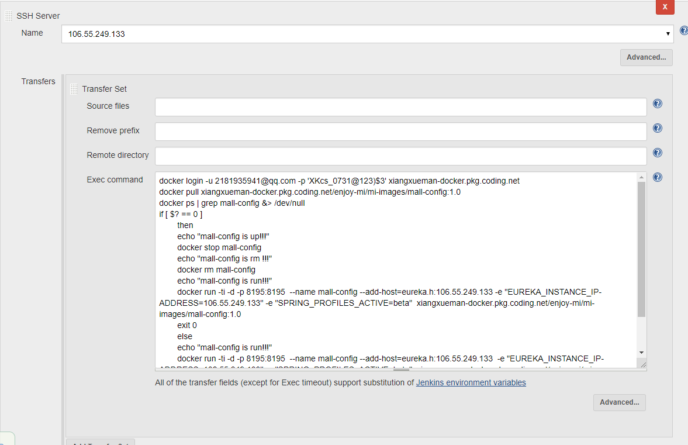
执行脚本
docker login -u 2181935941@qq.com -p 'XKcs_0731@123)$3' xiangxueman-docker.pkg.coding.net
docker pull xiangxueman-docker.pkg.coding.net/enjoy-mi/mi-images/mall-config:1.0
docker ps | grep mall-config &> /dev/null
if [ $? == 0 ]
then
echo "mall-config is up!!!"
docker stop mall-config
echo "mall-config is rm !!!"
docker rm mall-config
echo "mall-config is run!!!"
docker run -ti -d -p 8195:8195 --name mall-config --add-host=eureka.h:106.55.249.133 -e "EUREKA_INSTANCE_IP-ADDRESS=106.55.249.133" -e "SPRING_PROFILES_ACTIVE=beta" xiangxueman-docker.pkg.coding.net/enjoy-mi/mi-images/mall-config:1.0
exit 0
else
echo "mall-config is run!!!"
docker run -ti -d -p 8195:8195 --name mall-config --add-host=eureka.h:106.55.249.133 -e "EUREKA_INSTANCE_IP-ADDRESS=106.55.249.133" -e "SPRING_PROFILES_ACTIVE=beta" xiangxueman-docker.pkg.coding.net/enjoy-mi/mi-images/mall-config:1.0
exit 0
fi

mall-dashboard
项目构建
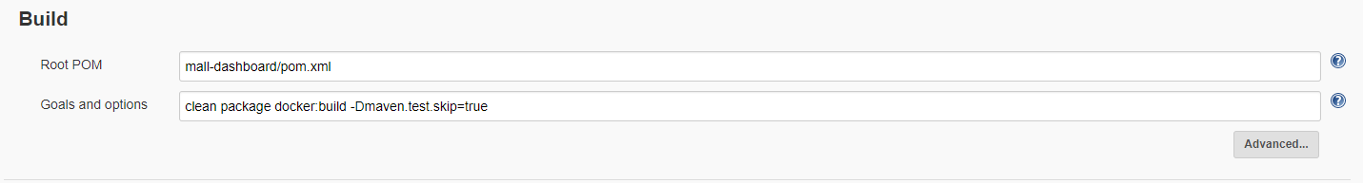

Push镜像到镜像仓库
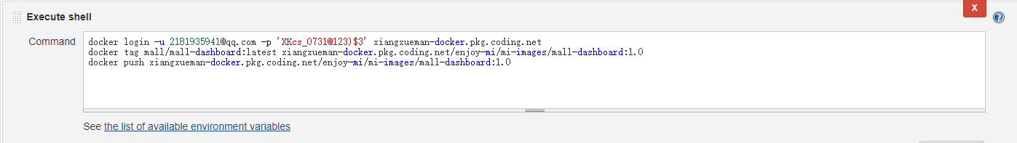
docker login -u 2181935941@qq.com -p 'XKcs_0731@123)$3' xiangxueman-docker.pkg.coding.net
docker tag mall/mall-dashboard:latest xiangxueman-docker.pkg.coding.net/enjoy-mi/mi-images/mall-dashboard:1.0
docker push xiangxueman-docker.pkg.coding.net/enjoy-mi/mi-images/mall-dashboard:1.0
远程发布
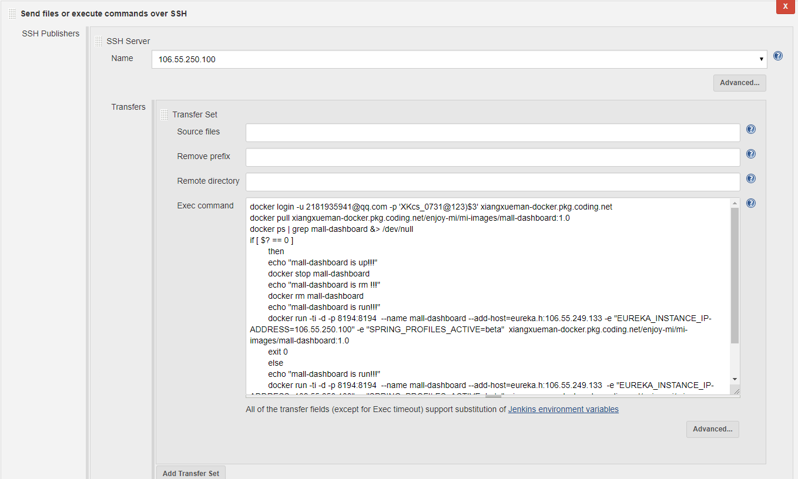

执行脚本
docker login -u 2181935941@qq.com -p 'XKcs_0731@123)$3' xiangxueman-docker.pkg.coding.net
docker pull xiangxueman-docker.pkg.coding.net/enjoy-mi/mi-images/mall-dashboard:1.0
docker ps | grep mall-dashboard &> /dev/null
if [ $? == 0 ]
then
echo "mall-dashboard is up!!!"
docker stop mall-dashboard
echo "mall-dashboard is rm !!!"
docker rm mall-dashboard
echo "mall-dashboard is run!!!"
docker run -ti -d -p 8194:8194 --name mall-dashboard --add-host=eureka.h:106.55.249.133 -e "EUREKA_INSTANCE_IP-ADDRESS=106.55.250.100" -e "SPRING_PROFILES_ACTIVE=beta" xiangxueman-docker.pkg.coding.net/enjoy-mi/mi-images/mall-dashboard:1.0
exit 0
else
echo "mall-dashboard is run!!!"
docker run -ti -d -p 8194:8194 --name mall-dashboard --add-host=eureka.h:106.55.249.133 -e "EUREKA_INSTANCE_IP-ADDRESS=106.55.250.100" -e "SPRING_PROFILES_ACTIVE=beta" xiangxueman-docker.pkg.coding.net/enjoy-mi/mi-images/mall-dashboard:1.0
exit 0
fi

mall-eureka
项目构建
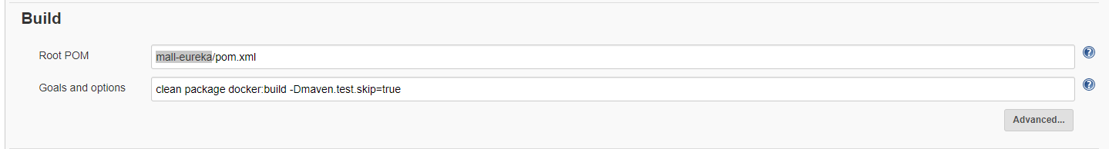

Push镜像到镜像仓库
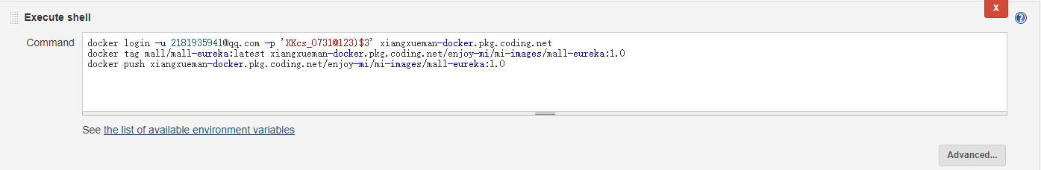
docker login -u 2181935941@qq.com -p 'XKcs_0731@123)$3' xiangxueman-docker.pkg.coding.net
docker tag mall/mall-eureka:latest xiangxueman-docker.pkg.coding.net/enjoy-mi/mi-images/mall-eureka:1.0
docker push xiangxueman-docker.pkg.coding.net/enjoy-mi/mi-images/mall-eureka:1.0
远程发布
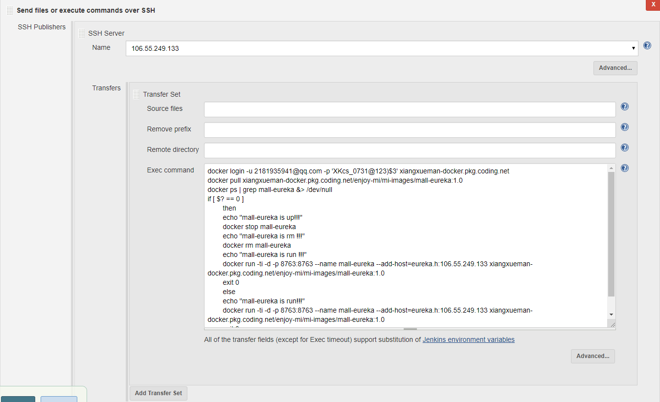
执行脚本
docker login -u 2181935941@qq.com -p 'XKcs_0731@123)$3' xiangxueman-docker.pkg.coding.net
docker pull xiangxueman-docker.pkg.coding.net/enjoy-mi/mi-images/mall-eureka:1.0
docker ps | grep mall-eureka &> /dev/null
if [ $? == 0 ]
then
echo "mall-eureka is up!!!"
docker stop mall-eureka
echo "mall-eureka is rm !!!"
docker rm mall-eureka
echo "mall-eureka is run !!!"
docker run -ti -d -p 8763:8763 --name mall-eureka --add-host=eureka.h:106.55.249.133 xiangxueman-docker.pkg.coding.net/enjoy-mi/mi-images/mall-eureka:1.0
exit 0
else
echo "mall-eureka is run!!!"
docker run -ti -d -p 8763:8763 --name mall-eureka --add-host=eureka.h:106.55.249.133 xiangxueman-docker.pkg.coding.net/enjoy-mi/mi-images/mall-eureka:1.0
exit 0
fi

mall-kill
项目构建
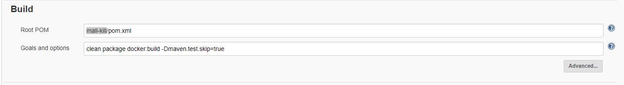
Push镜像到镜像仓库
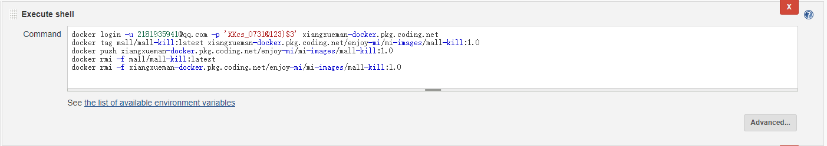
docker login -u 2181935941@qq.com -p 'XKcs_0731@123)$3' xiangxueman-docker.pkg.coding.net
docker tag mall/mall-kill:latest xiangxueman-docker.pkg.coding.net/enjoy-mi/mi-images/mall-kill:1.0
docker push xiangxueman-docker.pkg.coding.net/enjoy-mi/mi-images/mall-kill:1.0
docker rmi -f mall/mall-kill:latest
docker rmi -f xiangxueman-docker.pkg.coding.net/enjoy-mi/mi-images/mall-kill:1.0
远程发布
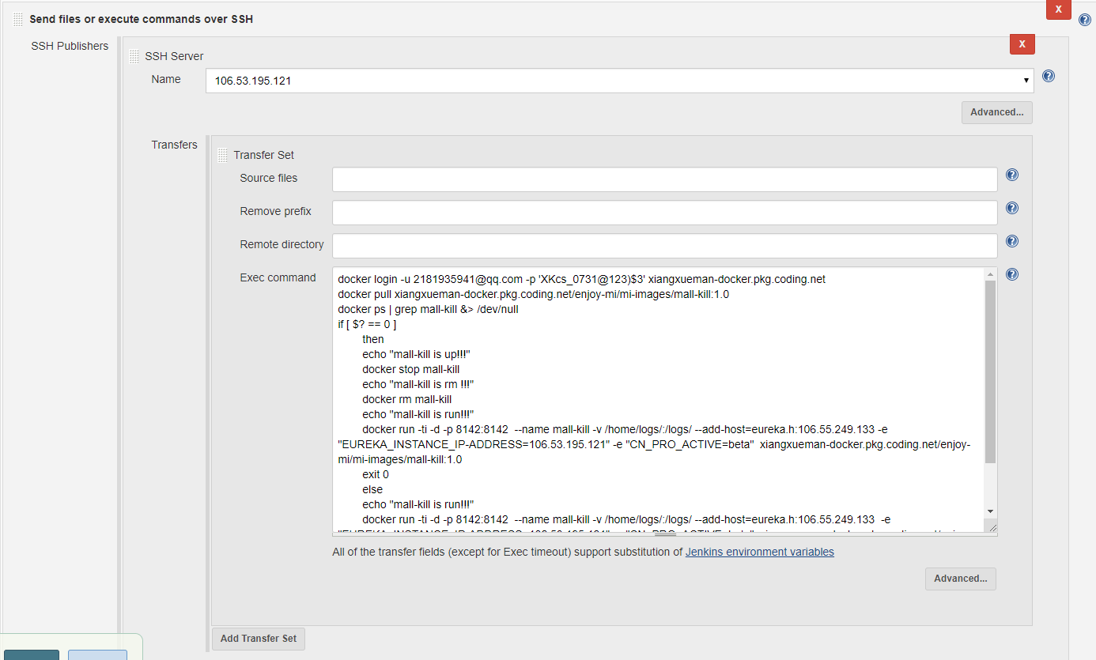
执行脚本
docker login -u 2181935941@qq.com -p 'XKcs_0731@123)$3' xiangxueman-docker.pkg.coding.net
docker pull xiangxueman-docker.pkg.coding.net/enjoy-mi/mi-images/mall-kill:1.0
docker ps | grep mall-kill &> /dev/null
if [ $? == 0 ]
then
echo "mall-kill is up!!!"
docker stop mall-kill
echo "mall-kill is rm !!!"
docker rm mall-kill
echo "mall-kill is run!!!"
docker run -ti -d -p 8142:8142 --name mall-kill -v /home/logs/:/logs/ --add-host=eureka.h:106.55.249.133 -e "EUREKA_INSTANCE_IP-ADDRESS=106.53.195.121" -e "CN_PRO_ACTIVE=beta" xiangxueman-docker.pkg.coding.net/enjoy-mi/mi-images/mall-kill:1.0
exit 0
else
echo "mall-kill is run!!!"
docker run -ti -d -p 8142:8142 --name mall-kill -v /home/logs/:/logs/ --add-host=eureka.h:106.55.249.133 -e "EUREKA_INSTANCE_IP-ADDRESS=106.53.195.121" -e "CN_PRO_ACTIVE=beta" xiangxueman-docker.pkg.coding.net/enjoy-mi/mi-images/mall-kill:1.0
exit 0
fi
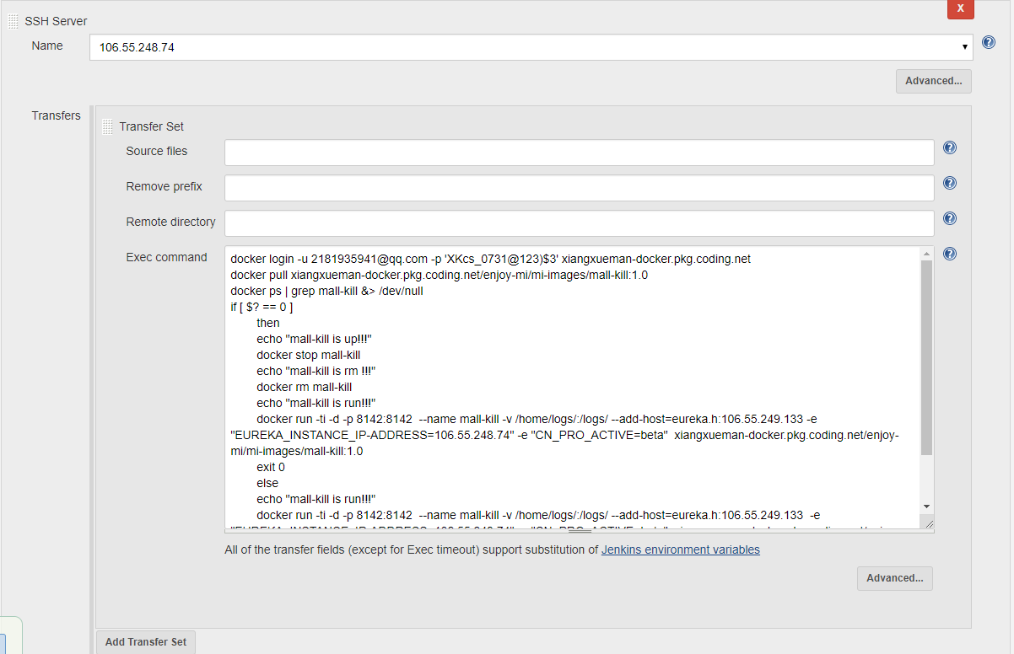
执行脚本
docker login -u 2181935941@qq.com -p 'XKcs_0731@123)$3' xiangxueman-docker.pkg.coding.net
docker pull xiangxueman-docker.pkg.coding.net/enjoy-mi/mi-images/mall-kill:1.0
docker ps | grep mall-kill &> /dev/null
if [ $? == 0 ]
then
echo "mall-kill is up!!!"
docker stop mall-kill
echo "mall-kill is rm !!!"
docker rm mall-kill
echo "mall-kill is run!!!"
docker run -ti -d -p 8142:8142 --name mall-kill -v /home/logs/:/logs/ --add-host=eureka.h:106.55.249.133 -e "EUREKA_INSTANCE_IP-ADDRESS=106.55.248.74" -e "CN_PRO_ACTIVE=beta" xiangxueman-docker.pkg.coding.net/enjoy-mi/mi-images/mall-kill:1.0
exit 0
else
echo "mall-kill is run!!!"
docker run -ti -d -p 8142:8142 --name mall-kill -v /home/logs/:/logs/ --add-host=eureka.h:106.55.249.133 -e "EUREKA_INSTANCE_IP-ADDRESS=106.55.248.74" -e "CN_PRO_ACTIVE=beta" xiangxueman-docker.pkg.coding.net/enjoy-mi/mi-images/mall-kill:1.0
exit 0
fi

mall-order-service
项目构建
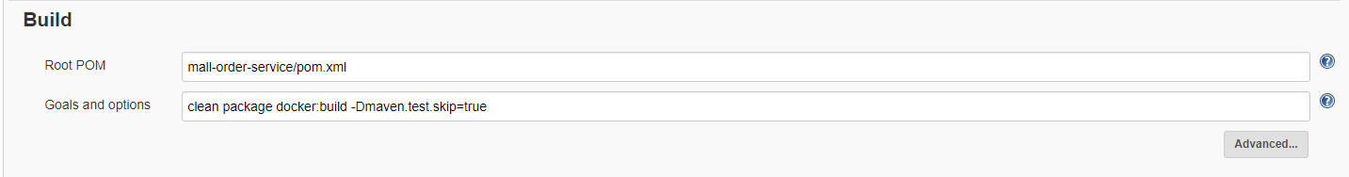
Push镜像到镜像仓库
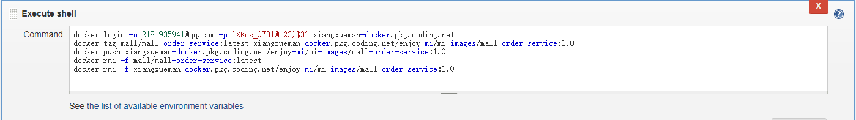
docker login -u 2181935941@qq.com -p 'XKcs_0731@123)$3' xiangxueman-docker.pkg.coding.net
docker tag mall/mall-order-service:latest xiangxueman-docker.pkg.coding.net/enjoy-mi/mi-images/mall-order-service:1.0
docker push xiangxueman-docker.pkg.coding.net/enjoy-mi/mi-images/mall-order-service:1.0
docker rmi -f mall/mall-order-service:latest
docker rmi -f xiangxueman-docker.pkg.coding.net/enjoy-mi/mi-images/mall-order-service:1.0
远程发布
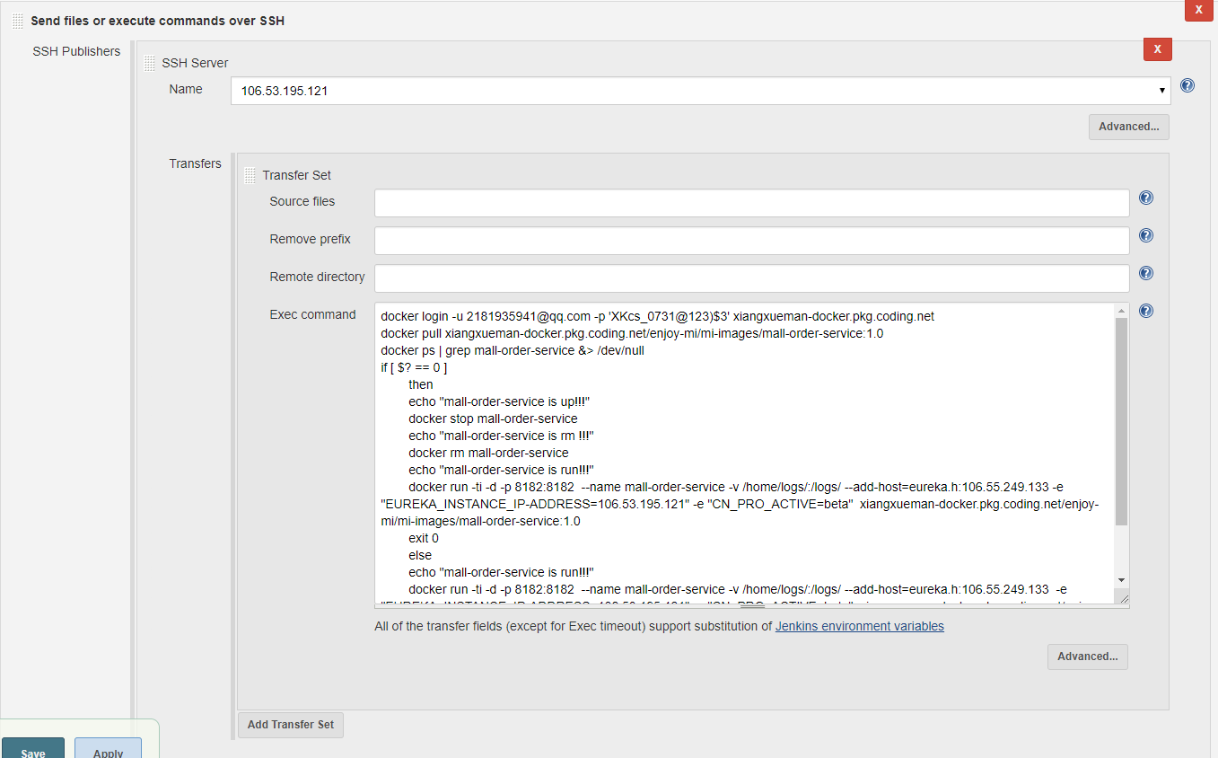
执行脚本
docker login -u 2181935941@qq.com -p 'XKcs_0731@123)$3' xiangxueman-docker.pkg.coding.net
docker pull xiangxueman-docker.pkg.coding.net/enjoy-mi/mi-images/mall-order-service:1.0
docker ps | grep mall-order-service &> /dev/null
if [ $? == 0 ]
then
echo "mall-order-service is up!!!"
docker stop mall-order-service
echo "mall-order-service is rm !!!"
docker rm mall-order-service
echo "mall-order-service is run!!!"
docker run -ti -d -p 8182:8182 --name mall-order-service -v /home/logs/:/logs/ --add-host=eureka.h:106.55.249.133 -e "EUREKA_INSTANCE_IP-ADDRESS=106.53.195.121" -e "CN_PRO_ACTIVE=beta" xiangxueman-docker.pkg.coding.net/enjoy-mi/mi-images/mall-order-service:1.0
exit 0
else
echo "mall-order-service is run!!!"
docker run -ti -d -p 8182:8182 --name mall-order-service -v /home/logs/:/logs/ --add-host=eureka.h:106.55.249.133 -e "EUREKA_INSTANCE_IP-ADDRESS=106.53.195.121" -e "CN_PRO_ACTIVE=beta" xiangxueman-docker.pkg.coding.net/enjoy-mi/mi-images/mall-order-service:1.0
exit 0
fi
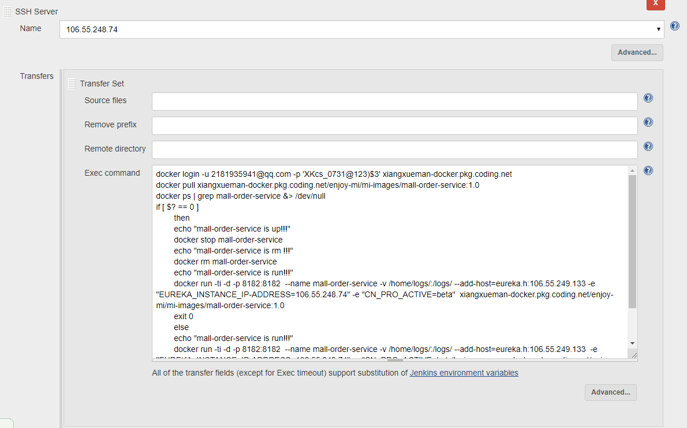
执行脚本
docker login -u 2181935941@qq.com -p 'XKcs_0731@123)$3' xiangxueman-docker.pkg.coding.net
docker pull xiangxueman-docker.pkg.coding.net/enjoy-mi/mi-images/mall-order-service:1.0
docker ps | grep mall-order-service &> /dev/null
if [ $? == 0 ]
then
echo "mall-order-service is up!!!"
docker stop mall-order-service
echo "mall-order-service is rm !!!"
docker rm mall-order-service
echo "mall-order-service is run!!!"
docker run -ti -d -p 8182:8182 --name mall-order-service -v /home/logs/:/logs/ --add-host=eureka.h:106.55.249.133 -e "EUREKA_INSTANCE_IP-ADDRESS=106.55.248.74" -e "CN_PRO_ACTIVE=beta" xiangxueman-docker.pkg.coding.net/enjoy-mi/mi-images/mall-order-service:1.0
exit 0
else
echo "mall-order-service is run!!!"
docker run -ti -d -p 8182:8182 --name mall-order-service -v /home/logs/:/logs/ --add-host=eureka.h:106.55.249.133 -e "EUREKA_INSTANCE_IP-ADDRESS=106.55.248.74" -e "CN_PRO_ACTIVE=beta" xiangxueman-docker.pkg.coding.net/enjoy-mi/mi-images/mall-order-service:1.0
exit 0
fi

mall-pay
项目构建
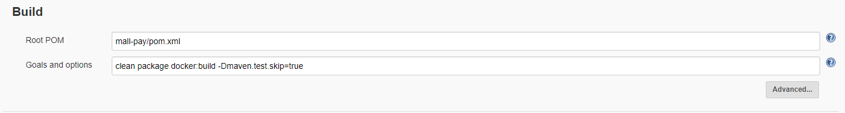
Push镜像到镜像仓库
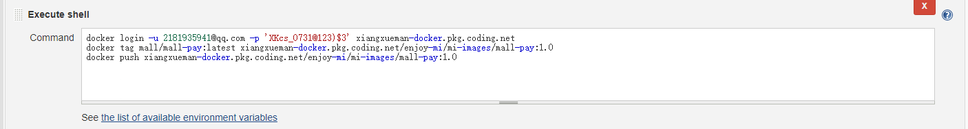
docker login -u 2181935941@qq.com -p 'XKcs_0731@123)$3' xiangxueman-docker.pkg.coding.net
docker tag mall/mall-pay:latest xiangxueman-docker.pkg.coding.net/enjoy-mi/mi-images/mall-pay:1.0
docker push xiangxueman-docker.pkg.coding.net/enjoy-mi/mi-images/mall-pay:1.0
远程发布
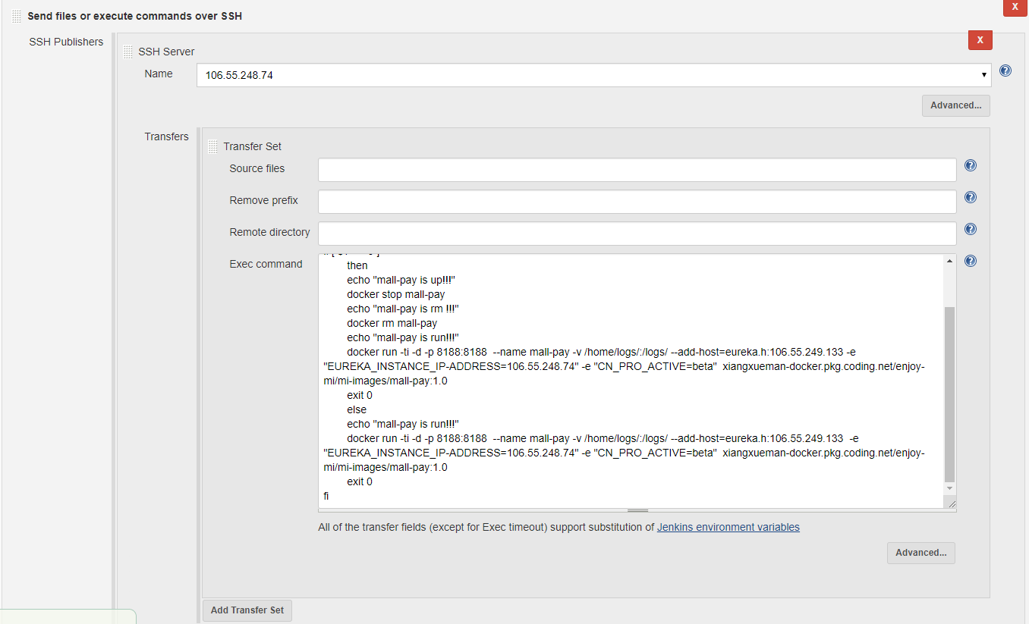
执行脚本
docker login -u 2181935941@qq.com -p 'XKcs_0731@123)$3' xiangxueman-docker.pkg.coding.net
docker pull xiangxueman-docker.pkg.coding.net/enjoy-mi/mi-images/mall-pay:1.0
docker ps | grep mall-pay &> /dev/null
if [ $? == 0 ]
then
echo "mall-pay is up!!!"
docker stop mall-pay
echo "mall-pay is rm !!!"
docker rm mall-pay
echo "mall-pay is run!!!"
docker run -ti -d -p 8188:8188 --name mall-pay -v /home/logs/:/logs/ --add-host=eureka.h:106.55.249.133 -e "EUREKA_INSTANCE_IP-ADDRESS=106.55.248.74" -e "CN_PRO_ACTIVE=beta" xiangxueman-docker.pkg.coding.net/enjoy-mi/mi-images/mall-pay:1.0
exit 0
else
echo "mall-pay is run!!!"
docker run -ti -d -p 8188:8188 --name mall-pay -v /home/logs/:/logs/ --add-host=eureka.h:106.55.249.133 -e "EUREKA_INSTANCE_IP-ADDRESS=106.55.248.74" -e "CN_PRO_ACTIVE=beta" xiangxueman-docker.pkg.coding.net/enjoy-mi/mi-images/mall-pay:1.0
exit 0
fi

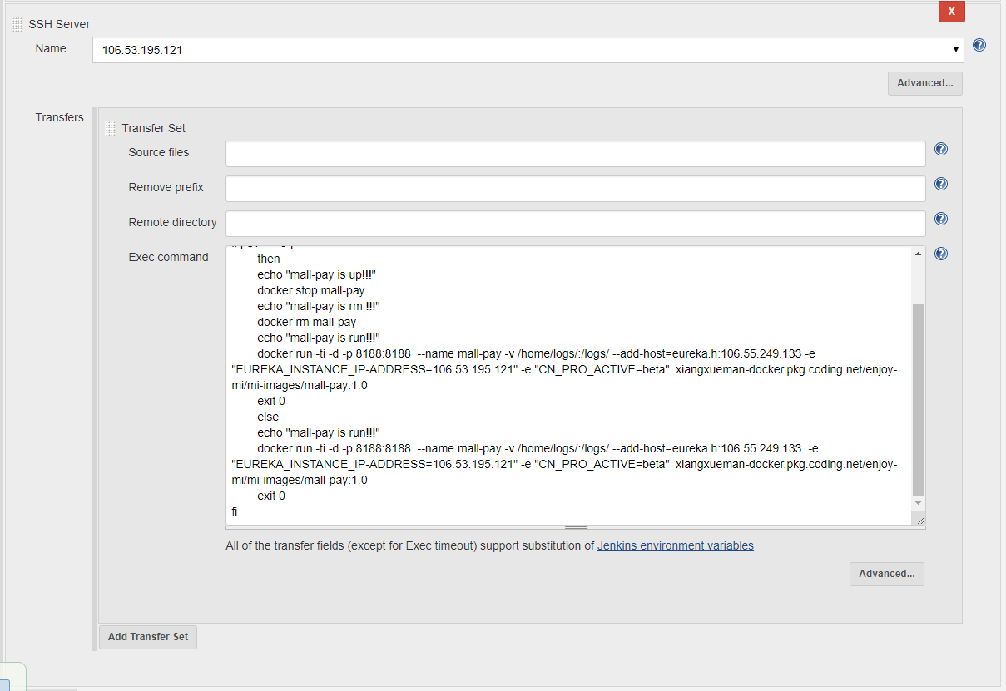
执行脚本
docker login -u 2181935941@qq.com -p 'XKcs_0731@123)$3' xiangxueman-docker.pkg.coding.net
docker pull xiangxueman-docker.pkg.coding.net/enjoy-mi/mi-images/mall-pay:1.0
docker ps | grep mall-pay &> /dev/null
if [ $? == 0 ]
then
echo "mall-pay is up!!!"
docker stop mall-pay
echo "mall-pay is rm !!!"
docker rm mall-pay
echo "mall-pay is run!!!"
docker run -ti -d -p 8188:8188 --name mall-pay -v /home/logs/:/logs/ --add-host=eureka.h:106.55.249.133 -e "EUREKA_INSTANCE_IP-ADDRESS=106.53.195.121" -e "CN_PRO_ACTIVE=beta" xiangxueman-docker.pkg.coding.net/enjoy-mi/mi-images/mall-pay:1.0
exit 0
else
echo "mall-pay is run!!!"
docker run -ti -d -p 8188:8188 --name mall-pay -v /home/logs/:/logs/ --add-host=eureka.h:106.55.249.133 -e "EUREKA_INSTANCE_IP-ADDRESS=106.53.195.121" -e "CN_PRO_ACTIVE=beta" xiangxueman-docker.pkg.coding.net/enjoy-mi/mi-images/mall-pay:1.0
exit 0
fi

mall-product-service
项目构建
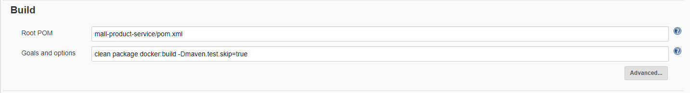
Push镜像到镜像仓库
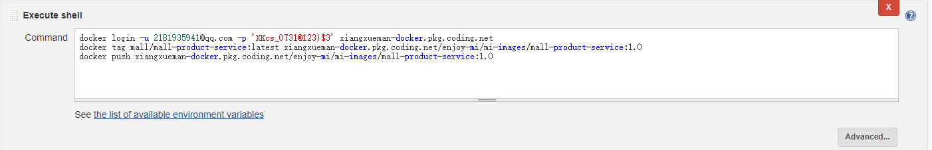
docker login -u 2181935941@qq.com -p 'XKcs_0731@123)$3' xiangxueman-docker.pkg.coding.net
docker tag mall/mall-product-service:latest xiangxueman-docker.pkg.coding.net/enjoy-mi/mi-images/mall-product-service:1.0
docker push xiangxueman-docker.pkg.coding.net/enjoy-mi/mi-images/mall-product-service:1.0

远程发布
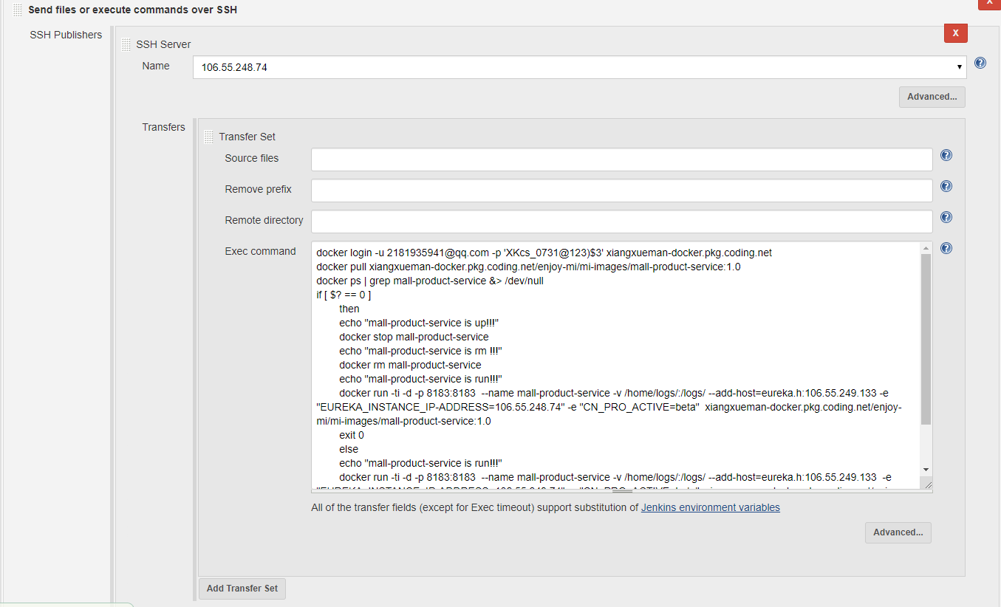
执行脚本
docker login -u 2181935941@qq.com -p 'XKcs_0731@123)$3' xiangxueman-docker.pkg.coding.net
docker pull xiangxueman-docker.pkg.coding.net/enjoy-mi/mi-images/mall-product-service:1.0
docker ps | grep mall-product-service &> /dev/null
if [ $? == 0 ]
then
echo "mall-product-service is up!!!"
docker stop mall-product-service
echo "mall-product-service is rm !!!"
docker rm mall-product-service
echo "mall-product-service is run!!!"
docker run -ti -d -p 8183:8183 --name mall-product-service -v /home/logs/:/logs/ --add-host=eureka.h:106.55.249.133 -e "EUREKA_INSTANCE_IP-ADDRESS=106.55.248.74" -e "CN_PRO_ACTIVE=beta" xiangxueman-docker.pkg.coding.net/enjoy-mi/mi-images/mall-product-service:1.0
exit 0
else
echo "mall-product-service is run!!!"
docker run -ti -d -p 8183:8183 --name mall-product-service -v /home/logs/:/logs/ --add-host=eureka.h:106.55.249.133 -e "EUREKA_INSTANCE_IP-ADDRESS=106.55.248.74" -e "CN_PRO_ACTIVE=beta" xiangxueman-docker.pkg.coding.net/enjoy-mi/mi-images/mall-product-service:1.0
exit 0
fi

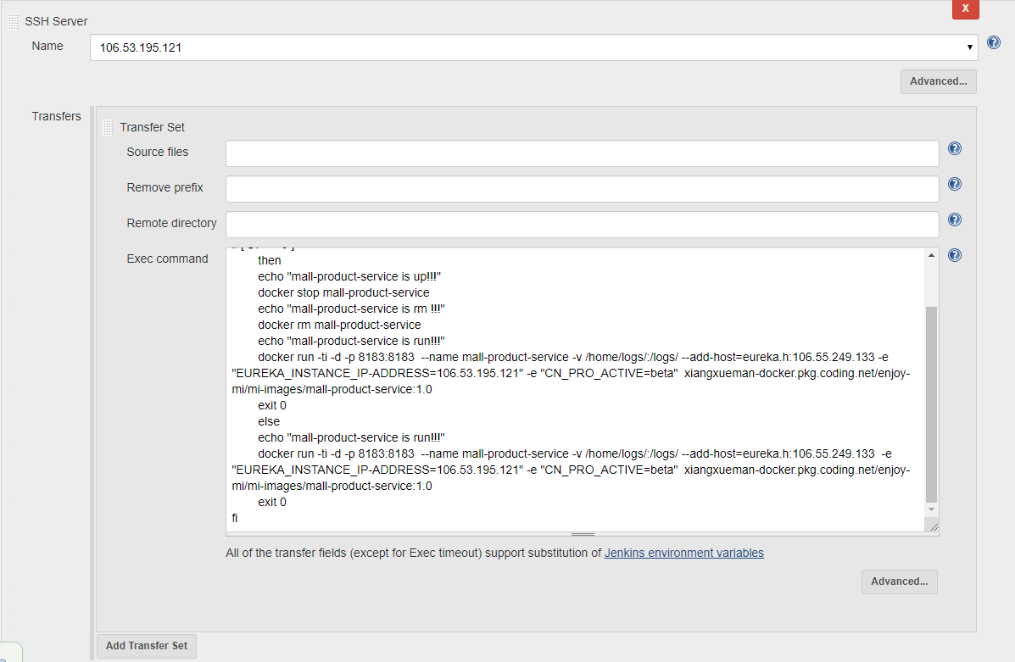
执行脚本
docker login -u 2181935941@qq.com -p 'XKcs_0731@123)$3' xiangxueman-docker.pkg.coding.net
docker pull xiangxueman-docker.pkg.coding.net/enjoy-mi/mi-images/mall-product-service:1.0
docker ps | grep mall-product-service &> /dev/null
if [ $? == 0 ]
then
echo "mall-product-service is up!!!"
docker stop mall-product-service
echo "mall-product-service is rm !!!"
docker rm mall-product-service
echo "mall-product-service is run!!!"
docker run -ti -d -p 8183:8183 --name mall-product-service -v /home/logs/:/logs/ --add-host=eureka.h:106.55.249.133 -e "EUREKA_INSTANCE_IP-ADDRESS=106.53.195.121" -e "CN_PRO_ACTIVE=beta" xiangxueman-docker.pkg.coding.net/enjoy-mi/mi-images/mall-product-service:1.0
exit 0
else
echo "mall-product-service is run!!!"
docker run -ti -d -p 8183:8183 --name mall-product-service -v /home/logs/:/logs/ --add-host=eureka.h:106.55.249.133 -e "EUREKA_INSTANCE_IP-ADDRESS=106.53.195.121" -e "CN_PRO_ACTIVE=beta" xiangxueman-docker.pkg.coding.net/enjoy-mi/mi-images/mall-product-service:1.0
exit 0
fi

mall-user-service
项目构建
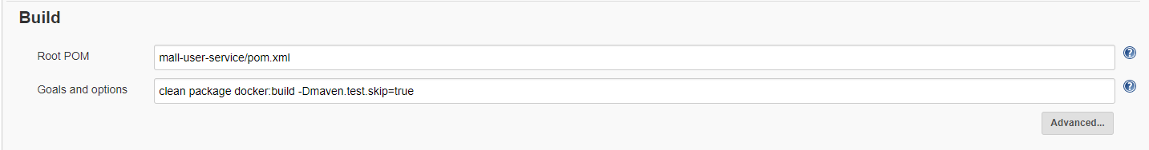
Push镜像到镜像仓库
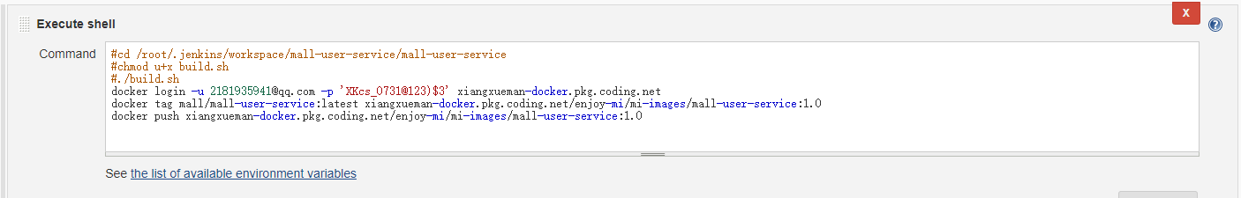
#cd /root/.jenkins/workspace/mall-user-service/mall-user-service
#chmod u+x build.sh
#./build.sh
docker login -u 2181935941@qq.com -p 'XKcs_0731@123)$3' xiangxueman-docker.pkg.coding.net
docker tag mall/mall-user-service:latest xiangxueman-docker.pkg.coding.net/enjoy-mi/mi-images/mall-user-service:1.0
docker push xiangxueman-docker.pkg.coding.net/enjoy-mi/mi-images/mall-user-service:1.0

远程发布
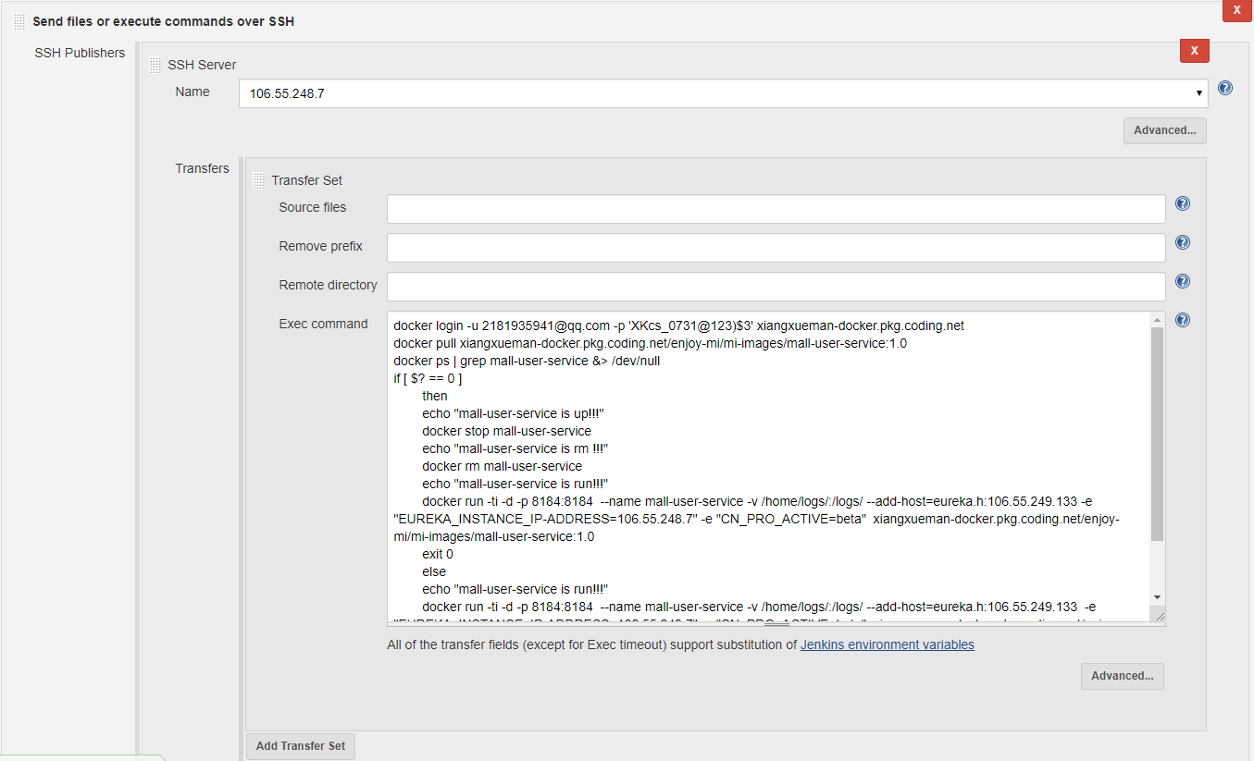
执行脚本
docker login -u 2181935941@qq.com -p 'XKcs_0731@123)$3' xiangxueman-docker.pkg.coding.net
docker pull xiangxueman-docker.pkg.coding.net/enjoy-mi/mi-images/mall-user-service:1.0
docker ps | grep mall-user-service &> /dev/null
if [ $? == 0 ]
then
echo "mall-user-service is up!!!"
docker stop mall-user-service
echo "mall-user-service is rm !!!"
docker rm mall-user-service
echo "mall-user-service is run!!!"
docker run -ti -d -p 8184:8184 --name mall-user-service -v /home/logs/:/logs/ --add-host=eureka.h:106.55.249.133 -e "EUREKA_INSTANCE_IP-ADDRESS=106.55.248.7" -e "CN_PRO_ACTIVE=beta" xiangxueman-docker.pkg.coding.net/enjoy-mi/mi-images/mall-user-service:1.0
exit 0
else
echo "mall-user-service is run!!!"
docker run -ti -d -p 8184:8184 --name mall-user-service -v /home/logs/:/logs/ --add-host=eureka.h:106.55.249.133 -e "EUREKA_INSTANCE_IP-ADDRESS=106.55.248.7" -e "CN_PRO_ACTIVE=beta" xiangxueman-docker.pkg.coding.net/enjoy-mi/mi-images/mall-user-service:1.0
exit 0
fi

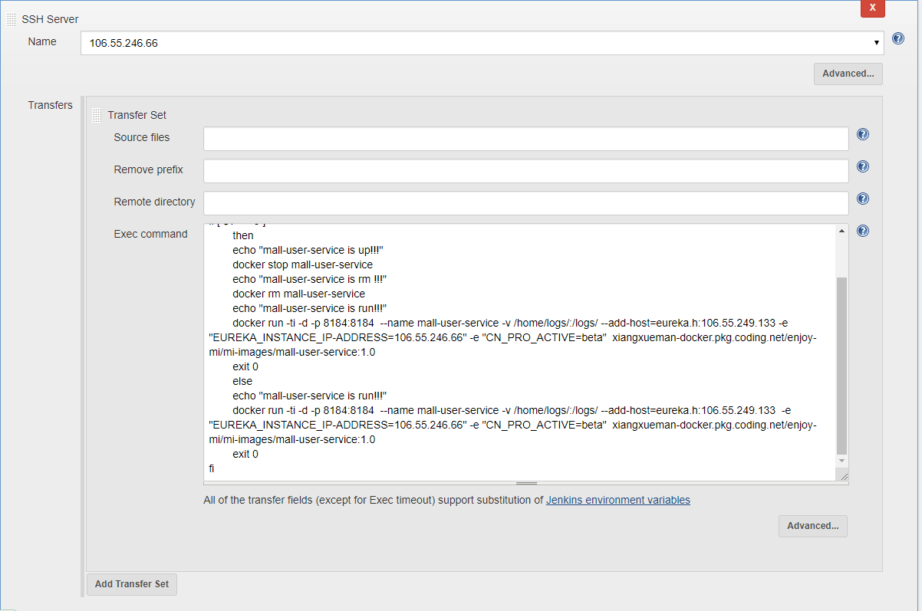
执行脚本
docker login -u 2181935941@qq.com -p 'XKcs_0731@123)$3' xiangxueman-docker.pkg.coding.net
docker pull xiangxueman-docker.pkg.coding.net/enjoy-mi/mi-images/mall-user-service:1.0
docker ps | grep mall-user-service &> /dev/null
if [ $? == 0 ]
then
echo "mall-user-service is up!!!"
docker stop mall-user-service
echo "mall-user-service is rm !!!"
docker rm mall-user-service
echo "mall-user-service is run!!!"
docker run -ti -d -p 8184:8184 --name mall-user-service -v /home/logs/:/logs/ --add-host=eureka.h:106.55.249.133 -e "EUREKA_INSTANCE_IP-ADDRESS=106.55.246.66" -e "CN_PRO_ACTIVE=beta" xiangxueman-docker.pkg.coding.net/enjoy-mi/mi-images/mall-user-service:1.0
exit 0
else
echo "mall-user-service is run!!!"
docker run -ti -d -p 8184:8184 --name mall-user-service -v /home/logs/:/logs/ --add-host=eureka.h:106.55.249.133 -e "EUREKA_INSTANCE_IP-ADDRESS=106.55.246.66" -e "CN_PRO_ACTIVE=beta" xiangxueman-docker.pkg.coding.net/enjoy-mi/mi-images/mall-user-service:1.0
exit 0
fi

mall-web-mng
项目构建
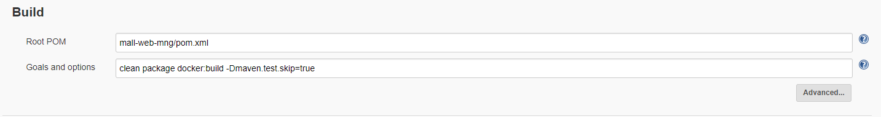
Push镜像到镜像仓库
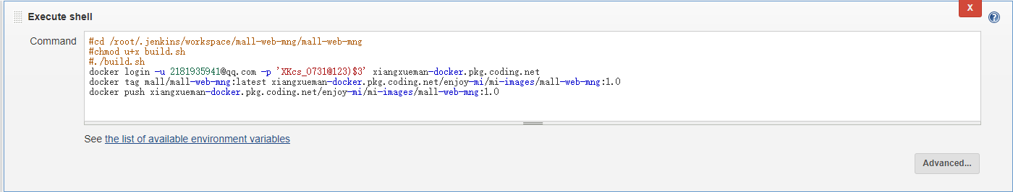
#cd /root/.jenkins/workspace/mall-web-mng/mall-web-mng
#chmod u+x build.sh
#./build.sh
docker login -u 2181935941@qq.com -p 'XKcs_0731@123)$3' xiangxueman-docker.pkg.coding.net
docker tag mall/mall-web-mng:latest xiangxueman-docker.pkg.coding.net/enjoy-mi/mi-images/mall-web-mng:1.0
docker push xiangxueman-docker.pkg.coding.net/enjoy-mi/mi-images/mall-web-mng:1.0
远程发布
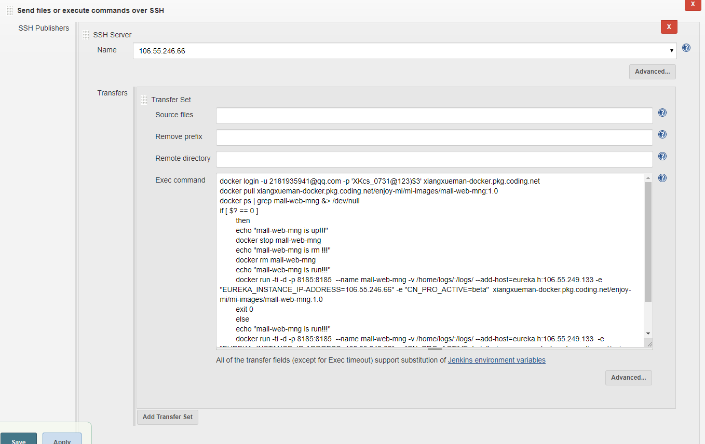
执行脚本
docker login -u 2181935941@qq.com -p 'XKcs_0731@123)$3' xiangxueman-docker.pkg.coding.net
docker pull xiangxueman-docker.pkg.coding.net/enjoy-mi/mi-images/mall-web-mng:1.0
docker ps | grep mall-web-mng &> /dev/null
if [ $? == 0 ]
then
echo "mall-web-mng is up!!!"
docker stop mall-web-mng
echo "mall-web-mng is rm !!!"
docker rm mall-web-mng
echo "mall-web-mng is run!!!"
docker run -ti -d -p 8185:8185 --name mall-web-mng -v /home/logs/:/logs/ --add-host=eureka.h:106.55.249.133 -e "EUREKA_INSTANCE_IP-ADDRESS=106.55.246.66" -e "CN_PRO_ACTIVE=beta" xiangxueman-docker.pkg.coding.net/enjoy-mi/mi-images/mall-web-mng:1.0
exit 0
else
echo "mall-web-mng is run!!!"
docker run -ti -d -p 8185:8185 --name mall-web-mng -v /home/logs/:/logs/ --add-host=eureka.h:106.55.249.133 -e "EUREKA_INSTANCE_IP-ADDRESS=106.55.246.66" -e "CN_PRO_ACTIVE=beta" xiangxueman-docker.pkg.coding.net/enjoy-mi/mi-images/mall-web-mng:1.0
exit 0
fi
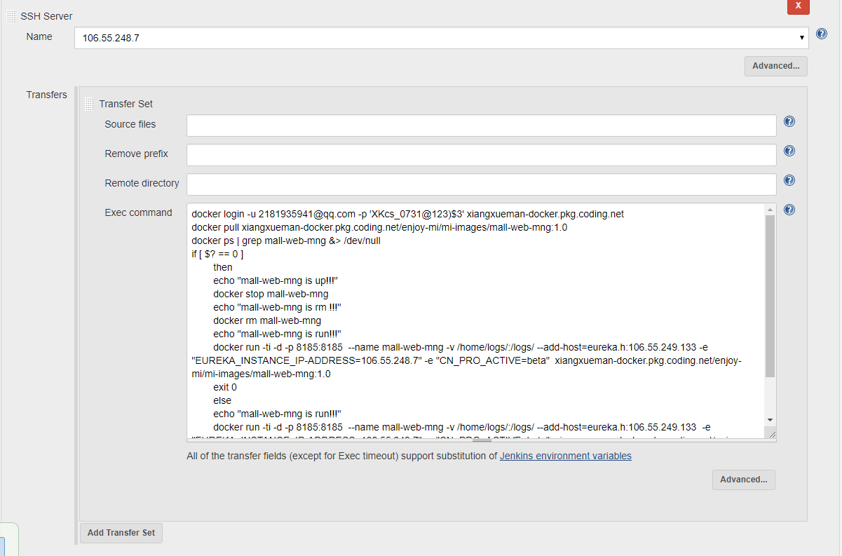
执行脚本
docker login -u 2181935941@qq.com -p 'XKcs_0731@123)$3' xiangxueman-docker.pkg.coding.net
docker pull xiangxueman-docker.pkg.coding.net/enjoy-mi/mi-images/mall-web-mng:1.0
docker ps | grep mall-web-mng &> /dev/null
if [ $? == 0 ]
then
echo "mall-web-mng is up!!!"
docker stop mall-web-mng
echo "mall-web-mng is rm !!!"
docker rm mall-web-mng
echo "mall-web-mng is run!!!"
docker run -ti -d -p 8185:8185 --name mall-web-mng -v /home/logs/:/logs/ --add-host=eureka.h:106.55.249.133 -e "EUREKA_INSTANCE_IP-ADDRESS=106.55.248.7" -e "CN_PRO_ACTIVE=beta" xiangxueman-docker.pkg.coding.net/enjoy-mi/mi-images/mall-web-mng:1.0
exit 0
else
echo "mall-web-mng is run!!!"
docker run -ti -d -p 8185:8185 --name mall-web-mng -v /home/logs/:/logs/ --add-host=eureka.h:106.55.249.133 -e "EUREKA_INSTANCE_IP-ADDRESS=106.55.248.7" -e "CN_PRO_ACTIVE=beta" xiangxueman-docker.pkg.coding.net/enjoy-mi/mi-images/mall-web-mng:1.0
exit 0
fi

mall-web-order
项目构建
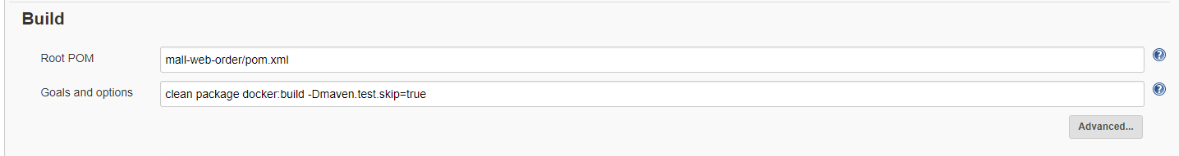
Push镜像到镜像仓库
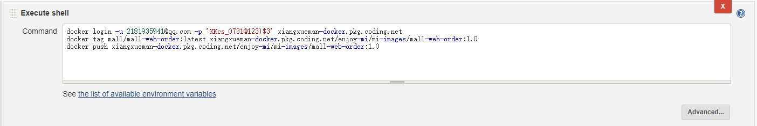
docker login -u 2181935941@qq.com -p 'XKcs_0731@123)$3' xiangxueman-docker.pkg.coding.net
docker tag mall/mall-web-order:latest xiangxueman-docker.pkg.coding.net/enjoy-mi/mi-images/mall-web-order:1.0
docker push xiangxueman-docker.pkg.coding.net/enjoy-mi/mi-images/mall-web-order:1.0
远程发布
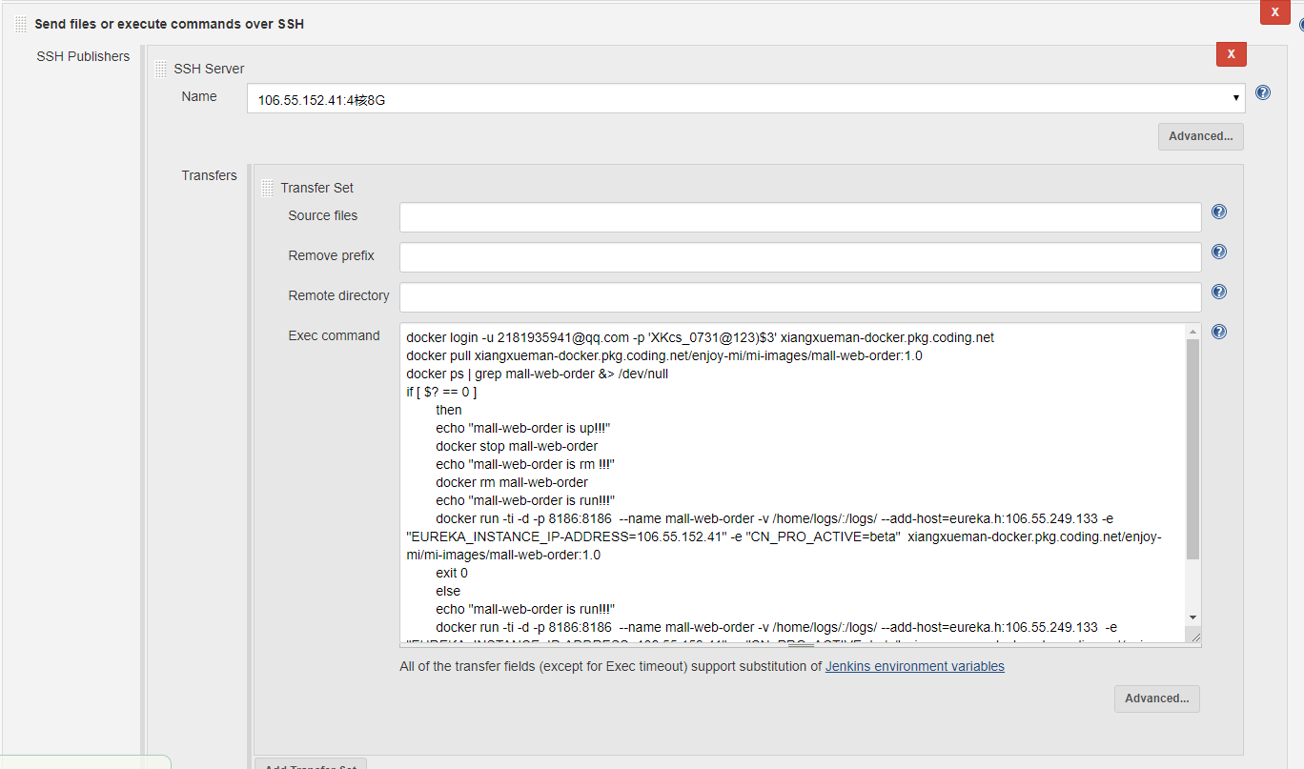
执行脚本
docker login -u 2181935941@qq.com -p 'XKcs_0731@123)$3' xiangxueman-docker.pkg.coding.net
docker pull xiangxueman-docker.pkg.coding.net/enjoy-mi/mi-images/mall-web-order:1.0
docker ps | grep mall-web-order &> /dev/null
if [ $? == 0 ]
then
echo "mall-web-order is up!!!"
docker stop mall-web-order
echo "mall-web-order is rm !!!"
docker rm mall-web-order
echo "mall-web-order is run!!!"
docker run -ti -d -p 8186:8186 --name mall-web-order -v /home/logs/:/logs/ --add-host=eureka.h:106.55.249.133 -e "EUREKA_INSTANCE_IP-ADDRESS=106.55.152.41" -e "CN_PRO_ACTIVE=beta" xiangxueman-docker.pkg.coding.net/enjoy-mi/mi-images/mall-web-order:1.0
exit 0
else
echo "mall-web-order is run!!!"
docker run -ti -d -p 8186:8186 --name mall-web-order -v /home/logs/:/logs/ --add-host=eureka.h:106.55.249.133 -e "EUREKA_INSTANCE_IP-ADDRESS=106.55.152.41" -e "CN_PRO_ACTIVE=beta" xiangxueman-docker.pkg.coding.net/enjoy-mi/mi-images/mall-web-order:1.0
exit 0
fi
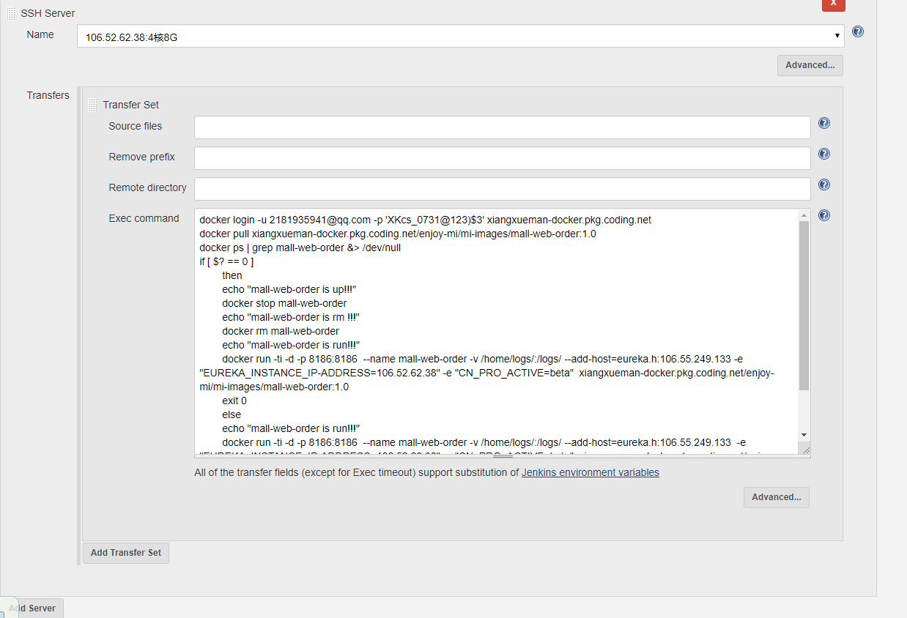
执行脚本
docker login -u 2181935941@qq.com -p 'XKcs_0731@123)$3' xiangxueman-docker.pkg.coding.net
docker pull xiangxueman-docker.pkg.coding.net/enjoy-mi/mi-images/mall-web-order:1.0
docker ps | grep mall-web-order &> /dev/null
if [ $? == 0 ]
then
echo "mall-web-order is up!!!"
docker stop mall-web-order
echo "mall-web-order is rm !!!"
docker rm mall-web-order
echo "mall-web-order is run!!!"
docker run -ti -d -p 8186:8186 --name mall-web-order -v /home/logs/:/logs/ --add-host=eureka.h:106.55.249.133 -e "EUREKA_INSTANCE_IP-ADDRESS=106.52.62.38" -e "CN_PRO_ACTIVE=beta" xiangxueman-docker.pkg.coding.net/enjoy-mi/mi-images/mall-web-order:1.0
exit 0
else
echo "mall-web-order is run!!!"
docker run -ti -d -p 8186:8186 --name mall-web-order -v /home/logs/:/logs/ --add-host=eureka.h:106.55.249.133 -e "EUREKA_INSTANCE_IP-ADDRESS=106.52.62.38" -e "CN_PRO_ACTIVE=beta" xiangxueman-docker.pkg.coding.net/enjoy-mi/mi-images/mall-web-order:1.0
exit 0
fi

mall-zuul
项目构建
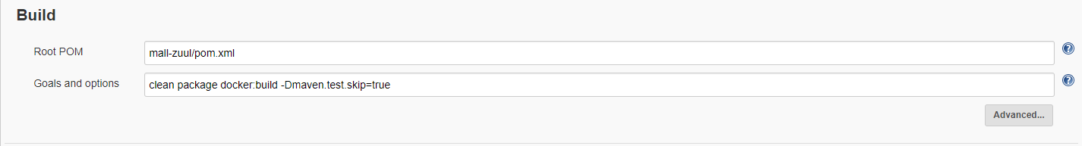
Push镜像到镜像仓库
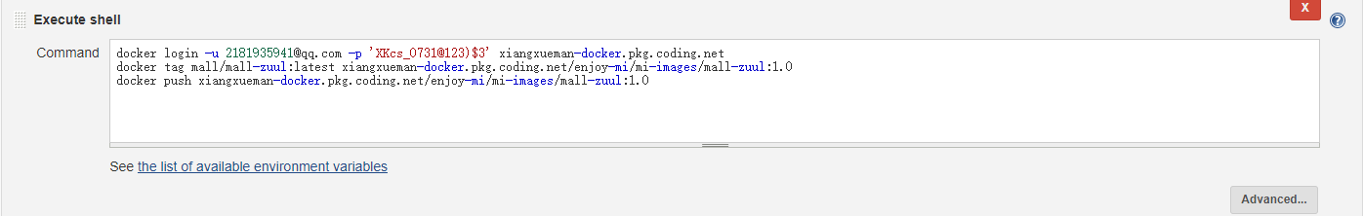
docker login -u 2181935941@qq.com -p 'XKcs_0731@123)$3' xiangxueman-docker.pkg.coding.net
docker tag mall/mall-zuul:latest xiangxueman-docker.pkg.coding.net/enjoy-mi/mi-images/mall-zuul:1.0
docker push xiangxueman-docker.pkg.coding.net/enjoy-mi/mi-images/mall-zuul:1.0
远程发布
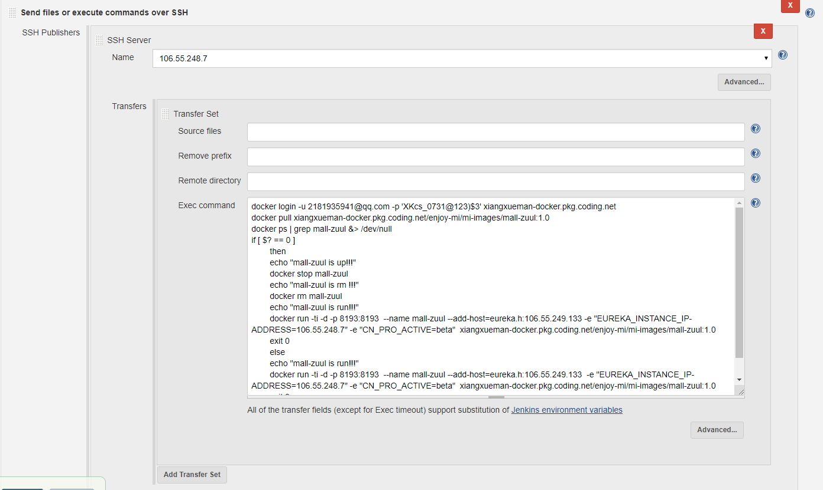
执行脚本
docker login -u 2181935941@qq.com -p 'XKcs_0731@123)$3' xiangxueman-docker.pkg.coding.net
docker pull xiangxueman-docker.pkg.coding.net/enjoy-mi/mi-images/mall-zuul:1.0
docker ps | grep mall-zuul &> /dev/null
if [ $? == 0 ]
then
echo "mall-zuul is up!!!"
docker stop mall-zuul
echo "mall-zuul is rm !!!"
docker rm mall-zuul
echo "mall-zuul is run!!!"
docker run -ti -d -p 8193:8193 --name mall-zuul --add-host=eureka.h:106.55.249.133 -e "EUREKA_INSTANCE_IP-ADDRESS=106.55.248.7" -e "CN_PRO_ACTIVE=beta" xiangxueman-docker.pkg.coding.net/enjoy-mi/mi-images/mall-zuul:1.0
exit 0
else
echo "mall-zuul is run!!!"
docker run -ti -d -p 8193:8193 --name mall-zuul --add-host=eureka.h:106.55.249.133 -e "EUREKA_INSTANCE_IP-ADDRESS=106.55.248.7" -e "CN_PRO_ACTIVE=beta" xiangxueman-docker.pkg.coding.net/enjoy-mi/mi-images/mall-zuul:1.0
exit 0
fi
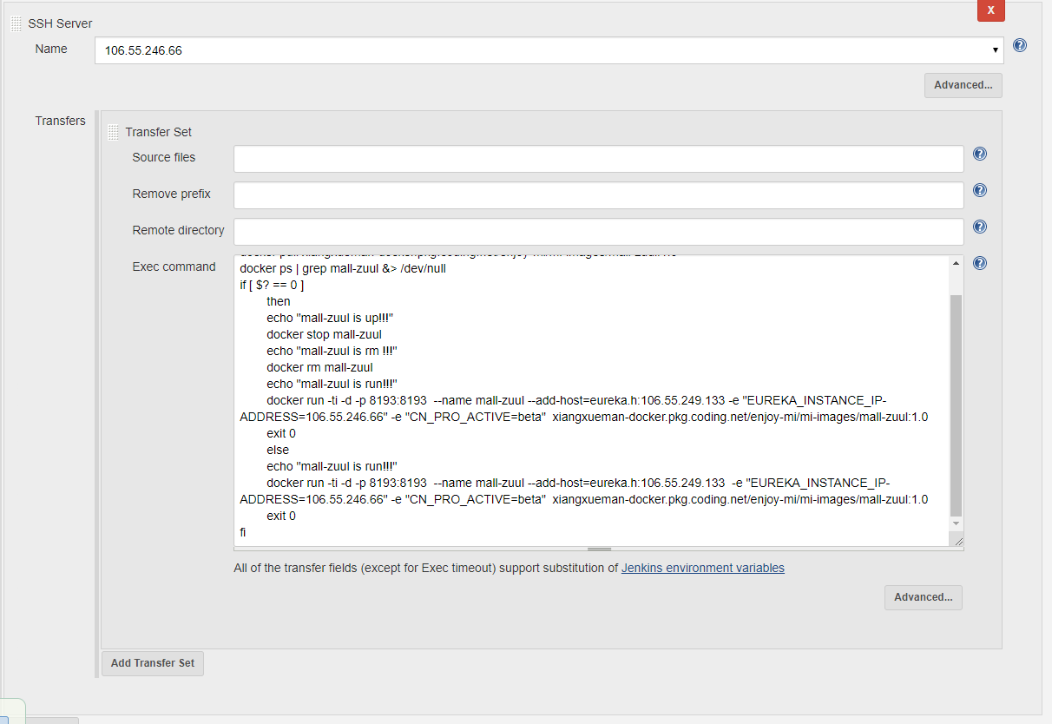
执行脚本
docker login -u 2181935941@qq.com -p 'XKcs_0731@123)$3' xiangxueman-docker.pkg.coding.net
docker pull xiangxueman-docker.pkg.coding.net/enjoy-mi/mi-images/mall-zuul:1.0
docker ps | grep mall-zuul &> /dev/null
if [ $? == 0 ]
then
echo "mall-zuul is up!!!"
docker stop mall-zuul
echo "mall-zuul is rm !!!"
docker rm mall-zuul
echo "mall-zuul is run!!!"
docker run -ti -d -p 8193:8193 --name mall-zuul --add-host=eureka.h:106.55.249.133 -e "EUREKA_INSTANCE_IP-ADDRESS=106.55.246.66" -e "CN_PRO_ACTIVE=beta" xiangxueman-docker.pkg.coding.net/enjoy-mi/mi-images/mall-zuul:1.0
exit 0
else
echo "mall-zuul is run!!!"
docker run -ti -d -p 8193:8193 --name mall-zuul --add-host=eureka.h:106.55.249.133 -e "EUREKA_INSTANCE_IP-ADDRESS=106.55.246.66" -e "CN_PRO_ACTIVE=beta" xiangxueman-docker.pkg.coding.net/enjoy-mi/mi-images/mall-zuul:1.0
exit 0
fi

项目架构图

