Modals, Shaped Images and Carousels

In this exercise, you will work with various bootstrap components and classes including modals, shaped images, and carousels (image sliders) There will be a guided portion and an “on your own section” Please follow instructions and complete both parts of this exercise as you will be graded on both parts.

# Modals

First, you will work with modals.

1. Download the zipped start files from blackboard (attached to the assignment dropbox) Once you unzip the files, locate the ModalStartFile.html and observe the code. You will see it is just a basic bootstrap template that we will customize and add to.

2. To get started, let’s visit the bootstrap documentation site page for modals: <https://getbootstrap.com/docs/4.3/components/modal/>

3. Here you can find information about modals and pre-built components you can implement and modify. We will start with a pre-built component. Scroll down and find the second pre-built component demo labeled as live demo.

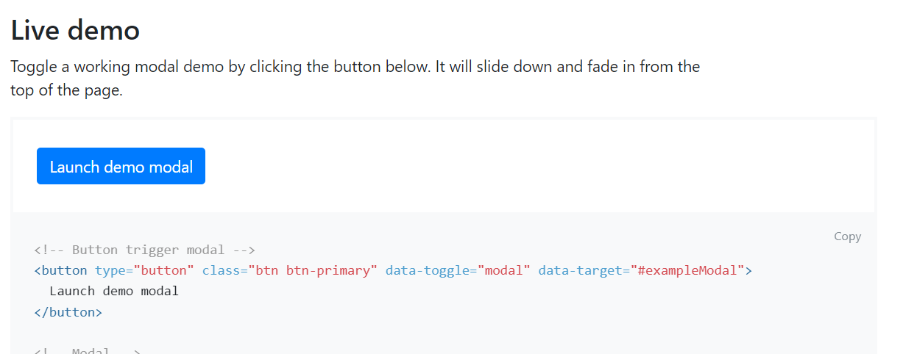

**Click the copy button next to the pre-built code and paste it into your modal start file just below the h1 element:**

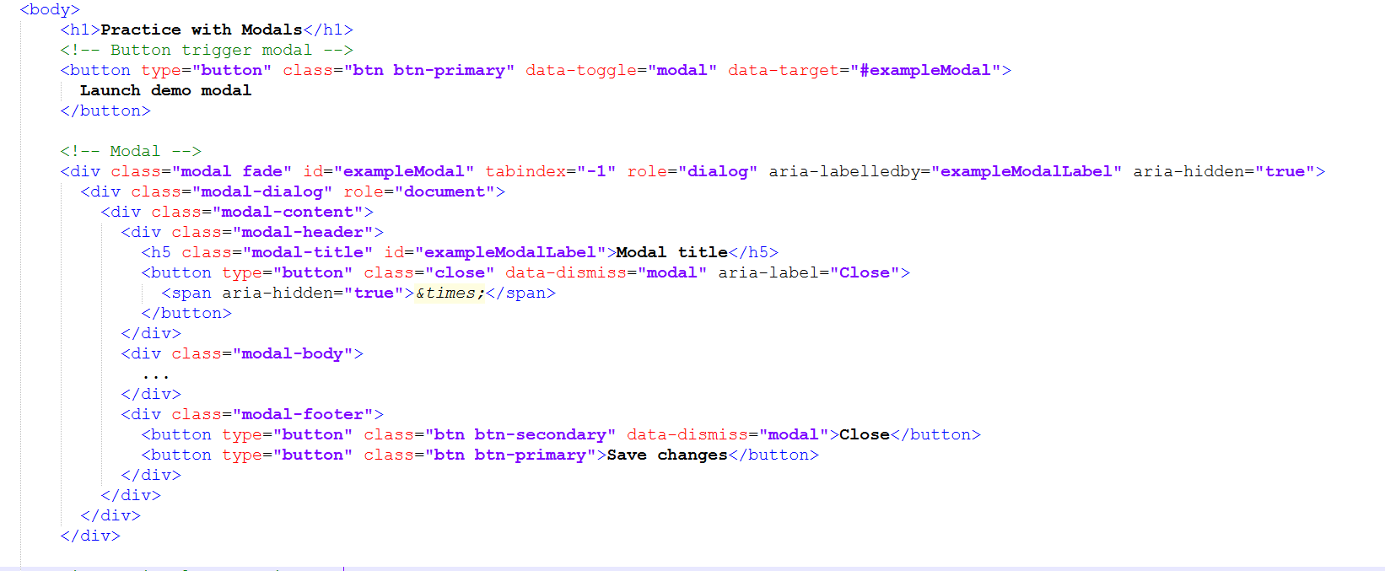

A few notes about the modal code.

There is a button trigger for the modal. When clicked, this button will launch the modal

The modal itself depend on JavaScript to work which is by default always linked in the started template provided on the bootstrap site.

The modal has several sections such as the modal content, modal header, modal title, modal body, and modal footer. At the bottom of the modal, you see there are various buttons. One is to close the modal and one is to “save changes” We will make some changes there soon.

Let’s customize the modal starting with the button trigger.

4. You can customize the button text and styles to your liking. Let’s change the text first.

Change the text that currently reads “launch demo modal” to “click here for more info!”



Preview the change sin browser and click the button to see what happens.

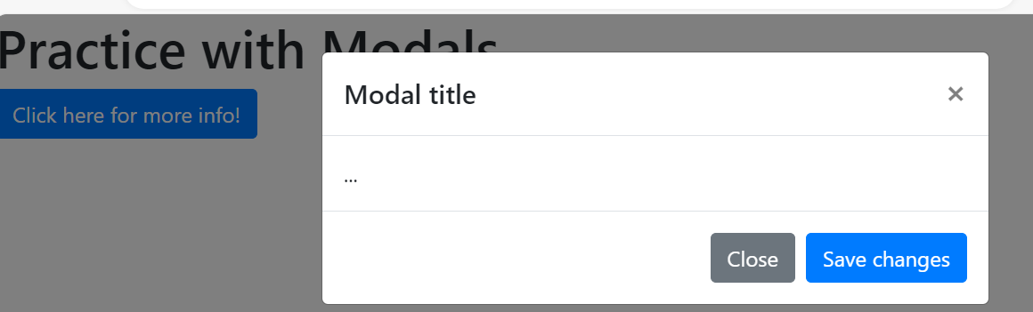

You will notice a pop up appears. It contains a heading that says modal title, …, and close and save buttons.

Let’s make some more adjustments.

5. Within the modal, update the h5 element to contain the text “general info”

Update the h5 text in the modal to read "general info"

6. Change what is in the div assigned the class modal body. In my screenshot below, I put a paragraph. You can put a table, a list, paragraphs, a sign-up form, anything you want! This is entirely open ended and will be left up to the student. I am going to keep it simple but I encourage you to have fun with it.



Now preview your changes in the browser.

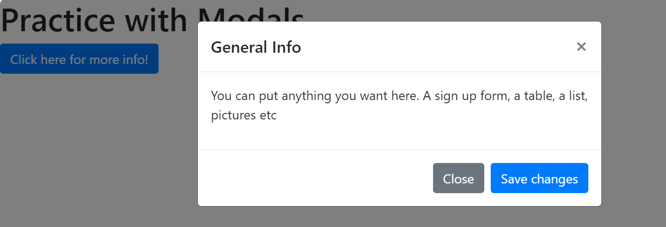

The content I put in modal body now appears in the center of the modal.

7. Next, I am going to delete the save changes button from the modal.

Simply delete the button element that has button text “save changes”

Your modal footer code will now look like this

<div class="modal-footer">
<button type="button" class="btn btn-secondary" data-dismiss="modal">Close</button></div>

8. Lastly, you can add some custom styles to the modal via CSS and/or contextual classes. First, let’s apply a contextual class to the close button the modal footer.

Update the button in the footer to have the class btn-danger instead of btn-secondary. Your updated code should look like this. The updated classes are outlined in red in the screenshot below.

button classes in modal-footer have been updated to "btn btn-danger"

The code outlined in red reads "btn btn-danger"

9. Next, add this declaration to the stylesheet modal.css

#exampleModal h5 {
color: #4d76ff
}

This changes the color of the h5 within the modal. Refresh your page, launch your modal and observe.

# Shaped Images

Bootstrap allows you to add classes that add shapes to your images.

Learn more here: <https://www.w3schools.com/bootstrap4/bootstrap_images.asp>

1. open the file shapedImagesStartFile.html

2. Observe the code. There is a simple grid with 3 images.

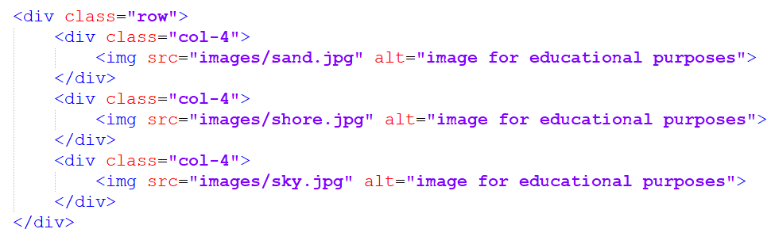

This is what the file looks like in browser:

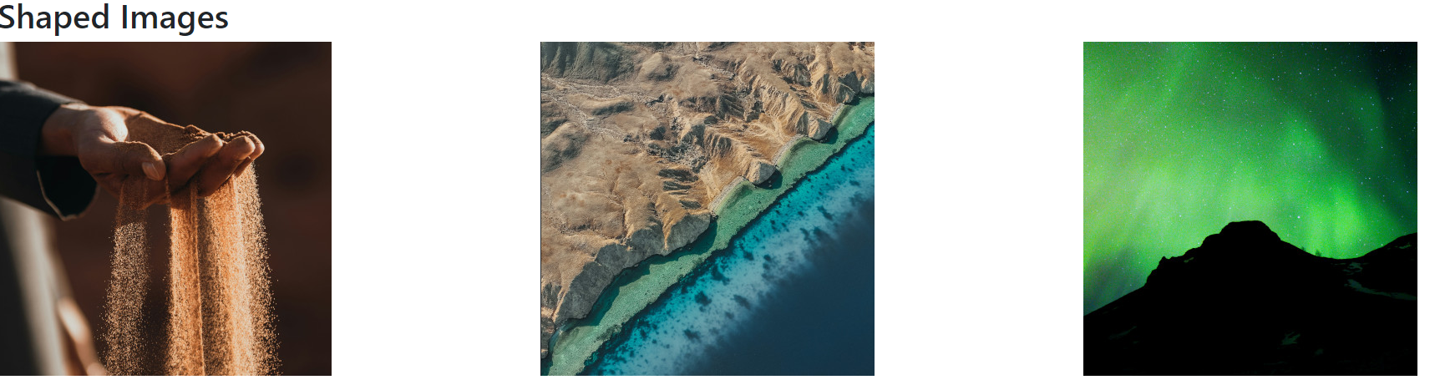

4. For this exercise, you will add the following classes:

Add the rounded class to the sand image

Add the rounded-circle to the shore image

Add the img-thumbnail class to the sky image

See the code below for reference (newly added code is outlined in red)

Add the rounded class to the sand image
Add the rounded-circle to the shore image
Add the img-thumbnail class to the sky image

The newly added code is outlined in red and reads
class="rounded"
class="rounded-circle"
class="img-thumbnail"

The changes on the first and last image are subtle but present. The first image has rounded corners and the last image has a border around it. 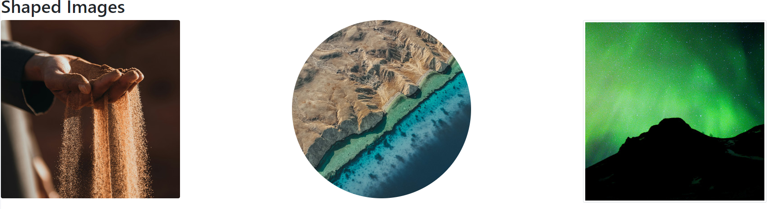

# Carousel

In this section, you will create a carousel. You can learn more about carousels here

<https://getbootstrap.com/docs/4.3/components/carousel/>

1. open the file carouselstartfile.html

You will notice there is already a carousel in the code, but it does not contain images. This section will discuss some of the code.

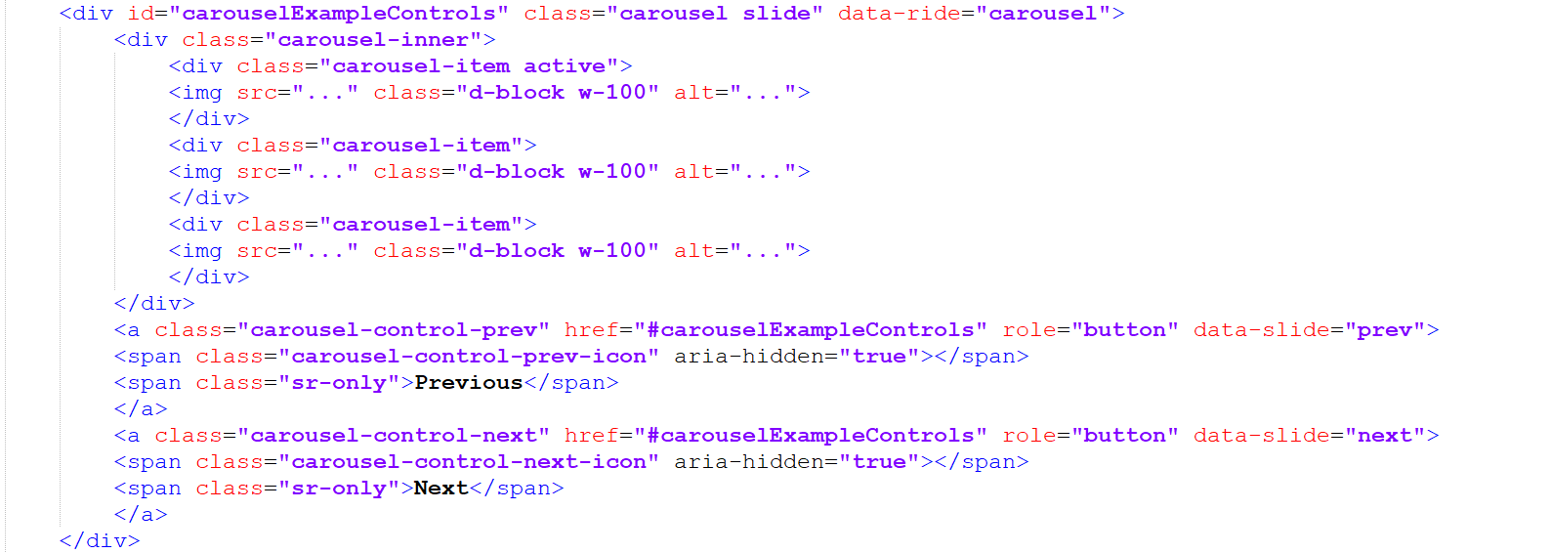

The carousel is contained in a div assigned an id of carouselExampleControls. The carousel is dependent on JavaScript to function as desired (the bootstrap JavaScript file is linked at the bottom of the start file)

You can see that there are divs with classes of carousel item for each image that will be placed into the carousel. Additionally, you can see there are black spaces (…) for the img src attribute and the alt attribute.

Each image is given a class of d-block and w-100. This sets the image to display block via bootstrap styles and sets the width of the image to 100%.

Lastly, beyond the images, there are controls for previous and next buttons.

2. To complete this exercise, find 3 images of your choosing and add them the carousel. Make sure to test the page to ensure that your carousel works.

Once you are finished with all activities, please zip and upload all files and submit to the dropbox. No need to upload to the server.