1. Create a folder for your bootstrap site. Within that folder, create 2 sub folders: css & images

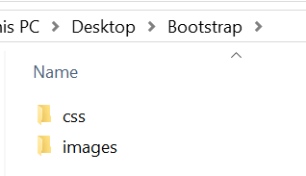

2. Go to the bootstrap documentation getting started page for version 4.3: <https://getbootstrap.com/docs/4.3/getting-started/introduction/>

3. Locate the starter template.

4. You will need to scroll to find the starter template (see image below) – When you find it, you can click the “copy” button in the upper right-hand corner of the code.

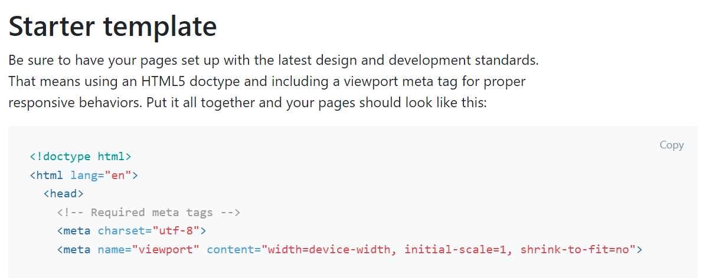

5. Paste the copied code into your text editor.

6. Save this first file as “index.html” to your bootstrap folder

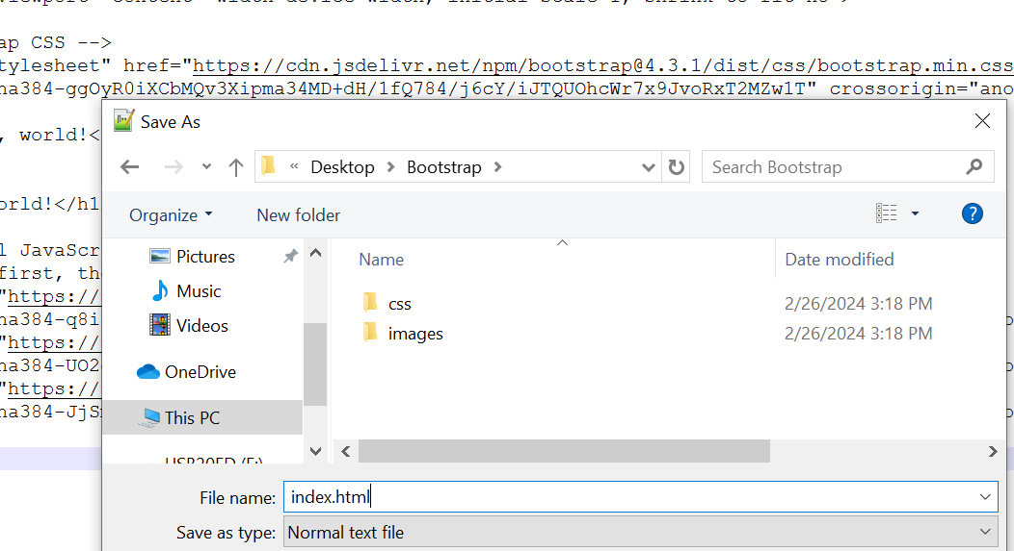

7. In the index.html page, edit the title so that the title matches the purpose of the homepage of your site. Edit the h1, so the h1 matches the purpose of the homepage. Add a navbar with functioning links. A simple nav element with anchor tags will do for now as you will learn how to create a responsive bootstrap navbar later. When setting up your links, take note of what you enter in the href attribute as you will then name your pages accordingly.

I.e.: below I have index.html, about.html, products.html and contact.html. I will have a page called index.html, a page called about.html, a page called products.html and a page called contact.html.

Additionally, you can see I went with generic title and h1 text. You can be more specific to your topic.

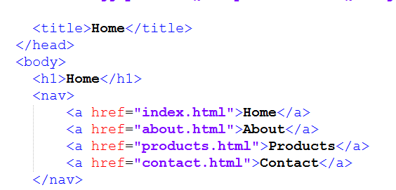

Lastly, add a stylesheet link to your index.html page

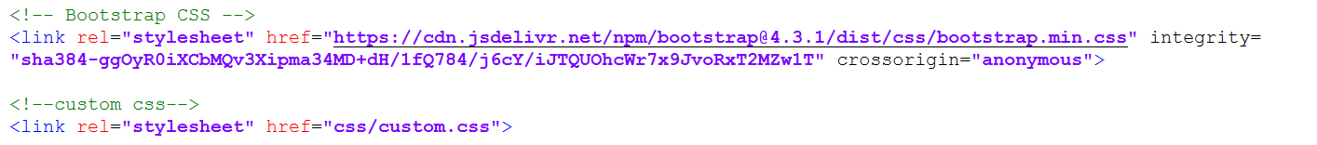

Please note that the stylesheet link for the custom.css file should go BELOW the bootstrap CSS.

8. Copy the code from the index.html file into a new blank document – no need to return to the starter template on the bootstrap documentation. Let’s save some time.

9. Create a new document in your text editor and paste the code from the index.html file into the new document.

10. save the new document as whatever your next page is. My next page is about.html so I will save mine accordingly.

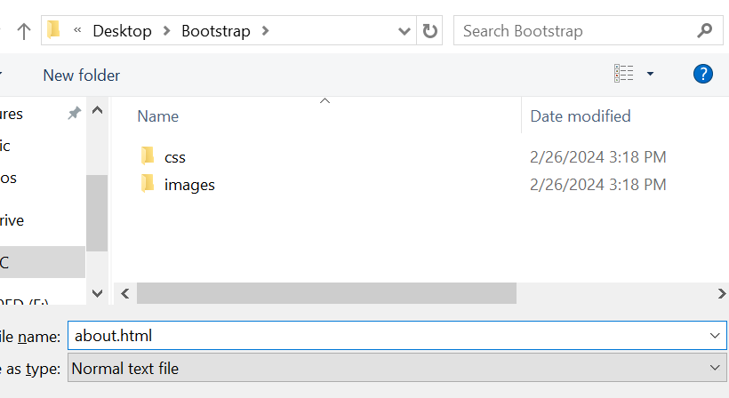

11. edit this new page so that the title and h1 have appropriate text for the page.

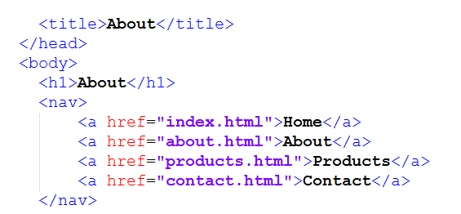

Please note that the nav does not change because it should be the same on each page. The link to the custom stylesheet should also be left alone.

12. Repeat steps 8-11 for the remaining pages. When finished, your folder should look like this:

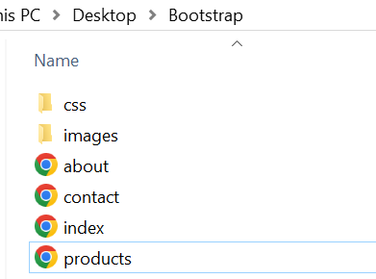

13. Finally, you will need to create the css file that you have linked to. – you don’t have to add any styles to your custom.css file yet, but I will be checking that it is there and ready to utilize in future labs.

Open your text editor and create a new blank document and save it to your css folder within your bootstrap folder as custom.css

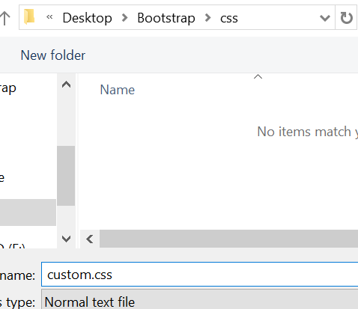

14. When complete, your CSS folder will not contain a custom CSS file.

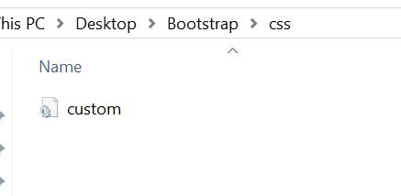

15. Once you create all of your pages, you should have a page for each page in your site. Each page should have a unique title and h1 tag. Furthermore, your navigation should be fully functioning. I should be able to access any page from any page. Lastly, each page should link to the external stylesheet “custom.css.” You don’t have to add any styles there yet, but you will in future weeks. Make sure that you’re testing your navigation to ensure it does work.

Here are all of my basic pages as a result of this lab. **Note**: Bootstrap styles have some default styling which you can override later which is why you’ll see these pages have sans-serif font and light blue links

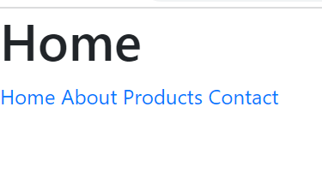 





16. Lastly, upload your bootstrap site to the live server, creating a link to this project on your landing page. And make sure to zip your bootstrap folder + files and submit to the dropbox along with a comment sharing your live URL.