Tables, Buttons, and Icons

In this exercise, you will be updating a table with bootstrap classes. In the first half of the exercise, the code to add is provided. You just need to read and follow along. In the second half of the exercise, there is an “on your own” section where you will be asked to add classes of your choosing and add comments where you made your own changes. Please complete both parts of these directions.

1. Download the start file attached to this dropbox and edit the html document in your favorite text editor.
2. You will see basic HTML file that contains links to the bootstrap CSS via CDN and the font awesome icon library.

Starting file in browser

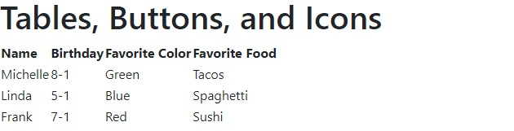

3. To make this a bootstrap table, apply the class of table to the table element.



It makes a significant difference:

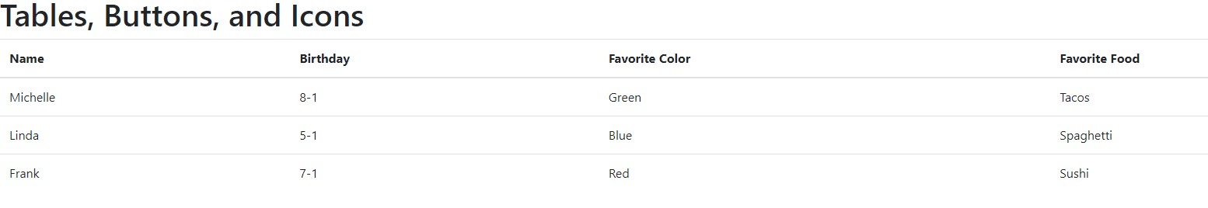

4. Next, let’s change the style of the table by condensing it.

Update the table classes:

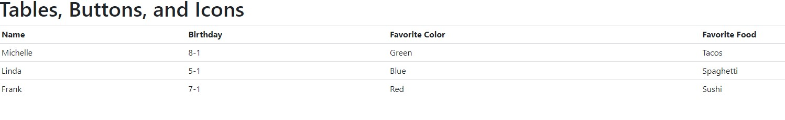

Notice this reduces some of the gaps between rows (compared to the previous iteration of the table)

We can add some of the bootstrap classes to add some style:

5. Update your classes accordingly:



This will stripe the table and make the first row (the content in the thead section darker)

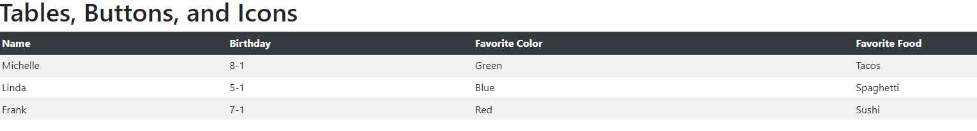

If we want to, we can apply a container class to our whole document as well, to keep this design from spanning across the entire screen.

6. Place an opening div tag with a class of container just after the opening body tag.

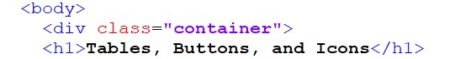

And place a closing div tag just before the closing body tag.

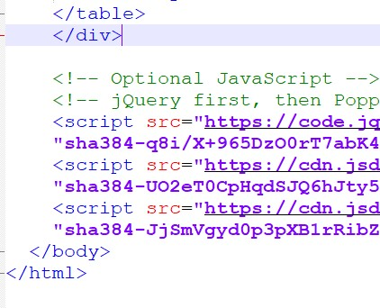

The result:

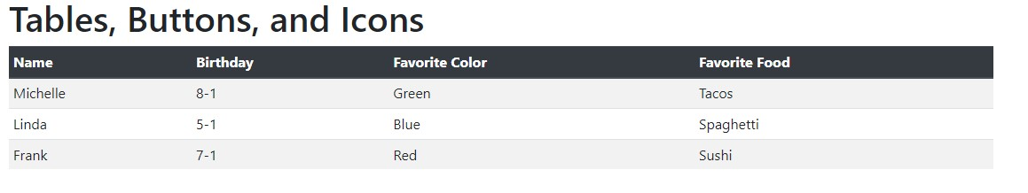

Let’s bring the favorite color column to life by adding some contextual classes (just for fun):

7. Add the following classes:

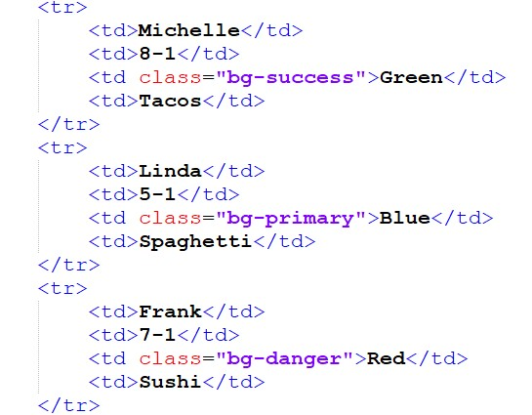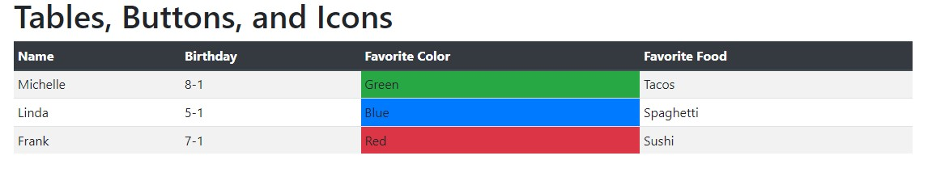

Next, let’s talk about buttons. We can insert any content we want into tables, so let’s add some buttons. Perhaps we want to convert the favorite food column into buttons that link to recipe pages for those food items or restaurants that serve them.

8. Update your code to make the fourth cell in each row a button. See screenshot below:

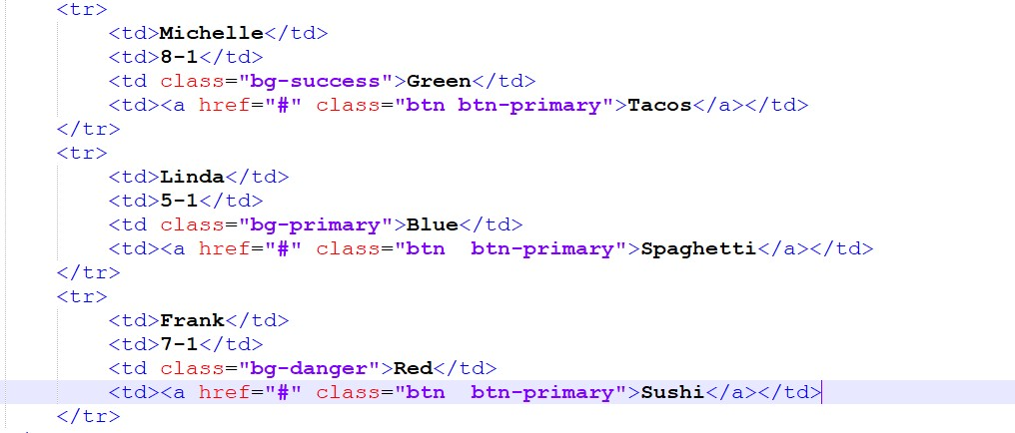

Feel free to update the href attribute to link to a website of your choice. (not required)

Please feel free to use something other than btn-primary to color the button if you wish.

9. Let’s add some font awesome icons next to the birthdays. Use the screenshot below to update your code:

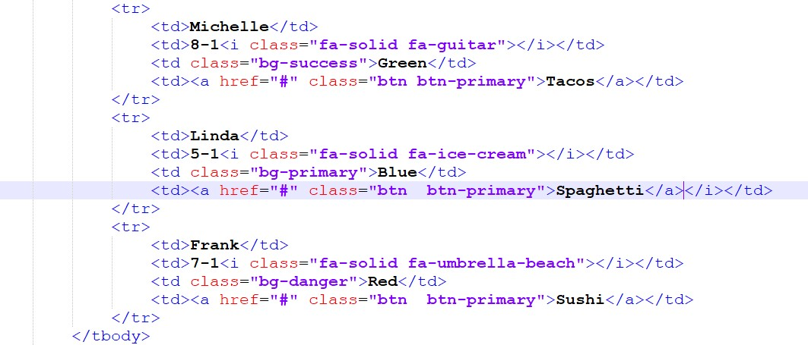

Result:

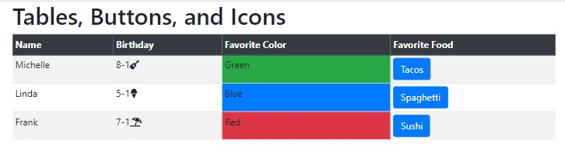

On your own:

1. Add one additional table style –add an html comment stating your choice
2. Modify an existing button style – add an html comment stating which style you modified

See the bootstrap documentation on buttons and tables for available classes you can use. <https://getbootstrap.com/docs/4.3/content/tables/> <https://getbootstrap.com/docs/4.3/components/buttons/>

Zip and upload to the dropbox. No need to upload guided exercises to the school host.