Books & Records Provider Integration
Design Summary
Rev 2.0 · 27 July 2026 · Two-page overview. Decision records, discovery items and full detail are in the Architecture Decision Document Rev 2.0.
The problem
- Multiple enterprise APIs, in distinct data domains, publish to and consume from a third-party books and records provider that runs a separate server instance per line of business.
- Those APIs are heavily dependent on the provider, but the enterprise experiences they serve cannot go down when the provider does.
- Every domain faces the same integration problems — data exchange, resiliency, scalability, security — and should not solve them five different ways.
The design
A shared integration gateway sits between the domain APIs and the provider. It is deliberately generic: it owns connectivity, delivery guarantees, ordering metadata, routing and security, and holds no knowledge of any domain’s data shape or business rules. Each domain owns its own data, its own local store, and the payloads it sends.
The gateway is deployed as independent cells — one per LOB instance — so a failure, a bad deploy or a runaway backlog is contained to a single line of business.
Availability comes from one property: domain APIs serve every read from their own local store and never call the provider synchronously. The provider and the gateway are on the write and refresh paths only.
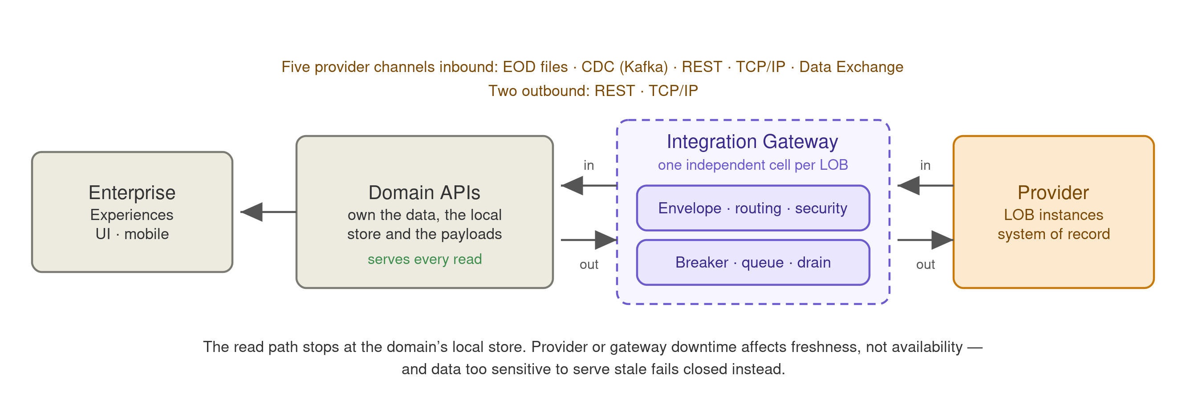
Key requirements
Requirement | Target | How it is met
Read availability | 99.95% market hours 99.9% otherwise | Served from the domain-local store; neither the provider nor the gateway is on the read path.
Write acceptance | 99.9% | Transactional outbox — a write is committed with its outbound intent in one local transaction, so acceptance never depends on the provider.
Freshness | p99 ≤ 5 s provider commit to visible (CDC) | Near-real-time change feed, monitored as a first-class indicator separately from availability.
Throughput | 6,000 inbound events/sec peak 900 outbound intents/sec peak | Horizontally scaled per cell; peak-to-average ratio, not average, sizes the system.
Recovery | RPO 0 for accepted writes RTO 15 min stateful components | Synchronous replication for outbox, pending queue and send-log; projections rebuilt by replay.
Write confirmation | Flagged at 15 min, escalated at 4 h | A durably accepted write that the provider has not yet booked is surfaced as pending, not presented as complete.
Correctness | No silent divergence from the system of record | Provider-sourced version on every message, nightly reconciliation against full files, and managed break resolution.
Values in orange are proposed defaults pending capacity planning and provider confirmation — see the placeholder register in the full document.

What the platform provides
Capability | What it means
One envelope, five channels | EOD files, CDC over Kafka, REST, TCP/IP and the forthcoming Data Exchange are normalised into a single generic envelope. Domains consume one shape and never need to know which channel an update came from.
Availability independent of the provider | Reads are served locally. Provider downtime degrades freshness, not availability.
Degraded-mode classification | Every data subject is classified: serve stale with an as-of stamp, serve with a visible staleness indicator, or fail closed. Balances, buying power and withdrawable cash fail closed rather than being served stale. Unclassified data defaults to fail closed.
Guaranteed ordering | Every message carries a monotonic version taken from the provider. Updates apply only if newer, so a nightly snapshot can never overwrite a change that happened after it — regardless of which channel each arrived on.
Guaranteed delivery | Transactional outbox, durable pending queue, and rate-limited replay on recovery. Per-entity order is held across outages: once a write for an entity is queued, later writes for it queue behind it rather than overtaking.
Correct idempotency per operation | Replace-style operations are safe to resend; additive operations such as booking a trade are de-duplicated through a send-log. The classification is supplied by the domain and driven by the provider’s actual contract.
Failure containment | Independent cells, circuit breakers, bulkheads and credentials per LOB instance. TCP/IP is isolated in its own pool so it cannot starve the others.
Quarantine, not silent skip | A message that cannot be processed halts that one entity and flags it, rather than being skipped — which would corrupt the entity and keep serving it as clean.
Reconciliation and break management | Nightly diff against the provider’s full files, executed by the owning domain, with owned breaks, resolution SLAs, ageing and audit evidence.
Fairness under load | Live user traffic, backlog drain and bulk backfill run in separate priority classes with guaranteed shares, so recovery work cannot starve customers.
Security and records | Per-LOB credentials in a vault, TLS/mTLS to the provider, encryption at rest, per-LOB authorisation on the internal bus, full audit trail, and retention aligned to books-and-records obligations.
Measurable operations | Freshness, queue age, quarantine depth, breaker state and reconciliation drift are tracked against defined objectives with separate error budgets for availability and freshness.
Design principles
- Generic pipe, domain-owned data. The shared layer carries messages and guarantees; it never learns what they mean. This is what stops it becoming the ESB that every team has to queue behind.
- The read path never touches the provider. Everything else in the availability story follows from this one constraint.
- Order by the provider’s version, never by our clock. Processing time reflects our pipeline, not the truth.
- Fail closed where stale is worse than absent. Availability is not unconditionally the right answer for financial figures.
- Contain failure to one line of business. Nothing shared may put every LOB in the same blast radius.
What is not settled yet
Four items gate the design and are being worked with the provider and internally:
Monotonic version | Does the provider expose a version, LSN or sequence per entity on every channel? The ordering guarantee depends on it. Highest priority.
Channel cardinality | Does any single file or topic carry entities belonging to more than one domain? This determines whether simple routing works or inbound load multiplies.
Records retention | Which of our stores constitute books and records? Expensive to retrofit, so it must be settled before datastore selection.
Volumetrics and provider SLAs | Confirmed peak volumes and per-instance SLAs; every threshold in the design derives from them.

