Books & Records Provider Integration
Design Summary
Rev 2.0 · 27 July 2026 · Overview only. Decision records, discovery items and full detail are in the Architecture Decision Document Rev 2.0.
The problem
- Multiple enterprise APIs, in distinct data domains, publish to and consume from a third-party books and records provider that runs a separate server instance per line of business.
- Those APIs depend heavily on the provider, but the enterprise experiences they serve cannot go down when the provider does.
- Every domain faces the same integration problems — data exchange, resiliency, scalability, security — and should not solve them five different ways.
The design
A shared integration gateway sits between the domain APIs and the provider. It is deliberately generic: it owns connectivity, delivery guarantees, ordering metadata, routing and security, and holds no knowledge of any domain’s data shape or business rules. Each domain owns its own data, its own local store, and the payloads it sends. The gateway is deployed as independent cells — one per LOB instance — so a failure or a bad deploy is contained to a single line of business.
Availability comes from one property: domain APIs serve every read from their own local store and never call the provider synchronously. The provider and the gateway are on the write and refresh paths only.
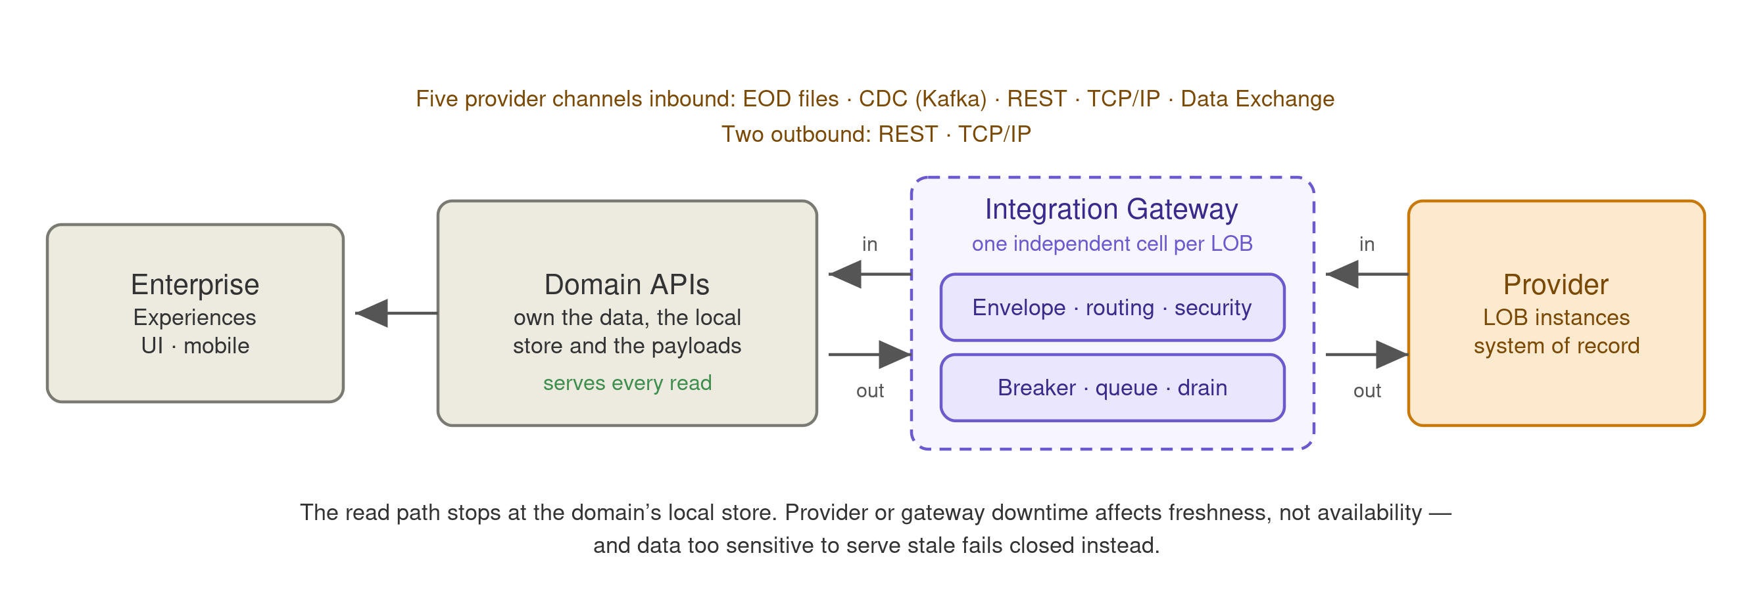
Key requirements
Requirement | Target | How it is met
Read availability | 99.95% market hours · 99.9% otherwise | Served from the domain-local store; neither the provider nor the gateway is on the read path.
Write acceptance | 99.9% | Transactional outbox — a write is committed with its outbound intent in one local transaction, so acceptance never depends on the provider.
Freshness | p99 ≤ 5 s provider commit to visible (CDC) | Near-real-time change feed, monitored separately from availability.
Throughput | 6,000 inbound events/sec peak · 900 outbound intents/sec peak | Horizontally scaled per cell; peak-to-average ratio, not average, sizes the system.
Recovery | RPO 0 for accepted writes · RTO 15 min stateful | Synchronous replication for outbox, queue and send-log; projections rebuilt by replay.
Write confirmation | Flagged at 15 min, escalated at 4 h | A write the provider has not yet booked is surfaced as pending, not presented as complete.
Orange values are proposed defaults pending capacity planning and provider confirmation.

What the platform provides
Capability | What it means
One envelope, five channels | EOD files, CDC over Kafka, REST, TCP/IP and the forthcoming Data Exchange are normalised into a single generic envelope. Domains consume one shape and never need to know which channel an update came from.
Availability independent of the provider | Reads are served locally. Provider downtime degrades freshness, not availability.
Degraded-mode classification | Every data subject is classified: serve stale with an as-of stamp, serve with a visible staleness indicator, or fail closed. Balances, buying power and withdrawable cash fail closed rather than being served stale; unclassified data defaults to fail closed.
Guaranteed ordering | Every message carries a monotonic version taken from the provider, and updates apply only if newer — so a nightly snapshot can never overwrite a change that happened after it, whichever channel each arrived on.
Guaranteed delivery | Transactional outbox, durable pending queue and rate-limited replay on recovery. Per-entity order holds across outages: once a write for an entity is queued, later writes queue behind it rather than overtaking.
Correct idempotency per operation | Replace-style operations are safe to resend; additive operations such as booking a trade are de-duplicated through a send-log. The classification is supplied by the domain and driven by the provider’s actual contract.
Failure containment and fairness | Independent cells, breakers, bulkheads and credentials per LOB instance; TCP/IP isolated in its own pool. Live traffic, backlog drain and bulk backfill run in separate priority classes so recovery cannot starve customers.
Quarantine, not silent skip | A message that cannot be processed halts that one entity and flags it, rather than being skipped — which would corrupt the entity and keep serving it as clean.
Reconciliation and break management | Nightly diff against the provider’s full files, executed by the owning domain, with owned breaks, resolution SLAs, ageing and audit evidence.
Security and records | Per-LOB credentials in a vault, TLS/mTLS to the provider, encryption at rest, per-LOB authorisation on the internal bus, full audit trail, and retention aligned to books-and-records obligations.
Measurable operations | Freshness, queue age, quarantine depth, breaker state and reconciliation drift tracked against defined objectives, with separate error budgets for availability and freshness.
Design principles
- Generic pipe, domain-owned data. The shared layer carries messages and guarantees; it never learns what they mean. That is what stops it becoming the ESB every team has to queue behind.
- The read path never touches the provider. Everything else in the availability story follows from this one constraint.
- Order by the provider’s version, never by our clock. Processing time reflects our pipeline, not the truth.
- Fail closed where stale is worse than absent. Availability is not unconditionally the right answer for financial figures.
- Contain failure to one line of business. Nothing shared may put every LOB in the same blast radius.
What is not settled yet
Four items gate the design and are being worked with the provider and internally:
Monotonic version | Does the provider expose a version, LSN or sequence per entity on every channel? The ordering guarantee depends on it. Highest priority.
Channel cardinality | Does any single file or topic carry entities belonging to more than one domain? This determines whether simple routing works or inbound load multiplies.
Records retention | Which of our stores constitute books and records? Expensive to retrofit, so it must be settled before datastore selection.
Volumetrics and provider SLAs | Confirmed peak volumes and per-instance SLAs; every threshold in the design derives from them.

