ATGS-W: An Automated Textbook Generator System on open-domain data from Wikipedia using Multi-Agent AI
TRAN Thanh-Nam^{1[1111-2222-3333-4444]}, PHAN VAN-Tho², and NGO-HO Anh-Khoa^{1[1111-2222-3333-4444]}
¹ Faculty of Information Technology, Nam Can Tho University, 168 Nguyen Van Cu Street, An Binh Ward, Can Tho City, Vietnam
{ttnam@nctu.edu.vn, s082019@nctu.edu.vn,nhakhoa@nctu.edu.vn}
Abstract. The rapid advancement of large language models (LLMs) has enabled new possibilities for automating educational content creation, yet challenges such as hallucination and the lack of reliable grounding mechanisms remain. This paper proposes, ATGS-W, an Automated Textbook Generation System (ATGS) built on open-domain data from Wikipedia, integrating Retrieval-Augmented Generation (RAG) through an adaptive retrieval mechanism (EKRE), a Writer–Judge multi-agent architecture, and a source-aware self-verification process. The system is designed to ensure tight alignment between source data, generated content, and academic structure.The results demonstrate that the proposed approach significantly improves accuracy, structural coherence, and overall reliability, while effectively reducing hallucination. These findings highlight the value of combining knowledge retrieval, multi-agent coordination, and source-based verification for automated textbook construction.
Keywords: RAG, automated textbook generation, LLMs, multi-agent systems, grounding.
- Introduction
In recent years, the rapid advancement of large language models (LLMs) (Brown et al., 2020) has created significant opportunities for automating content generation, particularly in the field of education. LLM-based systems are capable of producing coherent text and can flexibly support the development of learning materials, lecture content, and assessment questions. However, directly deploying these models in academic settings still presents notable challenges, most prominently the issue of hallucination, where the model generates information that is inaccurate or unsupported by reliable sources (Ji et al., 2023). To address this limitation, Retrieval-Augmented Generation (RAG) has been proposed as an approach that combines the generative strengths of LLMs with external knowledge retrieval, thereby substantially improving both the accuracy and reliability of generated content (Lewis et al., 2020). Recent studies further highlight RAG as a key paradigm for knowledge-intensive applications, including education, research, and academic support systems (Gao et al., 2023). At the same time, the field of artificial intelligence in education has been undergoing a marked shift, from traditional support tools toward more intelligent platforms capable of personalization and automated content generation (Zawacki-Richter et al., 2019).
Despite these advances, most existing systems remain focused on isolated tasks such as question answering, exercise generation, or short-form content creation. The challenge of constructing a complete textbook, with coherent structure, multi-chapter organization, and logical continuity, has yet to be fully explored. A promising direction to address this gap lies in multi-agent architectures, where different agents are designed to handle specialized roles such as knowledge retrieval, content organization, text generation, and output verification. This collaborative design can significantly enhance both the quality and consistency of the overall system (Park et al., 2023; Wu et al., 2023).
Building on these foundations, this paper presents an automated curriculum generation system that leverages open encyclopedic data from Wikipedia. The system is built on a multi-agent architecture that integrates knowledge retrieval with a source-aware self-evaluation mechanism.
The main contributions of this work are threefold: (1) An Adaptive Knowledge Retrieval Engine (EKRE), a dynamic retrieval module that estimates information quality via a Knowledge Score and triggers knowledge expansion when the retrieved content falls below a reliability threshold; (2) A Writer–Reviewer multi-agent architecture for curriculum construction, in which micro-writer agents generate content in parallel, while a chapter supervisor and a scholarly audit agent evaluate outputs to ensure accuracy, consistency, and global coherence; (3) A source-aware self-verification process, implemented as a critique–revision loop in which the scholarly audit agent selectively refines content based on knowledge coverage, citation accuracy, and pedagogical coherence, thereby reducing hallucinations.
- Related Work
Against the backdrop of a global education landscape undergoing rapid transformation driven by digitalization, artificial intelligence (AI) has emerged as a key force reshaping how knowledge is created and delivered. Traditionally, textbook development relied heavily on domain experts and required substantial time to ensure both accuracy and coherence. Today, however, with the support of large language models and vast open data sources such as Wikipedia, this process is increasingly becoming automated, more flexible, and continuously updatable. This shift has given rise to a growing line of research focused on leveraging AI to intelligently generate curricula and learning content.
One prominent direction is the integration of generative language models with knowledge retrieval mechanisms to improve both the quality and reliability of generated content. Early work laid the foundation by combining generative models with document retrieval systems, enabling outputs to be grounded in verifiable knowledge sources (Lewis et al., 2020). Subsequent studies extended this approach by incorporating retrieval directly into the training process, allowing models to learn how to access and utilize external knowledge more effectively (Guu et al., 2020). These advances have played a crucial role in mitigating factual inaccuracies and have become a cornerstone of data-driven content generation systems.
At the same time, the development of multi-agent architectures has opened up new possibilities for handling complex tasks. Recent research shows that multiple agents can collaborate through interaction, memory, and dialogue to solve multi-step problems more effectively (Park et al., 2023; Wu et al., 2023). Such mechanisms are particularly well suited to automated textbook construction, which requires the coordinated execution of multiple functions, including knowledge retrieval, content structuring, and output validation.
In the field of education, Intelligent Tutoring Systems (ITS) have long been studied as a means of personalizing learning and supporting students through knowledge-based models (Anderson et al., 1995). However, traditional ITS often rely on manually crafted rules and lack scalability. The emergence of LLMs offers far greater potential for automating the creation of educational content, but it also introduces challenges related to maintaining academic rigor and pedagogical appropriateness (Zawacki-Richter et al., 2019). In addition, the strong generative capabilities of LLMs have been well demonstrated in recent work (Brown et al., 2020), yet ensuring consistency, stability, and reliability remains a significant challenge. Approaches such as self-consistency in reasoning have been proposed to improve both the quality and robustness of generated outputs (Wang et al., 2022).
Despite substantial progress across these individual directions, most existing studies have only explored partial combinations of techniques such as retrieval-augmented generation and multi-agent systems, typically for narrow tasks like question answering, question generation, or short-form content creation. Some early applications in education have emerged, but they largely focus on generating isolated components of a textbook, such as outlines, lessons, or exercises. To date, there has been no system capable of constructing a complete textbook with coherent structure and continuity, while simultaneously ensuring accuracy through source-grounded verification mechanisms.
This gap highlights the need for a more comprehensive approach that fully integrates knowledge retrieval, multi-agent architectures, and self-verification mechanisms. This paper addresses that need by proposing a unified framework that combines these components, leveraging Wikipedia as a primary data source to ensure both the timeliness and reliability of the generated content.
- Our proposition
The proposed system aims to automate textbook construction with high levels of accuracy and consistency, built upon three core components: a multi-agent architecture, grounded knowledge retrieval, and a self-verification mechanism. This approach draws on prior work in Retrieval-Augmented Generation (Lewis et al., 2020; Guu et al., 2020), LLM-based multi-agent systems (Park et al., 2023; Wu et al., 2023), and research on detecting and mitigating hallucination through self-evaluation and factual consistency assessment (Manakul et al., 2023; Lin et al., 2022). The overall system is organized as a multi-stage pipeline to ensure tight alignment between source data, generated content, and the academic structure of the textbook.
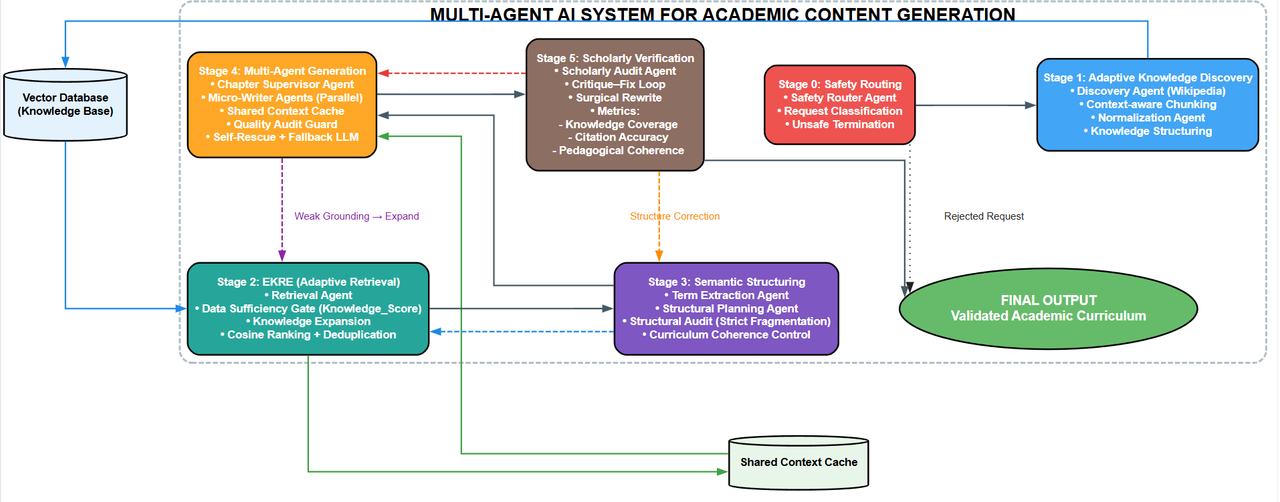
Figure 1. Multi-Agent Architecture for Academic Content Generation
In the first stage, Adaptive Knowledge Discovery, the system utilizes a multi-agent closed-loop pipeline to optimize input data. It begins with a Safety Router Agent validating incoming requests to ensure academic suitability and system integrity. Next, a Discovery Agent retrieves Wikipedia data, applying a context-aware recursive chunking algorithm to maintain semantic continuity within LLM context constraints. Finally, a dedicated normalization agent transforms this unstructured data into consistent knowledge entities, establishing a foundational knowledge base for subsequent retrieval and content generation.
In the next stage, the system deploys the Adaptive Knowledge Retrieval Engine (EKRE), an advanced mechanism built on retrieval-augmented generation and pretraining principles (Lewis et al., 2020; Guu et al., 2020). To overcome fixed-threshold limitations, EKRE utilizes a Data Sufficiency Gate to dynamically compute a Knowledge_Score based on concept density and semantic similarity. If this score falls below a reliability threshold, EKRE proactively triggers a Knowledge Expansion process, integrating cross-referenced materials to bridge informational gaps. Finally, the expanded data is ranked and filtered via cosine similarity and semantic deduplication. This yields a deeply refined context repository that preserves critical knowledge anchors, maximizes faithfulness, and effectively mitigates hallucination.
Based on the retrieved knowledge, the system operates through close coordination between a Term Extraction Agent and a Structural Planning Agent. The extraction agent identifies key knowledge entities from the vector database, applying an adaptive term budgeting strategy aligned with the target textbook scope. These terms then serve as “knowledge seeds” for the planning agent to cluster and organize into a multi-level outline following pedagogical progression. A key innovation lies in the Structural Audit Agent, which monitors the integrity of the generated outline. When issues such as thin chapters or deviations from expected subsection counts are detected, the system activates a Strict Fragmentation mechanism, forcing iterative restructuring until a balanced distribution of content density is achieved. This ensures that the textbook is not only scientifically sound but also pedagogically appropriate for higher education contexts.
Following structure establishment, content generation employs a Writer–Judge multi-agent architecture. In this framework, Micro-Writer Agents act as the Writers, generating content in parallel via a shared context cache. Concurrently, a Chapter Supervisor Agent acts as the Judge, enforcing a real-time Quality Audit Guard at the segment level. If citation density or length thresholds are unmet, the Judge triggers a Self-Rescue mechanism to safely regenerate content. Ultimately, this collaborative architecture ensures all sections remain tightly grounded with accurate inline citations, producing an academically robust draft ready for validation.
The final critical stage employs a source-aware self-verification process—an autonomous evaluation mechanism that continuously cross-checks generated content against retrieved source materials. Governed objectively by an independent Scholarly Audit Agent, this process executes a Critique–Fix loop to assess knowledge coverage, citation accuracy, and pedagogical coherence. Upon detecting hallucinations or insufficient sourcing, it triggers a Surgical Rewrite mechanism. Rather than regenerating full sections, it performs localized, sentence-level corrections using verified evidence, ensuring the final textbook is academically sound and fully grounded.
Overall, the system architecture is organized into three main layers: knowledge retrieval, structural construction, and content verification. The integration of grounded retrieval, multi-agent coordination, and self-verification not only enhances the quality of generated content but also significantly improves reliability, particularly in high-stakes applications such as automated textbook development.
The pseudocode of our algorithm is described below:

- Experimental Protocols
To enable an objective evaluation of the proposed multi-agent textbook generation system, this study constructs a dedicated experimental dataset specifically designed to assess the system’s ability to organize academic knowledge, retrieve relevant information, and generate complete curricula across multiple domains.
The primary data source is Wikipedia, selected for its well-defined hierarchical structure, extensive knowledge linking, and transparent, source-based retrieval enabled by its open-access nature. Using Wikipedia as the foundational knowledge base aligns with modern retrieval-grounded generation systems, where effective retrieval and verifiable sourcing are critical to improving content reliability (Lewis et al., 2020; Es et al., 2023).
The dataset consists of 10 academic topics spanning four major domains: Computer Science (Artificial Intelligence, Cybersecurity, Blockchain Technology, Software Engineering), Engineering (Nanotechnology, Quantum Computing), Natural Sciences (Climate Change, Bioinformatics), and Social Sciences (Sociology, Cognitive Psychology). These topics are selected based on three criteria: (1) high academic complexity requiring multi-level textbook structures; (2) sufficient depth of Wikipedia content, with at least 15 directly related articles per topic; and (3) cross-disciplinary representation to evaluate the system’s adaptability across diverse knowledge domains.
On average, each topic includes approximately 29 source documents, while the generated output reaches around 126,600 characters per textbook, equivalent to roughly 80–100 pages of standard academic material. This design supports evaluation not only at the paragraph level but also at the level of complete multi-chapter documents, aligning with recent trends in multi-domain and document-level robustness evaluation (Liang et al., 2022).
The ground truth is constructed as a three-layer Knowledge Matrix to enable structured and quantitative evaluation. First, Wikipedia’s category hierarchy serves as a reference syllabus framework for assessing the logical organization of generated outlines. Second, all referenced article titles within each topic are converted into a set of deterministic key terms, representing required knowledge entities for measuring concept coverage. Third, these entities are manually validated to remove semantic noise and ensure academic relevance. This approach also strengthens the evaluation of faithfulness and hallucination reduction in a more reliable manner (Manakul et al., 2023; Lin et al., 2022).
This dataset design offers three key advantages: (1) it ensures cross-domain coverage and supports generalizability; (2) it provides a benchmark that closely reflects real-world application scenarios; and (3) it establishes a well-structured ground-truth foundation for evaluating metrics such as Retrieval Precision, Structural Coherence, and Faithfulness in a deterministic manner, minimizing bias from LLM-as-a-judge approaches. As a result, the overall evaluation process achieves a higher level of reliability and aligns with contemporary standards in academic assessment.
This section presents the experimental design for comprehensively evaluating the effectiveness of the proposed multi-agent textbook generation system. The evaluation focuses on knowledge retrieval quality, content accuracy, structural coherence, and the degree of grounding in source knowledge. The protocol is built upon established evaluation frameworks for large language models and modern retrieval–generation systems, with particular emphasis on faithfulness, robustness, and multi-dimensional assessment (Liang et al., 2022; Es et al., 2023; Manakul et al., 2023).
To ensure representativeness and generalizability, the system is tested on a multi-domain dataset constructed from Wikipedia. Each topic is used to generate a complete multi-chapter textbook, enabling evaluation at both the paragraph level and the full-document level. Ground-truth curricula are constructed by combining Wikipedia’s hierarchical structure with manually validated academic outlines.
Evaluation is conducted using six quantitative metrics. First, Retrieval Precision measures the accuracy of retrieved documents, defined in line with standard information retrieval practice as:
$$Precision@k=\frac{∣D_{rel}∩D_{ret}∣}{∣D_{ret}∣}$$
where $D_{ret}$is the set of retrieved documents and $D_{rel}$is the set of relevant documents. This formulation follows traditional IR evaluation methods and is widely adopted in general frameworks such as HELM (Liang et al., 2022).
Next, the relevance between the query and retrieved context is measured by Context Relevance, computed as the average semantic similarity between the query and retrieved passages:
$$Context Relevance=\frac{1}{N}\sum_{i=1}^{N}{sim(q,}c_{i})$$
where sim(⋅) denotes cosine similarity in the embedding space. This approach aligns with modern RAG evaluation frameworks such as RAGAS, where contextual relevance is estimated via embedding-based similarity (Es et al., 2023).
To assess grounding in source knowledge, the study employs the Faithfulness metric, defined as the proportion of generated statements that can be verified against retrieved documents:
$$Faithfulness=\frac{∣Supported Statements∣}{∣Total Statements∣}$$
This metric directly reflects the extent of hallucination and is closely related to methods such as SelfCheckGPT (Manakul et al., 2023).
In addition, academic accuracy is measured using Answer Correctness, computed by comparing generated outputs with reference data:
$$Answer Correctness=sim(A_{gen},A_{ref})$$
where $sim(⋅)$ may be implemented as Exact Match, F1-score, or semantic similarity. This evaluation follows established question-answering benchmarks such as TruthfulQA (Lin et al., 2022).
At the document level, Structural Coherence evaluates the logical flow of the textbook. In this study, it is approximated by the semantic continuity between consecutive content units:
$$Coherence=\frac{1}{T-1}\sum_{i=1}^{T-1}{sim(}s_{i},s_{i+1})$$
This formulation is inspired by prior work on discourse coherence, particularly entity-based and graph-based models (Barzilay & Lapata, 2008; Guinaudeau & Strube, 2013), adapted to embedding space for compatibility with modern LLM settings.
Finally, Generation Stability measures system consistency across multiple independent runs. In this work, it is defined based on the variance of evaluation scores:
$$Stability=1-\frac{1}{M}\sum_{i=1}^{M}{Var(}S_{i})$$
where $S_{i}$ denotes the set of evaluation scores from the $i$-th run. This metric captures output consistency and follows principles used in robustness evaluation for large language models (Liang et al., 2022).
As noted in previous sections, most existing educational AI systems focus on isolated tasks (e.g., generating short lessons or standalone questions) and lack the capability to autonomously construct complete, structurally coherent multi-chapter curricula. Therefore, rather than comparing against disparate third-party tools that do not support document-level curriculum generation, this study designs an ablation-style evaluation. The proposed system is evaluated against five baselines representing different levels of architectural sophistication: (1) a zero-shot LLM without knowledge retrieval (which essentially simulates the standard use of commercial AI chatbots like ChatGPT or Gemini, operating without external data access or agentic workflows); (2) Vanilla RAG with standard retrieval; (3) Adaptive RAG with dynamic retrieval but without multi-agent coordination; (4) Multi-agent RAG without self-evaluation, which incorporates agent-based coordination but lacks source verification; and (5) the full proposed system, integrating EKRE, multi-agent architecture, and source-aware self-evaluation. This setup enables a clear ablation study to isolate the contributions of adaptive retrieval, multi-agent coordination, and the self-verification mechanism.
For the ablation study, baselines were standardized to ensure fair comparisons. To facilitate transparency and reproducibility, our complete implementation—including the multi-agent framework, Context-aware Recursive Chunking algorithm, prompt configurations, and evaluation suite—is publicly available in our GitHub repository . Results are averaged over multiple independent runs to mitigate randomness. Ultimately, this design addresses three key research questions: whether adaptive retrieval improves retrieval quality, whether the multi-agent architecture enhances document-level structural coherence, and whether self-evaluation effectively reduces hallucination while improving content faithfulness.
- Results and Discussion
The experimental results evaluate the effectiveness of the proposed multi-agent textbook generation system across six metrics: Retrieval Precision, Context Relevance, Faithfulness, Answer Correctness, Structural Coherence, and Generation Stability. Experiments are conducted on a multi-domain dataset derived from Wikipedia, with results averaged over multiple independent runs to ensure robustness. All metrics are computed automatically to enhance objectivity and reproducibility. The evaluation framework builds on recent advances in retrieval–generation assessment, particularly metrics related to contextual relevance, factual consistency, and accuracy (Es et al., 2023), along with approaches for hallucination control (Manakul et al., 2023) and comprehensive multi-dimensional evaluation frameworks (Liang et al., 2022).
For objective comparison, the proposed system is evaluated against five baselines representing different levels of system sophistication: Zero-shot LLM, Vanilla RAG, Adaptive RAG, Multi-agent RAG without Self-Evaluation, and the full proposed system. All methods are implemented using the same base model, dataset, and retrieval configuration to ensure fairness. Results are averaged across multiple independent runs to reduce the impact of randomness.
Through this design, the study aims to address three key research questions: whether adaptive retrieval improves retrieval quality, whether multi-agent architecture enhances structural coherence at the document level, and whether self-evaluation reduces hallucination while improving the faithfulness of generated content.

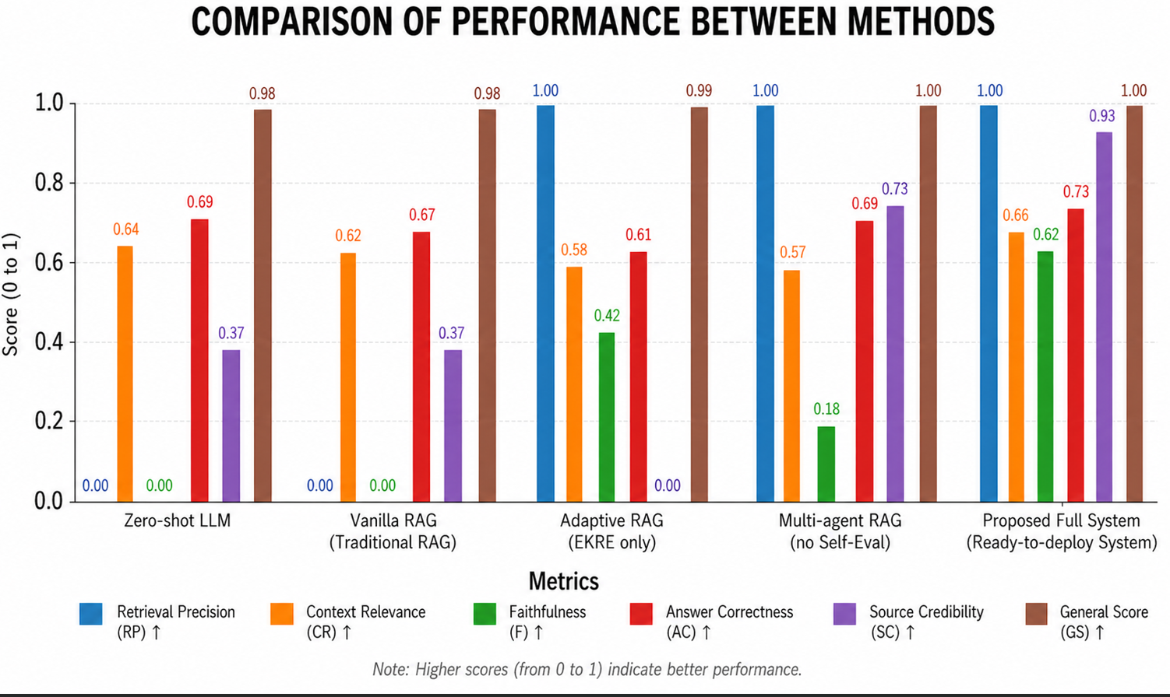
Figure 2. Quantitative comparison of different methods for textbook generation tasks
The results in Figure 2 indicate that the proposed system achieves the highest overall performance, demonstrating a clear advantage in simultaneously optimizing retrieval quality, structural coherence, and academic reliability.
Analysis of the baselines reveals the fundamental limitations of standard approaches. Zero-shot LLM and Vanilla RAG perform the weakest across core metrics, confirming that purely generative or basic retrieval methods lack the grounding and organization required for multi-chapter textbook construction. While Adaptive RAG (enhanced with EKRE) significantly improves retrieval precision and content faithfulness, its ability to organize content at a global level remains limited. In contrast, Multi-agent RAG without Self-Evaluation substantially enhances document-level coherence through agent coordination, but suffers from semantic inconsistencies and suboptimal faithfulness due to the lack of verification.
The full proposed system effectively bridges these gaps, achieving the most balanced performance. The integration of Source-Aware Self-Evaluation plays a central role, ensuring both structural integrity and high content faithfulness through source grounding and localized correction. Furthermore, all systems incorporating adaptive retrieval exhibit high generation stability across multiple runs, reflecting the pipeline's effectiveness in reducing variance. Overall, these findings validate that integrating EKRE, multi-agent coordination, and self-verification directly addresses the research questions and yields a superior architecture for automated curriculum generation.
- Conclusion
This study introduces an integrated approach to automated curriculum generation using artificial intelligence, combining knowledge retrieval from open data sources (Wikipedia), a multi-agent architecture, and a source-based verification mechanism. Experimental results demonstrate that applying adaptive Retrieval-Augmented Generation (EKRE) significantly improves content accuracy and grounding, while the source-based verification successfully reduces LLM hallucination. Furthermore, organizing the system as a multi-agent framework ensures high structural coherence at the document level, allowing for the generation of complete, multi-chapter curricula—an achievement beyond the scope of existing isolated systems.
Despite its potential, the system has limitations, primarily its reliance on Wikipedia, which may lack depth in highly specialized domains, and the high computational cost associated with multi-stage multi-agent verification. Future work will focus on integrating curated domain-specific knowledge sources, developing more nuanced evaluation methods for academic quality, and introducing personalization mechanisms tailored to individual learners.
References
- Brown, T. B., Mann, B., Ryder, N., Subbiah, M., Kaplan, J., Dhariwal, P., et al. (2020). Language models are few-shot learners. arXiv. https://doi.org/10.48550/arXiv.2005.14165
- Zhai, X., Chu, X., Chai, C. S., Jong, M. S. Y., Istenic, A., Spector, J., et al. (2025). A systematic review of large language models in education. International Journal of Educational Technology in Higher Education. https://www.sciencedirect.com/science/article/pii/S2666920X25001699
- Devlin, J., Chang, M.-W., Lee, K., & Toutanova, K. (2019). BERT: Pre-training of deep bidirectional transformers for language understanding. arXiv. https://doi.org/10.48550/arXiv.1810.04805
- Lewis, P., Perez, E., Piktus, A., Petroni, F., Karpukhin, V., Goyal, N., et al. (2020). Retrieval-augmented generation for knowledge-intensive NLP tasks. Advances in Neural Information Processing Systems. https://arxiv.org/abs/2005.11401
- Guu, K., Lee, K., Tung, Z., Pasupat, P., & Chang, M.-W. (2020). REALM: Retrieval-augmented language model pre-training. arXiv. https://doi.org/10.48550/arXiv.2002.08909
- Gao, Y., Xiong, Y., Gao, X., Jia, K., Pan, J., Bi, Y., et al. (2023). Retrieval-augmented generation for large language models: A survey. arXiv. https://arxiv.org/abs/2312.10997
- Ji, Z., Yu, T., Xu, Y., Lee, N., Ishii, E., & Fung, P. (2023). Towards mitigating LLM hallucination via self-reflection. Findings of ACL: EMNLP. https://aclanthology.org/2023.findings-emnlp.123
- Manakul, P., Liusie, A., & Gales, M. (2023). SelfCheckGPT: Zero-resource black-box hallucination detection for generative large language models. arXiv. https://doi.org/10.48550/arXiv.2303.08896
- Lin, S., Hilton, J., & Evans, O. (2022). TruthfulQA: Measuring how models mimic human falsehoods. arXiv. https://doi.org/10.48550/arXiv.2109.07958
- Liang, P., Bommasani, R., Lee, T., Tsipras, D., Soylu, D., Yasunaga, M., et al. (2022). Holistic evaluation of language models (HELM). arXiv. https://doi.org/10.48550/arXiv.2211.09110
- Es, S., James, J., Espinosa-Anke, L., & Schockaert, S. (2023). RAGAS: Automated evaluation of retrieval augmented generation. arXiv. https://doi.org/10.48550/arXiv.2309.15217
- Park, J. S., O’Brien, J., Cai, C. J., Morris, M. R., Liang, P., & Bernstein, M. S. (2023). Generative agents: Interactive simulacra of human behavior. arXiv. https://doi.org/10.48550/arXiv.2304.03442
- Wu, Q., Bansal, G., Zhang, J., Wu, Y., Li, B., Zhu, E., et al. (2023). AutoGen: Enabling next-gen LLM applications via multi-agent conversation. arXiv. https://doi.org/10.48550/arXiv.2308.08155
- Wang, X., Wei, J., Schuurmans, D., Le, Q., Chi, E., Narang, S., et al. (2022). Self-consistency improves chain of thought reasoning in language models. arXiv. https://doi.org/10.48550/arXiv.2203.11171
- Zawacki-Richter, O., Marín, V. I., Bond, M., & Gouverneur, F. (2019). Systematic review of research on artificial intelligence applications in higher education: Where are the educators? International Journal of Educational Technology in Higher Education. https://link.springer.com/article/10.1186/s41239-019-0171-0
- Anderson, J. R., Corbett, A. T., Koedinger, K. R., & Pelletier, R. (1995). Cognitive tutors: Lessons learned. Journal of the Learning Sciences, 4(2), 167–207.
- Holmes, W., Bialik, M., & Fadel, C. (2022). Artificial intelligence in education: A review. https://kronika.ac/wp-content/uploads/5-KKJ2327.pdf
- Barzilay, R., & Lapata, M. (2008). Modeling local coherence: An entity-based approach. Computational Linguistics, 34(1), 1–34. https://doi.org/10.1162/coli.2008.34.1.1
- Guinaudeau, C., & Strube, M. (2013). Graph-based local coherence modeling. In Proceedings of the 51st Annual Meeting of the Association for Computational Linguistics (Volume 1: Long Papers) (pp. 93–103). Association for Computational Linguistics. https://aclanthology.org/P13-1010/

https://github.com/PhanVanTho/MultiAgent-Curriculum-Gen-RAG

