Project Registration Form
(Project 2: synthesizing the knowledge learned (software analysis, design, databases, programming languages, etc.) combined with self-researched knowledge to design a system/program/application/software that solves at least one practical problem in society)

1. Basic Information
Name TV1: Hà Hoàng Phúc Student ID: 222683
Email: phuc222683@student.nctu.edu.vn Class: DH22TIN07
Name TV2: Student ID:
Email: Class:

2. Registered topic
Title: Programming Learning Website - CodequestAI

The topic is intended to be developed into a graduation thesis, and it is hoped that the advisor (name of advisor........................) will guide the thesis.

Summary of the topic: The programming learning website - CodequestAI is a modern programming learning platform that combines AI + Gamification to create a learning experience that is both engaging and effective.

What functions does the topic include:
(Authorization, search, statistics, reporting, management, etc.): Authorization (login/logout), user management (profile, forgot password), statistics (leaderboard, analysis), game management ([AI] personalized quiz, [AI] speed coding challenge, [AI] code scoring, [AI] lesson creation, [AI] code battle, [AI] debugging, [AI] code art), [AI] teaching, [AI] challenges, [AI] virtual assistant, and content pages (homepage, about, contact, features, dashboard).
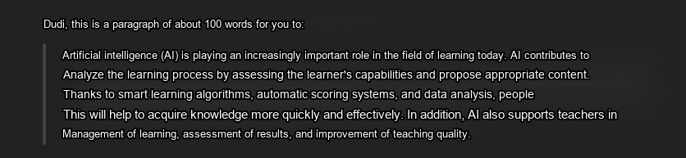

The topic includes the following contents: (yes/no)
System design analysis: Yes
Database: Available
Interface design: Yes
Development direction: Yes
The topic inherits from an existing topic: Yes
Other (specify):

Where the topic is applied: An interactive AI programming learning platform for education, training, and assessing programming skills for students, beginners, and training centers.

3. Other opinions:
- Do students have any additional suggestions for the advisor?



