Post 1:
def in_5_dong_cuoi(ten_file):
with open(name_file, 'r', encoding='utf-8') as f:
dong = f.readlines()
print(f"=== LAST 5 LINE OF FILE: {name_file} ===")
nam_dong_cuoi = dong[-5:]
for i, line in enumerate(nam_dong_cuoi, 1):
print(f" Line {len(dong) - 5 + i}: {line}", end='')
print()
in_5_dong_cuoi('sample.txt')
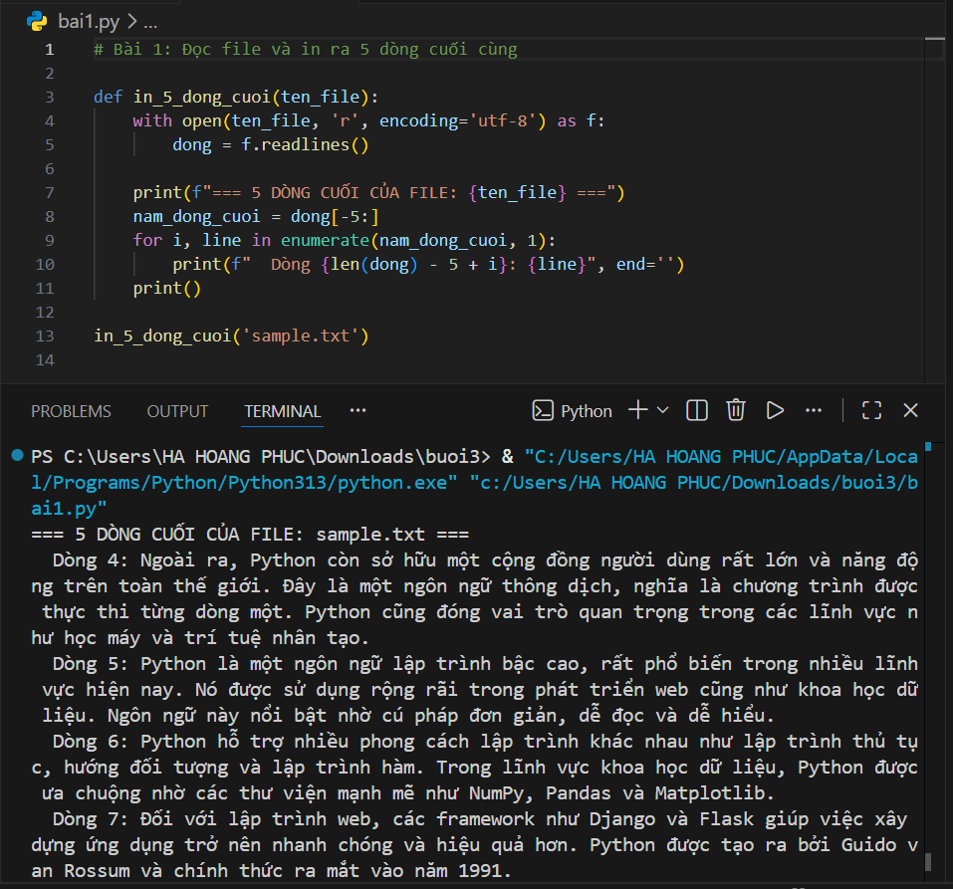
Lesson 2:
def tim_dong_dai_nhat(ten_file):
with open(name_file, 'r', encoding='utf-8') as f:
dong = f.readlines()
dong_dai_nhat = max(dong, key=lambda x: len(x.strip()))
so_thu_tu = dong.index(dong_dai_nhat) + 1
print(f"=== LONGEST LINE IN FILE: {name_file} ===")
print(f" Position: Number line {so_thu_tu}")
print(f" Length: {len(dong_dai_nhat.strip())} characters")
print(f" Content: {dong_dai_nhat.strip()}")
tim_dong_dai_nhat('sample.txt')
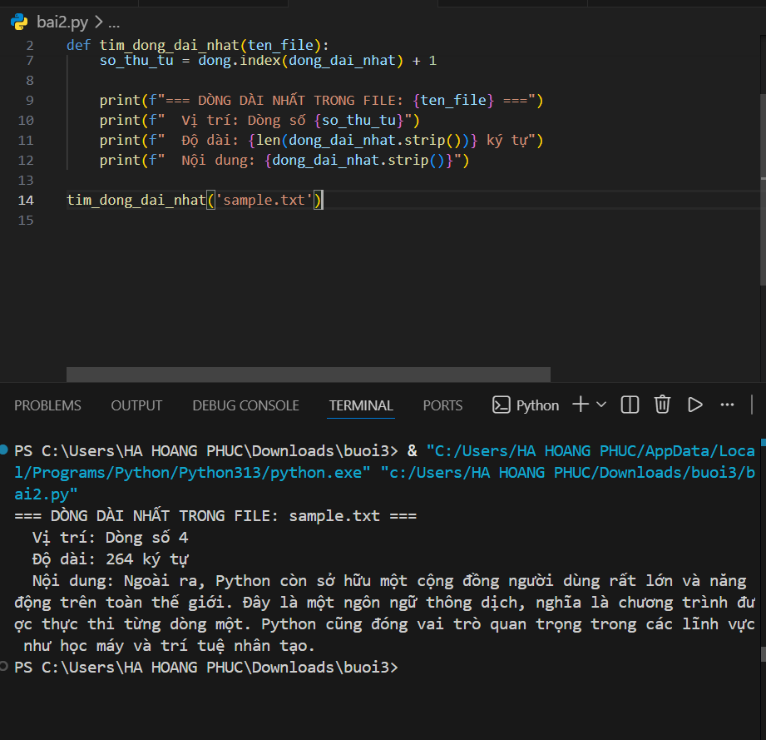
Lesson 3:
def tim_tu_dai_nhat(ten_file):
with open(name_file, 'r', encoding='utf-8') as f:
content = f.read()
import re
cac_tu = re.findall(r'[a-zA-ZÀ-ý]+', say_dung)
tu_dai_nhat = max(cac_tu, key=len)
print(f"=== LONGEST WORD IN FILE: {name_file} ===")
print(f" Longest word: '{tu_dai_nhat}'")
print(f" Length: {len(tu_dai_nhat)} characters")
tim_tu_dai_nhat('sample.txt')
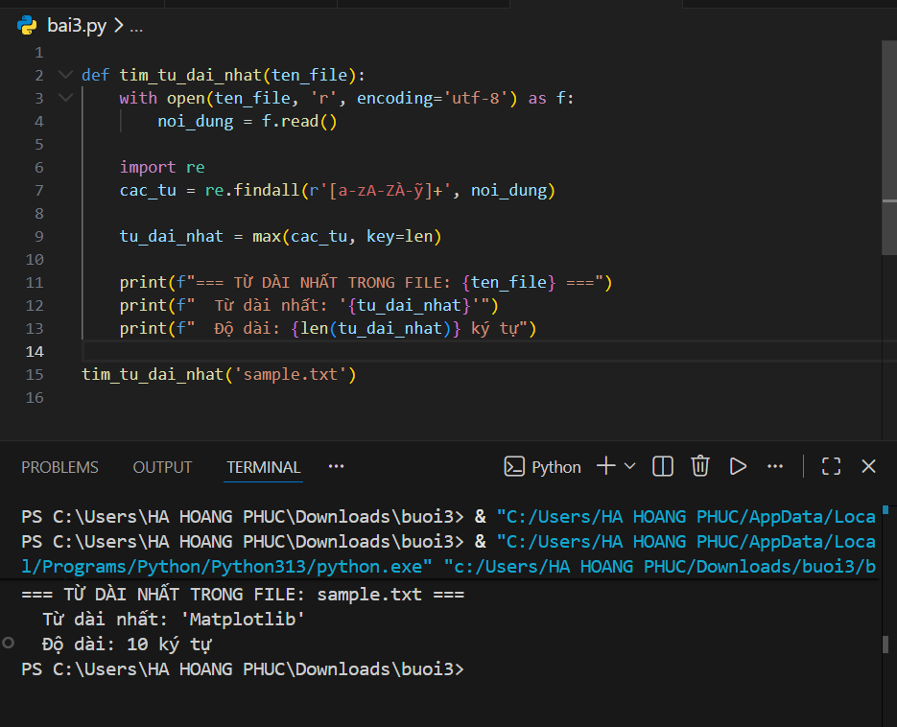

Lesson 4:

def thong_ke_chu_cai(ten_file):
with open(name_file, 'r', encoding='utf-8') as f:
noi_dung = f.read().lower()

thong_ke = {}
for character in language:
if ky_tu.isalpha():
thong_ke[ky_tu] = thong_ke.get(ky_tu, 0) + 1
thong_ke_sorted = dict(sorted(thong_ke.items()))

print(f"=== STATISTICS OF LETTERS IN FILE: {name_file} ===")
print(f" Total number of different letters: {len(thong_ke_sorted)}")
print()
for chu, so_lan in thong_ke_sorted.items():
print(f" '{cycle}': {so_lan} times")
thong_ke_chu_cai('sample.txt')
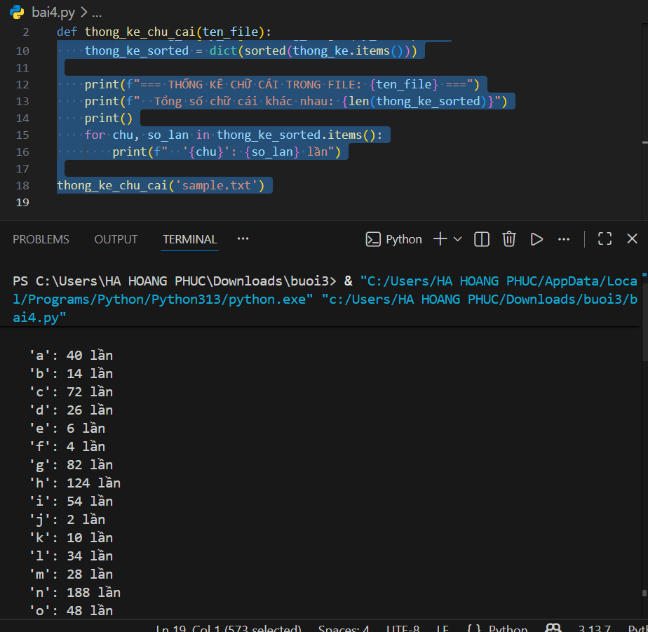
Lesson 5:

import re

def thong_ke_tan_suat_tu(ten_file):
with open(name_file, 'r', encoding='utf-8') as f:
noi_dung = f.read().lower()

cac_tu = re.findall(r'[a-zA-ZÀ-ý]+', say_dung)

thong_ke = {}
for tu in cac_tu:
thong_ke[tu] = thong_ke.get(tu, 0) + 1

thong_ke_sorted = sorted(thong_ke.items(), key=lambda x: x[1], reverse=True)

print(f"=== FREQUENCY OF WORDS IN FILE: {name_file} ===")
print(f" Total number of different words: {len(thong_ke_sorted)}")
print(f" Total number of words: {sum(thong_ke.values())}")
print()
print(f" {'FROM':<25} {'NUMBER OF OCCURRENCES':>18}")
print(f" {'-'*25} {'-'*18}")
for tu, so_lan in thong_ke_sorted:
print(f" {tu:<25} {so_lan:>18}")

thong_ke_tan_suat_tu('sample.txt')

