KHOA CÔNG NGHỆTHÔNG TIN
SUBJECT REGISTRATION FORM(Question 2: synthesize learned knowledge (analysis, software design, database, programming languages,…) combined with self-research knowledge to design a system/program/application/software that solves at least one practical problem in society)
1.PinetinbasicLast name&Namen TV1: Ha Hoang Phuc....................................MSSV: 222683....................Email: phuc222683@student.nctu.edu.vn.....................Class: DH22TIN07.................TV2's Full Name:...............................................................MSSV:...................................Email:............................................................................Class:.......................................
2. Registration topicTopic Name: Website to learn programming - CodequestAI.......................................................
The topic intends to develop into a graduation thesis, hoping to be accepted by the teacher(GV's full name……………………….) thesis instructions
Summary of topic content: Website to learn programming-CodequestAI is a modern programming learning platform, combining AI + Gamification to create a learning experience that is both fun and effective..........................................................................................................................
What functions does the topic include:(Decentralization, search, statistics, reporting, management,….): Decentralization (login/logout), user management (profile, forgotten password), statistics (rankings, analysis), game management ([AI] personalized coding quiz, [AI] speed challenge, [AI] code grading, [AI] lesson creation, [AI] code battle, [AI] debugging, [AI] code art), [AI] teaching, [AI] challenges, [AI] virtual assistant, and internal pages content (home, about, contact, featured, dashboard).
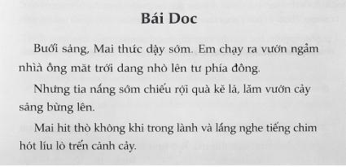
The topic has the following contents: (yes/no) System design analysis: Yes.................................................................Database: Yes........................................................................................Interface design: Yes................................................................................
Resend the registration form via Email:ttthao@nctu.edu.vn

 | FACULTY OF INFORMATION TECHNOLOGY  Development direction: Yes..................................................................................The topic has an inheritance from the existing topic: Yes.....................................................Other (specify):............................................................................................. .....................................................................................................................
Where is the topic applied: Interactive programming learning platform with AI for education, training, and assessment of programming skills for students, beginners, and training centers....................................................................................................
3. Other opinions: --Do students have any additional suggestions for instructors:
Field | Data Types | Description | Bind
UserID | int | Mãdùng người | Primary Key
Username | nvarchar | Tên nhập đăng | Not Unique null,
Password | nvarchar | Password | Not null
Role | nvarchar | Role | Not null
Resend the registration form via Email:ttthao@nctu.edu.vn

