TALRAG: A Self-Learning Temporal-Adaptive RAG Framework
NGUYEN Quoc-Dat1, Ngo-Ho Anh-Khoa1, and Ngo-Ho Anh-Khoi1*
1 Faculty of Information Technology, Nam Can Tho University, 168 Nguyen Van Cu Street, An Binh Ward, Can Tho City,
{dat223955@student.nctu.edu.vn,,
nhakhoi@nctu.edu
Abstract.Retrieval-AugmentedGeneration(RAG)hasbecomeapopular methodforreducinghallucinationsinLargeLanguageModels(LLMs). However,current RAGframeworksusually relyon static knowledgebasesand basicsemanticretrieval,whichlimitstheirabilitytohandledomain-specific reasoningandupdatewithnewinformation.Thislimitationisamajorissuein historicalquestionansweringsystems,wheretemporalcontext,causallinks, and factual reliability are highly important. Toaddress this, this paper proposes TALRAG,aselflearningandtemporaladaptiveRAGframeworkbuilt specificallyforVietnameseHistoricalQuestionAnswering.Thesystem combinesadaptiveretrievalusingmultiplescores,selflearningguidedbytrust assessment,andahuman-in-the-loopmechanismintoasinglearchitectureto keeptheknowledgeevolving.UnlikestandardRAGmodels,TALRAG continuouslyupdatesitsknowledgebasethrougha learningpipeline guidedby feedbackthatinvolveswebinformationgathering,reliabilitychecking,user validation,andautomaticvectoringestion.Toimprovehowthemodelreasons abouthistory,weintroduceanretrievalmechanismbasedonqueryintentthat dynamicallyscoresandcombinessemanticrelevance,timeproximity,and causalrelationshipsbasedonwhattheuserisasking.Thewholeprocessruns throughapipelinewithmultiplestages,includingFAISS-basedretrievalfrom multiplevectorstores,LLM-baseddocumentgrading,awebfallbackfor missingdata,andautomaticknowledgerefinement.Additionally,ourlearning approachbased on user feedback allows new external historical data to become trustedvectormemoryoncevalidatedbyusers,whichimprovesfuturesearch qualityandcutsdownonhallucinationrisks.Ourexperimentalresultsshow thatTALRAGclearlyoutperformstraditionalstaticRAGarchitecturesin retrievalrobustness,answerrelevance,andcontinuousknowledgeadaptation. Overall,thisproposedframeworkoffersascalableandreliablesolutionfor domain-specificAIassistantsthatrequiretrustworthyreasoningandtheability to learn over time.
Keywords:Retrieval-AugmentedGeneration(RAG);Self-LearningRAG; Human-in-the-Loop Learning; Temporal Adaptive Retrieval; Historical Question Answering; Knowledge Evolution; Large Language Models.

2
1 INTRODUCTION
In recent years, the rapid growth of Artificial Intelligence (AI) and digital information has increased the demand for question answering (QA) systems across many domains. Comparedwithtraditionalkeyword-basedsearch,modernQAsystemsprovidemore naturalandcontext-awareaccesstoinformation(Riloff&Thelen,2000).The developmentofTransformer-basedmodels(Vaswanietal.,2017),includingBERT (Devlinetal.,2019)andGPT-4(OpenAI,2023),hasfurtherimprovednatural language understanding and generation.
Despitetheseadvances,LargeLanguageModels(LLMs)stillsufferfrom hallucination,wheregeneratedoutputsmaycontainunsupportedorincorrect information(Jietal.,2023).Thisissueisespeciallycriticalinhistoricalquestion answeringbecausehistoricalanswersrequirefactualaccuracy,temporalconsistency, andreliablecausalinterpretation.Therefore,ahistoricalQAsystemmustnotonly retrieverelevantfactsbutalsoreasoncorrectlyaboutdates,dynasties,events,and causeandeffectrelationships.Retrieval-AugmentedGeneration(RAG)reduces hallucination by grounding LLMresponses in external knowledgesources rather than relyingonlyonmodelparameters(Lewisetal.,2020;Gaoetal.,2024).However, conventionalRAGstillhaslimitationsin historicalQAbecauseitoftenrelies mainly onsemanticsimilarity,lacksexplicittemporalandcausalreasoning,andusually operatesonstaticknowledgebasesthatcannotlearnfromuserfeedback(Dhingraet al.,2022; Asaietal.,2023;Yan etal.,2024). Toaddress theselimitations,thispaper introducesTALRAG,aRAGframeworkwithselflearningandtemporaladaptation forVietnamesehistoricalquestionanswering.UnlikestaticRAGmodels,TALRAG learnsfromvalidateduserfeedbackandupdatesitsvectormemorythroughaself learning pipeline guided by trust assessment.
Therestofthispaperisorganizedasfollows.Section2reviewsrelatedworkon RAG,adaptiveretrieval,andselflearningQAsystems.Section3presentsthe proposedTALRAGframework.Section4describestheexperimentalsetupand results. Section 5 concludes the paper and discusses future work.
2 RELATED WORK
Thedevelopmentofquestionanswering(QA)systemshasevolvedfromrule-based methodstoneuralandretrieval-augmentedapproaches.EarlyQAsystemsrelied mainlyonhandcraftedrulesandkeywordmatching,whichprovidedcontrollability butlimitedcontextualreasoningcapability(Riloff&Thelen,2000;Lehnert,1977). The emergence of Transformer-based models significantly improved natural language understandingandgeneration(Vaswanietal.,2017).Pre-trainedmodelssuchas BERTandGPT-4furtheradvancedcontextualrepresentation,reasoning,and conversationalinteraction(Devlinetal.,2019;OpenAI,2023).However,LLMsstill sufferfromhallucination,wheregeneratedanswersmaycontainunsupportedor factually incorrect information (Ji et al., 2023). This limitation is especially critical in

3
historical QA, where factual accuracy, temporal consistency, and causal interpretation are essential.
Retrieval-AugmentedGeneration(RAG)addresseshallucinationbygrounding LLMoutputsinexternaldocuments(Lewisetal.,2020).Denseretrievalmethods suchasDPRandSentence-BERTimprovesemanticsearch,whileFAISSenables efficientvectorretrievaloverlarge-scaledocumentcollections(Karpukhinetal., 2020;Reimers&Gurevych,2019;Johnsonetal.,2019).Recentsurveysshowthat RAGhasbecomeanimportantapproachforknowledge-intensiveNLPtasks(Gaoet al.,2024). Nevertheless,conventionalRAGsystemsstillfacelimitationsin historical questionanswering.Theyoftenrelymainlyonsemanticsimilarity,whichmay retrievedocumentsthatarelinguisticallyrelatedbuttemporallyorcausally inconsistent. Priorworkon time-awarelanguagemodelshighlightstheimportanceof temporalreasoningforknowledge-intensivetasksinvolvingtimelinesandevolving facts (Dhingra et al., 2022).
Severalstudieshaveattemptedtoimproveretrievalqualityandanswerreliability. BERT-basedre-rankingimprovespassagerankingbyrefiningtheorderofretrieved documents(Nogueira&Cho,2019),whileBEIRprovidesaheterogeneous benchmark for evaluating retrieval models across domains (Thakur et al., 2021). More recent frameworks such as Self-RAG and Corrective RAG introduce self-reflection or correctionmechanismstoimprovegenerationquality(Asaietal.,2023;Yanetal., 2024). GraphRAG further explores graph-based retrieval to capture global relationshipsamongentities(Edgeetal.,2024).However,theseapproachesstilldo notfullyaddresstheneedforatransparentmechanismthatcontinuouslyupdates domain knowledge from validated user interaction history.
IntheVietnameseNLPdomain,NguyenandNguyen(2020)introducedPhoNLP, whichsupportsVietnameselanguageprocessingandisrelevanttohistoricalQA because Vietnamese historical questions often contain named entities, dynastic names, temporalexpressions,andculturallyspecificterminology.ForthehistoricalQA baseline, this study uses ItihashQA. ItihashQA is a retrieval-augmented conversationalquestionansweringsystemdevelopedfortheBangladeshihistorical context.ItsreleasedimplementationfollowsastaticRAGarchitecture,where retrievedhistoricalcontextsarepassedtoalanguagemodelforresponsegeneration. SinceItihashQAisspecificallydesignedforhistoricalquestionanswering,thisstudy adoptsitas thebaselinesystemandadapts itsstaticRAGpipelineto theVietnamese historicalcorpusforcontrolledcomparison.Althoughtherepositorydescriptionalso referstothesystemasEkattorQA,thispaperconsistentlyusesthenameItihashQA according to the repository and work title.
Commercialdocument-groundedQAtoolssuchasGoogleNotebookLMand GeminiGemsalsodemonstratethepracticalvalueofretrieval-basedassistantsfor documentunderstandingandpersonalizedknowledgeaccess.Thesesystemsallow users toorganizesourcesorcreatecustomizedassistantsforspecifictasks.However, theirretrievalmechanisms,evaluationprocedures,andmemoryupdatestrategiesare not fully transparent for research reproduction. More importantly, they do not provide anexplicitselflearningpipelineguidedbytrustassessment,inwhichchathistory

4
validatedbyusersisconvertedintonewvectormemory.Therefore,althoughthese toolsareusefulfordocumentsynthesisandpersonalizedassistance,theyarenot directlyequivalenttoTALRAG’sknowledgeevolutionmechanismguidedby feedback.
Fromthereviewedliterature,threelimitationsremainclear.First,mostRAG systems rely heavily on semantic similarity and do not explicitly optimize retrieval for temporalandcausalreasoning,whichareessentialinhistoricalQA.Second,many adaptive RAG frameworks improveretrieval or generation quality but stilloperate on staticknowledgebasesafterdeployment.Third,existingdocument-groundedchatbot systems do not provide a transparent research-oriented mechanism for converting user feedback and chat history into validated vector memory.
TALRAGaddressesthesegapsbycombiningretrievalbasedonqueryintent, temporalandcausalscoring,documentgradingusinganLLM,webfallbackfor missinginformation,andselflearningguidedbyfeedback.Thekeynoveltyof TALRAGisits ability tolearn from userchathistory.Whenthesystemencountersa low-confidenceorunansweredquery,theinteractionbecomesalearningcandidate. Afterexternalknowledgeacquisition,reliabilityverification,andpositiveuser feedback,thevalidatedknowledgeisrefinedandingestedintothedynamicFAISS vectorstore.Inthisway,TALRAGdoesnotsimplyanswerquestionsfromafixed corpus;itcontinuouslyevolvesitshistoricalknowledgebasethroughknowledge validation guided by feedback.
3 PROPOSED TALRAG FRAMEWORK
ThemaincontributionofTALRAGisaselflearningpipelineguidedbytrust assessment that converts low-confidence or unanswered queries into opportunities for knowledgeexpansion.UnlikestandardRAGsystemsthatrelyonfixedvector databases,TALRAGusesvalidateduserfeedbackandchathistorytoupdateits dynamic vector memory over time.

5
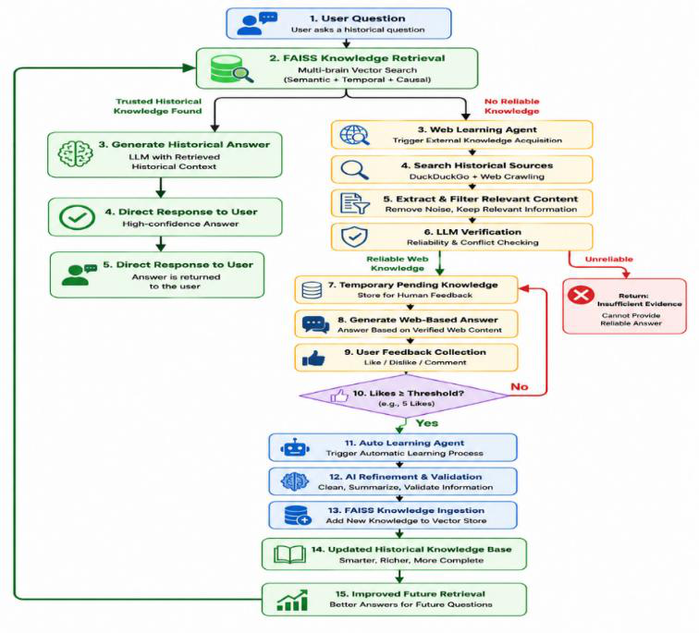
Fig. 1. self learning pipeline guided by trust assessment of TALRAG.
Toformallydescribetheproposedworkflow,Algorithm1presentsthemain
inferencepipeline,includingintentclassification,temporalandcausalretrieval,
documentgrading,andanswergeneration.Algorithm2describesthelearning
pipelinebasedonuserfeedbackhoặcselflearningpipeline,whereretrievalfailures
are converted into learning candidates through web acquisition, reliability
verification, user feedback, and FAISS ingestion.
Algorithm 1. TALRAG inference pipeline
Input:Userquestionq,chathistoryH,trustedvectorstoresV,languagemodel LLM
Output: Generated answer A, retrieved contexts C
1:Authenticate user request
2:Check user token balance
3:intent ←ClassifyQuery(q)
4:temporal_info ←ExtractTemporalEntities(q)
5:q_norm ←NormalizeQuestion(q)
6:candidate_docs ←MultiBrainFAISSRetrieve(q_norm, V)
7:for each document d in candidate_docs do
8: S_sem ←SemanticScore(q_norm, d)
9: S_temp ←TemporalScore(temporal_info, d)
10:
S_caus ←CausalScore(q_norm, d) 11: S_total ←α(intent) × S_sem
+ β(intent) × S_temp
+ γ(intent) × S_caus
12: end for
13: ranked_docs ←SortByScore(candidate_docs, S_total)

6
14: filtered_docs ←DocumentGrader(q, ranked_docs) 15: if filtered_docs is not empty then
16: C ←filtered_docs
17: A ←GenerateAnswer(LLM, q, C, H)
18: else
19:
A, C ←TrustAwareSelfLearning(q) 20: end if
21: Save conversation log
22: Update token balance
23: return A, C

Algorithm 2. Trust-aware self-learning pipeline
Input:Userquestionq,websearchengineW,languagemodelLLM,pending knowledge repository P, dynamic vector store V_dynamic, feedback threshold θOutput: Provisional answer A_web, verified web contexts C_web
1:web_results ←SearchWeb(W, q)
2:raw_chunks ←CrawlAndExtract(web_results)
3:relevant_chunks ←FilterRelevantContent(q, raw_chunks)
4:C_web, confidence ←VerifyReliability(LLM, q, relevant_chunks)
5:if confidence is low then
6: A_web ←"Insufficient evidence"
7: return A_web, ∅
8:end if
9:A_web ←GenerateWebBasedAnswer(LLM, q, C_web)
10: SaveToPendingKnowledge(P, q, A_web, C_web)
11: Collect user feedback for q
12: if PositiveFeedback(q) ≥θ then
13: refined_knowledge ←RefineKnowledge(LLM, q, A_web, C_web)
14: chunks ←ChunkText(refined_knowledge)
15: embeddings ←GenerateEmbeddings(chunks)
16: IngestIntoFAISS(V_dynamic, chunks, embeddings)
17: MarkKnowledgeAsApproved(P, q)
18: end if
19: return A_web, C_web
TheTALRAGworkflowbeginswhenausersubmitsahistoricalquestion.The systemfirst performsauthentication andtoken balancechecking to ensuresecure and controlledaccess.Thequeryisthenclassifiedintointenttypessuchasfactual, temporal,causal,orcomparativequestions.Thisclassificationguidestheretrieval process because different historical questions require different evidence priorities.
Tosupporthistoricalreasoning,TALRAGappliesalightweighttemporal extractionmechanismtoidentifyyears,dynasties,historicalperiods,andothertime-relatedexpressions.Thesetemporalsignalsareusedtoguidedocumentretrievaland

7
ranking,helpingthesystemavoidcontextsthataresemanticallysimilarbut historically misaligned.
Theretrievalcomponentisbasedonmulti-sourceFAISSretrieval.Itretrieves candidatedocumentsfromtrustedhistoricalsources,approvedknowledge,and dynamicallylearnedvectormemory.Insteadofrankingdocumentsonlybysemantic similarity, TALRAG computes a combined retrieval score:
Stotal = (α × Ssemantic) + (β × Stemporal) + (γ × Scausal)
whereSsemanticmeasuressemanticsimilaritybetweenthequestionandthe document,S_temporalmeasureschronologicalconsistency,andScausalmeasures causal alignment with the query. The weights α, β, and γ are adjusted according to the classifiedqueryintent.Forexample,temporalquestionsassignhigherweightto Stemporal, while causal questions prioritize Scausal.
Afterretrieval,therankeddocumentsareprocessedbyanLLM-baseddocument gradingmodule.Thismodulefiltersnoisy,weaklyrelated,orcontradictorycontexts beforeanswergeneration.Ifsufficientreliablecontextremains,theLLMgeneratesa grounded answer using the filtered evidence.
If the trusted retrieval pipeline cannot find sufficient reliable knowledge, TALRAG activatesthetrust-awareself-learningpipeline.Inthisstage,thesystemsearches externalsourcesandextractscandidatehistoricalevidence.Theextractedcontentis filteredforrelevanceandcheckedforreliabilitybeforebeingusedtogeneratea provisionalanswer.Importantly,knowledgeacquiredfromthewebisnotdirectly inserted intothetrustedknowledgebase.Instead,itis storedin apendingknowledge repository until it receives sufficient positive user feedback.
Thecentralnoveltyofthisframeworkistheuseofuserinteractionhistoryasa learningsignal.Whenaprovisionalanswerreceivesenoughpositivefeedback,the automatic learning module refines the verified content, splits it into chunks, generates embeddings,andingestsitintothedynamicFAISSvectorstore.Asaresult,future similar questions can retrieve this validated knowledge directly from vector memory.
This design allows TALRAG to continuously improve its historical coverage while reducingtheriskofcontaminatingthetrustedknowledgebasewithunreliable information.Finally,thesystemrecordsinteractionlogs,retrievaltraces,feedback signals, and token usage for monitoring, resource management, and future analysis.
4 EXPERIMENTS
ToevaluatetheeffectivenessofTALRAG,weconductedaRAGAS-based comparativeexperimentagainsttheItihashQAbaseline.ItihashQAisaretrieval-augmentedhistoricalquestionansweringsystemoriginallydevelopedforthe Bangladeshihistoricalcontext.In thisstudy,itsstaticRAGpipelineis adapted tothe Vietnamesehistoricalcorpusforcontrolledcomparison.Thebaselineretrievesthe top-ksemanticallysimilarchunksfromthevectordatabaseanddirectlypassesthem to the language model for answer generation.
In contrast, TALRAG extends the standard RAG workflow with intent classification,temporalandcausalscoring,documentgradingusinganLLM,web

9
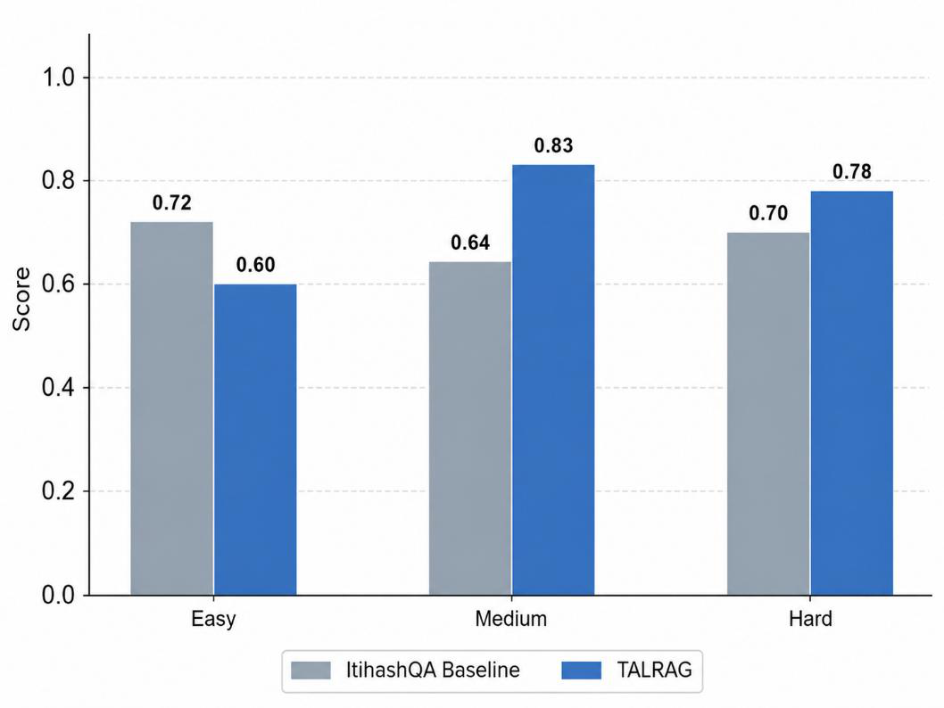
Fig. 2a. Answer Relevancy comparison between ItihashQA baseline and TALRAG.
ThelargestimprovementappearsinAnswerRelevancy.OnEasyquestions, TALRAGimprovesfrom0.35to0.44.OnMediumquestions,itincreasesfrom0.18 to0.79.OnHardquestions,TALRAGmaintainsascoreof0.70,whilethebaseline dropsto0.09.TheseresultsindicatethatTALRAGgeneratesanswersthataremore directlyalignedwithusers’historicalquestions,especiallyasquestioncomplexity increases.

10
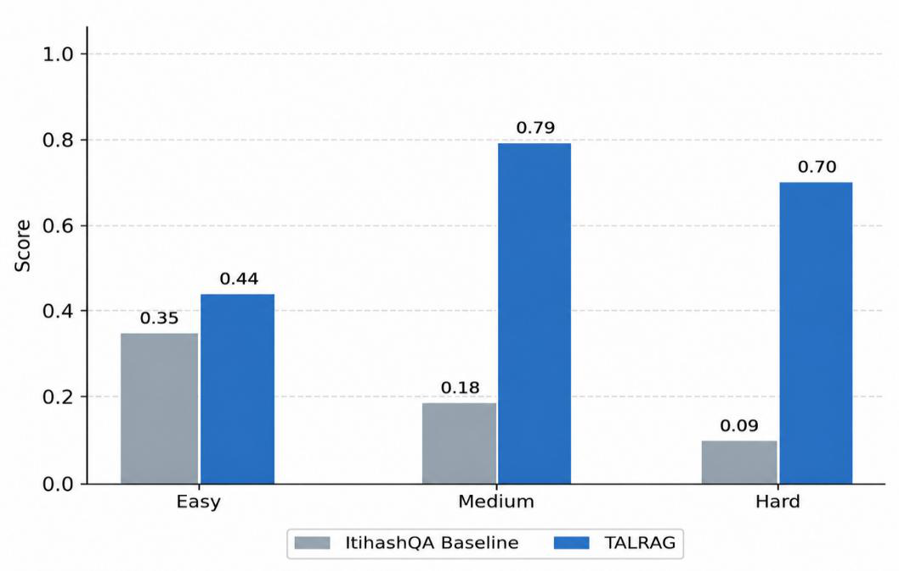
Fig. 2b. Faithfulness comparison between ItihashQA baseline and TALRAG.
ForFaithfulness,TALRAGperformsbetteronMediumandHardquestions,with scoresof0.83and0.78comparedwiththebaselinescoresof0.64and0.70, respectively.However,onEasyquestions,thebaselineobtainsahigherFaithfulness scoreof0.72comparedwithTALRAG’s0.60.Thissuggeststhatsimplefactual questionsmaynotalwaysrequirecomplexadaptiveretrieval,andstricterfiltering may sometimes remove useful context for straightforward lookup questions.
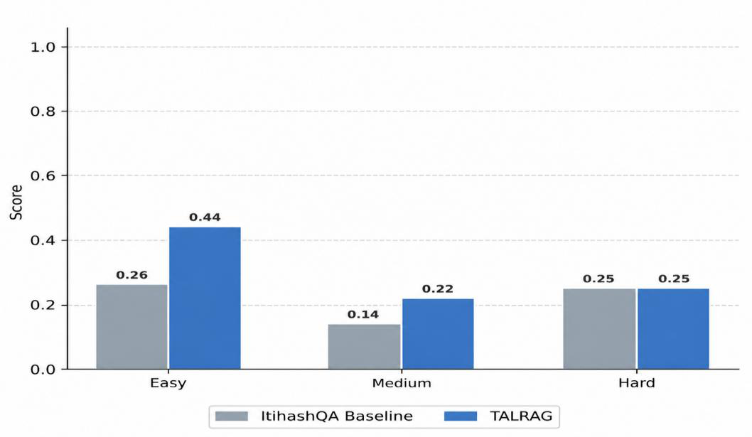
Fig. 2c. Context Precision comparison between ItihashQA baseline and TALRAG.

11
IntermsofContextPrecision,TALRAGimprovesoverthebaselineacrossall difficultylevels.OnEasyquestions,thescoreincreasesfrom0.26to0.44.On Mediumquestions,itincreasesfrom0.14to0.22.OnHardquestions,bothsystems achieveapproximately0.25,withTALRAGshowingaslightimprovement.These results showthattemporal-causalscoringanddocumentgradinghelpretrievecleaner and more relevant contexts.
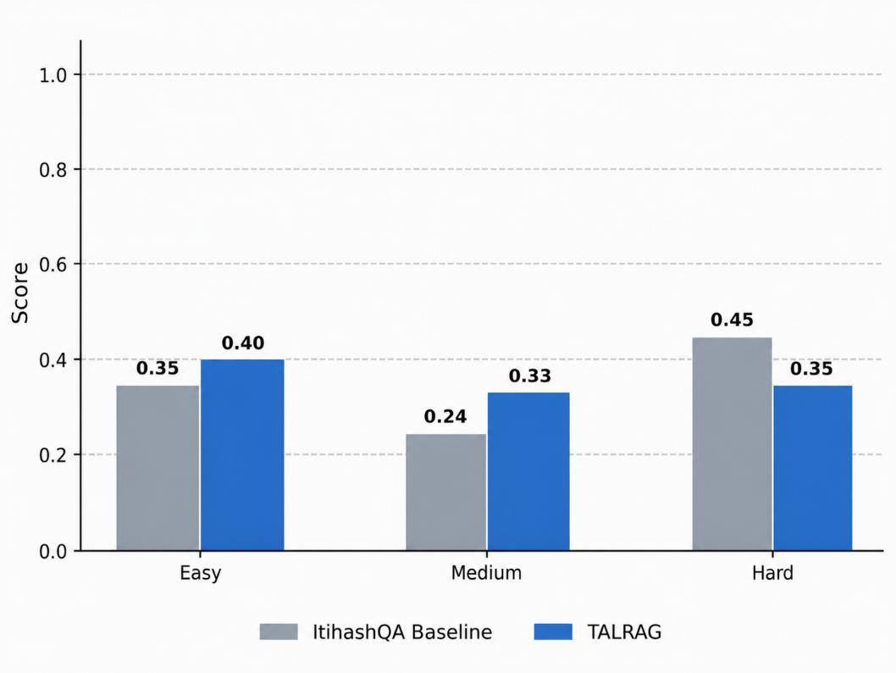
Fig. 2d. Context Recall comparison between ItihashQA baseline and TALRAG.
ForContextRecall,TALRAGimprovesoverthebaselineonEasyandMedium questions, increasing from 0.35 to 0.40 and from 0.24 to 0.33, respectively. However, onHardquestions,thebaselineobtainsahigherscoreof0.45comparedwith TALRAG’s0.35.Thissuggeststhatthebaselinemayretrievebroaderevidencein somedifficultmulti-hopquestions,whileTALRAGprioritizesprecisionand relevance through stricter filtering.
TALRAGachieveshigheraveragescoresthanthebaselineonallfourRAGAS metrics.Faithfulnessimprovesfrom0.68to0.73,AnswerRelevancyimprovesfrom 0.21to0.64,ContextPrecisionimprovesfrom0.22to0.31,andContextRecall improvesfrom0.35to0.36.ThelargestgainisobservedinAnswerRelevancy, showing the effectiveness of retrieval based on query intent and adaptive re-ranking.
TheseresultsconfirmthatTALRAGimprovestheoverallqualityofVietnamese historical question answering compared with a static RAG baseline. The improvement ismainlyattributedtothreecomponents:adaptiveretrievalusingmultiplescores, LLM-baseddocumentgrading,andtheselflearningpipelineguidedbytrust assesment. At the same time, the results show thatTALRAG does not outperform the baseline in everyindividualcase. In particular, thelowerEasyFaithfulness score and lowerHardContextRecallscoresuggestthatstricterfilteringcanreduceuseful evidencecoverage.Futureworkshouldinvestigateadaptivethresholds,largertop-k retrieval for difficult questions, and better precision-recall balancing.

12
TheRAGASevaluationshowsthatTALRAGprovidesamorerelevant,context-aware,andRAGarchitecturethatcanimproveovertimeforVietnamesehistorical QA.Bycombiningtemporalandcausalretrieval,documentgrading,andtrust-aware self-learning,TALRAGturnsstaticprocessofretrievalandgenerationintoa continuously evolving historical knowledge system.
5 CONCLUSION
ThisresearchintroducedTALRAG,aRAGframeworkwithselflearningand temporal adaptation for Vietnamese historical question answering. Unlikestatic RAG systems that mainly rely on semantic similarity and fixed vector databases, TALRAG combinesadaptiveretrieval,temporalandcausalreasoning,documentgrading,and self learning guided by trust assessment in a unified workflow.
ThemaincontributionofTALRAGisitsselflearningpipelineguidedbytrust assessment.Whenreliableinformationcannotberetrievedfromthetrustedvector store,thesystemacquiressupplementaryhistoricalevidencefromexternalsources, verifiesitsreliability,storesitaspendingknowledge,andusesuserfeedbackto decidewhetheritshouldbeingestedintoFAISSasreusablevectormemory.This mechanism allows TALRAG to learn from user interaction history while reducing the risk of contaminating the knowledge base with unreliable information.
TALRAGdemonstratesthatRAGcanbeextendedfromastaticprocessof retrievalandgenerationintoacontinuouslyevolvinghistoricalknowledgesystem. Futureworkwillfocusonimprovingrecallformulti-hopquestions,integrating knowledgegraphstomodelrelationshipsamonghistoricalentities,andexploring multimodalretrievalforhistoricalmaps,scanneddocuments,ancientscripts,and artifacts.
REFERENCES
1.Chen,Jiawei,Lin,Hongyu,Han,Xianpei,&Sun,Le.(2023).Benchmarking LargeLanguageModelsinRetrieval-AugmentedGeneration.arXivpreprint arXiv:2309.01414.
2.Devlin,Jacob,Chang,Ming-Wei,Lee,Kenton,&Toutanova,Kristina.(2019).
BERT: Pre-training of Deep Bidirectional Transformers for Language Understanding.InProceedingsofthe2019ConferenceoftheNorthAmerican Chapter of the Association for Computational Linguistics (NAACL), 4171–4186. 3.Ji,Ziwei,Lee,Nayeon,Frieske,Rita,Yu,Tiezheng,Su,Dan,Xu,Yan,Ishii, Etsuko,Bang,YeJin,Madotto,Andrea,&Pascual,Damien.(2023).Surveyof Hallucination in Natural Language Generation. ACM Computing Surveys, 55(12), 1–38.
4.Lewis,Patrick,Perez,Ethan,Piktus,Aleksandra,Petroni,Fabio,Karpukhin, Vladimir,Goyal,Naman,Küttler,Heinrich,Lewis,Mike,Yih,Wen-tau, Rocktäschel,Tim,Riedel,Sebastian,&Kiela,Douwe.(2020).Retrieval-

13
AugmentedGenerationfor Knowledge-IntensiveNLPTasks.Advances inNeural Information Processing Systems (NeurIPS), 33, 9459–9474.
5.Nogueira,Rodrigo,&Cho,Kyunghyun.(2019).PassageRe-rankingwithBERT. arXiv preprint arXiv:1901.04085.
6.OpenAI. (2023). GPT-4 Technical Report. arXiv preprint arXiv:2303.08774. 7.Riloff,Ellen,&Thelen,June.(2000).ARule-basedQuestionAnsweringSystem forReadingComprehensionTests.InProceedingsoftheANLP/NAACL WorkshoponReadingComprehensionTestsasEvaluationResourcesforNLP, 13–21.
8.Thakur,Nandan,Reimers,Nils,Daxenberger,Johannes,&Gurevych,Iryna.
(2021). BEIR: A Heterogeneous Benchmark for Information Retrieval Evaluation. arXiv preprint arXiv:2104.08663.
9.Vaswani,Ashish,Shazeer,Noam,Parmar,Niki,Uszkoreit,Jakob,Jones,Llion, Gomez,AidanN.,Kaiser,Lukasz,&Polosukhin,Illia.(2017).AttentionIsAll YouNeed.InAdvancesinNeuralInformationProcessingSystems(NeurIPS), 5998–6008.
10. Himu, A. D., Azad, M. S., Rahman, R., & Hasan, M. R. (2024). Towards Accurate AI-DrivenItihashQA:AConversationalQuestionAnsweringSystemAppliedin Bangladeshi Historical Context. GitHub repository. [Online]. Available: https://github.com/shawmoonazad/ItihashQA. Accessed: May 14, 2026.
11. Asai,Akari,Wu,Zeqiu,Wang,Yizhong,Slotnick,Avirup,Sonthalia,Rishi,& Hajishirzi,Hannaneh.(2023).Self-RAG:LearningtoRetrieve,Generate,and Critique through Self-Reflection. International Conference on Learning Representations (ICLR).
12. Yan,Shi-Qi,Gu,Jia-Chen,Zhu,Yun-Ze,&Ling,Zhen-Hua.(2024).Corrective Retrieval Augmented Generation. arXiv preprint arXiv:2401.15884.
13. Gao,Yunfan,Xiong,Yun,Gao,Xinyu,Jia,Kangxiang,Pan,Jinliu,Bi,Yutong, Dai,Yi,Sun,Jiawei,&Wang,Haofen.(2024).Retrieval-AugmentedGeneration for Large Language Models: A Survey. arXiv preprint arXiv:2312.10997.
14. Nguyen,DatQuoc,&Nguyen,AnhTuan.(2020).PhoNLP:AJointOverloaded Model for Vietnamese Natural Language Processing. arXiv preprint arXiv:2011.01544.
15. Dhingra,Bhuwan,Cole,JeremyR.,Eisenschlos,JulianMartin,Gillick,Daniel, Eisenstein,Jacob,&Cohen,WilliamW.(2022).Time-AwareLanguageModels as Temporal Knowledge Bases. Transactions of the Association for Computational Linguistics, 10, 257–273.
16. Ouyang,Long,Wu,Jeffrey,Jiang,Xu,Almeida,Diogo,Wainwright,Carroll, Mishkin,Pamela,Zhang,Chong,Agarwal,Sandhini,Slama,Katarina,Ray,Alex, Schulman,John,Hilton,Jacob,Kelton,Fraser,Miller,Luke,Simens,Maddie, Askell,Amanda,Welinder,Peter,Christiano,Paul,Leike,Jan,&Lowe,Ryan.
(2022). TrainingLanguageModels toFollowInstructionswithHumanFeedback. Advances in Neural Information Processing Systems (NeurIPS).
17. Karpukhin,Vladimir,Oguz,Barlas,Min,Sewon,Lewis,Patrick,Wu,Ledell, Edunov,Sergey,Chen,Danqi,&Yih,Wen-tau.(2020).DensePassageRetrieval

14
for Open-Domain Question Answering. In Proceedings of the 2020 Conference on Empirical Methods in Natural Language Processing (EMNLP).
18. Reimers, Nils, & Gurevych, Iryna. (2019). Sentence-BERT: Sentence Embeddings UsingSiameseBERT-Networks.InProceedingsofthe2019Conferenceon Empirical Methods in Natural Language Processing (EMNLP).
19. Edge,Darren,Trinh,Ha,Cheng,Newman,Bradley,Joshua,Chao,Shuo,Mody, Apurva,Truitt,Steven,&Larson,Jonathan.(2024).FromLocaltoGlobal:A GraphRAG Approach to Query-Focused Summarization. arXiv preprint arXiv:2404.16130.
20. Johnson,Jeff,Douze,Matthijs,&Jégou,Hervé.(2019).Billion-scaleSimilarity Search with GPUs. IEEE Transactions on Big Data, 7(3), 535–547.
21. Zheng,Lianmin,Chiang,Wei-Lin,Sheng,Ying,Zhuang,Siyuan,Wu,Zhanghao, Zhuang,Yonghao,Lin,Zi,Li,Zhuohan,Li,Dacheng,Xing,Eric,Zhang,Hao,& Stoica, Ion. (2023). Judging LLM-as-a-Judgewith MT-Bench and Chatbot Arena. arXiv preprint arXiv:2306.05685.
22. Google.(2023).NotebookLM.[Online].Available:https://notebooklm.google/. Accessed: May 14, 2026.
23. Google.(2024).GeminiGems.[Online].Available:https://gemini.google.com/. Accessed: May 14, 2026.

