Your homework is to finish my program. Unzip the project and open it with Visual Studio.

The Dog class is fine, look it over, but do not change that code.

Just add 4 lines of code in the Main method, as the comments show, such that you get this output when you run the program:

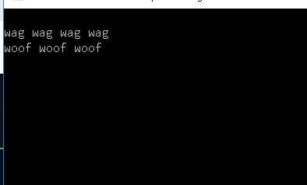

By reviewing the 1-DemoClassOnClasses.pptx, you should be able to figure this out.