Efficient Real-Time Fire Surveillance: A Lightweight Motion-Heuristic Skip Module for Accelerated Inference in Indoor Environments
Hoang Van-Ha, Jong Weon Lee, Park Chun-Su
2026.05.20

Abstract

Conventional deep learning (DL)-based fire and smoke detection systems perform inference on every video frame using high-complexity models to classify the presence of fire or smoke. However, in surveillance scenarios, particularly indoor environments, video streams frequently contain long periods of static background frames with little or no motion, rendering per-frame inference redundant and wasteful of computational resources. To address this limitation, this study proposes an efficient inference acceleration framework for fire and smoke surveillance systems that combines a motion-aware skip module with an Eager mode for recall recovery. The skip module leverages motion detection to selectively bypass unnecessary DL inference on non-informative frames, while the Eager mode periodically forces inference updates to mitigate missed detections from slow-developing or nearly stationary smoke events.
Evaluation on a large-scale dataset comprising 150 indoor videos demonstrates that the proposed framework achieves nearly 30% higher throughput than the baseline performing per-frame inference, with only a 0.05% reduction in recall. In contrast, using the skip module alone results in a 1.24% recall drop, highlighting the effectiveness of the Eager mode in recovering detection performance while preserving most of the throughput gain. These results demonstrate that the proposed framework provides an effective plug-and-play inference acceleration strategy for real-time indoor fire and smoke surveillance systems.

1 Introduction
Fires and wildfires, if not detected and controlled in their early stages, can quickly escalate, especially under dry and windy conditions, resulting in catastrophic consequences, including loss of life, destruction of property, and damage to natural ecosystems. For instance, in 2017, urban fires and wildfires in California, USA, caused an estimated economic loss of 10 billion USD [1]. More recently, in 2025, a forest fire in Gyeongsang Province, South Korea, burned approximately 90,000 acres, resulting in at least 27 fatalities and the evacuation of nearly 40,000 residents [2]. These incidents highlight the critical importance of automated early-stage fire and smoke detection systems for enabling timely intervention and minimizing damage.
In recent years, DL-based approaches have emeraged as the prevailing methodology in fire and smoke detection systems [3], [4]. In practical deployments, such systems are commonly integrated into CCTV video pipelines, where DL-based classifiers or object detectors perform inference on every individual frame. While this per-frame paradigm is straightforward to implement, it exhibits two major limitations. First, it relies solely on spatial information within isolated frames, neglecting temporal cues like motion video sequences. Second, in surveillance scenarios, particularly in indoor environments, video streams can exhibit minimal visual variation across consecutive frames due to static scene content. Indiscriminately applying computationally intensive DL models to every frame under these conditions introduces significant processing redundancy, increasing latency and computational overhead without improving detection performance. This inefficiency is further amplified by the well-known accuracy-efficiency trade-off in DL: high-accuracy models typically demand substantial computational resources, and indiscriminate frame processing amplifies resource demands, and indiscriminate per-frame inference magnifies these demands, posing a significant barrier to real-time deployment.

A common strategy for reducing inference cost is to substitute a high-complexity model with a lightweight alternative; however, this approachtypically compromises detection reliability ­ an unacceptable trade-off in safety-critical applications such as fire and smoke surveillance. This study adopts a complementary approach: rather than replacing the classifier, we propose an efficient inference acceleration framework that introduces a lightweight, motion-aware skip module acting as a computational gate upstream of the classifier. The skip module leverages frame differencing-based motion estimation to selectively bypass DL inference on static, non-informative frames, while forwarding only frames with significant scene activity to the high-capacity classifier. To address a key failure mode of motion-based skipping — namely, missed detections arising from slow-developing or nearly stationary smoke events — the framework additionally incorporates an Eager mode that periodically forces inference updates to recover detection recall. As illustrated in Fig. 1, the conventional pipeline processes every frame through the classifier, whereas the proposed pipeline adds the skip module early in the process to conditionally suppress redundant inference calls.
The main contributions of this work are summarized as follows:
- Motion-Aware Skip Module: A lightweight skip module is proposed that exploits frame differencing-based motion estimation to identify and bypass DL inference on static frames, thereby reducing computational cost without modifying the underlying classifier. The proposed module is designed as a plug-and-play component compatible with existing fire and smoke detection pipelines. A systematic hyperparameter optimization procedure is further developed to identify the optimal operating configuration for maximizing throughput while preserving detection performance.
- Indoor Fire and Smoke Video Dataset: We construct an annotated dataset comprising 150 indoor fire and smoke videos (including fire, smoke, and background-only classes) captured by static surveillance cameras at resolutions ranging from 814 × 720 to 3840 × 2160. The dataset covers diverse environments such as warehouses, parking areas, and offices under varying lighting conditions, providing a realistic benchmark for evaluating detection systems in static surveillance scenarios.
- Comprehensive System Evaluation and Analysis: The proposed framework is integrated with a high-capacity DL classifier (BIG model) and evaluated on the constructed dataset against a per-frame inference baseline and existing methods. Results demonstrate approximately 30% higher throughput than the baseline, with a recall reduction of less than 0.05% when the Eager mode is active — compared to a 1.24% recall drop when the skip module is used alone — highlighting the effectiveness of the Eager mode in recovering detection performance while preserving most throughput gains. Comprehensive System Evaluation and Analysis: The proposed framework is integrated with a high-capacity DL classifier (BIG model) and evaluated on the constructed dataset against a per-frame inference baseline and existing methods. Results demonstrate approximately 30% higher throughput than the baseline, with a recall reduction of less than 0.05% when the Eager mode is active — compared to a 1.24% recall drop when the skip module is used alone — highlighting the effectiveness of the Eager mode in recovering detection performance while preserving most throughput gains. Beyond quantitative benchmarking, a detailed efficiency analysis of the proposed system is conducted, and success and failure cases.
The rest of this paper is organized as follows: Section 2 reviews existing fire and smoke detection methods for video and relevant motion detection techniques, contextualizing the need for efficient processing in static surveillance scenarios. Section 3 describes the proposed system architecture, the design of the skip-module, its integration with the classifier, the hyperparameter optimization strategy, and the Eager mode proposed to address missed detections arising from slow-developing or nearly stationary smoke events. Section 4 presents the experimental setup, evaluation metrics, and results on the large-scale indoor video dataset, including comparative analyses against the baseline and an existing temporally-aware method, and qualitative examination of success and failure cases of the proposed skip module. Finally, Section 5 summarizes the key findings and discusses limitations and future research directions.

2 Related Work
Fire and Smoke Detection in Images and Videos: Automated fire and smoke detection has attracted considerable research interest, with deep learning emerging as the dominant paradigm. The work [3] provides a comprehensive survey of visual fire detection methods, highlighting the rapid adoption of DL-based approaches in this domain. The majority of these methods formulate the problem as image-level binary classification (fire/smoke vs. none) or object detection, in which a model receives a single RGB image and outputs either a class label with confidence score or localized bounding boxes [5], [6]. Research efforts have primarily focused on improving model accuracy and inference speed through architectural modifications and advanced training strategies. In video-based deployments, these image classifiers are applied directly to each frame, enabling integration with existing pipelines without architectural changes.
However, processing frames independently discards temporal information inherent in video data that is potentially informative for detection. [7] survey video-based fire and smoke detection approaches and highlight the benefit of modeling temporal dynamics. Representative methods include the work of [8], who combine a CNN for spatial feature extraction with a bidirectional LSTM for temporal modeling, and [9], who employ 3D CNNs with attention mechanisms to jointly capture spatio-temporal patterns. While these approaches demonstrate improved detection performance over purely image-based methods, they introduce greater computational cost and require more laborious dataset construction involving temporal annotation. Hybrid methods address this partially by combining image-based classifiers with lightweight temporal postprocessing — such as temporal voting [10] or motion-based false positive suppression [11] — yet still apply DL inference unconditionally to every frame, regardless of scene content.
Across both paradigms, the dominant deployment pattern applies DL inference to each frame or short clip, without considering whether inference is warranted given the frame content. In surveillance scenarios, particularly indoors, video streams frequently consist of purely background frames with no motion, in which fire or smoke is generally unlikely. Motivated by this observation, we propose a skip module that filters such motion-free frames prior to DL inference, reducing computational cost while with minimal degradation in detection reliability. The module prioritizes retaining positive frames (fire/smoke present) while skipping negative frames (background only), functioning as a complementary accelerator for any existing frame-
wise detection pipeline.
Motion Detection and the Proposed Skip Module: The skip decision in our module relies on motion estimation, which connects to the well-studied problem of background subtraction. [12] and [13] provide comprehensive reviews of background subtraction methods, ranging from simple statistical models to deep learning-based approaches. More robust methods such as MOG2 and KNN [14] model the scene background statistically and are resilient to gradual illumination changes; however, they introduce non-trivial memory overhead and initialization latency. As the skip module is designed primarily as a fast, lightweight gate, we instead adopt motion estimation based on frame differencing, which offers minimal computational overhead and requires no background model initialization.
Existing efficient video inference methods, such as FrameExit [15], employ learned gating mechanisms to selectively process frames based on prediction confidence, thereby reducing redundant inference; however, they require joint training of the gating mechanism and the underlying classifier, limiting plug-and-play applicability to pre-trained models. In contrast, this study adopts a training-free approach by integrating lightweight frame-differencing-based motion estimation as a plug-and-play gate, requiring no retraining of the underlying classifier, as described in Section 3.

3 The proposed method

3.1 System Overview
The proposed system is a fire and smoke detection pipeline that processes a continuous video stream and classifies each frame as either containing fire/smoke or not. The proposed framework augments the conventional frame-wise inference pipeline with a lightweight skip module S, which serves as a gating mechanism that selectively suppresses unnecessary DL inference on frames with low likelihood of containing fire or smoke — most commonly, static background frames — thereby reducing redundant computation and improving overall throughput. Formally, let 𝑓_{𝑡} denote the video frame at time step 𝑡, M the DL classifier, and 𝑦̂_{𝑡} ∈ {0,1} the predicted label for 𝑓_{𝑡}.
a) Baseline Pipeline
(
:
No Skip Module
-
Static
Camera
Video Stream
(
)
Frame
Reader
BIG Model
Inference
(
∼
)
ms/frame
40
Fire or Smoke Detected?
Process Fire/Smoke Event

Yes
No
frame
frame
b) Proposed Pipeline
(
With Skip Module
-
:
ms/frame — 25 FPS (runs on
50
every
frame)
Static
Camera
)
(
Video Stream
Frame
Reader
Lightweight
Skip Module
(
∼
1.79
ms/frame
)
Skip
Frame?
Skip Inference
BIG Model
Inference
(
∼
)
ms/frame
50
Detected?
Process Fire/Smoke Event

Yes (
∼
)
% negative frames
30
No
Yes
No
Baseline (no skip):
40
ms/frame (
25
FPS) — BIG Model runs on
every
frame
Proposed (with skip):
=(0
.
27
×
1
.
79)+(0
.
73
×
41
.
79)
≈
31
.
0
ms/frame
(
≈
32
FPS
)
Speedup:
≈
1
.
3
×
(
+29
%
FPS)
Assumes 90% of all frames are negative, the skip rate of negative frames is 30%.
Why are the big model speeds different? Fig 1 is very important. Improve the quality
Figure 1: Conventional frame-wise inference pipeline (top) versus the proposed skip-module-enabled pipeline (bottom) for indoor fire and smoke detection.
Baseline system. Each frame is directly passed to the classifier: (you need to add more explanation for this. At least 2~3 paragraphs)
𝑦̂_{𝑡} = M(𝑓_{𝑡})
Proposed system. The skip module S first evaluates 𝑓_{𝑡} based on inter-frame motion cues and outputs a binary gate decision 𝑠_{𝑡}. While this work instantiates S solely using motion-based cues, the formulation is general and can incorporate other types of cues such as color, texture, or learned features. The resulting system output is given by:
_{𝑦̂𝑡 = {}M(𝑓𝑡) if 𝑠_{𝑡} = 1 (run inference)
0 if 𝑠_{𝑡} = 0 (skip, label as negative)
In this work, skip module S derives 𝑠_{𝑡} from the motion estimated between 𝑓_{𝑡} and the previous frame 𝑓_{𝑡−1}. Frames with little or no motion are unlikely to contain fire or smoke, and are therefore skipped without invoking the classifier M. The classifier M is typically a high-capacity and accurate model, but it is computationally expensive. In contrast, S is deliberately designed to be computationally lightweight, introducing negligible overhead. The objective of S is to skip as many non-event frames as possible while minimizing missed fire and smoke detections, thereby improving overall system throughput (FPS) while maintaining high detection accuracy. The architecture and operation of SSS are described in the following subsection.

3.2 Skip Module Design

The proposed skip module is designed to suppress redundant DL inference by selectively identifying informative frames in continuous video streams. Figure 2 illustrates the procedure of the proposed skip module where Bs, τ …. (define symbols in Figure 2 here). Further Algorithm 1 formalizes the procedure of S. (if possible, add more explanation like AccMotionDet)

Skip module
S
Frame
f
t
Frame
f
t
−
1
Motion Detector
D
e.g., FrameDiff, AccMotionDet
(
)
Grid Partition:
Blocks of Size
B
s
×
B
s
Any active
block
(
>τ
)
?
PASS
→
BIG MODEL
SKIP
✓
Next Frame
Scale down + Pad
Scale down + Pad
Yes
No
Figure 2: Skip Module for Fire and Smoke Detection

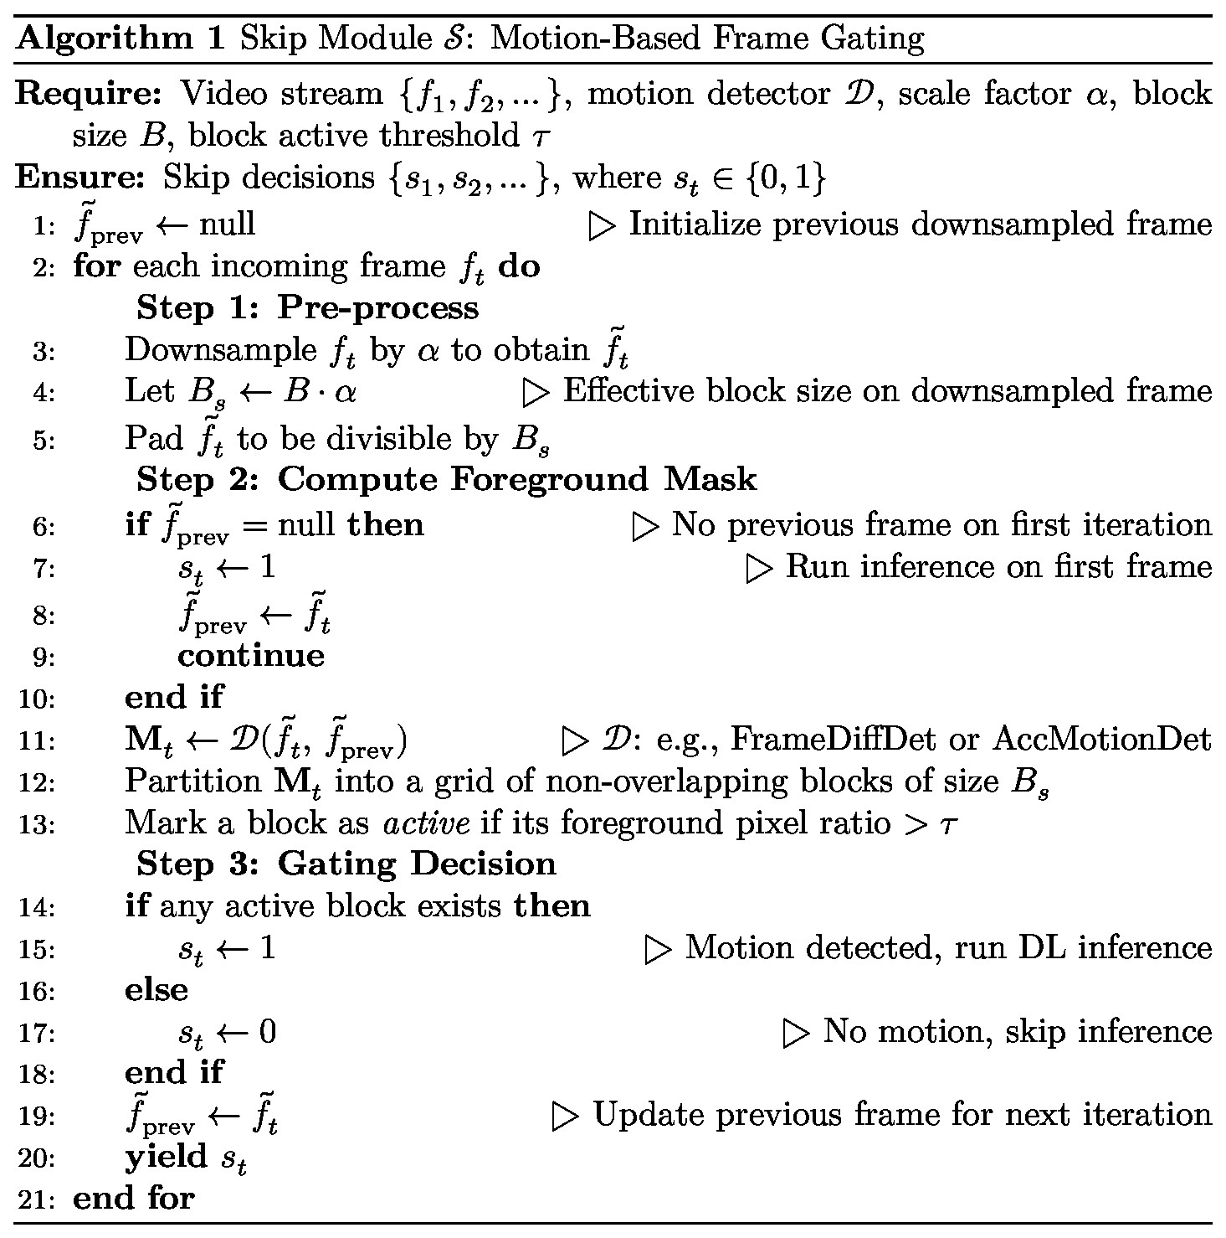
Use Input and Output instead of Require and Ensure
As shown in Figure 2 and Algorithm 1, the skip module S can leverage various types of information such as motion, color, or texture, to compute the skip decision 𝑠_{𝑡}. In this work, we focus on motion information derived from consecutive frames as the primary cue. Specifically, we design and evaluate two motion-based variants of S: (1) FrameDiffDet — a frame differencing-based method, and (2) AccMotionDet — a motion accumulation-based method. Both approaches are selected for their simplicity and low computational cost, making them well-suited for real-time deployment. The details of each approach are described in the following subsections. (explain FrameDiff simply)

3.2.1 FrameDiffDet — Naive Motion Detection
Let 𝐹_{𝑡} and 𝐹_{prev} denote the grayscale frames converted from the downsampled inputs 𝑓_{𝑡}̃ and 𝑓_{prev}̃ , respectively. The detector takes these two consecutive downsampled frames as input and produces a binary foreground mask M_{𝑡} ∈ {0,255} as output,
where each pixel is marked active (255) if the absolute inter-frame intensity difference exceeds a sensitivity threshold 𝜏_{𝑑}, and inactive (0) otherwise. The procedure is formalized in Algorithm 2.
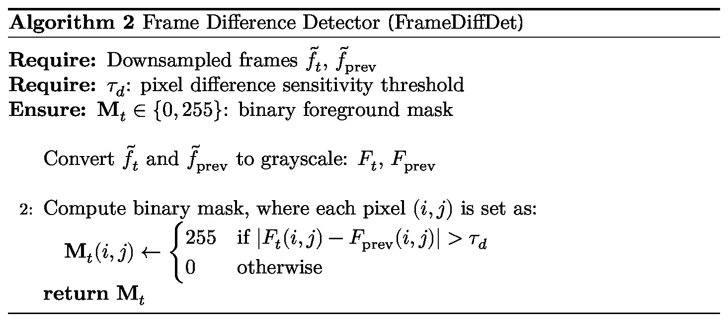

3.2.2 AccMotionDet — Motion Detection with Accumulation
Inspired by [16], we design the lightweight motion detector AccMotionDet which can… to handle … (add more explanation).
Let 𝐹_{𝑡} and 𝐹_{prev} denote the grayscale frames converted from the downsampled frames 𝑓_{𝑡}̃ and 𝑓_{prev}̃ (symbol is not correct), respectively. Let K_{𝑡−1} ∈ [0,𝐾_{max}] denote the per-pixel accumulated motion mask from the previous frame. The detector takes two consecutive downsampled frames and K_{𝑡−1} as input, and produces a binary foreground mask M_{𝑡} ∈ {0,255} and the updated mask K_{𝑡} as output. K_{𝑡} is incremented by 𝜔 when the inter-frame pixel difference exceeds 𝜏_{𝑑}, and decays by 𝛿 each frame, bounded at 𝐾_{max} to prevent unbounded growth under persistent motion. A pixel is marked active (255) only when K_{𝑡} ≥ 𝜏_{𝑚}, suppressing transient noise and single-frame flicker, and inactive (0) otherwise. The procedure is formalized in Algorithm 3.
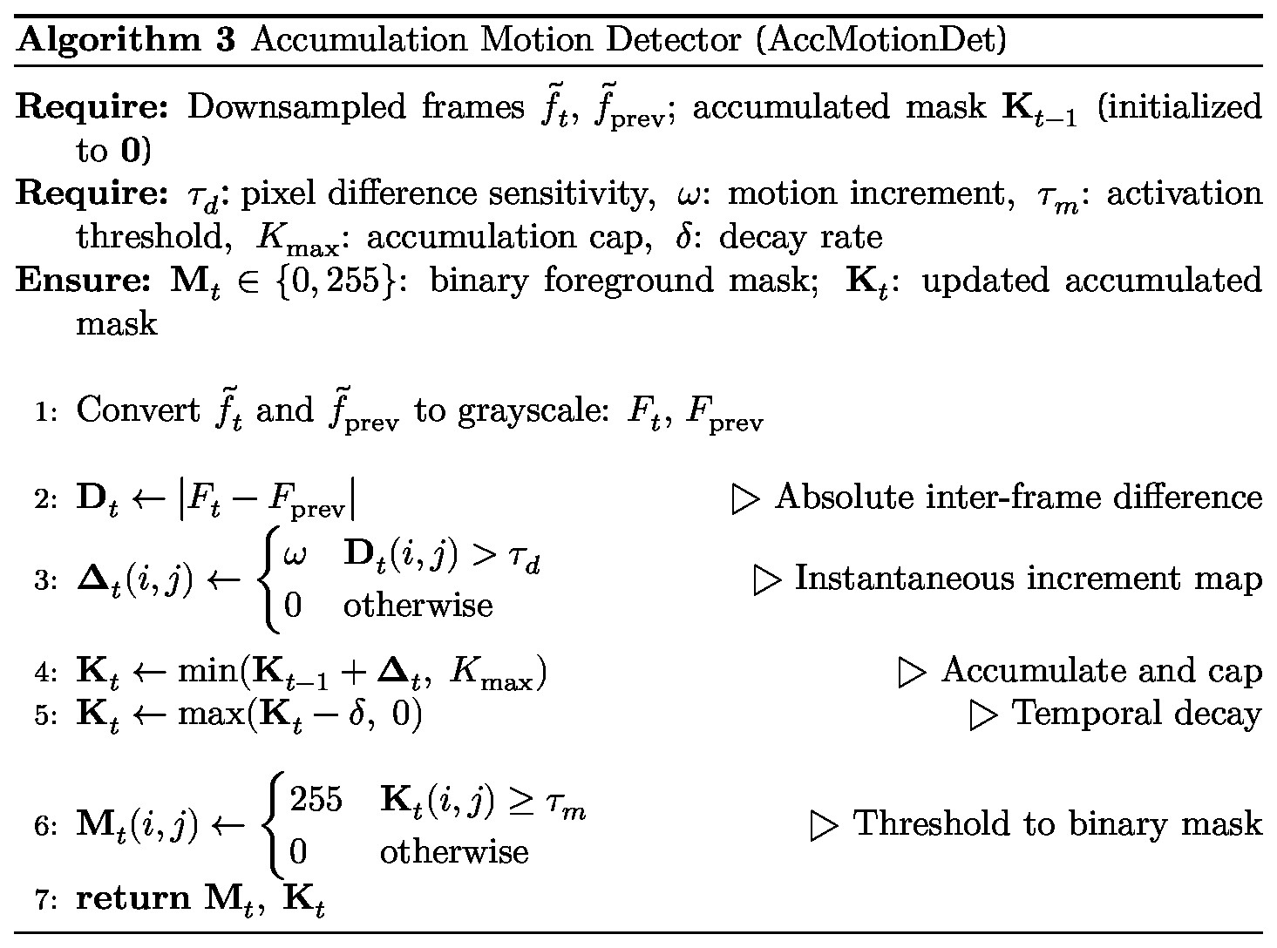

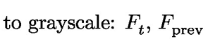
- to grayscale frames Ft and Fprev

how about this?

Input: Downsampled frames \tilde{f}_t, \tilde{f}_{prev}; accumulated mask K_{t-1} (initialized to 0)

Parameters: \tau_d: pixel difference sensitivity, \omega: motion increment, \tau_m: activation threshold, K_{max}: accumulation cap, \delta: decay rate

Output: M_t \in {0,255}: binary foreground mask; K_t: updated accumulated mask

3.2 Eager Mode Design

A preliminary analysis of the self-constructed indoor surveillance video dataset revealed that slow-developing or nearly stationary smoke events constitute a key challenge for the skip module. In such cases, the subtle inter-frame motion associated with these events may fall below the activation threshold of the motion detector, causing the skip module to incorrectly bypass frames containing actual fire or smoke activity. To mitigate this limitation, the proposed framework augments the skip module with an Eager mode that periodically forces inference updates.
When the classifier M produces positive fire/ smoke predictions on 𝑊_{fire} consecutive non-skipped frames, the system transition from Normal mode to Eager mode and suppresses all skip decisions by setting 𝑠_{𝑡} = 1, forcing inference on every frame. The system remains in Eager mode until the scene is declared safe again, which occurs when the classifier M returns negative predictions for 𝑊_{clr} consecutive frames. At that point, the system returns to Normal mode with the skip module re-enabled.
Additionally, while operating in Normal mode, the system periodically forces inference on 𝑊_{fire} consecutive frames after every N_{chk} skipped frames. This mechanism ensures the classifier retains opportunities to detect emerging fire or smoke activity and transition to Eager mode when necessary. Consequently, the proposed design improves recall for slow-developing or nearly stationary smoke events while preserving the throughput gains provided by the skip module during Normal mode operation.
Figure 7 illustrates the state machine of eager mode with the transition conditions and corresponding actions for each state and how states transition during system operation.
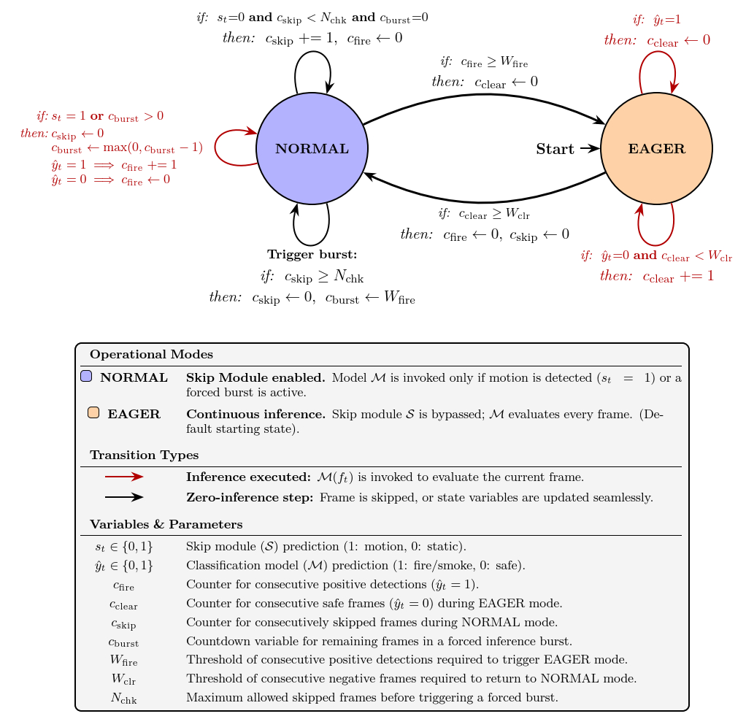
Figure 7: State machine of the Eager mode extension to the Skip Module. Transitions are annotated with if conditions and then actions specifying variable updates. In Normal mode, S operates as designed, with periodic forced checks every 𝑁_{chk} frames. Upon 𝑊_{fire} consecutive positive predictions, the system enters Eager mode, bypassing S (i.e., 𝑠_{𝑡} = 1) to forward every frame to M. The system returns to Normal mode after 𝑊_{clr} consecutive negative predictions.
Cfire -> cevent, cburst->cforce, …. This state diagram is difficult to understand..

3.3 Skip Module Hyperparameter Optimization

The skip module S, as described in Algorithm 1, is governed by several hyperparameters, including scale factor 𝛼, block active threshold 𝜏, and pixel difference sensitivity threshold 𝜏_{𝑑}, all of which can significantly affect overall system throughput and detection performance. To identify the optimal configuration, we employ a constrained grid search over a validation set 𝐷_{val}. Let 𝑅_{base} denote the baseline recall obtained without frame skipping. For each candidate configuration 𝜃 ∈ Θ, we evaluate the full pipeline Read → S(𝜃) → [M](?? Revise this) and compute recall 𝑅(𝜃) and skip rate 𝑆_{𝑟}(𝜃) (see Section 4.2 for formal definitions).

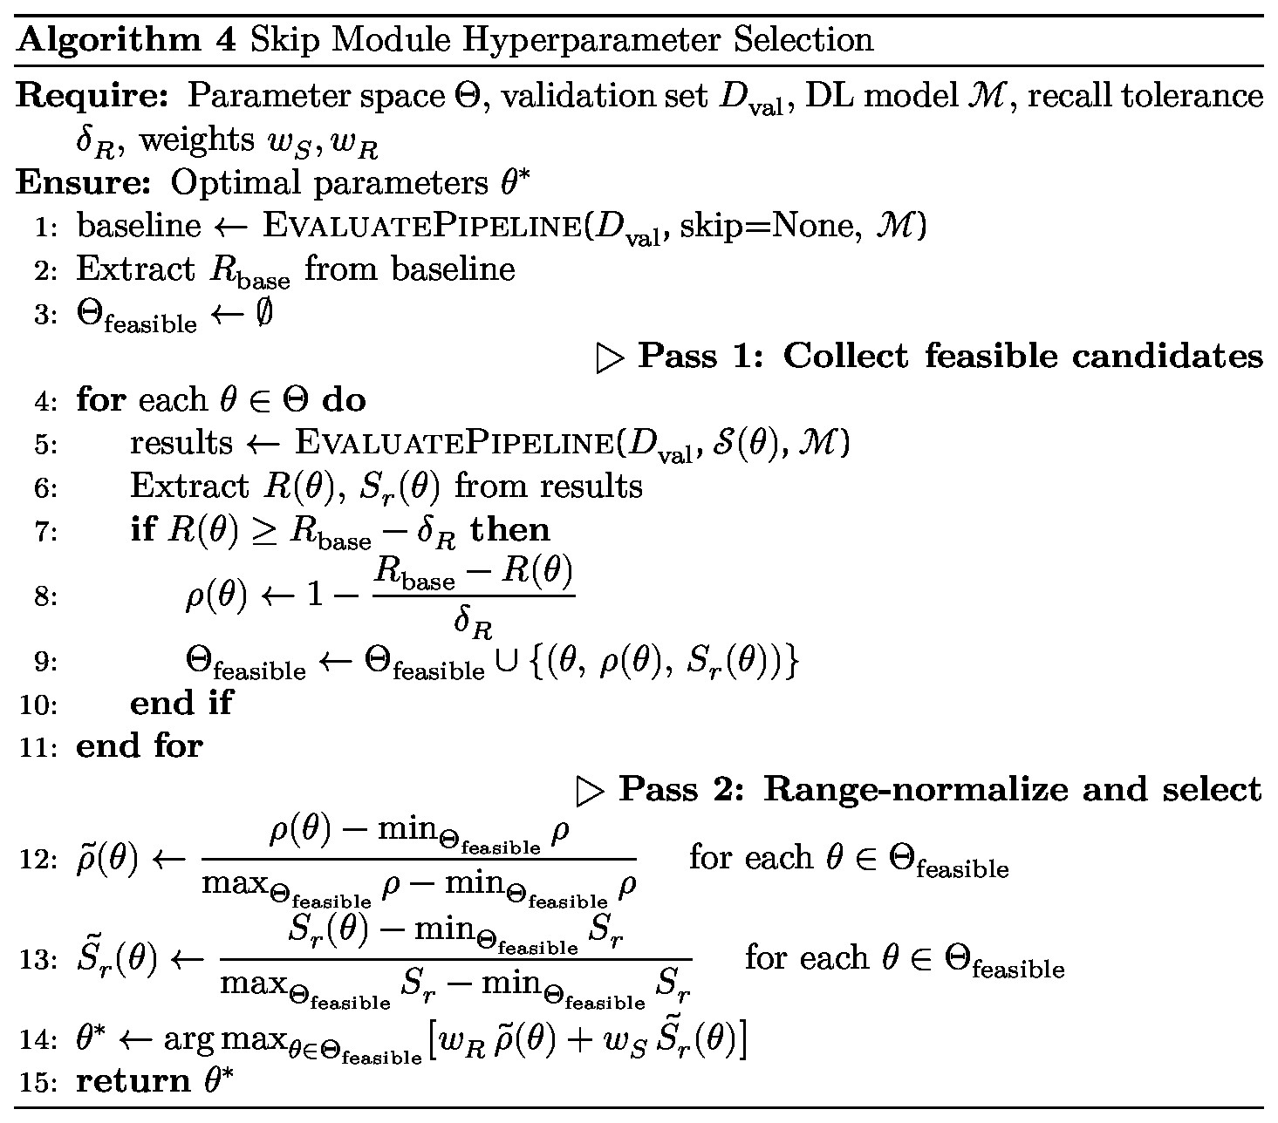

Feasibility constraint. A candidate configuration 𝜃 is feasible only if:
𝑅(𝜃) ≥ 𝑅_{base} − 𝛿_{𝑅}, (1)
where 𝛿_{𝑅} > 0 denotes the maximum allowable recall drop (e.g., 𝛿_{𝑅} = 0.01 permits at most a 1% reduction relative to the baseline).
Scoring and selection. For each feasible candidate, we compute the recall retention score
𝜌(𝜃) = (1 − (𝑅base − 𝑅(𝜃))/ 𝛿_{𝑅}, (2)

which maps the recall drop linearly onto [0,1] within the feasible region. Both 𝜌(𝜃) and 𝑆_{𝑟}(𝜃) are range-normalized over Θ_{feasible} (Pass 2 of Algorithm 4), yielding 𝜌(̃ 𝜃) and 𝑆_{𝑟}̃ (𝜃) ∈ [0,1], so that the weights 𝑤_{𝑆} and 𝑤_{𝑅} directly reflect their relative importance. The optimal configuration is then defined as
𝜃∗ = arg max [𝑤_{𝑅} 𝜌(̃ 𝜃) + 𝑤_{𝑆} 𝑆_{𝑟}̃ (𝜃)], (3)
𝜃∈Θfeasible
where Θ_{feasible} = {𝜃 ∈ Θ ∶ 𝑅(𝜃) ≥ 𝑅_{base} − 𝛿_{𝑅}} and 𝑤_{𝑆} + 𝑤_{𝑅} = 1.
FAR guarantee and exclusion from scoring. Let 𝐹𝑃(𝜃) and 𝐹𝑃_{base} denote the number of false positives produced by the skip-enabled and baseline systems, respectively. Let 𝑁_{skip_neg}(𝜃) denote the number of ground-truth negative frames skipped by the skip module S under configuration 𝜃 (see Section 4.2 for definitions of FAR, 𝑆_{𝑟}, and 𝑁_{neg}).
Since skipped frames bypass classifier inference and are assigned negative labels, false positives can only originate from frames processed by classifier M, Therefore,
𝐹𝑃(𝜃) = 𝐹𝑃_{base} − 𝑎
for some 𝑎 ≥ 0. Further, because a skipped false positive must simultaneously be both a baseline false positive and a skipped negative frame
𝑎 ≤ min(𝐹𝑃_{base},𝑁_{skip_neg})
without requiring any assumption on the relationship between the skip module S and the classifier M. Dividing by 𝑁_{neg} and substituting FAR_{base} = 𝐹𝑃_{base}/𝑁_{neg} and 𝑆_{𝑟}(𝜃) = 𝑁_{skip_neg}/𝑁_{neg} yields the assumption-free interval:
FAR(𝜃) ∈ [max(0, FAR_{base} − 𝑆_{𝑟}(𝜃)), FAR_{base}]. (4)
The upper bound confirms that the skip module cannot increase the false alarm rate by design. the primary safety risk is therefore recall degradation caused by incorrectly skipped fire/smoke frames, which motivates enforcing the recall constraint as a hard feasibility gate. Explicit FAR optimization is unnecessary since S operates solely on inter-frame motion cues without access to outputs of M. Consequently, its hyperparameters do not directly control which baseline false positives are removed, and including FAR in the objective function may favor configurations that overfit to validation-specific error patterns. We therefore report FAR(𝜃) only as an observed consequence metric in the experimental results.

4 Experiments and Results
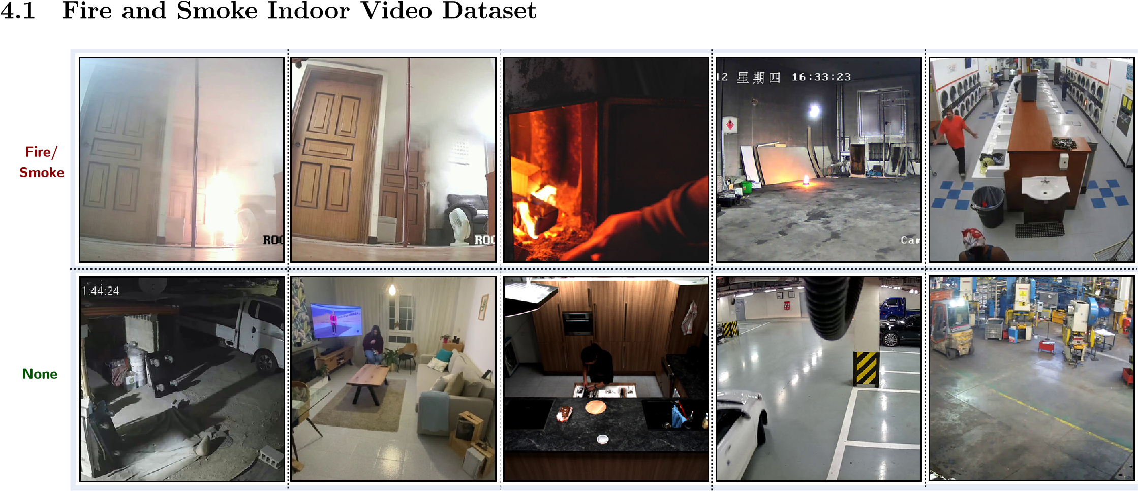
Figure 3: Representative frames extracted from the indoor fire and smoke video dataset used in this study.
Table 1: Comparison of existing fire and smoke video datasets with the proposed dataset (150 videos; static CCTV cameras; diverse indoor environments). Unlike most existing datasets, 143 out of 150 videos are recorded at HD resolution (1280×720) or above, matching commercial surveillance camera standards.
Model | Category | Videos | Resolution Min | Resolution  Max | FireSmoke | Normal | Indoor | Outdoor
FireSense (2010)[18] | Moving camera | 49 | 300 × 240 | 1600 × 1200 | 24 | 25 | 10 | 39
KMU (2011)[23] | Static camera | 38 | 320 × 240 | 320 × 240 | 28 | 10 | 10 | 28
VisiFireBilkent (2015)[22] | Static camera | 39 | 320 × 240 | 720 × 576 | 38 | 1 | 6 | 32
Mivia FIRE (2015)[24] | Static camera | 31 | 320 × 240 | 800 × 600 | 28 | 3 | 4 | 27
Mivia SMOKE (2015)[24] | Static camera | 149 | 292 × 240 | 292 × 240 | 76 | 73 | 0 | 149
FURG (2015)[20] | Moving camera | 22 | 240 × 344 | 1920 × 1080 | 17 | 5 | 3 | 19
USTC Smoke (2017)[25] | Static camera | 30 | 1920 × 1080 | 1920 × 1080 | 22 | 8 | 30 | 0
FireNet (2019)[17] | Moving camera | 62 | 352 × 222 | 1920 × 1080 | 46 | 16 | 30 | 32
FiSmo (2020)[19] | Moving camera | 88 | 320 × 240 | 1920 × 1080 | 80 | 8 | 0 | 88
D-Fire (2021)[21] | Static camera | 100 | 1280 × 720 | 1280 × 720 | 50 | 50 | 0 | 100
VDS3 (2022)[27] | Mix camera | 20 | 352 × 288 | 2048 × 1536 | 8 | 12 | 6 | 14
Ours (2026)- This work | Static camera | 150 | 814 × 720 | 3840 × 2160 | 75 | 75 | 150 | 0
Several existing benchmarks address this detection task, including FireNet [17], Firesense [18], FiSmo [19], and FURG [20]. However, these were recorded with moving cameras and are therefore unsuitable for static surveillance scenarios. Staticcamera datasets such as DFire [21], VisiFire Bilkent [22], KMU Fire and Smoke [23], Mivia Fire and Mivia Smoke datasets [24], and USTC Smoke [25] do exist; however, they collectively suffer from several limitations: a predominance of outdoor scenes, a small number of video samples, low spatial resolution, and insufficient diversity in fire/smoke appearances and environmental conditions.
To address these deficiencies, we constructed a dedicated static indoor video dataset by aggregating clips from multiple heterogeneous sources. Fire and smoke samples were sourced from the Korea AI Fire Dataset [26], the USTC Smoke Dataset [25], and the VDS3 Dataset [27], supplemented by videos collected from open online platforms (Pexels, Pixabay, and YouTube). Non-fire/smoke (negative) samples were compiled from self-recorded footage captured by real CCTV cameras in various indoor environments (e.g., parking areas), along with videos from the Safe & Unsafe Behavior in Workplaces dataset [28], the Indoor Action dataset [29], the MPII Cooking 2 Dataset [30], and the WiseNet dataset [31]. Table 1 summarizes the properties of the self-collected video dataset alongside a comparison with existing datasets, and Figure 3 presents representative sample frames from our dataset.
For the hyperparameter optimization described in Section 3.3, the video dataset was further partitioned into a validation set, 𝐷_{val} (46 videos), used to select the optimal skip-module hyperparameters, and a test set, 𝐷_{test} (104 videos), used for the final evaluation of the proposed system against the baseline and existing methods. The partition adhered to a 30:70 ratio (validation:test), following the protocol of [10], and was performed using stratified sampling to preserve balanced class distributions in both subsets.

4.2 Evaluation Metrics
Performance is evaluated under frame-level evaluation, following the standard protocol for fire and smoke detection in videos [32]. Frame-level evaluation measures detection performance for each individual frame, providing a strict assessment of classification accuracy. The following label definitions apply to this evaluation protocol:
- True Positive (𝑇𝑃): Correct detection of fire or smoke.
- True Negative (𝑇𝑁): Correct identification of the absence of fire or smoke.
- False Positive (𝐹𝑃): Incorrect detection of fire or smoke when none is present.
- False Negative (𝐹𝑁): Failure to detect fire or smoke when present.
Quantitative results are reported using standard classification metrics — accuracy, recall, false alarm rate (FAR), precision, F1-score, and frames per second (FPS) — as defined below.
𝑇𝑃 + 𝑇𝑁
(5)
Accuracy
=
𝑇𝑃 + 𝑇𝑁 + 𝐹𝑃 + 𝐹𝑁
,
Recall
(
R
)
=
𝑇𝑃
𝑇𝑃 + 𝐹𝑁
,
False Alarm Rate
(
FAR
)
=
𝐹𝑃
𝐹𝑃 + 𝑇𝑁
,
Precision
(
P
)
=
𝑇𝑃
𝑇𝑃 + 𝐹𝑃
,
F1-score
=2
×
𝑃 × 𝑅
𝑃 + 𝑅
,
FPS
=
Total Frames
,
(6)
(7)
(8)
(9)
(10)
Total Processing Time (seconds)
where 𝑇𝑃, 𝑇𝑁, 𝐹𝑃, and 𝐹𝑁 represent True Positive, True Negative, False Positive, and False Negative, respectively.
In addition to standard metrics, we report the skip rate 𝑆_{𝑟}, a system-level efficiency criterion specific to the proposed skipbased framework. Skip rate measures the proportion of ground-truth negative frames correctly bypassed by the skip module S, defined as
𝑆𝑟 = 𝑁_{skip_neg}/𝑁neg (11)
where 𝑁_{skip_neg} is the number of ground-truth negative frames assigned 𝑠_{𝑡} = 0 by the skip module S (i.e., background frames bypassed without invoking big DL model M), and 𝑁_{neg} is the total number of ground-truth negative frames in the evaluated set. A higher 𝑆_{𝑟} indicates greater computational savings, while a drop in recall may signals unsafe skipping of fire/smoke frames.

4.3 Models and Implementation Details
Baseline Models: To demonstrate both the superiority of the high-capacity classifier over lightweight alternatives and the effectiveness of the proposed skip module in accelerating its inference, we evaluate the following baseline models alongside our BIG model:
- MobileNet [33]: A modified MobileNet architecture fine-tuned for fire and smoke detection.
- FireNet [17]: A lightweight CNN-based image classifier comprising 14 layers, with a model size of 7.5 MB and approximately 650k trainable parameters.
- YOLOv5s [10]: A lightweight object detector based on YOLOv5 [34], trained with hyperparameters selected via grid search on the D-Fire dataset [21].
- YOLOv5l [10]: A heavier variant of the above, based on the larger YOLOv5l architecture, offering higher capacity at increased computational cost.
Proposed Classifier (BIG Model M — HGNetV2): The BIG model M is obtained by fine-tuning a pretrained High-
Performance GPU Network v2 (HGNetV2), specifically the hgnetv2_b5.ssld_stage2_ft_in1k checkpoint [35] from the
Timm library [36], which was originally trained using SSLD knowledge distillation [37]. HGNetV2 [38] is a high-capacity CNN architecture designed to achieve substantially higher accuracy than models of comparable inference speed on NVIDIA GPUs, making it well-suited for real-life deployment. For fine-tuning, a dataset of 253,325 fire/smoke/normal images was compiled from internet sources and partitioned into training (90%) and validation (10%) subsets. The model was trained for 100 epochs with a batch size of 64 using the Adam optimizer [39], configured with a learning rate of 0.003, weight decay of 0.05, and a warmup over the first 5 epochs. The training was conducted on a single NVIDIA RTX 5090 GPU (32 GB
VRAM) paired with an Intel Core Ultra 9 285K processor and 128 GB of system RAM, running PyTorch 2.7.1 with CUDA Toolkit 12.8. All input images were preprocessed by resizing to 3 × 360 × 640 (𝐶 × 𝐻 × 𝑊). The fine-tuned model achieved a classification accuracy of 98.34% and a high recall of 98.12% on the validation set.
Implementation Details: Unless stated otherwise, all experiments were conducted on a workstation equipped with an
Intel Core i9-10900K CPU, 64 GB DDR4 system memory, and an NVIDIA GeForce RTX 3090 GPU (24 GB VRAM), running
Windows 10 Pro (22H2, build 19045). Deep learning inference was performed using PyTorch 2.7.1 under CUDA 12.9, and video processing and motion estimation were carried out using OpenCV 4.11 (CPU-only).

4.4 Results

4.4.1 Hyperparameter Optimization Results
In this work, the recall tolerance 𝛿_{𝑅} is set to 𝛿_{𝑅} = 0.015, permitting a maximum absolute recall drop of 1.5% relative to the baseline. At the baseline recall of approximately 95%, this ensures the worst-case deployed system retains a recall of at least 93.5%, while affording the hyperparameter search sufficient flexibility to identify configurations with meaningful efficiency gains. The optimization weights are set to 𝑤_{𝑆} = 0.7 and 𝑤_{𝑅} = 0.3, prioritizing skip rate (the primary determinant of throughput gain) while using recall retention as a secondary criterion to favor configurations closer to baseline performance among feasible candidates.
4.4.1.1 Hyperparameter Optimization Results for the FrameDiffDet-based Skip Module To identify the optimal configuration for the FrameDiffDet-based skip module, we performed a systematic grid search over four hyperparameters: scale factor 𝛼, block size 𝐵, block active threshold 𝜏, and difference sensitivity threshold 𝜏_{𝑑}, yielding a total of 2×2×3×4 = 48 candidate configurations. The search space is as follows:
- Scale factor 𝛼 ∈ {0.5,1.0}: controls the downsampling ratio applied to input frames prior to motion computation. A smaller 𝛼 reduces computational cost but may lose subtle motion detail. For simplicity, we evaluate full resolution (𝛼 = 1.0) and half resolution (𝛼 = 0.5).
- Block size 𝐵 ∈ {16,32}: determines the spatial granularity of motion detection, expressed in pixels of the original frame (the effective block size on the downsampled frame is 𝐵_{𝑠} = 𝐵 ⋅ 𝛼). Smaller blocks (𝐵 = 16) capture localized motion from small fire or smoke regions, while larger blocks (𝐵 = 32) aggregate motion over a broader spatial context, providing greater robustness against isolated pixel-level noise.
- Block active threshold 𝜏 ∈ {0.05,0.10,0.15}: defines the minimum foreground pixel ratio within a block for it to be declared active; inference is triggered if at least one active block is detected. A low value (𝜏 = 0.05) is sensitive to sparse motion within a block, minimizing missed detections, while a higher value (𝜏 = 0.15) demands denser local motion, suppressing responses to minor pixel-level disturbances. The three values provide a systematic sweep from fine to coarse sensitivity.
- Difference sensitivity threshold 𝜏_{𝑑} ∈ {3,5,7,10}: defines the minimum absolute inter-frame intensity change required for a pixel to be declared active. This range is chosen to cover diverse sensitivity levels, from near-noise-level detection (𝜏_{𝑑} = 3, responding to subtle illumination changes) to robust large-motion detection (𝜏_{𝑑} = 10, requiring strong, unambiguous motion).
Table 2 presents representative configurations illustrating the recall–efficiency trade-off; the full search space of 48 configurations is omitted for brevity. The results reveal a fundamental limitation of FrameDiffDet: it fails to deliver meaningful throughput improvement under the safety constraint 𝛿_{𝑅} = 0.015.
Among all 48 evaluated configurations, only three satisfy the recall constraint, all requiring the lowest sensitivity setting 𝜏_{𝑑} = 3. The best-ranked feasible configuration (𝛼=0.5, 𝐵=16, 𝜏=0.05, 𝜏_{𝑑}=3) achieves a skip rate of merely 0.94%, bypassing fewer than 1 in 100 background frames. Consequently, the FPS of all feasible configurations (22.0–23.3) falls below the no-skip baseline (24.7), indicating that the skip module overhead outweighs the benefit of skipped inference calls. Conversely, configurations that do achieve substantial skip rates (reaching 47–60% at higher 𝜏_{𝑑} values of 7 and 10) suffer severe recall degradation of 5–10%, far exceeding the safety tolerance.
These results demonstrate that FrameDiffDet, without noise suppression or robust sustained-motion confirmation, is unsuitable as a skip gate: it either skips too few frames to yield any efficiency gain, or skips too aggressively and suffer unacceptable recall loss. This motivates the development of AccMotionDet, which accumulates motion evidence over multiple frames to provide a more reliable signal for skip decisions, as described in the following section.
Table 2: Representative FrameDiffDet hyperparameter configurations evaluated on the validation set, illustrating the recall–efficiency trade-off across the full search space of 48 configurations (subset shown for brevity). Configurations with a ranking score of “-” violate the recall constraint (𝛿_{𝑅} = 0.015) and are included solely to illustrate the trade-off at higher skip rates. Recall (%) reports the retained recall with the absolute drop relative to the baseline in parentheses, i.e., 𝑅 (−Δ𝑅). The best and second-best values per metric are highlighted in bold and italic underline, respectively.

Exp. | Parameters |  |  |  | Metrics |  |  |  | Ranking Score
 | Scale factor  𝛼 | Block size  𝐵 | Block active threshold 𝜏 | Diff threshold  𝜏_{𝑑} | Recall (%)↑ | Skip Rate (%)↑ | FAR (%)↓ | FPS ↑
Baseline (No Skip module) | - | - | - | - | 94.35 (-0.00) | 0.0 | 0.74 | 24.7 | -
FrameDiff | 0.5 | 16.0 | 0.05 | 3.0 | 93.97 (-0.38) | 0.94 | 0.737 | 23.3 | 0.8046
FrameDiff | 1.0 | 16.0 | 0.1 | 3.0 | 93.54 (-0.81) | 0.97 | 0.737 | 22.3 | 0.7000
FrameDiff | 1.0 | 16.0 | 0.05 | 3.0 | 94.18 (-0.17) | 0.72 | 0.737 | 22.0 | 0.3000
FrameDiff | 0.5 | 16.0 | 0.1 | 3.0 | 92.83 (-1.51) | 1.35 | 0.737 | 23.6 | -
FrameDiff | 1.0 | 16.0 | 0.15 | 3.0 | 92.05 (-2.30) | 1.53 | 0.737 | 22.5 | -
FrameDiff | 1.0 | 32.0 | 0.05 | 3.0 | 91.63 (-2.72) | 2.43 | 0.737 | 23.2 | -
FrameDiff | 1.0 | 16.0 | 0.05 | 5.0 | 91.46 (-2.88) | 1.94 | 0.737 | 22.6 | -
FrameDiff | 0.5 | 16.0 | 0.15 | 3.0 | 91.45 (-2.90) | 3.92 | 0.737 | 24.3 | -
FrameDiff | 0.5 | 32.0 | 0.05 | 3.0 | 90.98 (-3.36) | 7.11 | 0.737 | 25.3 | -
FrameDiff | 0.5 | 16.0 | 0.05 | 5.0 | 90.55 (-3.80) | 6.23 | 0.737 | 24.7 | -
FrameDiff | 0.5 | 16.0 | 0.1 | 7.0 | 88.87 (-5.47) | 47.22 | 0.733 | 37.3 | -
FrameDiff | 0.5 | 16.0 | 0.05 | 10.0 | 88.19 (-6.16) | 49.0 | 0.733 | 38.3 | -
FrameDiff | 0.5 | 32.0 | 0.05 | 10.0 | 84.56 (-9.79) | 59.53 | 0.73 | 45.5 | -
Table 3: Representative AccMotionDet hyperparameter configurations and their corresponding validation-set performance. Note that the “Recall (%)” column displays the retained recall alongside the absolute recall drop relative to the baseline in parentheses, i.e., Recall (-Recall Drop). The best and second-best results for each metric are highlighted in bold and italic underline, respectively. Note that Motion increment 𝜔 = 5 and Decay rate 𝛿 = 0.1 are fixed across all configurations.
Method | Parameters |  |  |  |  |  |  |  |  |  | Ranking Score
 | Scale factor  𝛼 | Block size  𝐵 | Block active threshold 𝜏 | Diff threshold  𝜏𝑑 | Activation threshold  𝜏𝑚 | Acc. cap  𝐾max | Recall (%)↑ | FAR (%)↓ | Skip Rate  (%)↑ | FPS ↑
Baseline (No Skip module) | - | - | - | - | - | - | 94.35  (-0.00) | 0.74 | 0 | 24.7 | -
AccMotionDet | 0.5 | 32 | 0.05 | 5 | 5 | 15 | 93.9 (-0.45) | 0.737 | 44.39 | 36.3 | 0.8020
AccMotionDet | 0.5 | 32 | 0.1 | 5 | 5 | 25 | 93.33 (-1.02) | 0.737 | 55.09 | 41.1 | 0.7912
AccMotionDet | 0.5 | 32 | 0.05 | 5 | 5 | 25 | 93.92 (-0.42) | 0.737 | 42.89 | 35.7 | 0.7903
AccMotionDet | 0.5 | 32 | 0.1 | 5 | 5 | 35 | 93.35 (-0.99) | 0.737 | 54.42 | 40.8 | 0.7898
AccMotionDet | 0.5 | 32 | 0.05 | 5 | 5 | 35 | 93.93 (-0.42) | 0.737 | 42.38 | 35.5 | 0.7856
AccMotionDet | 0.5 | 32 | 0.1 | 5 | 5 | 15 | 93.22 (-1.13) | 0.737 | 56.3 | 41.8 | 0.7785
AccMotionDet | 0.5 | 32 | 0.1 | 3 | 5 | 15 | 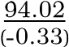 | 0.737 | 39.76 | 34.5 | 0.7756
AccMotionDet | 0.5 | 32 | 0.1 | 3 | 5 | 25 | 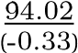 | 0.737 | 39.36 | 34.3 | 0.7705
AccMotionDet | 0.5 | 32 | 0.1 | 3 | 5 | 35 | 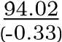 | 0.737 | 39.09 | 34.2 | 0.7671
AccMotionDet | 0.5 | 32 | 0.05 | 3 | 10 | 15 | 93.81 (-0.53) | 0.735 | 42.63 | 35.7 | 0.7591
4.4.1.2 Hyperparameter Optimization Results for the AccMotionDet-based Skip Module The hyperparameter search for AccMotionDet is designed to mirror the FrameDiffDet study while accounting for the temporal accumulation of motion scores over consecutive frames. Details of the search space (of 96 configurations) are as follows:
- Scale factor (𝛼 ∈ {0.5,1.0}) and Block size (𝐵 ∈ {16,32}): Retained from FrameDiffDet to maintain consistency in the spatial resolution and grid density trade-offs.
- Block active threshold (𝜏 ∈ {0.05,0.10}): Restricted to a narrower range than in FrameDiffDet, as temporal accumulation naturally suppresses false activations, rendering more aggressive thresholds unnecessary.
- Difference sensitivity threshold (𝜏_{𝑑} ∈ {3,5}): Limited to the lower end of the FrameDiffDet search space, as higher values were found to cause excessive frame skipping and unacceptable recall degradation, as described in Section 4.4.1.1.
- Accumulation step (𝜔 = 5) and Decay rate (𝛿 = 1): We fix these parameters to streamline the hyperparameter search, allowing us to focus on the primary sensitivity controls: the activation threshold (𝜏_{𝑚}) and accumulation cap (𝐾_{max}). Since the optimal tuning of 𝜏_{𝑚} and 𝐾_{max} depends directly on by 𝜔, keeping 𝜔 constant provides a stable baseline for optimization. Furthermore, setting 𝛿 = 1 ensures consistent, linear decay behavior while reducing the dimensionality of the search space.
- Activation threshold (𝜏_{𝑚} ∈ {5,10}): This threshold serves as the decision gate for the motion mask, labeling pixels as active only when their accumulated motion score exceeds 𝜏_{𝑚}. Given the fixed accumulation parameters (𝜔 = 5,𝛿 = 1), 𝜏_{𝑚} = 5 and 𝜏_{𝑚} = 10 are approximately equivalent to requiring motion signals over 2 and 3 consecutive frames, respectively.
- Accumulation cap (𝐾_{max} ∈ {15,25,35}): This parameter limits the maximum accumulated motion score to prevent runaway accumulation during prolonged activity. Without this cap, prolonged or intense motion could drive the accumulated score to arbitrarily large values, such that the subsequent temporal decay requires excessive time to clear the score once motion ceases. By selecting a range of values, we diversify the system’ s saturation behavior, allowing us to tune how quickly the module resets following high-activity periods.
Table 3 presents representative configurations of the AccMotionDet-based skip module evaluated on the validation set. The results show a marked improvement over FrameDiffDet, with several configurations achieving skip rates of 39%–
56% while maintaining high recall (above 93%, relative to the baseline of 94.35%), remaining within the safety constraint 𝛿_{𝑅} = 0.015. The best-ranked configuration (𝛼=0.5, 𝐵=32, 𝜏=0.05, 𝜏_{𝑑}=5, 𝜏_{𝑚}=5, 𝐾_{max}=15) achieves a skip rate of 44.39% with a recall drop of only 0.45%, yielding a throughput of 36.3 FPS — a substantial improvement over the 24.7 FPS baseline.

4.4.2 Frame-Level Performance and Throughput: Baselines and Skip Module
Table 4: Frame-level performance and throughput of the proposed pipeline against lightweight fire-and-smoke detectors on the test set. “Our Big Model (with Skip Module)” refers to the full proposed pipeline. Recall, FAR, Accuracy, and Precision are reported in percentage (%); FPS is averaged across all frames in the test videos. GFLOPs denotes the static per-frame floating-point operations (10⁹) of the detection model. The best and second-best values per metric are highlighted in bold and italic underline, respectively.
Method | Recall ↑ | FAR ↓ | Accuracy ↑ | F1-Score ↑ | Precision ↑ | FPS ↑ | GFLOPs  ↓ | Model size (Mb) ↓
MobileNet [33] | 5.84 | 0.18 | 77.49 | 0.11 | 91.06 | 35.15 | 1.135 | 20.6
FireNet [17] | 34.1 | 13.47 | 74.07 | 0.38 | 44.11 | 48.12 | 0.018 | 7.45
YOLOv5l [10] | 49.36 | 3.61 | 85.22 | 0.61 | 81.0 | 78.08 | 107.7 | 88.5
YOLOv5s [10] | 68.58 | 10.39 | 84.61 | 0.68 | 67.29 | 109.94 | 15.8 | 13.7
Our Big Model  (without Skip Module) | 95.62 | 0.25 | 98.77 | 0.97 | 99.17 | 24.97 | 30.61 | 430.0
Our Big Model (with Skip Module) | 94.38 | 0.14 | 98.56 | 0.97 | 99.54 | 32.32 | 30.61 | 430.0
Table 4 benchmarks the proposed pipeline (AccMotionDet skip module with the optimal configuration paired with the Big Model) against lightweight fire-and-smoke detectors, described in Section 4.3. The baseline BIG Model (without skip module)achieves the highest recall (95.62%),accuracy (98.77%),and F1-score (0.97),substantially outperforming all lightweight alternatives. This gap reflects the consequences of neural scaling laws [40], [41], [42]: the BIG model benefits from both a more expressive architecture and a significantly larger training dataset. Notably, MobileNet and FireNet exhibit neardegenerate recall of 5.84% and 34.1%, respectively, rendering them unsuitable for safety-critical fire and smoke detection despite their speed and compactness. YOLOv5s achieves the highest throughput (109.94 FPS) but still suffers a recall of 68.58%, roughly 27 percentage points below the BIG model, confirming that no lightweight alternative achieves an acceptable accuracy–efficiency balance on this task.
Effect of the Skip Module: Integrating the skip module yields a consistent set of improvements across nearly all metrics. Throughput increases from 24.97 to 32.32 FPS, a gain of approximately 29%, while the F1-score is fully preserved at 0.97.
Recall drops by only 1.24 percentage points (95.62% → 94.38%), remaining within the safety constraint 𝛿_{𝑅} = 0.015. A less obvious but notable benefit is the reduction in FAR from 0.25% to 0.14%, accompanied by a precision increase from 99.17% to 99.54%: by suppressing inference on near-static background frames, the skip module also eliminates a class of incorrect detections that the BIG model would otherwise generate.

4.4.3 Comparison with Temporal Post-Processing
Temporal Persistence Thresholding (TPT) [10] augments the standard per-frame inference pipeline with a lightweight postprocessing stage designed to suppress isolated false alarms. Unlike the proposed skip module, TPT does not reduce the number of frames forwarded to the classifier — every frame is still processed by the classification model. Instead, a circular boolean buffer of length 𝑊 records the raw per-frame predictions over a rolling window. A detection is confirmed only if the fraction of positive predictions within the buffer exceeds a persistence threshold 𝜏_{persist}; otherwise, the prediction is suppressed and the frame is relabelled as negative.
Table 5: Representative hyperparameter grid search results for Temporal Persistence Thresholding (TPT) on the validation set. The best and second-best values per metric are highlighted in bold and italic underline, respectively.
Experiment | Window Size  𝑊 | Persist  Threshold  𝜏persist | Recall (%)↑ | FAR (%)↓ | Accuracy (%)  ↑ | Precision (%) ↑ | F1 Score ↑ | FPS ↑
Big Model without Skip Module (Baseline) | - | - | 94.35  (-0.00) | 0.7403 | 98.26 | 97.02 | 0.9566 | 24.6617
TPT_{strict}  (Conservative: safety-first) | 5.0 | 0.2 | 94.22 (-0.13) | (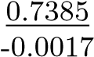 ) | 98.24 | 97.02 | 0.956 | 24.6546
TPT_{balanced}  (Balanced between Recall  Drop and FAR decrease  gain) | 10.0 | 0.5 | 93.7 (-0.65) | 0.7315  (-0.0087) | 98.13 | 97.03 | 0.9534 | 24.6544
Table 6: Frame-level performance comparison between the no-skip baseline, TPT variants, and the proposed pipeline (Big Model with AccMotionDet skip module) on the test set. The best and second-best values per metric are highlighted in bold and italic underline, respectively.
Method | Recall (%)↑ | FAR (%)↓ | Accuracy (%)↑ | Precision (%)↑ | F1 Score ↑ | Skip Rate (%)↑ | FPS ↑
Baseline (notemp) | 95.616 | 0.251 | 98.767 | 99.166 | 0.9736 | 0.0 | 24.97
TPT_{strict}  (𝑊 = 5, 𝜏_{persist} = 0.2) | 95.519 | 0.25 | 98.745 | 99.168 | 0.9731 | 0.0 | 24.96
TPT_{balanced}  (𝑊 = 10, 𝜏_{persist} = 0.5) | 95.123 | 0.247 | 98.653 | 99.174 | 0.9711 | 0.0 | 24.96
Big Model with Skip module (AccMotionDet) | 94.384 | 0.136 | 98.562 | 99.541 | 0.9689 | 34.93 | 32.32
We follow the hyperparameter selection protocol of [10], evaluating TPT on the validation set D_{val}. Two representative configurations are reported: a strict variant (TPT_{strict}: 𝑊 = 5, 𝜏_{persist} = 0.2) and a balanced variant (TPT_{balanced}: 𝑊 = 10, 𝜏_{persist} = 0.5), with the full grid search results on the validation set shown in Table 5. Both configurations are then compared against the proposed pipeline on test set in Table 6.
Table 6 highlights a clear distinction between temporal post-processing and the proposed skip module in terms of the efficiency–accuracy trade-off. TPT processes every frame through the full Big Model and therefore does not improve throughput, with FPS remaining essentially unchanged (24.97 to 24.96). In contrast, the AccMotionDet-based skip module skips 34.93% of negative frames and increases FPS from 24.97 to 32.32, corresponding to an approximately 29% throughput gain. It also achieves the largest reduction in FAR, decreasing from 0.251% to 0.136% (about 46% relative reduction), whereas the
TPT variants provide only negligible FAR improvement. Among the two TPT settings, TPT_{balanced} attains slightly lower recall than TPT_{strict} (95.123% vs. 95.519%) while producing nearly the same FAR (0.247% vs. 0.250%), indicating limited sensitivity to the persistence threshold. Finally, the recall reduction of AccMotionDet is modest (95.62% → 94.38%) and remains within the safety constraint 𝛿_{𝑅} = 0.015.

4.4.4 AccMotionDet Skip Module with Eager Mode
As established in Section 4.4.2, the AccMotionDet-based skip module achieved a throughput improvement of nearly 30% in FPS; however, this came at the cost of a 1.24% reduction in recall, which is likely attributable to missed detections in slow-developing or nearly stationary smoke scenarios. To address this limitation, the Eager mode is introduced as a complementary mechanism to augment the skip module and recover recall in such cases. In this section, the Eager mode is evaluated in conjunction with the AccMotionDet-based skip module, with its hyperparameters fixed to the optimal values identified in Section 4.4.2.1 (i.e., 𝛼=0.5,𝐵=32,𝜏=0.05,𝜏𝑑=5,𝜏𝑚=5, 𝐾max=15). A grid search is then conducted over the Eager mode parameters to identify the optimal configuration, as follows:

- Confirmation window 𝑊_{fire} ∈ {1,2,3}: defines the number of consecutive positive predictions required to trigger a transition into Eager mode. A deliberately small range is chosen to ensure the system reacts swiftly to early signs of fire or smoke.
- Clearance window 𝑊_{clr} ∈ {3,5,7}: This parameter defines the number of consecutive negative predictions required to exit eager mode and resume normal skip operation. The range is deliberately set larger than that of 𝑊_{fire}, reflecting an asymmetric cost structure: a premature exit risks missed detections, whereas a delayed exit only causes the system to run unnecessary inference on a few extra frames — a minor and acceptable efficiency loss.
- Forced-check interval 𝑁_{chk} ∈ {10,20,30,50}: defines the maximum number of consecutive frames that are skipped in Normal mode before the system forces an inference call, irrespective of the skip module decision. This serves as a safety net against false negatives — for instance, slowly developing or settled smoke may produce insufficient interframe motion to trigger S, causing the scene to be treated as static and inference to be suppressed indefinitely. If the forced inference yields a positive prediction and the 𝑊_{fire} criterion is satisfied, the system transitions into Eager mode. Smaller values increase check frequency at the cost of redundant inference on truly static scenes, whereas larger values reduce this overhead at the expense of a longer worst-case recovery delay. The selected range provides a systematic sweep from aggressive (𝑁_{chk} = 10) to infrequent (𝑁_{chk} = 50) checking.
Following the hyperparameter selection protocol described in Section 3.3, the optimal Eager mode configuration is identified on the validation set D_{val}, with results reported in Table 7.
The best-ranked configuration (𝑊_{fire} = 1,𝑊_{clr} = 7,𝑁_{check} = 50) is then evaluated on the test set D_{test} and compared against the skip-only configuration in Table 8.
Table 8 reports the effect of Eager mode on system performance. Eager mode successfully recovers recall on slow-developing or settled smoke scenarios, increasing from 94.384% (AccMotionDet only) to 95.565% (AccMotionDet+ Eager), nearly matching the baseline recall of 95.616% (Big Model without skip module)— a recovery of critical importance in safety-critical applications. However, this improvement comes with two costs: the skip rate slightly decreases from 34.93% to 34.21%, and the false alarm rate (FAR) increases from 0.136% to 0.251%.
Despite the reduced skip rate, overall throughput marginally increases from 32.32 to 32.54 FPS. This is explained by the reduced computational overhead in Eager mode: rather than executing the full AccMotionDet pipeline (Algorithm 3),our implementation converts each frame to grayscale, stores it for subsequent use in Normal mode, and applies only temporal decay. Consequently, per-frame computation in Eager mode is lighter than in Normal mode (where both the full-step AccMotionDet skip module and Big Model inference are active), yielding the observed FPS gain despite the lower skip rate.
Table 7: Representative validation-set grid search results for AccMotionDet (optimal configuration from Section 3.3) augmented with Eager mode. The “Recall (%)” column reports retained recall with the absolute drop relative to the baseline in parentheses (i.e., Recall − Recall Drop). The best and second-best results per metric are highlighted in bold and italic underline, respectively.
Method |  | Parameters |  |  | Metrics |  |  | Ranking Score
 | ^{𝑊}𝑓𝑖𝑟𝑒 | ^{𝑊}𝑐𝑙𝑟 | ^{𝑁}𝑐ℎ𝑘 | Recall (%)↑ | FAR (%)↓ | Skip Rate (%)↑ | FPS ↑
Baseline (No Skip module) | - | - | - | 94.35 (-0.00) | 0.74 | 0.0 | 24.7 | -
AccMotionDet | - | - | - | 93.9 | 0.737 | 44.39 | 36.6 | -
AccMotionDet (Eager Mode) | 1.0 | 7.0 | 50.0 | 94.35 (-0.00) | 0.74 | 43.72 | 36.4 | 0.9946
AccMotionDet (Eager Mode) | 1.0 | 7.0 | 30.0 | 94.35 (-0.00) | 0.74 | 43.35 | 36.3 | 0.9637
AccMotionDet (Eager Mode) | 2.0 | 3.0 | 50.0 | 94.35 (-0.00) | 0.737 | 43.25 | 36.2 | 0.9553
AccMotionDet (Eager Mode) | 2.0 | 7.0 | 50.0 | 94.35 (-0.00) | 0.74 | 43.19 | 36.2 | 0.9501
AccMotionDet (Eager Mode) | 3.0 | 3.0 | 50.0 | 94.35 (-0.00) | 0.737 | 42.72 | 36.0 | 0.9115
AccMotionDet (Eager Mode) | 3.0 | 7.0 | 50.0 | 94.35 (-0.00) | 0.74 | 42.67 | 35.9 | 0.9067
AccMotionDet (Eager Mode) | 1.0 | 7.0 | 20.0 | 94.35 (-0.00) | 0.74 | 42.57 | 35.9 | 0.8985
AccMotionDet (Eager Mode) | 2.0 | 3.0 | 30.0 | 94.35 (-0.00) | 0.737 | 42.54 | 35.9 | 0.8958
AccMotionDet (Eager Mode) | 2.0 | 7.0 | 30.0 | 94.35 (-0.00) | 0.74 | 42.47 | 35.9 | 0.8905
AccMotionDet (Eager Mode) | 3.0 | 3.0 | 30.0 | 94.35 (-0.00) | 0.737 | 41.72 | 35.6 | 0.8275
AccMotionDet (Eager Mode) | 3.0 | 7.0 | 30.0 | 94.35 (-0.00) | 0.74 | 41.65 | 35.5 | 0.8221
Table 8: Comparison of Video-level performance metrics, measuring the delay and initial detection speed. The best and second-best results for each metric are highlighted in bold and italic underline, respectively.
Method | Recall (%)↑ | FAR (%)↓ | Accuracy (%)↑ | Precision (%)↑ | F1 Score ↑ | Skip Rate (%)↑ | FPS ↑
Baseline (notemp) | 95.616 | 0.251 | 98.767 | 99.166 | 0.9736 | 0.0 | 24.97
TPT_{strict}  (𝑊 = 5, 𝜏_{persist} = 0.2) | 95.519 | 0.25 | 98.745 | 99.168 | 0.9731 | 0.0 | 24.96
TPT_{balanced}  (𝑊 = 10, 𝜏_{persist} = 0.5) | 95.123 | 0.247 | 98.653 | 99.174 | 0.9711 | 0.0 | 24.96
Big Model with Skip module (AccMotionDet) | 94.384 | 0.136 | 98.562 | 99.541 | 0.9689 | 34.93 | 32.32
Big Model with Skip module  (AccMotionDet + Eager  𝑁chk = 50,𝑊clr =  7,𝑊fire = 1) | 95.565 | 0.251 | 98.755 | 99.166 | 0.9733 | 34.31 | 32.54

4.4.4 Quantitative and Qualitative Analysis
4.4.4.1 Efficiency of Skip Module To evaluate the efficiency of the skip module, the BIG model was run on the test set D_{test} with and without the skip module. The average processing time of the skip module, the BIG model inference time, and the overall system FPS were recorded in both cases. The results are visualized in Figure 4.
As shown in Figure 4, the skip module requires an average processing time of only 1.79 ms per frame, which is approximately
×22 lower than the BIG model inference time of 39.88 ms. In the best case, the skip module correctly identifies and bypasses
Big Model
Avg. Infer.
Skip Module
Avg. Proc.
0
10
20
30
40
50
×
22
cheaper
39
.
88
1
.
79
Timeperframe(ms)
a) Time Budget
(
Without Skip
With Skip
0
10
20
30
40
+29
.
4
%
24
.
97
32
.
32
FramesperSecond(FPS)
(
b) Throughput
Figure 4: Computational efficiency of the proposed skip-module: (a) average processing time of the skip module (1.79 ms) compared to the BIG model inference time (39.88 ms), representing a ×22 reduction; (b) system throughput with and without the skip-module, yielding a 29.4% improvement in FPS.
negative frames, contributing only 1.79 ms of overhead. In the worst case, where the skip module fails to bypass a frame and the BIG model inference is subsequently invoked, the additional latency introduced by the skip module is 1.79 ms — a mere 4.5% increase relative to the BIG model inference time. Overall, integrating the skip module improves system throughput by approximately 30% on D_{test}, demonstrating its effectiveness for real-time fire and smoke detection in indoor surveillance scenarios.
4.4.4.2 Qualitative Analysis To understand how the skip module operates in coordination with the Big Model, we visualize the inference results of the AccMotionDet skip module on the test set D_{test} in RGB images together with the corresponding foreground motion masks generated by the skip module. The qualitative examples are organized into two major categories: success cases and failure cases. Success Cases
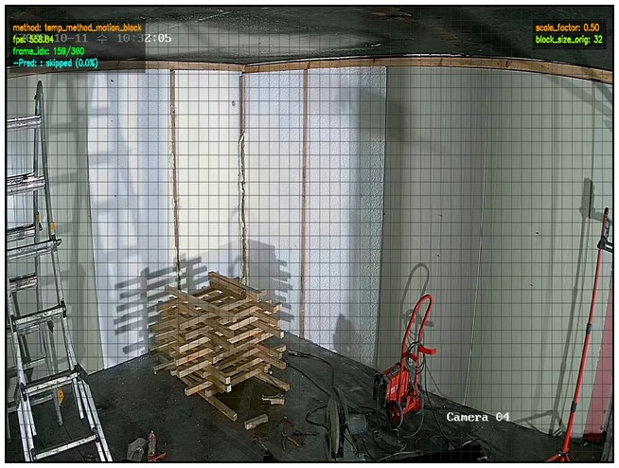  Frame  Type  RGB | 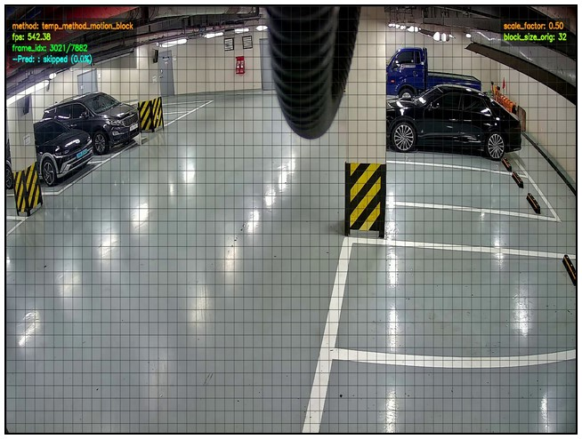 | 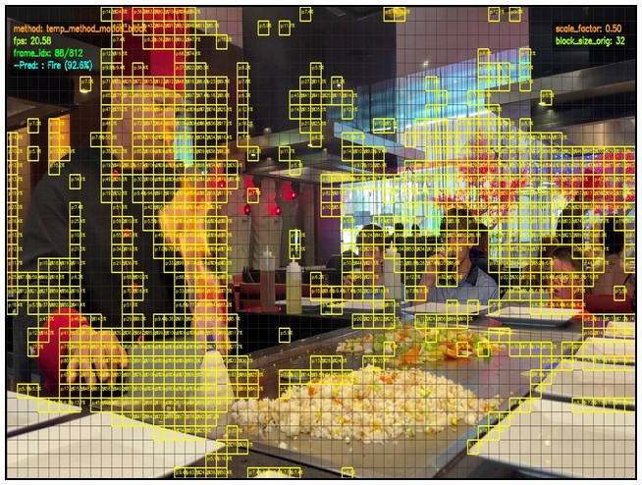 | 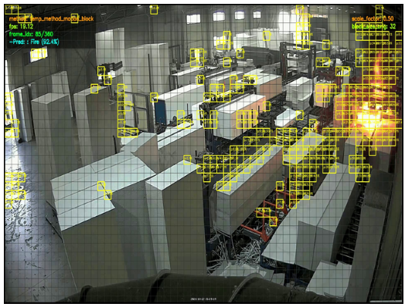
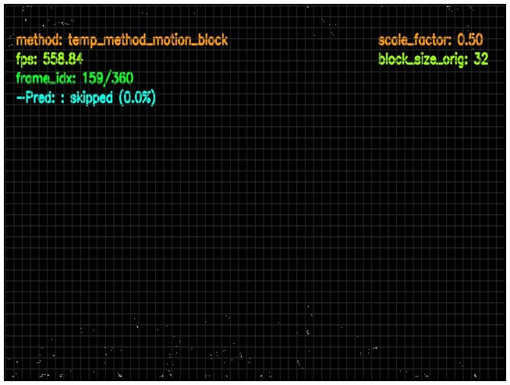  Motion  Mask  a) SKIP  Static BG ✓ SKIP | 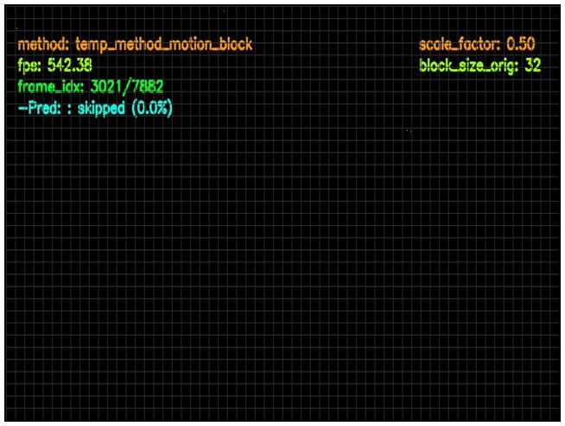  b) SKIP  Static BG ✓ SKIP | 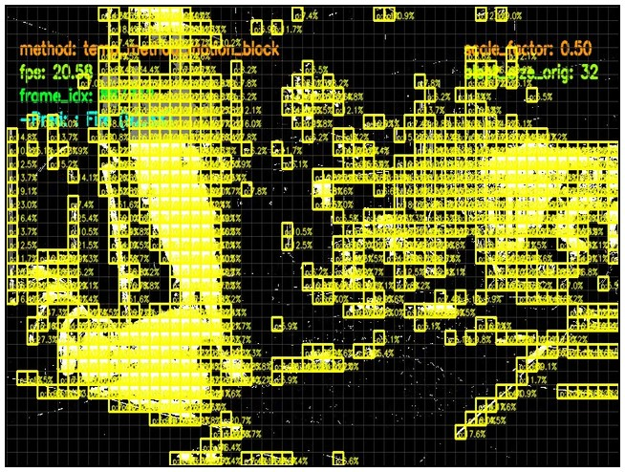  c) INFER  Fire/Smoke ✓ RUN DL MODEL | 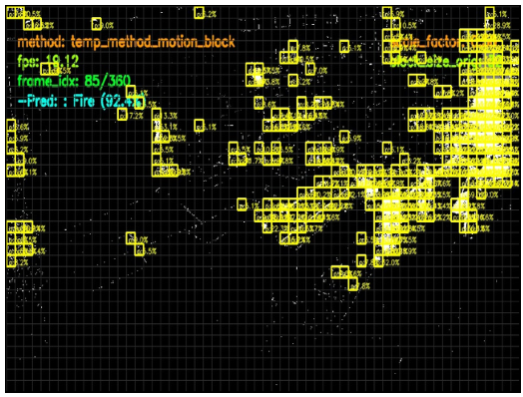  d) INFER  Fire/Smoke ✓ RUN DL MODEL
Figure 5: Qualitative results illustrating successful skip module operations. (a) and (b) Static background frames are correctly identified and skipped, avoiding unnecessary inference. (c) and (d) Frames containing active fire or smoke trigger the motion accumulator, correctly prompting the full deep learning model to evaluate the frame.
Figure 5 shows four representative success cases in which the skip module S operates as intended. These cases can be grouped into two categories:
- Correctly skipped static background frames (Fig. 5a,b): AccMotionDet identifies static background frames and skips them without invoking the Big Model. The corresponding motion masks are empty, indicating no active motion regions.
- Correctly inferred fire/smoke frames (Fig. 5c,d): The module correctly detects active fire and smoke regions and forwards these frames for inference. The yellow boxes indicate motion-active blocks detected by AccMotionDet,
which are concentrated in the fire/smoke regions, consistent with the continuous nature of these phenomena. Failure Cases
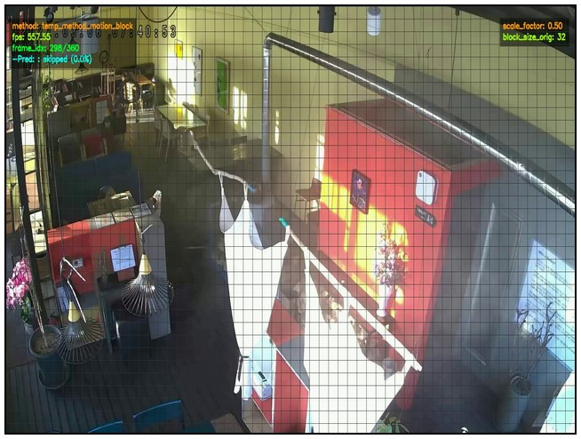  Frame  Type  RGB | 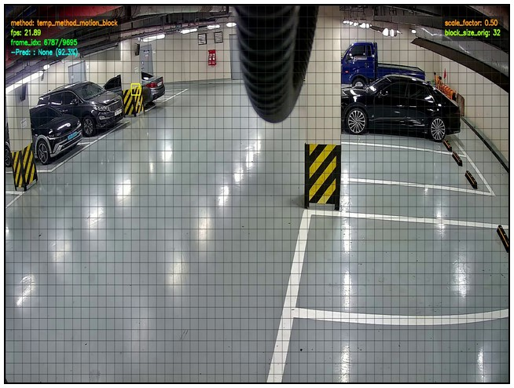 | 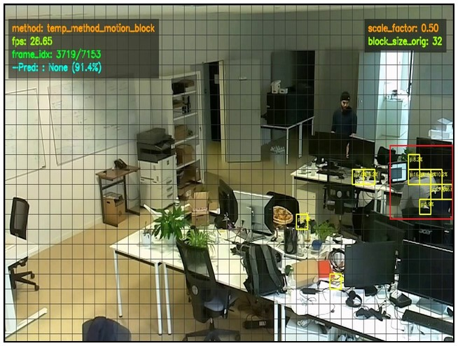 | 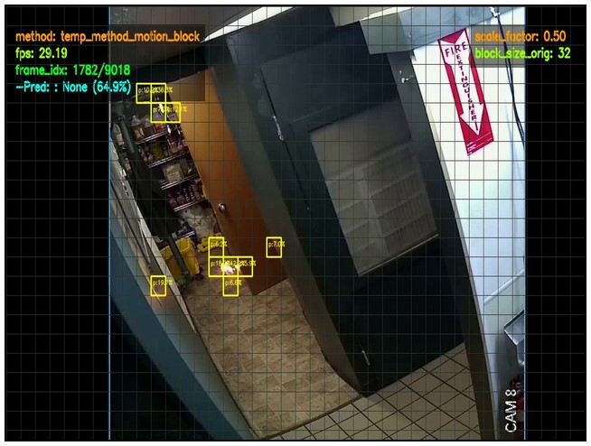 | 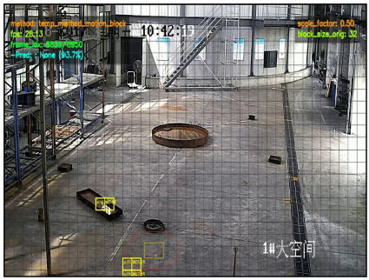
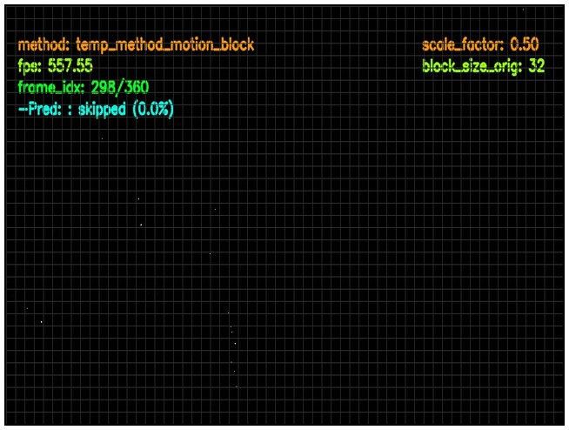  Motion  Mask  a) WRONGLY SKIPPED  Slow Smoke  (✗ MISSED) | 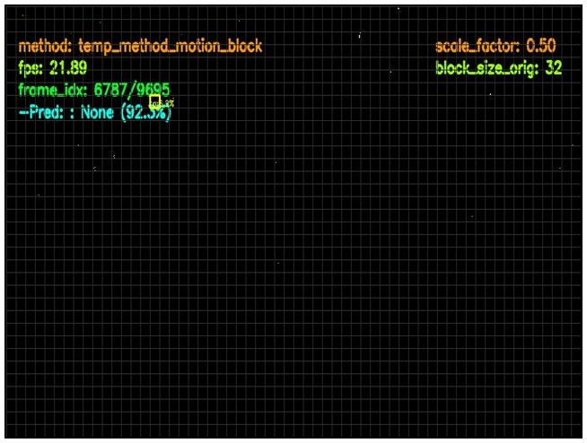  b) WASTED INFER  Incorrect Motion Detection (✗ NO SAVINGS) | 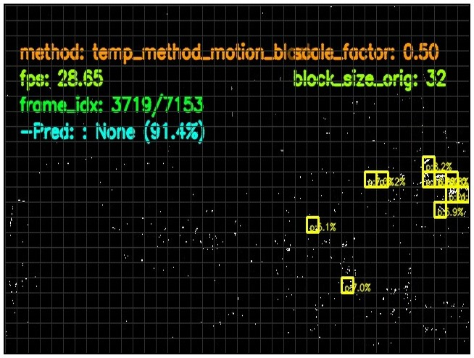  c) WASTED INFER  Persistent Motion  (✗ NO SAVINGS) | 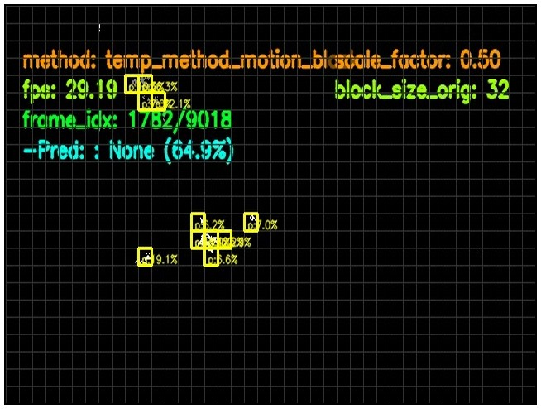  d) WRONG PREDICTION  Properly Infer  But Wrongly Predicted  (✗ BIG MODEL ERROR) | 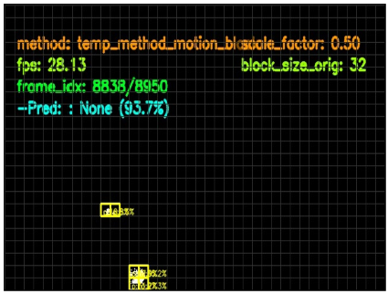  e) WRONG PREDICTION  Properly Infer  But Wrongly Predicted  (✗ BIG MODEL ERROR)
Figure 6: Qualitative analysis of skip module failure modes. (a) Missed detection: slow-developing or settled smoke fails to trigger the motion accumulator. (b–c) Wasted inferences: inaccurate motion detection OR persistent motion (e.g., human activity) saturates the accumulator, preventing frame skipping. (d–e) Big Model error: frames are correctly passed to the deep learning model, yet the model produces incorrect predictions.
Figure 6 shows five representative failure cases, which can be grouped into three categories:
- Wrongly skipped frames (Fig. 6a): Slowly developing smoke or smoke in its settling phase produces motion that is too subtle to trigger the skip module, leading to missed detections.
- Wrongly passed frames / wasted inference (Fig. 6b,c): Noise or persistent non-fire motion prevents background frames from being skipped, resulting in unnecessary inference.
- Incorrect Big Model predictions (Fig. 6d,e): Even when fire or smoke frames are correctly forwarded, the Big Model may still produce an incorrect label, especially when the target occupies only a small portion of the frame.
4.4.4.3 Analysis of Eager Mode: Recall–FAR Trade-off

A notable drawback of Eager mode shown in Table 8 is its tendency to increase false alarms (from 0.136% to 0.251%). Our analysis reveals that Eager mode cannot distinguish false-alarm-prone static scenes from genuine slow-developing or settled smoke events, as both exhibit near-zero inter-frame motion. In such static scenes, the classifier may produce fire/smoke predictions on several consecutive frames, causing the system to enter and remain in Eager mode with prolonged forced inference and elevated FAR. This highlights a fundamental limitation of heuristic, motion-based skip logic: it is insufficient to robustly handle all scenarios. We leave this as an open research question, with potential directions including skip modules that incorporate richer cues (such as color, texture, or learned features) to discriminate between these scene types.

5 Conclusion
We propose a lightweight, plug-and-play skip module S designed to accelerate real-time fire and smoke detection in indoor surveillance scenarios. Operating at a negligible fraction (≈4.5%) of the computational cost of the DL classifier M, the skip module S efficiently filters out static background frames before they reach M, reducing unnecessary inference overhead. Experiments on a real-world video dataset demonstrate that the proposed approach achieves approximately 30% throughput improvement while sustaining high detection recall, with a recall drop of only 1.23% relative to the baseline. When augmented
with Eager mode, the recall drop is further reduced to 0.05%, nearly fully recovering baseline performance.
Nevertheless, the proposed approach has certain limitations. First, the skip module S relies solely on inter-frame motion cues, which may be unsuitable for outdoor surveillance scenarios where persistent motion sources — such as swaying vegetation, moving vehicles, etc. — are continuously present, potentially causing S to pass the majority of frames to M and negating the efficiency gain. Second, the hyperparameters of S require dataset-specific tuning prior to deployment, incurring additional optimization overhead. Third, the overall detection accuracy of the system remains bounded by the capacity of M, which is treated as a fixed component and not optimized in this work.
Future work may explore alternative skip strategies — such as leveraging color, texture, or learned features as gating cues
— and extend the framework to outdoor surveillance scenarios where motion-based filtering is less effective. Additionally, designing a hyperparameter-free or self-adaptive skip module, as well as jointly optimizing the skip module and the classifier in an end-to-end training framework, represent promising directions for further improving system efficiency and detection accuracy.

References
- N. F. P. A. (NFPA), “NFPA report - largest fire losses in the united states.” Jan. 1AD. Available: https:
//www.nfpa.org/education-and-research/research/nfpa-research/fire-statistical-reports/large-loss-fires-in-theunited-states/largest-fire-losses-in-the-united-states
- “South korea wildfires become biggest on record as disaster chief points to ‘harsh reality’ of climate crisis | south korea | the guardian.” Jul. 2025. Available: https://www.theguardian.com/world/2025/mar/27/south-korea-firesdeath-toll-rises-worst-in-history
- G. Cheng, X. Chen, C. Wang, X. Li, B. Xian, and H. Yu, “Visual fire detection using deep learning: A survey,” Neurocomputing, vol. 596, p. 127975, 2024.
- D. Gragnaniello, A. Greco, C. Sansone, and B. Vento, “Fire and smoke detection from videos: A literature review under a novel taxonomy,” Expert Systems with Applications, vol. 255, p. 124783, 2024.
- X. Geng, Y. Su, X. Cao, H. Li, and L. Liu, “YOLOFM: An improved fire and smoke object detection algorithm based on YOLOv5n,” Scientific Reports, vol. 14, no. 1, p. 4543, 2024.
- Z. A. Khan et al., “Optimized cross-module attention network and medium-scale dataset for effective fire detection,” Pattern Recognition, vol. 161, p. 111273, 2025.
- R. A. Khan, U. I. Bajwa, R. H. Raza, and M. W. Anwar, “Beyond boundaries: Advancements in fire and smoke
detection for indoor and outdoor surveillance feeds,” Engineering Applications of Artificial Intelligence, vol. 142, p. 109855, 2025.
- Y. Cao, F. Yang, Q. Tang, and X. Lu, “An attention enhanced bidirectional LSTM for early forest fire smoke recognition,” IEEE Access, vol. 7, pp. 154732–154742, 2019.
- M. M. Ali and M. Ghodrat, “Toward reliable fire detection in indoor CCTV footage: Reducing false alarms from benign flames using 3D attention CNNs,” IEEE Access, 2025.
- P. V. A. de Venancio, R. J. Campos, T. M. Rezende, A. C. Lisboa, and A. V. Barbosa, “A hybrid method
for fire detection based on spatial and temporal patterns,” Neural Computing and Applications, vol. 35, no. 13, pp. 9349–9361, 2023.
- D. Gragnaniello, A. Greco, C. Sansone, and B. Vento, “FLAME: Fire detection in videos combining a deep neural network with a model-based motion analysis,” Neural Computing and Applications, vol. 37, no. 8, pp. 6181–6197, 2025.
- A. Sobral and A. Vacavant, “A comprehensive review of background subtraction algorithms evaluated with synthetic and real videos,” Computer Vision and Image Understanding, vol. 122, pp. 4–21, 2014.
- B. Garcia-Garcia, T. Bouwmans, and A. J. R. Silva, “Background subtraction in real applications: Challenges, current models and future directions,” Computer Science Review, vol. 35, p. 100204, 2020.
- Z. Zivkovic and F. Van Der Heijden, “Efficient adaptive density estimation per image pixel for the task of background subtraction,” Pattern recognition letters, vol. 27, no. 7, pp. 773–780, 2006.
- A. Ghodrati, B. E. Bejnordi, and A. Habibian, “Frameexit: Conditional early exiting for efficient video recognition,” in Proceedings of the IEEE/CVF conference on computer vision and pattern recognition, 2021, pp. 15608–15618.
- C. Yu, Z. Mei, and X. Zhang, “A real-time video fire flame and smoke detection algorithm,” Procedia Engineering, vol. 62, pp. 891–898, 2013.
- A. Jadon, M. Omama, A. Varshney, M. S. Ansari, and R. Sharma, “FireNet: A specialized lightweight fire & smoke detection model for real-time IoT applications,” arXiv preprint arXiv:1905.11922, 2019.
- “Firesense.” Available: https://www.firesense.eu/
- M. T. Cazzolato et al., “Fismo: A compilation of datasets from emergency situations for fire and smoke analysis,” in Brazilian symposium on databases-SBBD, SBC Uberlândia, Brazil, 2017, pp. 213–223.
- C. R. Steffens, R. N. Rodrigues, and S. S. da Costa Botelho, “An unconstrained dataset for non-stationary video based fire detection,” in 2015 12th latin american robotics symposium and 2015 3rd brazilian symposium on robotics (LARS-SBR), IEEE, 2015, pp. 25–30.
- P. V. A. de Venâncio, A. C. Lisboa, and A. V. Barbosa, “An automatic fire detection system based on deep
convolutional neural networks for low-power, resource-constrained devices,” Neural Computing and Applications, vol. 34, no. 18, pp. 15349–15368, 2022.
- E. Cetin, “Computer vision based fire detection software.” 2015. Available: http://signal.ee.bilkent.edu.tr/VisiFire/
- B. C. Ko, S. J. Ham, and J. Y. Nam, “Modeling and formalization of fuzzy finite automata for detection of irregular fire flames,” IEEE Transactions on Circuits and Systems for Video Technology, vol. 21, no. 12, pp. 1903–1912, 2011.
- P. Foggia, A. Saggese, and M. Vento, “Real-time fire detection for video-surveillance applications using a combination of experts based on color, shape, and motion,” IEEE TRANSACTIONS on circuits and systems for video technology, vol. 25, no. 9, pp. 1545–1556, 2015.
- G. Lin, Y. Zhang, Q. Zhang, Y. Jia, G. Xu, and J. Wang, “Smoke detection in video sequences based on dynamic texture using volume local binary patterns.” KSII Trans. Internet Inf. Syst., vol. 11, no. 11, pp. 5522–5536, 2017.
- “AI-hub.” Available: https://aihub.or.kr/aihubdata/data/view.do?dataSetSn=71751
- L. Huang, G. Liu, Y. Wang, H. Yuan, and T. Chen, “Fire detection in video surveillances using convolutional neural networks and wavelet transform,” Engineering Applications of Artificial Intelligence, vol. 110, p. 104737, 2022.
- O. Önal and E. Dandıl, “Video dataset for the detection of safe and unsafe behaviours in workplaces,” Data in Brief, vol. 56, p. 110791, 2024.
- D. Deniz, E. Ros, E. M. Ortigosa, and F. Barranco, “Optimized edge-cloud system for activity monitoring using knowledge distillation,” Electronics, vol. 13, no. 23, p. 4786, 2024.
- M. Rohrbach et al., “Recognizing fine-grained and composite activities using hand-centric features and script data,” International Journal of Computer Vision, vol. 119, no. 3, pp. 346–373, 2016.
- R. Marroquin, J. Dubois, and C. Nicolle, “WiseNET: An indoor multi-camera multi-space dataset with contextual information and annotations for people detection and tracking,” Data in brief, vol. 27, p. 104654, 2019.
- C. R. Steffens, R. N. Rodrigues, and S. S. da Costa Botelho, “Non-stationary VFD evaluation kit: Dataset and metrics to fuel video-based fire detection development,” in Latin american robotics symposium, Springer, 2016, pp. 135–151.
- D. Mukhopadhyay, R. Iyer, S. Kadam, and R. Koli, “FPGA deployable fire detection model for real-time video surveillance systems using convolutional neural networks,” in 2019 global conference for advancement in technology (GCAT), IEEE, 2019, pp. 1–7.
- G. Jocher, “YOLOv5 by Ultralytics.” May 2020. doi: 10.5281/zenodo.3908559. Available: https://github.com/ultra lytics/yolov5
- “Timm/hgnetv2_b5.ssld_stage2_ft_in1k · hugging face.” Sep. 2025. Available: https://huggingface.co/timm/hgne tv2_b5.ssld_stage2_ft_in1k
- R. Wightman, “PyTorch image models,” GitHub repository. https://github.com/rwightman/pytorch-image-models; GitHub, 2019. doi: 10.5281/zenodo.4414861
- C. Cui et al., “Beyond self-supervision: A simple yet effective network distillation alternative to improve backbones,” arXiv preprint arXiv:2103.05959, 2021.
- “PaddleClas/docs/en/models/PP-HGNetV2_en.md at f1233c18455b8acde4fc42ab0bea575fa06daa8e · PaddlePaddle/ PaddleClas.” Available: https://github.com/PaddlePaddle/PaddleClas/blob/f1233c18455b8acde4fc42ab0bea575fa0 6daa8e/docs/en/models/PP-HGNetV2_en.md?plain=1#L33
- D. P. Kingma and J. Ba, “Adam: A method for stochastic optimization,” arXiv preprint arXiv:1412.6980, 2014.
- J. Hestness et al., “Deep learning scaling is predictable, empirically,” arXiv preprint arXiv:1712.00409, 2017.
- I. M. Alabdulmohsin, B. Neyshabur, and X. Zhai, “Revisiting neural scaling laws in language and vision,” Advances in Neural Information Processing Systems, vol. 35, pp. 22300–22312, 2022.
- Y. Bahri, E. Dyer, J. Kaplan, J. Lee, and U. Sharma, “Explaining neural scaling laws,” Proceedings of the National Academy of Sciences, vol. 121, no. 27, p. e2311878121, 2024.

