

**实验报告**

课程： 网站设计与开发

专业： 数字媒体技术

班级： 1801班

学号： 41809060125

姓名： 贺阳合

**《网站设计与开发》实验四**

1. **实验目的**

实现文件上传和多媒体文件浏览操作

**二、实验内容**

（1）使用文件上传控件实现文件上传

（2）使用图片控件动态显示图片

**三、实验程序**

<%@ Page Language="C#" AutoEventWireup="true" CodeFile="photo.aspx.cs" Inherits="index" %>

<!DOCTYPE html PUBLIC "-//W3C//DTD XHTML 1.0 Transitional//EN" "http://www.w3.org/TR/xhtml1/DTD/xhtml1-transitional.dtd">

<html xmlns="http://www.w3.org/1999/xhtml">

<head runat="server">

<!doctype html>

<html long="zh">

<meta charset="utf-8">

<title>上?传?文?件t</title>

<style type="text/css">

*{

margin: 0;

padding: 0;

}

#head{

height: 90px;

}

#head .Logo{

width: 72px;

height: 72px;

vertical-align: middle;

}

#head .LogoName{

font-size: 40px;

font-family: "楷?体?";

color: #00BFFF;

display: inline;

position: absolute;

top: 137px;

left: 448px;

width: 556px;

}

#wrap {

height: 408px;

width: 100%;

position:relative;

}

#wrap .logWrap{

height: 408px;

width: 600px;

position: absolute;

top: 50%;

left: 50%;

right: 50%;

margin: 0 0 0 -300px;

display: inline-block;

}

#wrap .banner{

height: 300px;

width: 300px;

position: absolute;

top: 26%;

}

#wrap .logShow {

float: right;

height: 408px;

width: 368px;

position: absolute;

top: 0%;

left: 55%;

right: 45%

}

.LoginButton a button {

width: 100%;

height: 45px;

background-color: #21a4ee;

border: none;

color: white;

font-size: 18px;

}

.logShow .LoginIndex.LoginTop .p1 {

display: inline-block;

font-size: 28px;

margin-top: 110px;

width: 86%;

}

#wrap .logShow .LoginIndex.LoginTop {

width: 86%;

border-bottom: 1px solid #ee7700;

margin-bottom: 60px;

margin-top: 0px;

margin-right: auto;

margin-left: auto;

}

.logShow .InputStr img {

position: absolute;

top: 12px;

left: 8px;

}

.logShow .InputStr input {

width: 100%;

height: 42px;

text-indent: 2.5rem;

}

#wrap .logShow .InputStr {

width: 86%;

position: relative;

margin-bottom: 30px;

margin-top: 30px;

margin-right: auto;

margin-left: auto;

}

#wrap .logShow .LoginButton {

width: 86%;

margin-top: 0px;

margin-right: auto;

margin-bottom: 0px;

margin-left: auto;

}

</style>

</head>

<body>

<form id="form1" runat="server">

<label>学§号?：阰</label>

<asp:TextBox ID="TextBox1" runat ="server"></asp:TextBox>

<label>上?传?文?件t：阰</label>

<asp:FileUpload ID="up1" runat="server" />

<br />

<br />

<asp:Button ID = "Button1" runat ="server" Text = "上?传?文?件t" OnClick ="Button1_Click" />

</form>

</body>

</html>

Photo.aspx.cs:

using System;

using System.Collections.Generic;

using System.Linq;

using System.Web;

using System.Web.UI;

using System.Web.UI.WebControls;

public partial class index : System.Web.UI.Page

{

protected void Page_Load(object sender, EventArgs e)

{

}

protected void Button1_Click(object sender, EventArgs e)

{

//测a试?文?件t类え?型í是?否?符?合?的?变?量?

string id = TextBox1.Text.Trim();

//设Θ?置?服务?器÷中D保馈?存?文?件t的?路·径?

String path = Server.MapPath("./up/"+id);

Boolean fileOK = false;

//判D断?是?否?选?择?了?文?件t

if (up1.HasFile)

{

//返う?回?文?件t的?扩?展1名?

String fileExtension =

System.IO.Path.GetExtension(up1.FileName).ToLower();

//设Θ?置?限T定¨的?文?件t类え?型í

String[] allowedExtensions = { ".txt", ".doc", ".gif", ".jpg", ".mp4" };

//判D断?用?户§选?择?的?文?件t类え?型í是?否?受酣?限T

for (int i = 0; i < allowedExtensions.Length; i++)

{

if (fileExtension == allowedExtensions[i])

{

fileOK = true;

}

}

}

//如?果?文?件t大洙?于?00M，?则ò不?允ê许í上?传?

if (up1.PostedFile.ContentLength > 1024 * 102400)

{

fileOK = false;

}

//如?果?文?件t类え?型í符?合?

if (fileOK)

{

// 将?文?件t保馈?存?到?指?定¨的?文?件t夹D下?

path += "/" + up1.FileName;

Response.Write("<script>alert('文?件t上?传?成é功|！?');</script>");

}

else

{

Response.Write("<script>alert('文?件t上?传?成é功|！?');</script>");

}

}

}

**四、实验结果**

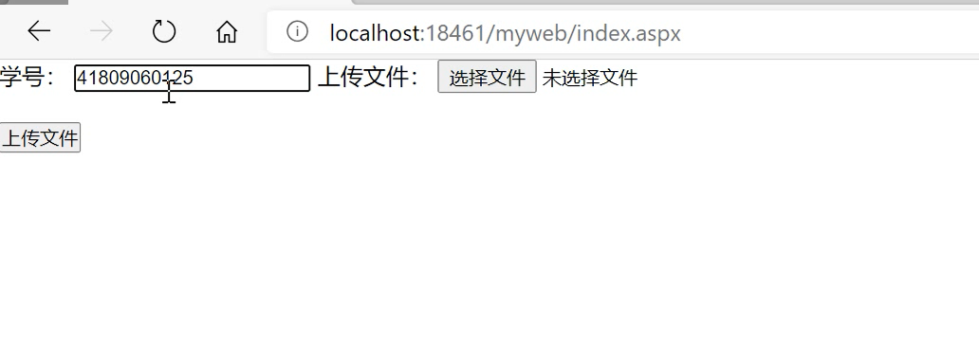

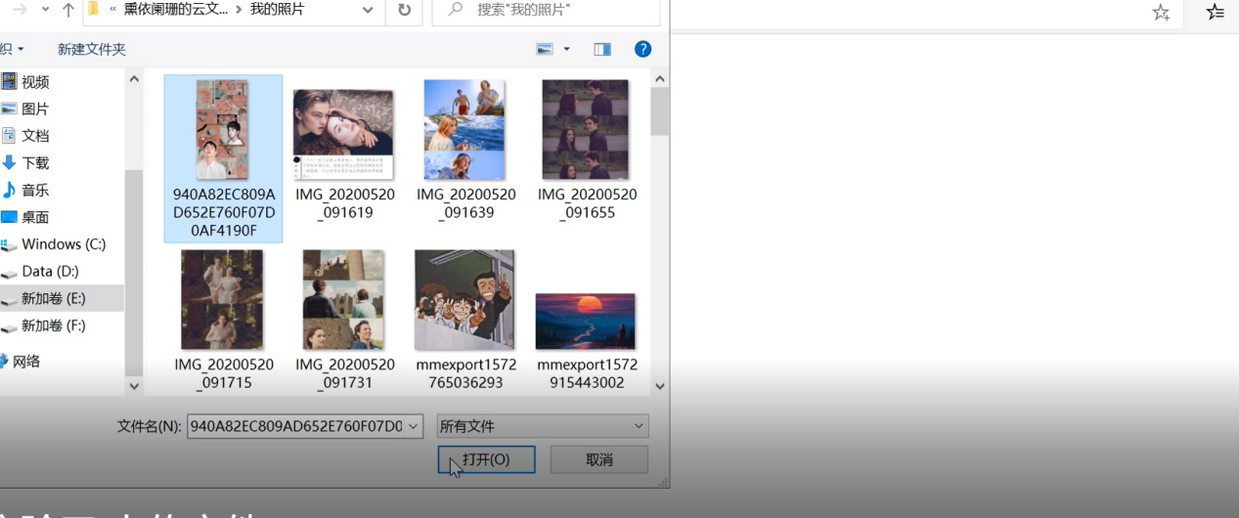

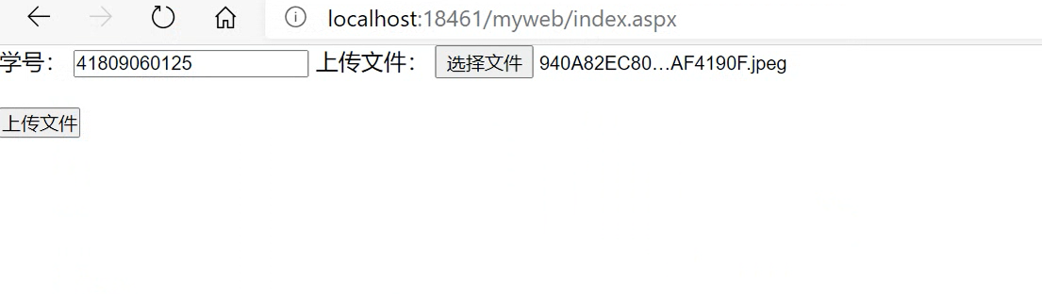

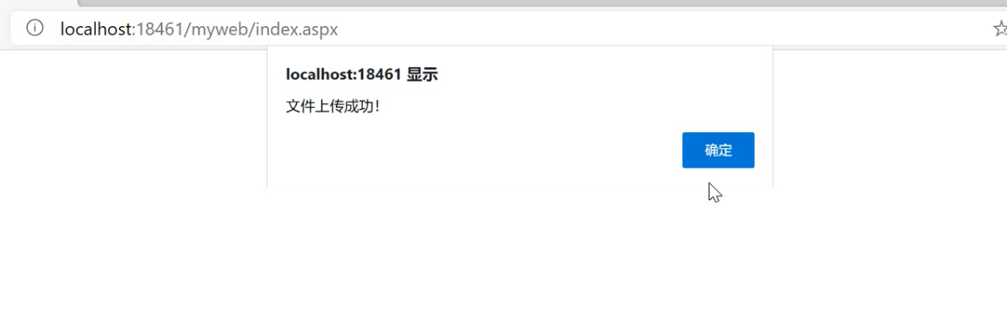

1. **实验感想**

通过这次实验，我掌握了网站中的文件上传和多媒体文件浏览操作，在此基础上实现了使用文件上传控件和使用图片控件动态显示图片，为以后实现更复杂的网站操作打下了坚实的基础。