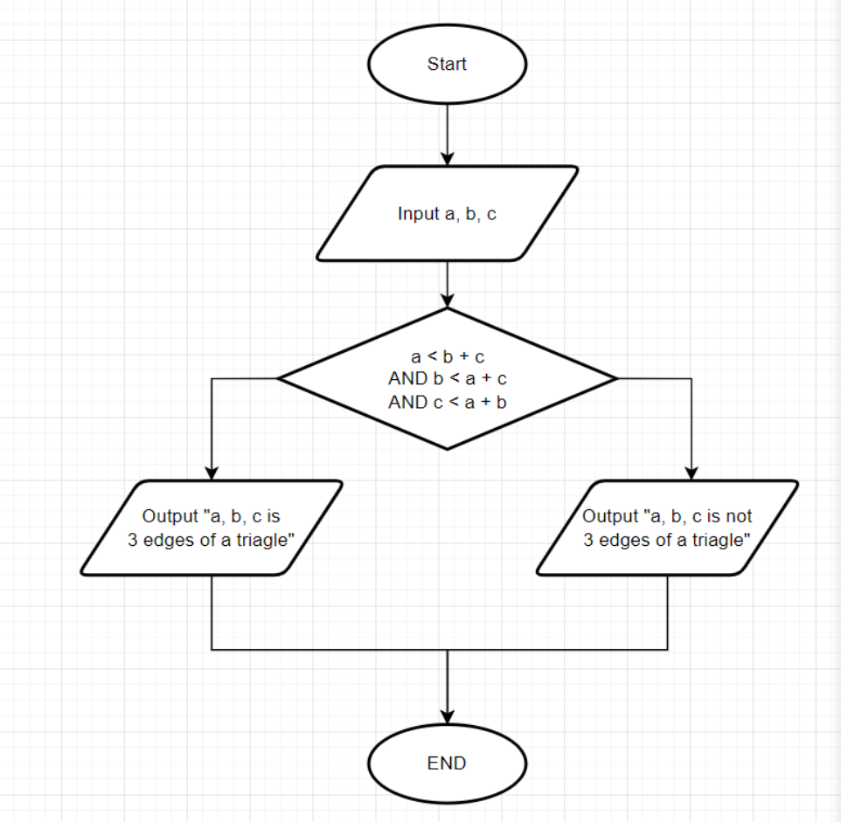

Begin

Input a,b,c

If a<b + c, b<a+c,c<a+b

Output “a,b,c is 3 edges of a triagle

Else Output “a,b,c is not 3 edges of a triagle

End.