Online Learning Platform (Google Classroom)

Software Architecture Document

Version 1.1

Table of Contents

1. Introduction 4

1.1 Purpose 4

1.2 Scope 4

1.3 Definitions, Acronyms, and Abbreviations 4

1.4 References 4

1.5 Overview 4

2. Architectural Representation 4

2.1 Scenarios 4

2.2 Logical View 4

2.3 Process View 4

2.4 Development View 5

2.5 Physical View 5

3. Architectural Goals and Constraints 5

4. Use-Case View 6

4.1 Use-Case diagram 6

4.2 Use-Case realization 6

4.2.1 Teachers related use case 6

4.2.2 Students realed use case 14

5. Logical View 18

5.1 Overview 18

5.1.1 Subsystems 18

5.1.2 Teacher Management subsystem 18

5.1.3 Student Management subsystem 19

5.2 Architectural Significantly Design Packages 19

5.2.1 Class diagram 19

6. Process View 19

6.1 System sequence diagram 20

7. Development View 27

8. Implementation View 27

9. Size and Performance 28

10. Quality 28

Software Architecture Document

# Introduction

Google Classroom is a free blended learning platform for educational institutions that aims to simplify creating, distributing, and grading assignments. The primary purpose of Google Classroom is to streamline the process of sharing files between teachers and students.

## Purpose

## This document provides a comprehensive architectural overview of the system, using a number of different architectural views to depict different aspects of the system. It is intended to capture and convey the significant architectural decisions which have been made on the system’s scope

## Scope

The software architecture document covers all aspects of the system, both static and dynamic. The reference model is the view model, which includes many different views of the system, making the document complete and coherent.

The document examines class diagrams, package diagrams, and other static architecture designs under the system's static behavior. Use case realization and system sequence diagrams are used to expound on the system's dynamic characteristics.

## Definitions, Acronyms and Abbreviations

DBMS – Database Management System.

MVC – Model view control architecture.

## Overview

The architectural representation of the project, including architectural representation, architectural aims and limitations, and use case realizations, are covered in other parts. The next sections go into the exact details of the four main viewpoints (logical view, process view, deployment view and implementation in further depth.

# Architectural Representation

# 2.1. Scenarios.

**Audience:**

The entire system's stakeholders, including the end-users.

**Area:**

Describes a series of scenarios and use cases that reflect some of the system's most important and core features. Describes the system's actors and use cases. The documents discuss exception cases, exception outputs, and other relevant cases in addition to the basic work flow.

# 2.2. Logical view.

**Audience:**

Tester, Developer, UX/UI designer

**Area:**

Describes the object model's design. The system's subsystems and their interactions are also described.

**2.3. Process view**

**Audience:**

Programmer

**Area:**

Non-functional requirements refer to the component of the design that deals with concurrency and synchronization. Extends the system's behavior at runtime.

**2.4. Development view**

**Audience:**

Testers, Programmers

**Area:**

Explains the system's modules and subsystem divisions.

**2.5. Physical view**

**Audience:**

System administration, Project Manager, Database engineers

**Area:**

Describes the data model's architecturally significant persistent parts. Describes the mapping of software to hardware and depicts the distributed characteristics of the system.

# Architectural Goals and Constraints

Data in the system must be represented in such a way that it can best combine with current class documentation methods.

The system must be accessible both within the class intranet and outside of the class on the Internet.

The system must ensure that data is completely protected against unwanted access. User identity and password control are required for all accesses.

A client-server system will be used to implement Google Classroom. The client software runs on PCs, while the server software runs on Google's servers. This will be accomplished by encapsulating the web application in Docker images.

# Use-Case View

## Use case diagram

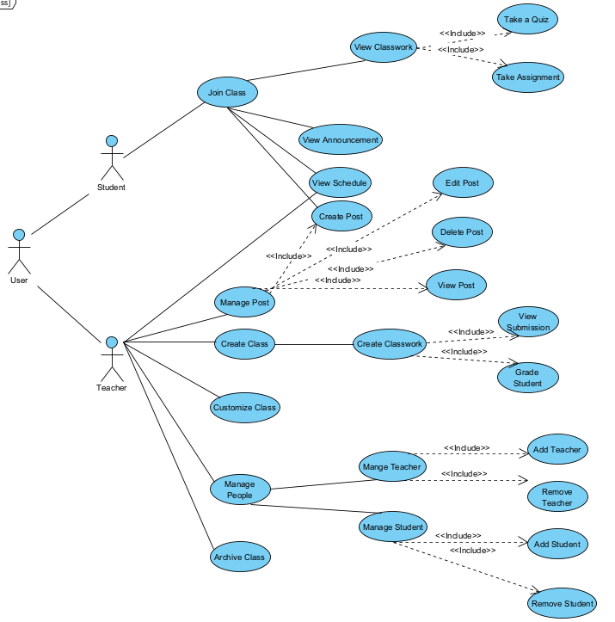

## Use-case Realizations.

*4.2.1. Teachers related use cases*

4.2.1.1. Create class.

| Use case name | Create Class |
| --- | --- |
| Scenario | Teachers create class |
| Triggering event | Teachers give information  Google Class creates class with the information |
| Brief description | This use-case allows users to create google class room |
| Actors | Teachers, Google Class |
| Related use cases | Archive Class |
| Pre-conditions | Teachers should have a google class account |
| Post-conditions | Google Class absorbed the information that teachers gave and create a class based on the information. |
| Flow of events | * Teacher click on the create button * Agree with the rules * Fill in the class information * Google Class create class |
| Exception conditions | None. |

4.2.1.2. Customize Class.

| Use case name | Customize class |
| --- | --- |
| Scenario | Change theme of teaching class |
| Triggering event | none |
| Brief description | This process for user to customize class |
| Actors | Teacher |
| Related use cases | none |
| Preconditions | Login successfully first! |
| Post conditions | none |
| Flow of events | First, at the top left, move mouse pointer to Menu icon (icon https://lh3.googleusercontent.com/I8a7h5BNddyGoYZTGNP2jPf4vJbuU6xFq3rh5KJ0ybekQC2AS3ERfEDtEUIrc94bA-KHAD_TGuF011yLWpXgar098r82V6yjHYZUdnGP9hG4qbzK9F03XJsCwNSdqwvTWBVMoGZe)  (when hovering over this icon, the mouse pointer will turn into a pointing hand icon, it will appear as a tooltip like a small box named “Main Menu” with text color: white and background-color: black. Also, the menu icon background will be blurred a little bit with a gray circle around it).  Then, when clicking 1 time in this Menu icon (https://lh3.googleusercontent.com/I8a7h5BNddyGoYZTGNP2jPf4vJbuU6xFq3rh5KJ0ybekQC2AS3ERfEDtEUIrc94bA-KHAD_TGuF011yLWpXgar098r82V6yjHYZUdnGP9hG4qbzK9F03XJsCwNSdqwvTWBVMoGZe), Menu icon disappeared and a selection panel (background-color: white) will be displayed in left-side (including “Classes” with icon like a house in the left-side of “Classes” text, “Calendar”- under “Classes” with icon calendar in the left-side of  “Calendar” text, “Enrolled” with “To-do” with notebook icon in the left-side of “To-do” text, user’s classes with different color cycle icon in the left-side of class’s name , “Archived classes”  with save icon in the left-side of it and “Settings” with bolts icon in left-side of it respectively). Text-color in this selection panel is black.  When hovering the mouse pointer in “Teaching” part with any class (with class icon in left and name of class beside), the mouse pointer will turn into a pointing hand icon with text color: black and background will be blurred with gray color a little bit).  Then, click it 1 time into any teaching class. A new page will appear (with background-color: white; text: black).  In the middle top, there are names of options like “Stream”, “Classwork”, “People”, “Grades”. And now, the interface of this use case specification is in the “Stream” part.  In the top right, they are a bolts icon (https://lh6.googleusercontent.com/RZKVs15YL4fp5k3O5YGqMRKO26smJBSNOIp1xNMrsWutYw-bcAWo7YK9cHcBN1q_h7LvBrp-6Lc-DGu80z8Z3qqV9mXf_h-CW8tFQSeULAov7OKd1zeOUB0f_idJHRNW7lbiWiaZ), icon (https://lh6.googleusercontent.com/IeTJZM9rKgUOG3ZvOYMDKigAKPs-Zvn7dn6HbKfHwD3qeEsf533UjenOXJ1SQ9RTWFQZ2As0pUwM4y3D7My96Gv1ZkU3AIfktqbRBdB-u6ns5VM2rxE-Ova-1pwTQUFvZ8TC6rZU) and icon profile of the user respectively from left to right.  In the top left, they are Menu icon (https://lh3.googleusercontent.com/I8a7h5BNddyGoYZTGNP2jPf4vJbuU6xFq3rh5KJ0ybekQC2AS3ERfEDtEUIrc94bA-KHAD_TGuF011yLWpXgar098r82V6yjHYZUdnGP9hG4qbzK9F03XJsCwNSdqwvTWBVMoGZe) on the left-side and text name of the teaching class on the right-side. Under, it is a rectangular box that describes the name of class “SAD Final Project (2021)”. In the top right of this box, it is a small rectangular “Customize” with icon (https://lh5.googleusercontent.com/ocvLOQhFzLKnXzi1H8TVEtRx-Fv2LwwZYuVN8QdHePMj3hlFxUIFm8m8a_aHD3wcZNeSwxOV6ZbVpg34fSXQKS0HOTZLHLzQdqyp444dlg5-zsSNhfu1w9Kn-MbCsiU_aZ4qeZvN) beside. The user can change the theme of the class by clicking on it.  When hovering in this small button, the background color will be blurred a little bit and mouse pointer will be turned into a pointing hand. Then, when the user clicks on it, there are 2 options displayed to choose “Upload photo” and “Select theme” under the icon in the left-side respectively.  When hovering in this part, the background color will be blurred a little bit and the mouse pointer will be turned into a pointing hand. Then clicking “Upload photo” a new box will be displayed named “Gallery” with background-color: white and text: black. User can upload a photo to upload by dragging and dropping a photo from computer to the part “Drag a photo here” (text-color: gray) with icon (https://lh6.googleusercontent.com/jwoorWl4QjMK6n1RejrCJiADmV36PnUvToL0oM9mKy1qBEQnniWm3Ny5NTX9HV0MpUPMcXFL1xIvtqYld9BTjBxWEWI11_wLmMUcCarmkgtLgvHWaae66fkWQQUs6TdHtgFBinNI) above. The mouse pointer will be turned into a pointing hand when hovering in this part.  Also, users can click to part “Select a photo from your computer” (like a small rectangular with background-color: gray; text-color: black, mouse pointer will be turned into a pointing hand when hovering in this part) to upload an image for the class theme. When uploading is done, the user clicks the “Select class theme” (in bottom left with background-color: blue; text-color: white) to confirm the set theme for class. Otherwise, user click into button “Cancel” beside (with background-color: gray and text-color: black) or icon (https://lh6.googleusercontent.com/S6yMWJ8Hy3b3HISl1S3gNpDBYfJSTtFQkz_C44laEX-1t4lGXWN4v9GfEwQYpjsmq6fFC4RZNsOgJEDRK_A6yPoZFb8CAgyjLgNZMntoFkzZqKqDvP56su50ZzvhvWpZ2H7uZM-m) in the top right of the “Gallery” part to dismiss the process.  In other way to customize the theme of class, user click to “Select theme” in below “Upload photo” in “Customize” part like description above (mouse pointer will be turned into hand pointer with background-color: gray blurred a little bit). When clicking on it, a new box will appear in the “Gallery” including small parts like “General”, “English & History”, “Math & Science'', ''Arts ``,''More ``. “More” has smaller parts “Sports”, “Other”. Part which is being chosen to be bold and underlined with color: blue. When user hovering any theme, it will be blurred background a little bit and display name of theme, mouse pointer turns into hand pointer. Then, user click to choose any theme, border will be bold with color: blue and displayed icon “check” like (https://lh5.googleusercontent.com/LsK01VnzyLdIhNKPllflePDQ-rKpAM3iyV2-cQ_fC3sW5MbqHkHIxF03EbVynen379xjYznHM4RfeE8dH7XjeKKUP7OgQvFdeZ-9Hz2l8rHIahglo0JZQZ90WdfCWlWK3mya_QXU) in the top left of the theme. To confirm, the user clicks the “Select class theme” in the bottom left (background-color: blue; text-color: white, bold a little bit when hovering), then clicks it to set the theme. Finally, a notification “class theme uploaded” will be displayed in the left bottom (background-color: black, text: white). |
| Exception conditions | none |

4.2.1.3. Create Classwork.

| Use case name | Create Classwork |
| --- | --- |
| Scenario | Teachers create classwork |
| Triggering event | Teachers give information  Google Class creates classwork based on the information |
| Brief description | This use-case allows users to create classwork |
| Actors | Teachers, Google Class |
| Related use cases | Create class |
| Pre-conditions | Teachers should have a created a class |
| Post-conditions | Google Class absorbed the information that teachers gave and created a classwork based on the information. |
| Flow of events | * Teacher click on the create button on the Classwork screen * Choose type of classwork * Fill in the classwork information * Google Class create classwork |
| Exception conditions | None. |

4.2.1.4. Manage People.

| Use case name | Manage People |
| --- | --- |
| Scenario | Invite and Delete people |
| Triggering event | In a specific class, teacher invite other or delete other teachers and students |
| Brief description | This use case allow teacher to manage people in the class |
| Actors | Teachers |
| Related use cases | Null |
| Preconditions | Null |
| Post conditions | Null |
| Flow of events | First teacher clicks on (PEOPLE) button on the top of the main page this will lead teacher to the people tab. In this page teacher can see 2 section, one is  (TEACHER) and one is  (STUDENTS). In teacher section teachers can add or invite other teachers by clicking on (INVITE TEACHER) button. Then a pop up window will appear:  Teacher types name or email of the person who they want to invite into a “Type a name or email” text box. After entering the email the text box turn into this  and teachers click the (INVITE) button which has now turned into orange in order to complete the action. Teachers can cancel their action by clicking  (CANCEL) button.  After invited successfully a pending message will be shown in the teacher section:  If the email’s domain of the person who has been invited is not valid a red notification bar will appear. This bar will automatically disappear in 5 seconds and teacher have to delete the current email and retype a new one.  In the student section teacher can add or invite student by clicking on (INVITE STUDENT) button. Same as the teacher section a pop up window will appear: |
| Exception condition | If email’s domain is not valid invitation cannot be sent. |

4.2.1.3. Grade Student.

| Use case name | Grade student |
| --- | --- |
| Scenario | Grade student’s submission |
| Triggering event | In a specific class, teacher mark student’s submission |
| Brief description | This use case allow teacher view and mark student’s submission |
| Actors | Teachers |
| Related use cases | Null |
| Preconditions | Null |
| Post conditions | Null |
| Flow of events | First teacher clicks on (GRADE)  button , it leads teacher to the grading section of the class.  Teacher can view student’s submission by hovering their mouse to an individual student and click on  button then click on  (VIEW SUBMISSION) button. This button will bring teacher to the  (STUDENT ANSWER) section. In this page teacher can see student’s submission:  Teacher can grade student by type the score into  text box. The score input **has to a number,** if teacher input other format but not a number a red warning window (GRADE MUST BE NUMBERS) will pop up and user’s invalid input will be deleted. Click  (DISMISS) to turn off the pop up window .If teacher input a valid format in the text box, the score will be saved as draft  . After the score has been saved click on  (RETURN) button to return score. A pop up window will just to confirm that student can notify and check their grades. Click  (RETURN) button to complete the action or click  (CANCEL) button to discard. |
| Exception condition | If input type is not valid user’s invalid input will be deleted and a red warning window will pop up. |

4.2.1.3. View Schedule.

| Use case name | View Schedule |
| --- | --- |
| Scenario | View Schedule in Google Classroom |
| Triggering event | none |
| Brief description | helping users to know time and to-do-lists in every class they’ve taken part in |
| Actors | Users |
| Related use cases | none |
| Preconditions | Login successfully first! |
| Post conditions | none |
| Flow of events | First, at the top left, move mouse pointer to Menu icon (icon https://lh3.googleusercontent.com/I8a7h5BNddyGoYZTGNP2jPf4vJbuU6xFq3rh5KJ0ybekQC2AS3ERfEDtEUIrc94bA-KHAD_TGuF011yLWpXgar098r82V6yjHYZUdnGP9hG4qbzK9F03XJsCwNSdqwvTWBVMoGZe)  (when hovering over this icon, the mouse pointer will turn into a pointing hand icon, it will appear as a tooltip like a small box named “Main Menu” with text color: white and background-color: black. Also, menu icon background will be blurred a little bit with a gray circle around it).  Then, when clicking 1 time in this Menu icon (https://lh3.googleusercontent.com/I8a7h5BNddyGoYZTGNP2jPf4vJbuU6xFq3rh5KJ0ybekQC2AS3ERfEDtEUIrc94bA-KHAD_TGuF011yLWpXgar098r82V6yjHYZUdnGP9hG4qbzK9F03XJsCwNSdqwvTWBVMoGZe), Menu icon disappeared and a selection panel (background-color: white) will be displayed in left-side (including “Classes” with icon like a house in the left-side of “Classes” text, “Calendar”- under “Classes” with icon calendar in the left-side of  “Calendar” text, “Enrolled” with “To-do” with notebook icon in the left-side of “To-do” text, user’s classes with different color cycle icon in the left-side of class’s name , “Archived classes”  with save icon in the left-side of it and “Settings” with bolts icon in left-side of it respectively). Text-color in this selection panel is black.  When hovering the mouse pointer in the “Calendar” part (with icon calendar in left and text “Calendar” beside), the mouse pointer will turn into a pointing hand icon with text color: black and background will be blurred with gray color a little bit).  Then, click it 1 time. A new page will appear (with background-color: white; text: black).  In the top right, they are icon Calendar (can not click), icon (https://lh6.googleusercontent.com/IeTJZM9rKgUOG3ZvOYMDKigAKPs-Zvn7dn6HbKfHwD3qeEsf533UjenOXJ1SQ9RTWFQZ2As0pUwM4y3D7My96Gv1ZkU3AIfktqbRBdB-u6ns5VM2rxE-Ova-1pwTQUFvZ8TC6rZU) and icon profile of the user respectively from left to right.  In the top left, they are Menu icon (https://lh3.googleusercontent.com/I8a7h5BNddyGoYZTGNP2jPf4vJbuU6xFq3rh5KJ0ybekQC2AS3ERfEDtEUIrc94bA-KHAD_TGuF011yLWpXgar098r82V6yjHYZUdnGP9hG4qbzK9F03XJsCwNSdqwvTWBVMoGZe) on the left-side and text “Calendar” on the right-side. Under, it is a rectangular box to choose the class's user. In this rectangular box with a text “All classes” in the left-side and icon (https://lh3.googleusercontent.com/gjcH0LCKjv7iRhNqoaXa8QiwI9Ct-0WgbuDYks7YLF3bZ4mG-h3dRFEBKwHku-sTZnPvB8tydVr9VXWEaveJVIx6LaZNhmwBb5pBNkXfzMCS34Bj_t7rVTtX-hSGcz3iOnWUgtc-) in the right-side to choose available user’s classes. When hovering in this icon (https://lh3.googleusercontent.com/gjcH0LCKjv7iRhNqoaXa8QiwI9Ct-0WgbuDYks7YLF3bZ4mG-h3dRFEBKwHku-sTZnPvB8tydVr9VXWEaveJVIx6LaZNhmwBb5pBNkXfzMCS34Bj_t7rVTtX-hSGcz3iOnWUgtc-), the mouse pointer will turn into a pointing hand icon. Then, clicking on it, a box list of class’s username will appear. They include the name of the class's user (with text-color: black; background-color: white). Then clicking other parts, this box will disappear.  Under this box, it is a week time with format MM DD – MM DD, YYYY and icon (https://lh3.googleusercontent.com/q2YTR2xNXAVQkJijs8bRZ8_wSriwrkgq7UiznPeCARMwYAlCLh5bRj5zW3olGGGa-C6kL0-PPPn1j-YCsf25L-oDBoy_uVSxeOm2gF5dsSHjJlUapN987q3lLZ41J6zD0hp57rER ) in left-side and( https://lh3.googleusercontent.com/oFt6MHlqUGLeGDeOpCUw47DNx8DjK66iIN9AMw6KLDr_fPmgqA-T967lBiTNUBAN302SDK0FW6bcH2Ya7v_hz8DpPOYWw75cIkJpGG6HrDdFVyG7HlDcIbFpGgPowm4PdTmKdA5i) right-side with text-color: black, background-color: white to move previous or next week. When hovering icon (https://lh3.googleusercontent.com/q2YTR2xNXAVQkJijs8bRZ8_wSriwrkgq7UiznPeCARMwYAlCLh5bRj5zW3olGGGa-C6kL0-PPPn1j-YCsf25L-oDBoy_uVSxeOm2gF5dsSHjJlUapN987q3lLZ41J6zD0hp57rER) (https://lh3.googleusercontent.com/oFt6MHlqUGLeGDeOpCUw47DNx8DjK66iIN9AMw6KLDr_fPmgqA-T967lBiTNUBAN302SDK0FW6bcH2Ya7v_hz8DpPOYWw75cIkJpGG6HrDdFVyG7HlDcIbFpGgPowm4PdTmKdA5i), mouse pointer turns into pointing hand icon and blurring background a little bit. Then, click it, it will show previous or next week depending on user click (https://lh3.googleusercontent.com/q2YTR2xNXAVQkJijs8bRZ8_wSriwrkgq7UiznPeCARMwYAlCLh5bRj5zW3olGGGa-C6kL0-PPPn1j-YCsf25L-oDBoy_uVSxeOm2gF5dsSHjJlUapN987q3lLZ41J6zD0hp57rER) or (https://lh3.googleusercontent.com/oFt6MHlqUGLeGDeOpCUw47DNx8DjK66iIN9AMw6KLDr_fPmgqA-T967lBiTNUBAN302SDK0FW6bcH2Ya7v_hz8DpPOYWw75cIkJpGG6HrDdFVyG7HlDcIbFpGgPowm4PdTmKdA5i) respectively.  Under, it is a calendar that shows the last 7 days in the week. Each day is divided in a retangular. It will show weekdays with format like Sun, Mon, …and days with format decimal in the under with bigger text-size. The current day has a text-color: blue in the weekday’s name and day’s name has a text-color: white with a blue circle around it in the background.  In this interface, it will show assignments in the next few days with background-color: orange and text-color: white.  And when the user clicks on any assignment. There is a new page displayed. It describes how a user can “Add or create” him/her work. It also shows a description about the course's name like this interface “Final Project Sad” with teacher’s name and the time of assignment with grade below respectively and the time of deadline on the right-side. User can add comment in “Class comments” part and then click ( https://lh3.googleusercontent.com/ffQWHnqukzgbjb-hq-loMrvmn3QeKimLx9-VTar42XwYioZikpmXv-7GOlT7Lar40WwVXNQ2YCCmT0z07bWZpqrJI9B1wzTGaGS5Gq8U1KrvDdLTWGjhSyeOwAQTpENtembjaiKd) to send comments which everyone in this class can see. However, if a user wants to send private comments, they input text in the “Private comments” part to send private comments to their teacher. |
| Exception conditions | none |

4.2.1.3. Manage Post.

| Use case name | Manage Post |
| --- | --- |
| Scenario | Create and delete post |
| Triggering event | In a specific class, user creates the post and delete their own posts |
| Brief description | When user choose in a specific course in the classroom, user can only do a post with the textual description |
| Actors | Students, Teachers |
| Related use cases | Null |
| Preconditions | Null |
| Post conditions | Null |
| Flow of events | Choose the appropriate classroom.  Clicking into the announcement box and there are 4 ways for users to announce something:   * Attach the file from Google Drive: user can use the material from their own drive or the recent file that user have accessed then enter the “Post” button * Attach the file from our PCs, Laptops: press “Browse” button or drop the files into it and enter the “Post” button. * Attach the link: embedded the link in the box and then click the “Insert” button or press “Enter” * Attach the video: paste the YouTube links and then click the “Insert” button or press “Enter”   And to complete a post, must-have things is the text about the information with the format options: bold, italic, underline and cancel underline  To delete the post, just click the more option which is 3 dots and confirm it |
| Exception condition | If the posting is not valid user cannot post any announcements |

4.2.2. Students related use cases.

4.2.2.1. Join a class

| Use case name | Join Class |
| --- | --- |
| Scenario | Join a specific class by using class code or email invitation |
| Triggering event | Student enters class code and submit or teachers sent email invitation and accept |
| Brief description | When student enters a valid class code, the Google Classroom will check the validation of the code  to match the teachers’ code and redirect the main screen of the class |
| Actor | Student |
| Related use cases | Null |
| Preconditions | Null |
| Post conditions | Null |
| Flow of events | If it’s your first time to access to classroom.google.com pick the role “Student”. User can do in two ways:   * The first one is using the “Add” button and enter the valid class code for it then it’s will take student to the appropriate class * The second one is to check the students' mailbox and the student will get notification about “Sending invitation” message from the lecturer just press “Join” button. Then it’s also taking students directly to the classroom course |
| Exception condition | If the entered class code is invalid, the user will be asked to enter them again and appeared “Class not found” message appears. |

4.2.2.2. Take Quiz.

| Use case name | Take quiz |
| --- | --- |
| Scenario | Student take quiz in a class |
| Triggering event | In a specific class, student can take quiz |
| Brief description | This use case allow student to take quiz, review quiz and submit quiz |
| Actors | Student |
| Related use cases | Null |
| Preconditions | Null |
| Post conditions | Null |
| Flow of events | First, student clicks on  (STREAM), this will lead user to the stream of the class. In this page student can see topics which have been uploaded by the teacher. User click on  (OPEN) button on top right of the topic in order to access the quiz. This will bring student to a new page where student will need to click on the quiz tittle in the middle of the page to access the quiz.  Types of quiz:  Multiple Choice Question:  + Student needs to click on one circle in which student think that it is the correct one  after being clicked the box turn green . Students are allowed to choose ONLY ONE answer, if student chooses a new answer, the new answer will show a green box and the old green box disappear.     * Short/Long Answer Question:   + Student click on the text and type their answer     * Checkbox Question:   + Students can click on many boxes  after being clicked the box turn green . Student click on as many answers as they want.     * Dropbox Question:   + Click on  (CHOOSE) button, a dropdown menu will appear, click on the correct answer       * File Upload Question   + Click on  (ADD FILE) button, students choose file to upload from local computer   * Linear Scale Question   + Click on the number that corresponds best to what student want     * Date and Time Question   + Type in correct form of date and time to answer the question      After finishing the quiz students click (TURN IN)  Button to submit their file. After successfully submitted the (TURN IN) button turn to (TURNED IN) . |
| Exception condition | If input type is not valid user’s invalid input will be deleted and a red warning window will pop up. |

4.2.2.3. Complete Assignment

| Use case name | Complete Assignment |
| --- | --- |
| Scenario | Choose a specific assignment and complete |
| Triggering event | In a specific course, students have some assignments and have to complete it |
| Brief description | When students are in the classroom, they will see some specific icon and their task is to finish them . |
| Actor | Student |
| Related use case | Null |
| Preconditions | Null |
| Post conditions | Null |
| Flow of events | Access to classroom.google.com. Also, enter a specific course there are several ways to do the assignments:   * Access the stream section and press in question mark icon then choose your option and press “Turn in”. With other assignment, the users can attach the file or create online to submit it or even can “Mark as done” * In the upcoming section in the stream, press the “view all” see the Question mark icon choose your option and press “Turn in” * Click the specific day that has that deadline, choose the option then submit it. With other assignment, the users can attach the file or create online to submit it or even can “Mark as done” |
| Exception condition | If the assignments cannot be submitted on time, the “Missing” message will be appeared when students access to those assignments |

# Logical View

## Overview

### Subsystems

Google Class can be divided into 2 main subsystems.

1. Teacher management subsystem
2. Student management subsystem

*5.1.1.1. Teacher management subsystem*

This subsystem offers the services that cover all aspects of teacher administration. This subsystem's main use cases are as follows:

* Create class
* Customize Class
* Create Classwork
* Manage People
* Grading Student
* View Schedule
* Manage Post
* Account Setting

These use cases are acted out by every user that interacts with the system. Some actions will be prohibited depending on the access level.

*5.1.1.2. Student management subsystem*

This subsystem offers the services that cover all aspects of student administration. This subsystem's main use cases are as follows:

* Join a class
* Take a quiz
* Complete Assignment

## Architectural Significantly Design Packages

*5.2.1. Class diagram*

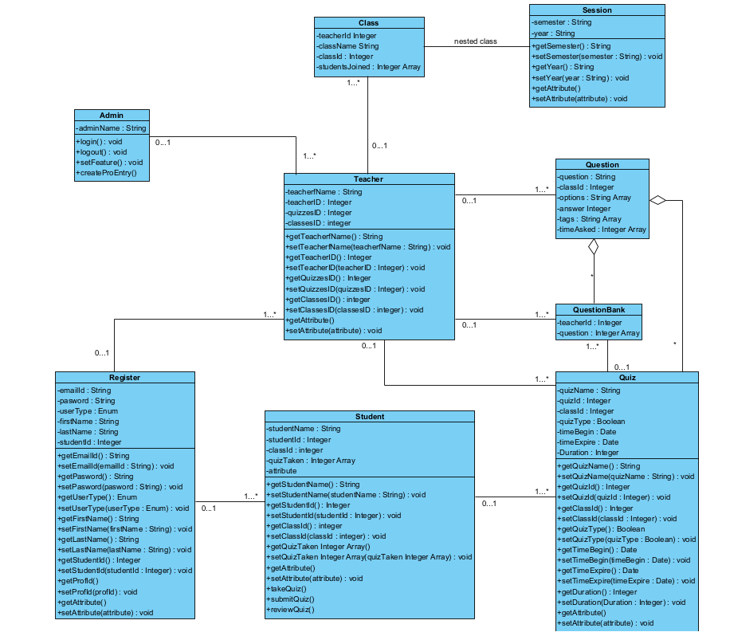

# Process View

6.1. System sequence diagrams

6.1.1. Create class

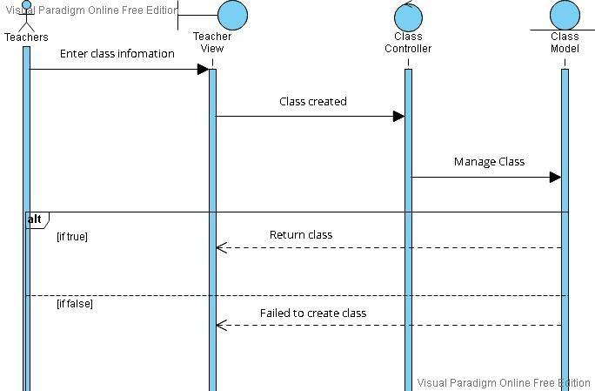

6.1.2. Customize class

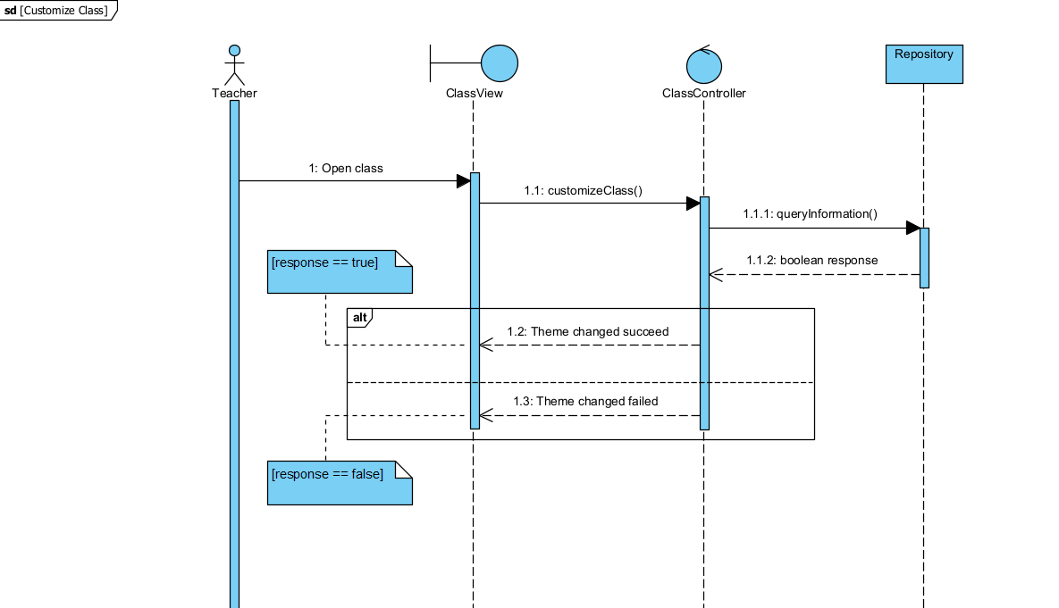

6.1.3. Create classwork.

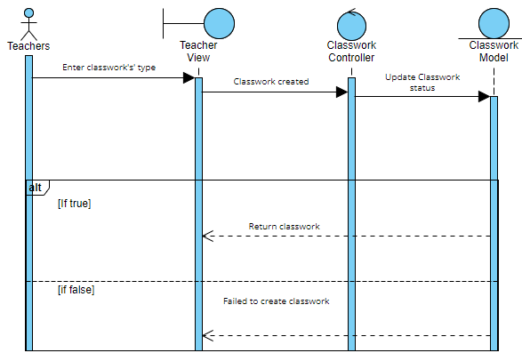

6.1.4. Manage people.

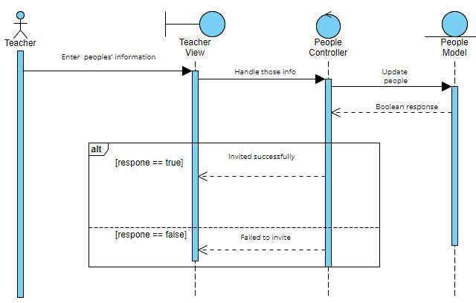

6.1.5. Grading student

. 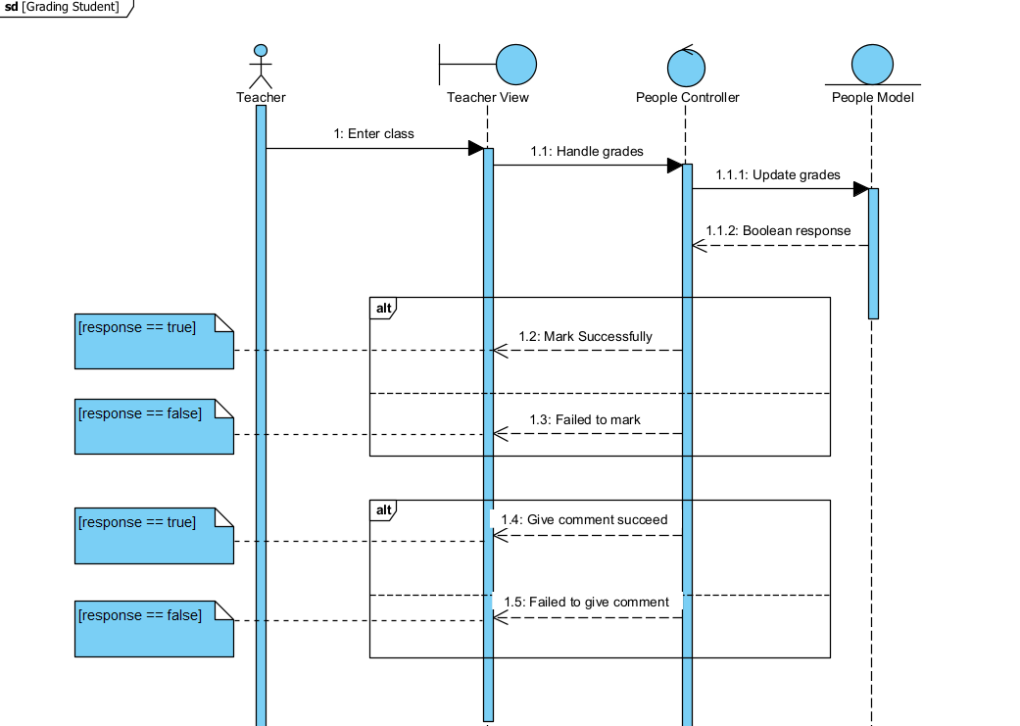

6.1.6. View schedule.

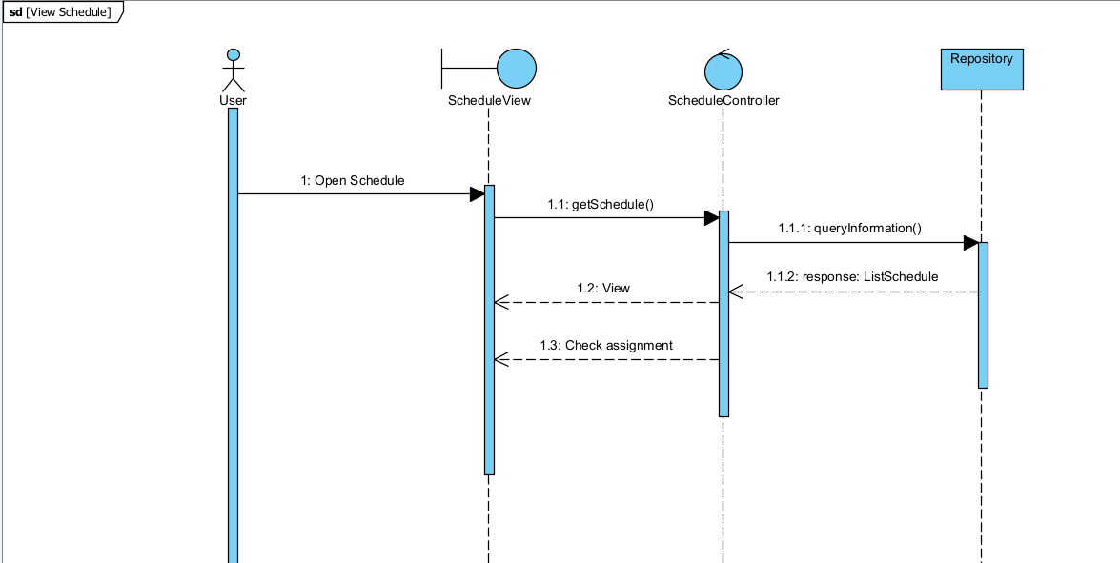

6.1.7. Manage post.

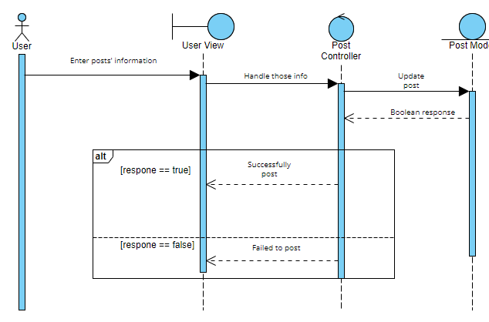

6.1.8. Account setting.

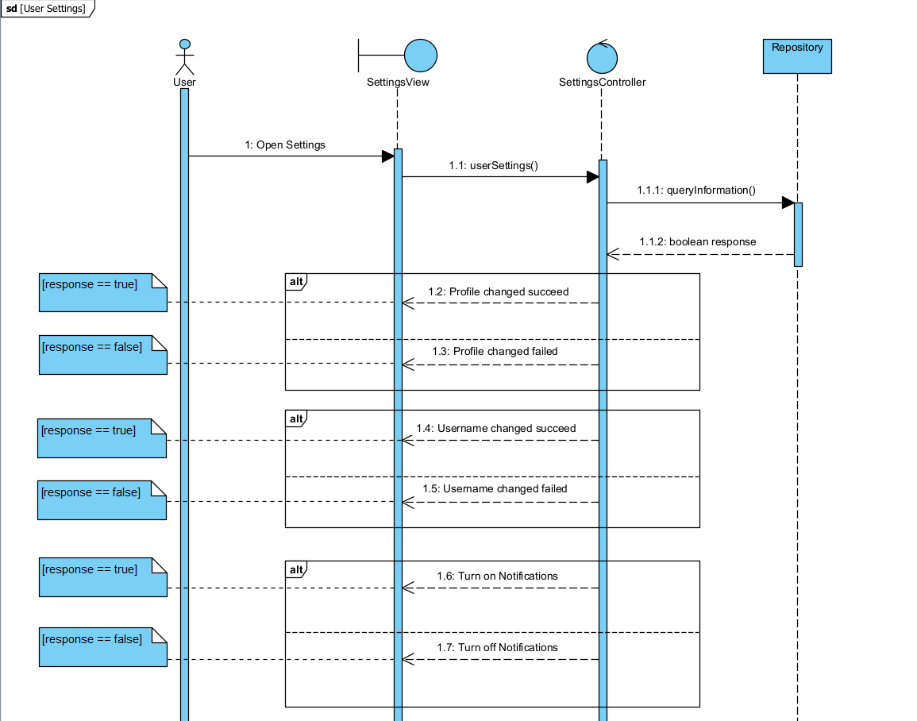

6.1.9. Archive class.

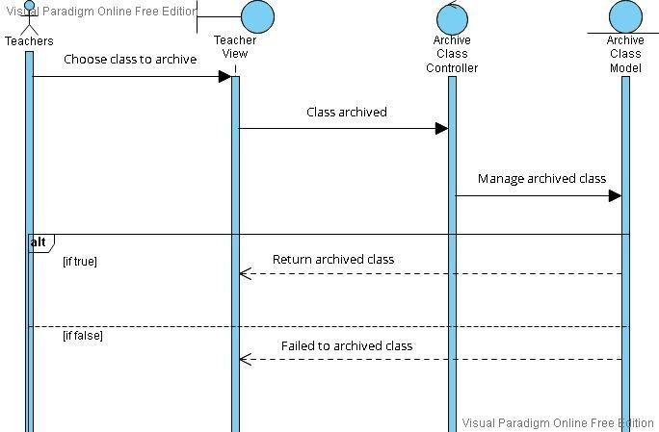

6.1.10. Join class.

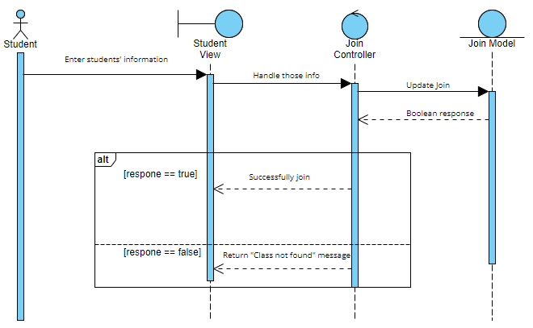

6.1.11. Take quiz.

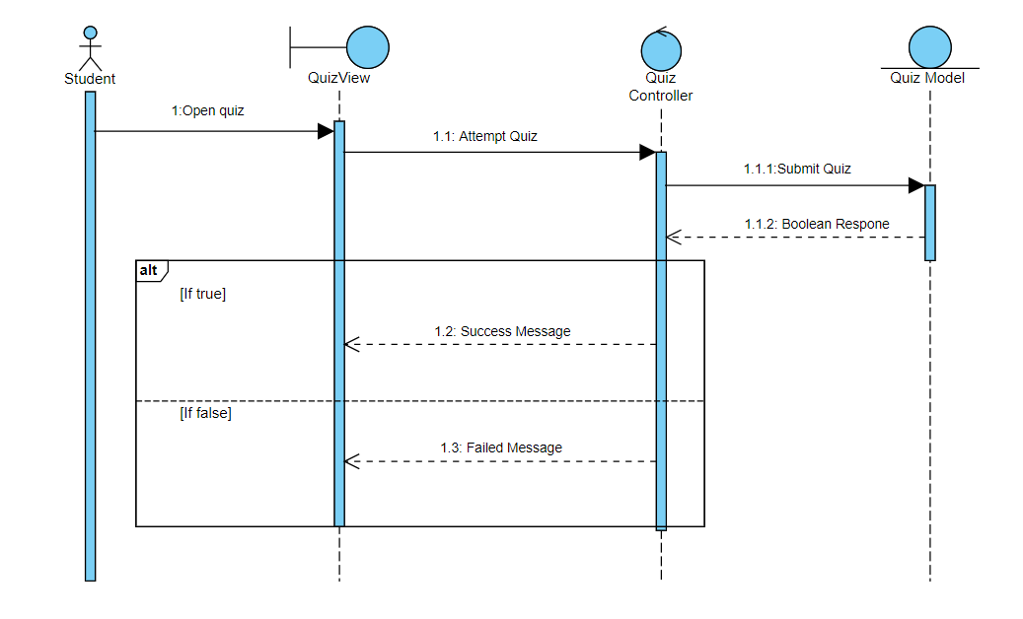

6.1.12. Complete assignment.

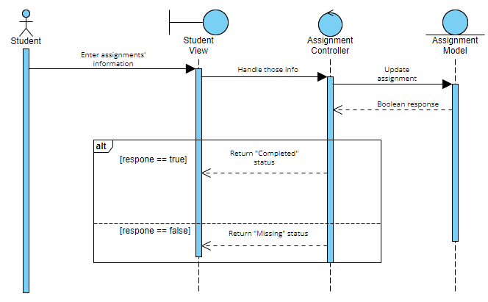

# Deployment View

This platform is hosted on a distant server because it is a web application. The database will be kept on a separate server. All processing is done at the back-end, except for the statistical graph generation, thus the client machine doesn't have to use much CPU power. All data processing will be done in the front-end while creating statistical graphs, thus the client computer will require a certain degree of efficiency.

# Implementation View

The MVC architecture pattern is used in Google Classroom web application. The fundamental rationale for using this style is to layer functions, which improves maintainability and reusability.

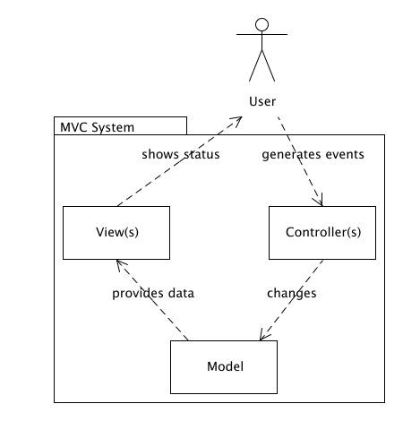

The graphical user interfaces are contained in the View layer. Controller classes manage the behavior of these web pages. Model classes that hold the business login are invoked and instantiated by controller classes. This method of separating software packages minimizes complexity.

Two layers can be created from the model classes. The data access layer and the business layer. Spring framework is used to alter the data access layer. The key entity classes, such as Student and Teacher, are found in the business layer.

The Spring framework is used to do object relational mapping. There is a class in the program for each database entity that allows data access operations to that entity.

# Size and Performance

Google Classroom will be hosted on the free web hosting space classroom.google.com because it is a web application. To utilize this software system, users will not need to install any components.

The software's size has yet to be determined, although it is expected to be between 150 and 250 megabytes.

To access the system, the client PCs must have a web browser installed. Except for the compilation of statistics reports, all functions will be processed in the backend. The front-end will create statistical reports, which will need some processing capacity from the client machine.

# Quality

The system's user interface must be simple to use and acceptable for a computer-literate user group who will not require any further training.

Google Classroom features must have built-in online aid for the user. The System's online help will contain step-by-step instructions on how to use it. Definitions for words and acronyms will be included in the online help.