SAMPLE OF PRACTICE TEST

(180 minutes)

**Question1:** Run the CodeGen1 project with the attached Codegen9.kpl file. When printing the results, print the student code, your full name, and the name of the KPL file in the first two lines. The image has the information of the machine you run the program on as shown in the image below:

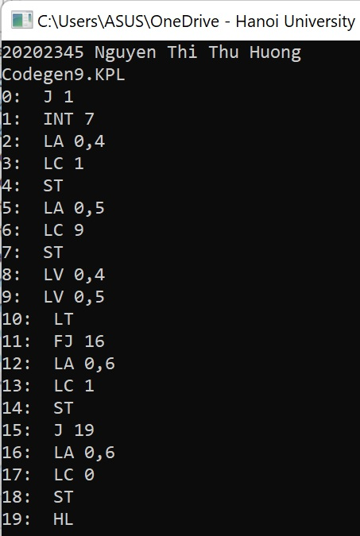

Explain the correspondence between the instructions of the target program and the statements of the source program.

**Câu 2:** Run project TypeChecking with file semantics9.kpl as required in the comments at the beginning of the file.

**Question3:** There is a change in the syntax rule in KPL as follows:

<Arguments> ::= SB_LPAR <Arguments1> SB_RPAR

<Arguments1> ::= <Expression> <Arguments2>

<Arguments1> ::= ε

<Arguments2> ::= SB_COMMA <Expression> <Arguments2>

<Arguments2> ::= ε

Change the code of the parser according to this change. Execute the parser with the attached file parser9.kpl and print the result.

Display the changes of your code. Show which functions were changed.

The changes of my code:

void compileArguments(void) {

eat(SB_LPAR);

compileArguments1();

eat(SB_RPAR);

}

void compileArguments1(void)

{

if (lookAhead->tokenType != SB_RPAR) {

compileExpression();

compileArguments2();

}

}

void compileArguments2(void) {

while (lookAhead->tokenType == SB_COMMA) {

eat(SB_COMMA);

if (lookAhead->tokenType == SB_RPAR) {

error(ERR_INVALIDARGUMENTS, lookAhead->lineNo, lookAhead->colNo);

}

compileExpression();

}

}