Name: Nguyễn Hữu Hoàng Hải Anh

Student ID: 20226010

**LAB 1. SCANNER**

*This report includes*

1. Results received when executing project with files
2. All types of errors that can be found by the scanner and other KPL test files
3. 43 Cases follow the correct automata

**A, Results received when executing project with files**

1. **Example 1 (*example1.kpl*)**

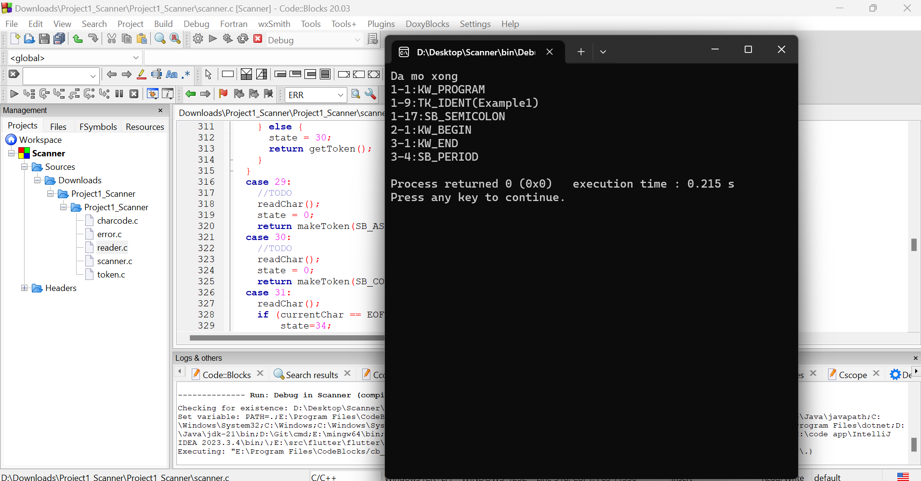

***Results received:***

Da mo xong

1-1:KW_PROGRAM

1-9:TK_IDENT(Example1)

1-17:SB_SEMICOLON

2-1:KW_BEGIN

3-1:KW_END

3-4:SB_PERIOD

1. **Example 2 (*example2.kpl*)**

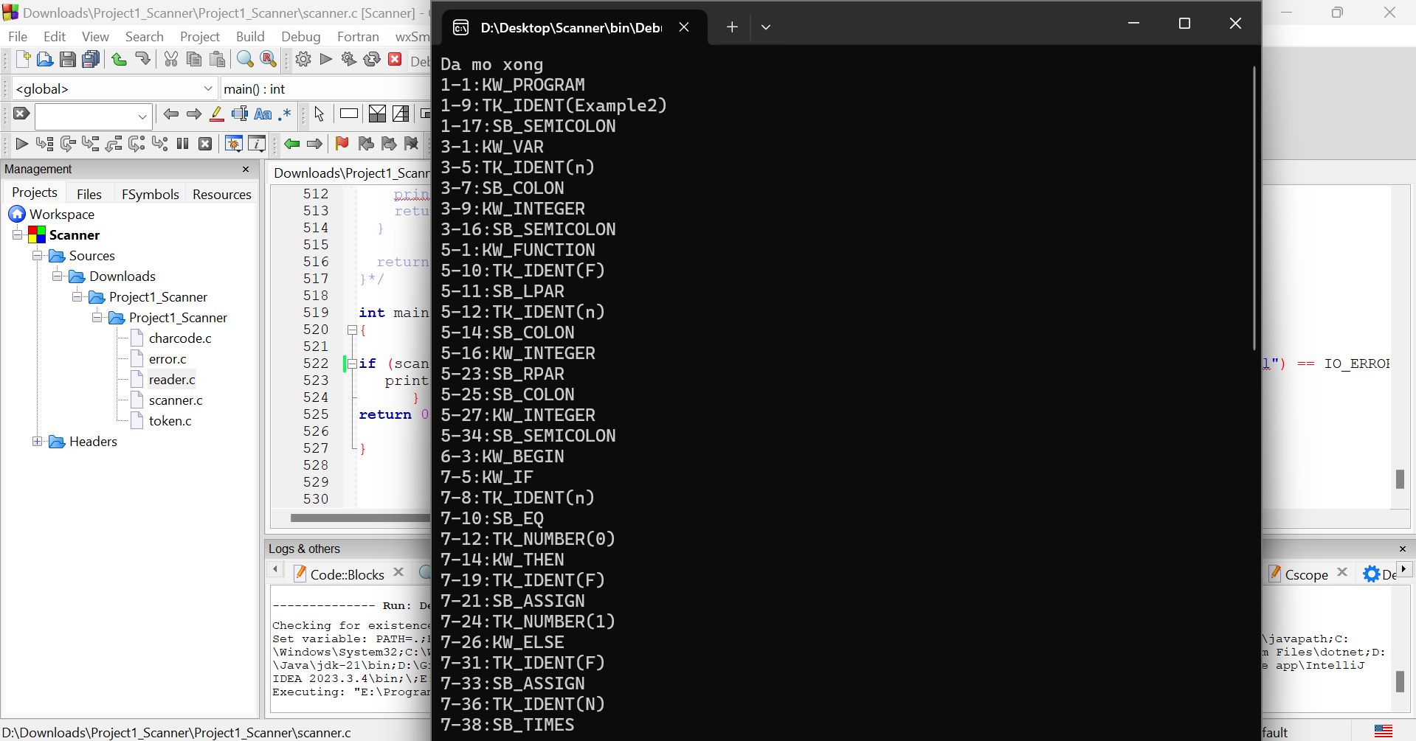

***Img1. Line 1 – Line 7 (38)***

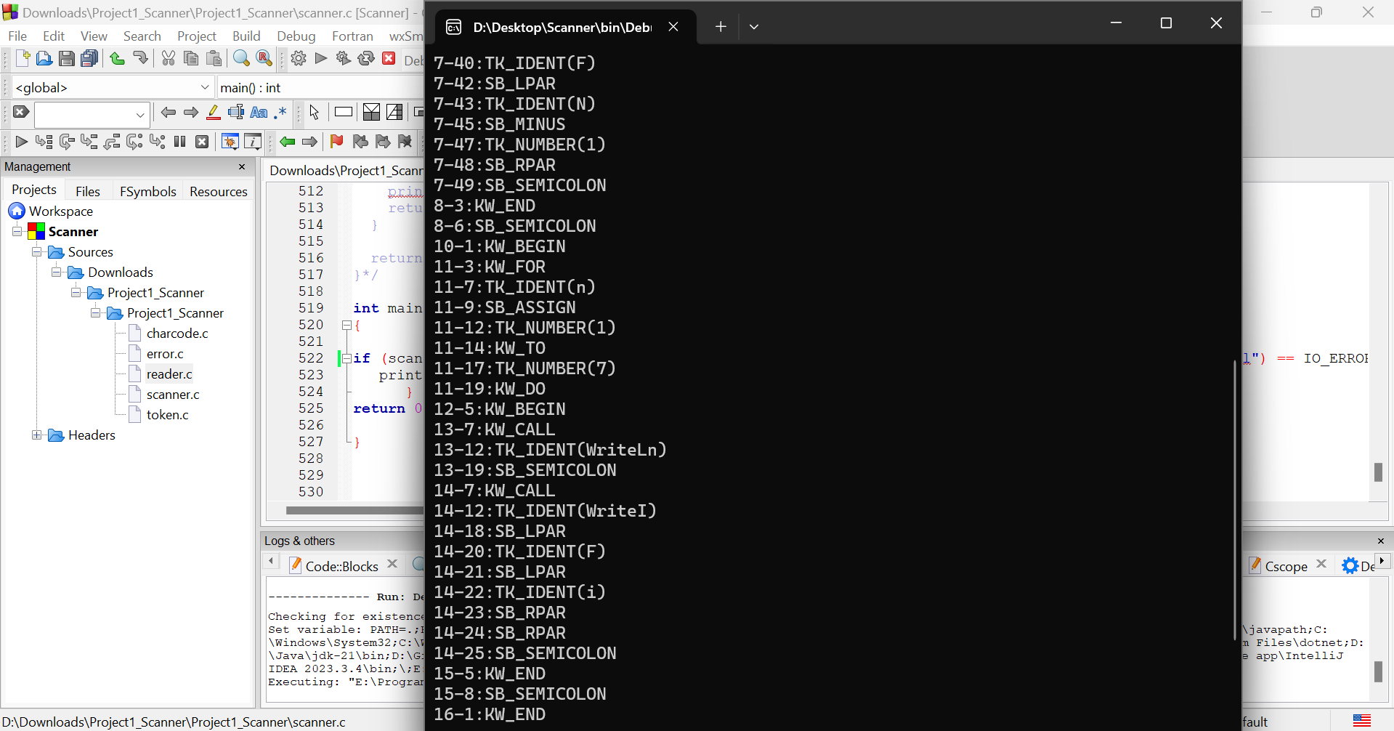

***Img2. Line 7 (40) – Line 16 (1)***

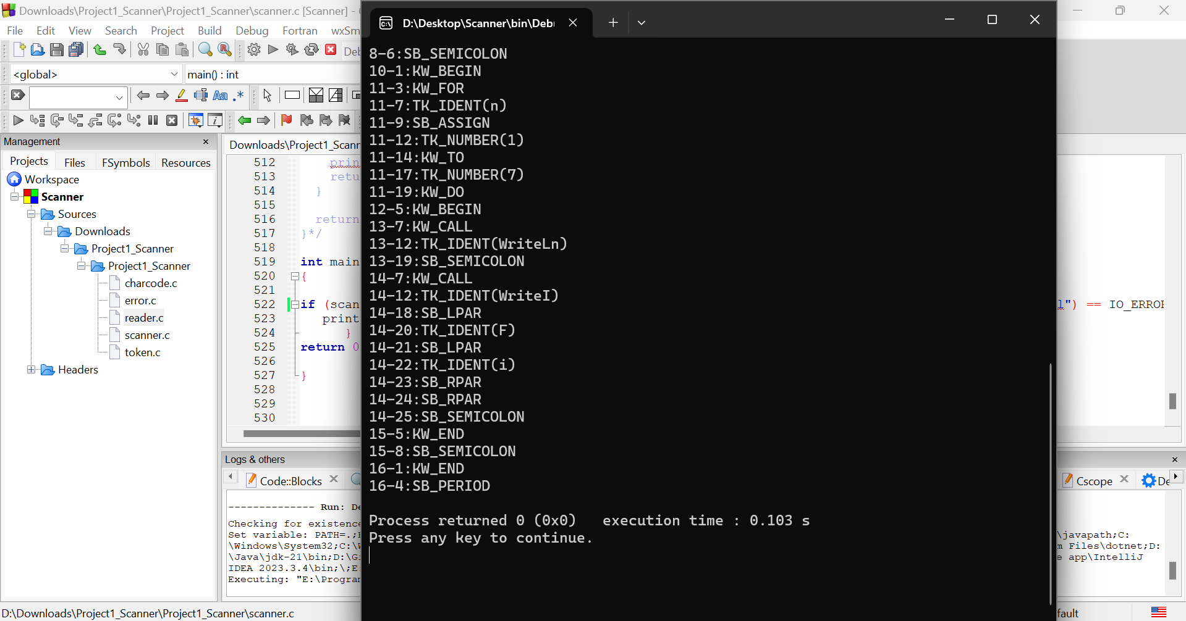

***Img3. Line 16 (4)***

***Results received:***

Da mo xong

1-1:KW_PROGRAM

1-9:TK_IDENT(Example2)

1-17:SB_SEMICOLON

3-1:KW_VAR

3-5:TK_IDENT(n)

3-7:SB_COLON

3-9:KW_INTEGER

3-16:SB_SEMICOLON

5-1:KW_FUNCTION

5-10:TK_IDENT(F)

5-11:SB_LPAR

5-12:TK_IDENT(n)

5-14:SB_COLON

5-16:KW_INTEGER

5-23:SB_RPAR

5-25:SB_COLON

5-27:KW_INTEGER

5-34:SB_SEMICOLON

6-3:KW_BEGIN

7-5:KW_IF

7-8:TK_IDENT(n)

7-10:SB_EQ

7-12:TK_NUMBER(0)

7-14:KW_THEN

7-19:TK_IDENT(F)

7-21:SB_ASSIGN

7-24:TK_NUMBER(1)

7-26:KW_ELSE

7-31:TK_IDENT(F)

7-33:SB_ASSIGN

7-36:TK_IDENT(N)

7-38:SB_TIMES

7-40:TK_IDENT(F)

7-42:SB_LPAR

7-43:TK_IDENT(N)

7-45:SB_MINUS

7-47:TK_NUMBER(1)

7-48:SB_RPAR

7-49:SB_SEMICOLON

8-3:KW_END

8-6:SB_SEMICOLON

10-1:KW_BEGIN

11-3:KW_FOR

11-7:TK_IDENT(n)

11-9:SB_ASSIGN

11-12:TK_NUMBER(1)

11-14:KW_TO

11-17:TK_NUMBER(7)

11-19:KW_DO

12-5:KW_BEGIN

13-7:KW_CALL

13-12:TK_IDENT(WriteLn)

13-19:SB_SEMICOLON

14-7:KW_CALL

14-12:TK_IDENT(WriteI)

14-18:SB_LPAR

14-20:TK_IDENT(F)

14-21:SB_LPAR

14-22:TK_IDENT(i)

14-23:SB_RPAR

14-24:SB_RPAR

14-25:SB_SEMICOLON

15-5:KW_END

15-8:SB_SEMICOLON

16-1:KW_END

16-4:SB_PERIOD

1. **Example 3 (*example3.kpl*)**

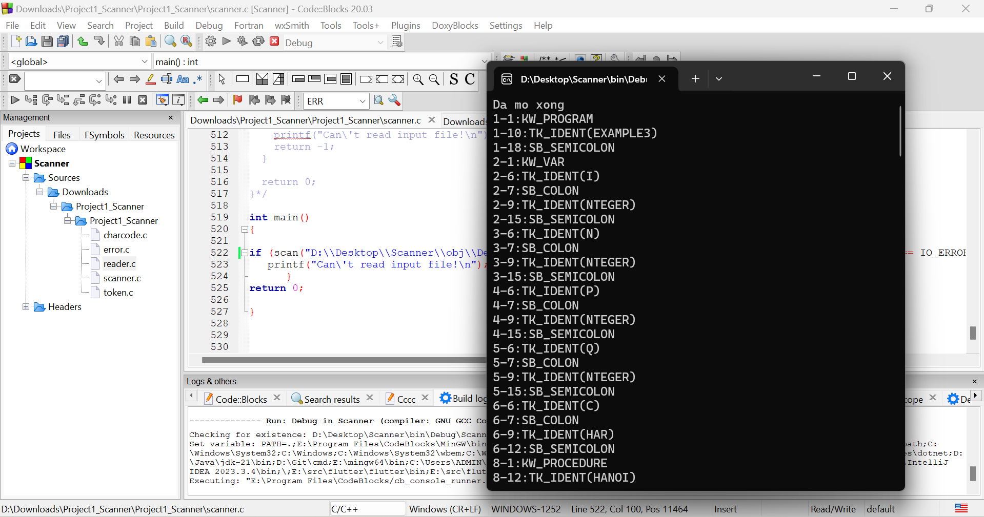

***Img4. Line 1 – Line 8 (12)***

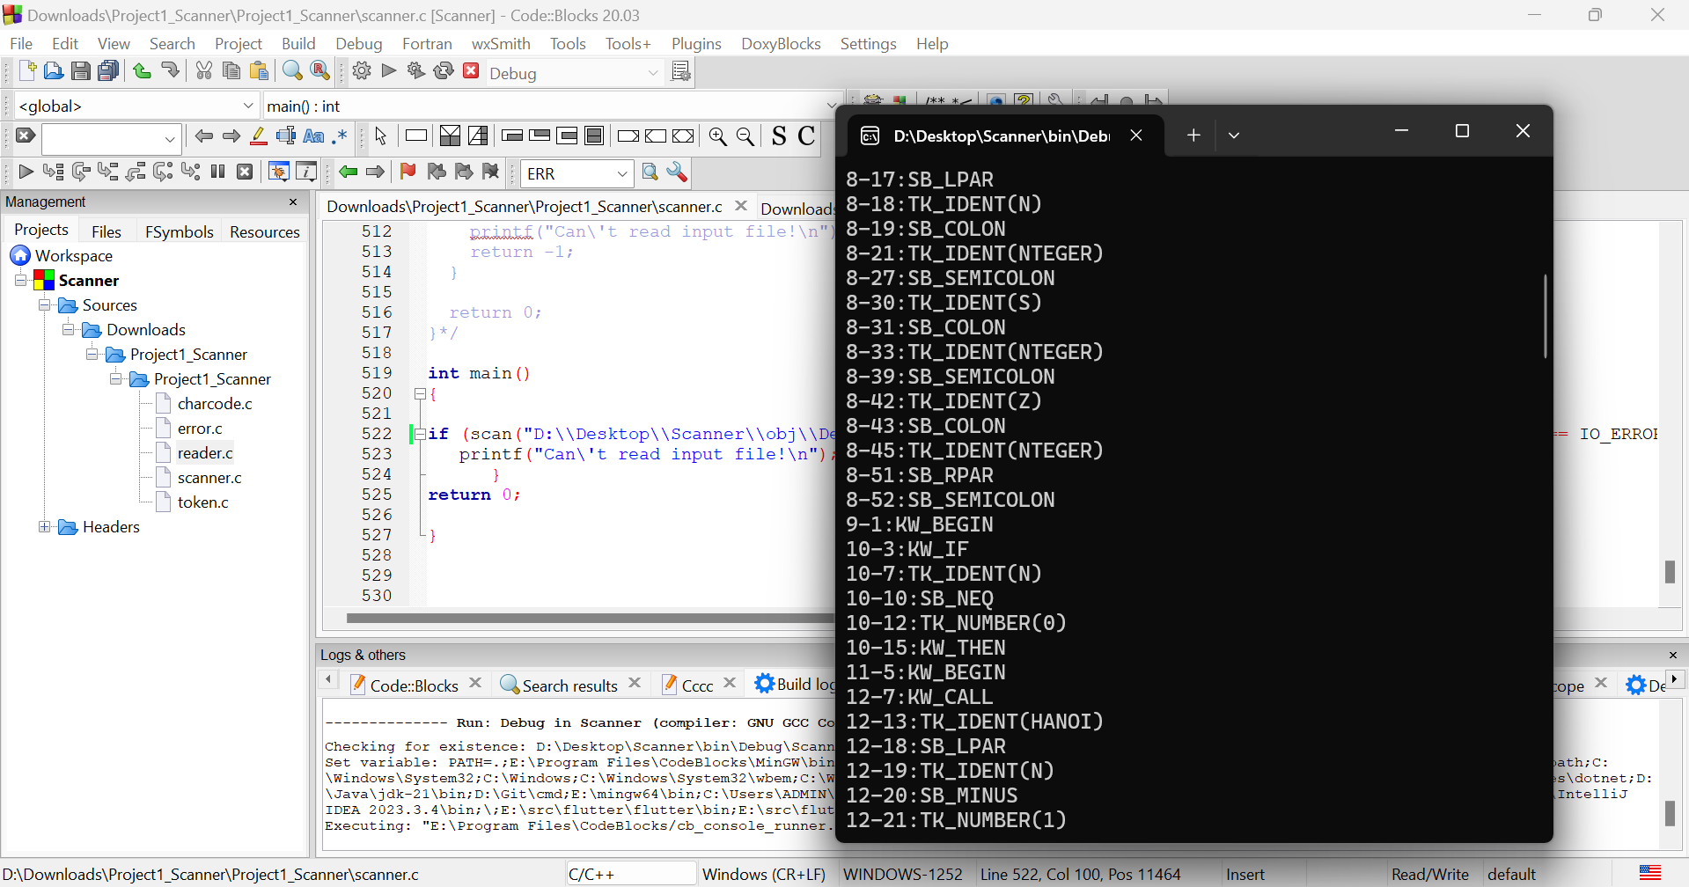

***Img5. Line 8 (17) – Line 12 (21)***

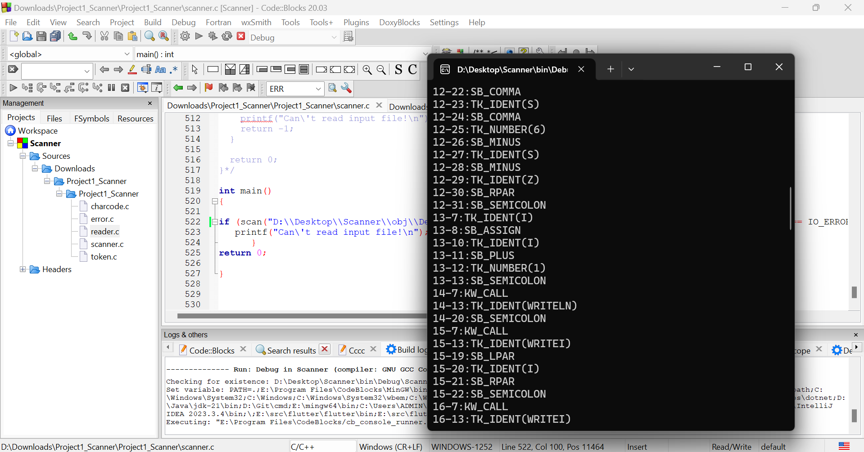

***Img6. Line 12 (22) – Line 16 (13)***

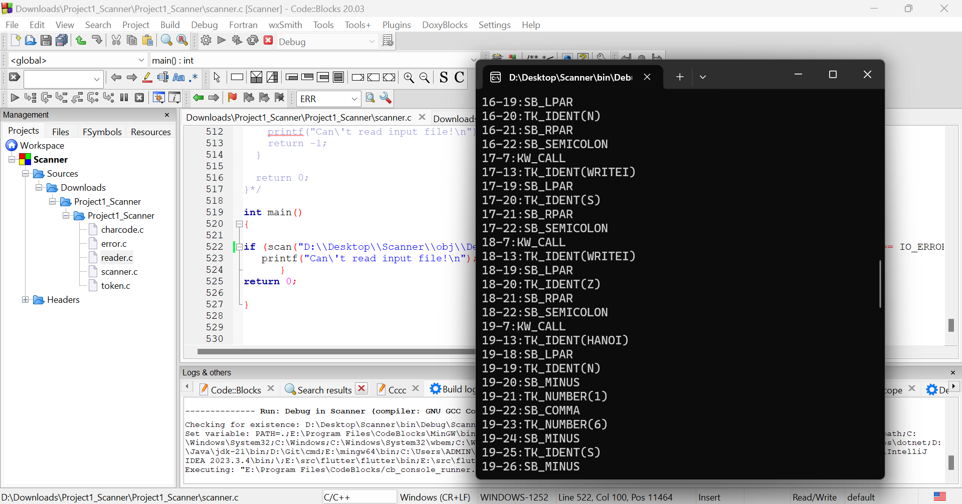

***Img7. Line 16 (19) – Line 19 (26)***

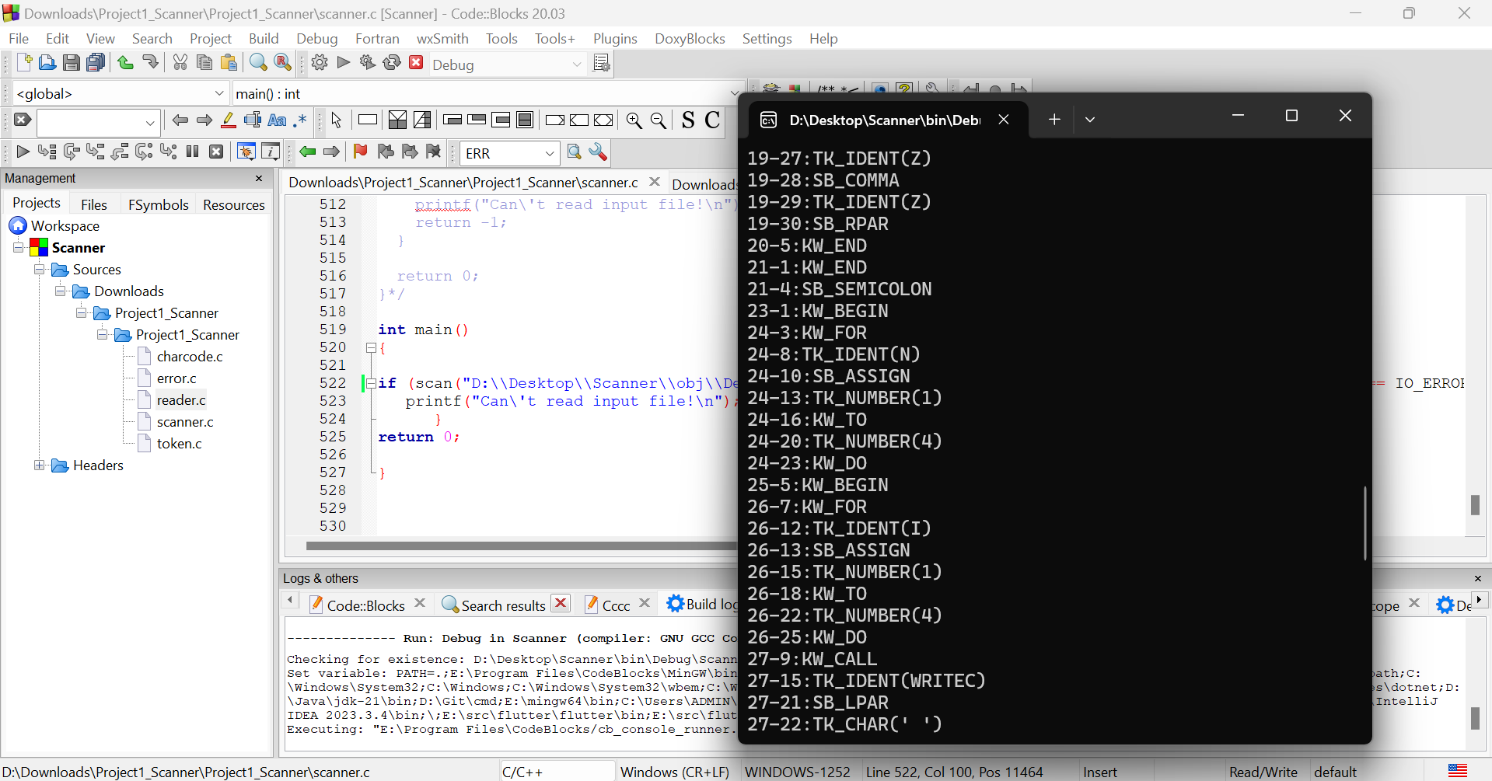

***Img8. Line 19 (27) – Line 27 (22)***

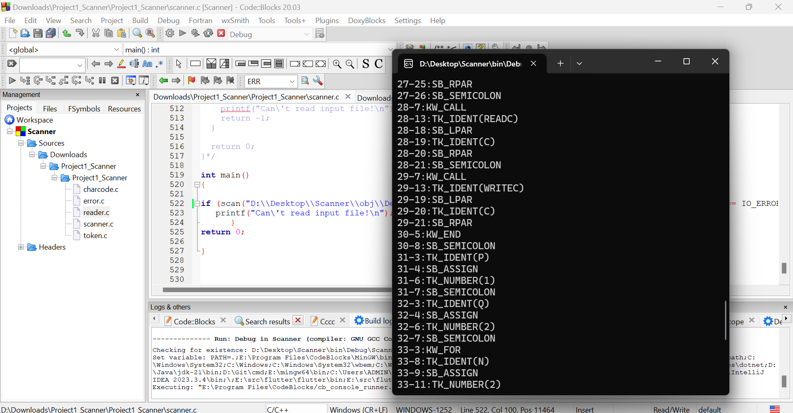

***Img9. Line 27 (25) – Line 33 (11)***

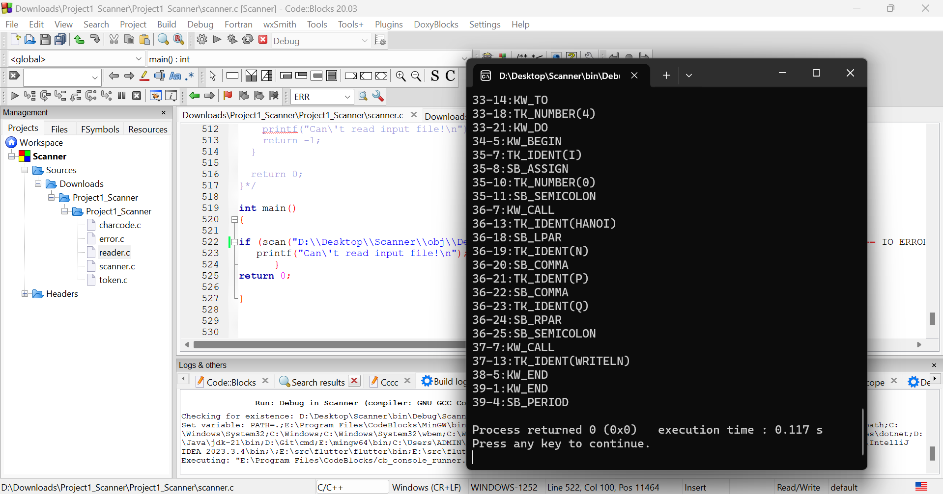

***Img10. Line 33 (14) – Line 39***

***Results received:***

Da mo xong

1-1:KW_PROGRAM

1-10:TK_IDENT(EXAMPLE3)

1-18:SB_SEMICOLON

2-1:KW_VAR

2-6:TK_IDENT(I)

2-7:SB_COLON

2-8:KW_INTEGER

2-15:SB_SEMICOLON

3-6:TK_IDENT(N)

3-7:SB_COLON

3-8:KW_INTEGER

3-15:SB_SEMICOLON

4-6:TK_IDENT(P)

4-7:SB_COLON

4-8:KW_INTEGER

4-15:SB_SEMICOLON

5-6:TK_IDENT(Q)

5-7:SB_COLON

5-8:KW_INTEGER

5-15:SB_SEMICOLON

6-6:TK_IDENT(C)

6-7:SB_COLON

6-8:KW_CHAR

6-12:SB_SEMICOLON

8-1:KW_PROCEDURE

8-12:TK_IDENT(HANOI)

8-17:SB_LPAR

8-18:TK_IDENT(N)

8-19:SB_COLON

8-20:KW_INTEGER

8-27:SB_SEMICOLON

8-30:TK_IDENT(S)

8-31:SB_COLON

8-32:KW_INTEGER

8-39:SB_SEMICOLON

8-42:TK_IDENT(Z)

8-43:SB_COLON

8-44:KW_INTEGER

8-51:SB_RPAR

8-52:SB_SEMICOLON

9-1:KW_BEGIN

10-3:KW_IF

10-7:TK_IDENT(N)

10-9:SB_NEQ

10-12:TK_NUMBER(0)

10-15:KW_THEN

11-5:KW_BEGIN

12-7:KW_CALL

12-13:TK_IDENT(HANOI)

12-18:SB_LPAR

12-19:TK_IDENT(N)

12-20:SB_MINUS

12-21:TK_NUMBER(1)

12-22:SB_COMMA

12-23:TK_IDENT(S)

12-24:SB_COMMA

12-25:TK_NUMBER(6)

12-26:SB_MINUS

12-27:TK_IDENT(S)

12-28:SB_MINUS

12-29:TK_IDENT(Z)

12-30:SB_RPAR

12-31:SB_SEMICOLON

13-7:TK_IDENT(I)

13-8:SB_ASSIGN

13-10:TK_IDENT(I)

13-11:SB_PLUS

13-12:TK_NUMBER(1)

13-13:SB_SEMICOLON

14-7:KW_CALL

14-13:TK_IDENT(WRITELN)

14-20:SB_SEMICOLON

15-7:KW_CALL

15-13:TK_IDENT(WRITEI)

15-19:SB_LPAR

15-20:TK_IDENT(I)

15-21:SB_RPAR

15-22:SB_SEMICOLON

16-7:KW_CALL

16-13:TK_IDENT(WRITEI)

16-19:SB_LPAR

16-20:TK_IDENT(N)

16-21:SB_RPAR

16-22:SB_SEMICOLON

17-7:KW_CALL

17-13:TK_IDENT(WRITEI)

17-19:SB_LPAR

17-20:TK_IDENT(S)

17-21:SB_RPAR

17-22:SB_SEMICOLON

18-7:KW_CALL

18-13:TK_IDENT(WRITEI)

18-19:SB_LPAR

18-20:TK_IDENT(Z)

18-21:SB_RPAR

18-22:SB_SEMICOLON

19-7:KW_CALL

19-13:TK_IDENT(HANOI)

19-18:SB_LPAR

19-19:TK_IDENT(N)

19-20:SB_MINUS

19-21:TK_NUMBER(1)

19-22:SB_COMMA

19-23:TK_NUMBER(6)

19-24:SB_MINUS

19-25:TK_IDENT(S)

19-26:SB_MINUS

19-27:TK_IDENT(Z)

19-28:SB_COMMA

19-29:TK_IDENT(Z)

19-30:SB_RPAR

20-5:KW_END

21-1:KW_END

21-4:SB_SEMICOLON

23-1:KW_BEGIN

24-3:KW_FOR

24-8:TK_IDENT(N)

24-10:SB_ASSIGN

24-13:TK_NUMBER(1)

24-16:KW_TO

24-20:TK_NUMBER(4)

24-23:KW_DO

25-5:KW_BEGIN

26-7:KW_FOR

26-12:TK_IDENT(I)

26-13:SB_ASSIGN

26-15:TK_NUMBER(1)

26-18:KW_TO

26-22:TK_NUMBER(4)

26-25:KW_DO

27-9:KW_CALL

27-15:TK_IDENT(WRITEC)

27-21:SB_LPAR

27-22:TK_CHAR(' ')

27-25:SB_RPAR

27-26:SB_SEMICOLON

28-7:KW_CALL

28-13:TK_IDENT(READC)

28-18:SB_LPAR

28-19:TK_IDENT(C)

28-20:SB_RPAR

28-21:SB_SEMICOLON

29-7:KW_CALL

29-13:TK_IDENT(WRITEC)

29-19:SB_LPAR

29-20:TK_IDENT(C)

29-21:SB_RPAR

30-5:KW_END

30-8:SB_SEMICOLON

31-3:TK_IDENT(P)

31-4:SB_ASSIGN

31-6:TK_NUMBER(1)

31-7:SB_SEMICOLON

32-3:TK_IDENT(Q)

32-4:SB_ASSIGN

32-6:TK_NUMBER(2)

32-7:SB_SEMICOLON

33-3:KW_FOR

33-8:TK_IDENT(N)

33-9:SB_ASSIGN

33-11:TK_NUMBER(2)

33-14:KW_TO

33-18:TK_NUMBER(4)

33-21:KW_DO

34-5:KW_BEGIN

35-7:TK_IDENT(I)

35-8:SB_ASSIGN

35-10:TK_NUMBER(0)

35-11:SB_SEMICOLON

36-7:KW_CALL

36-13:TK_IDENT(HANOI)

36-18:SB_LPAR

36-19:TK_IDENT(N)

36-20:SB_COMMA

36-21:TK_IDENT(P)

36-22:SB_COMMA

36-23:TK_IDENT(Q)

36-24:SB_RPAR

36-25:SB_SEMICOLON

37-7:KW_CALL

37-13:TK_IDENT(WRITELN)

38-5:KW_END

39-1:KW_END

39-4:SB_PERIOD

**B, All types of errors that can be found by the scanner and other KPL test files**

Error Handling: Scanner handles 5 unusual cases

* Identifier too long (ERR_IDENTTOOLONG)
* Number too long (ERR_NUMBERTOOLONG)
* Invalid character/symbol (ERR_INVALIDSYMBOL)
* Invalid character constant (ERR_INVALIDCHARCONSTANT)
* Comment not ended (ERR_ENDOFCOMMENT)

*I have built a KPL program myself to detect and test all the errors defined in the lab with comments about the corresponding errors.*

PROGRAM TestErrors;

VAR

ThisIdentTooLong: INTEGER; (* ERR_IDENTTOOLONG *)

A: INTEGER;

B: INTEGER;

C: INTEGER;

BEGIN

A := 12345678901; (* ERR_NUMBERTOOLONG *)

B := 2;

C := '&&'; (*ERR_INVALIDCHARCONSTANT*)

C := @ (*ERR_INVALIDSYMBOL*)

(* This is an unterminated comment --> ERR_ENDOFCOMMENT

END.

**err1.kpl**

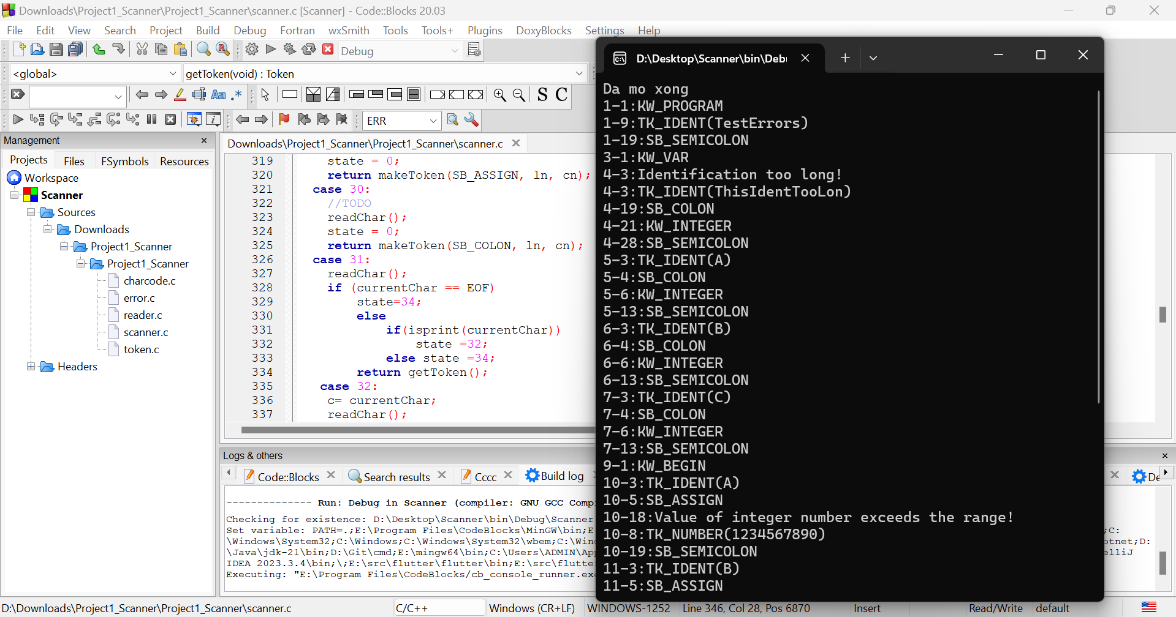

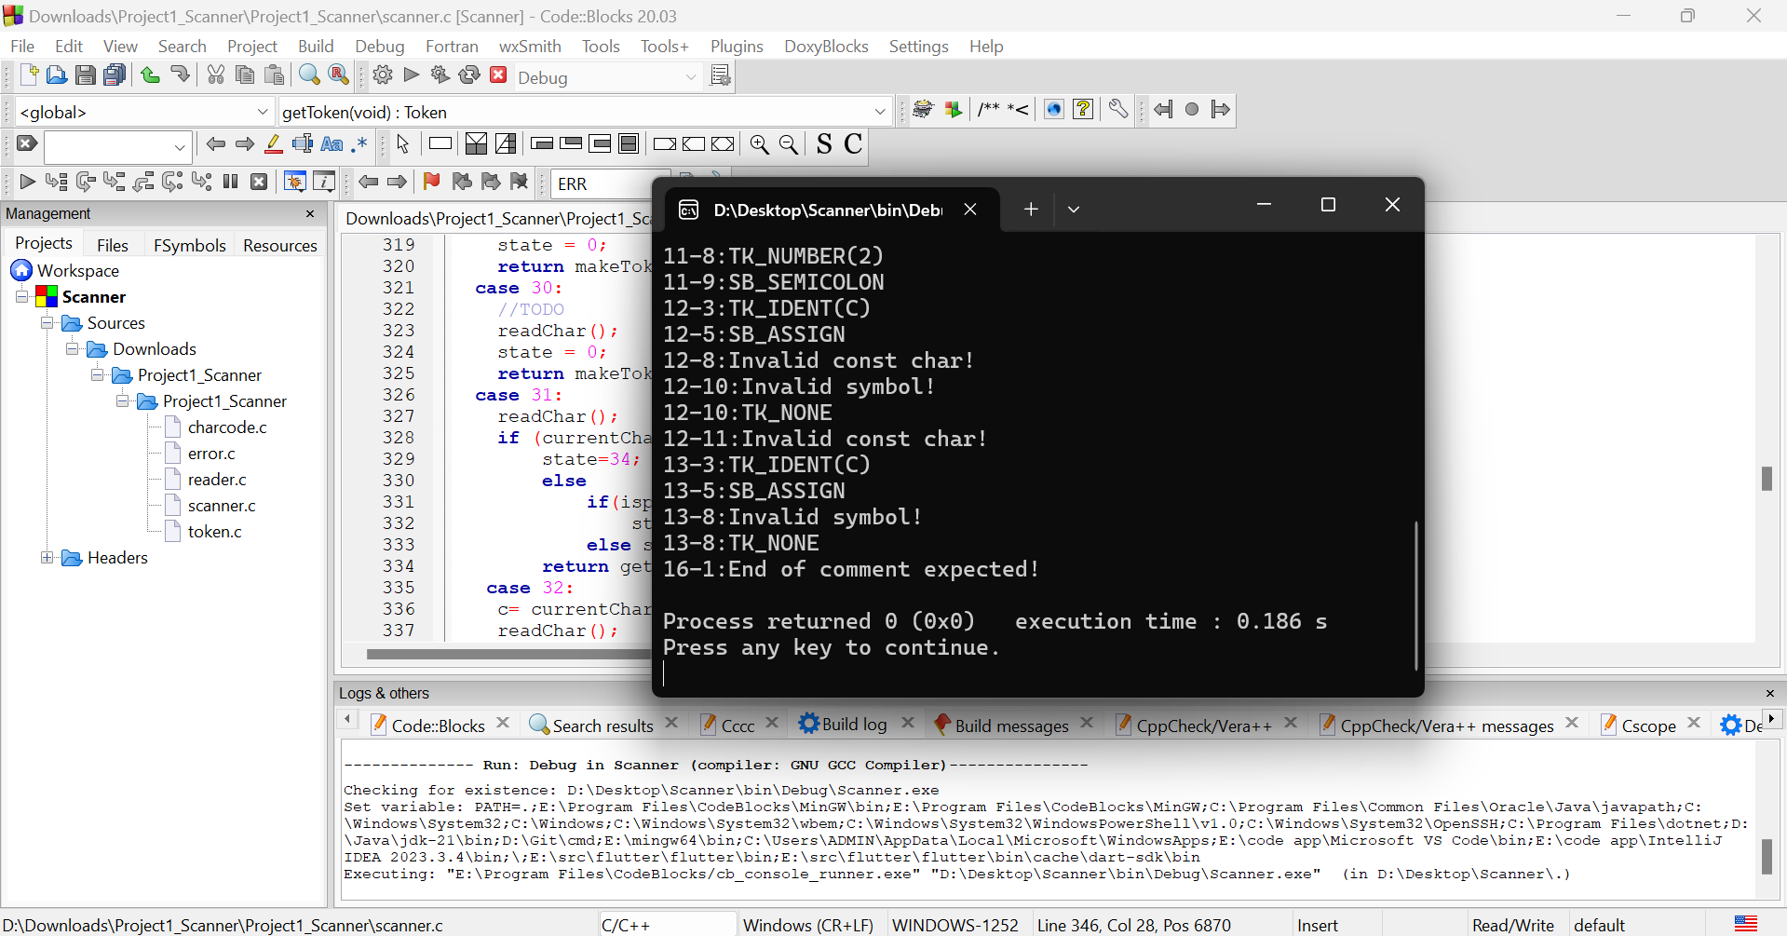

After executing the project with the above *err1.kpl* file, I got **the results related to the errors:**

4-3:Identification too long!

10-18:Value of integer number exceeds the range!

12-8:Invalid const char!

12-10:Invalid symbol!

12-11:Invalid const char!

13-8:Invalid symbol!

16-1:End of comment expected!

**C, 43 Cases follow the correct automata**

I have implemented 43 cases as automata in which I have added some more commands to sample cases as well as completed the //ToDo cases.

**Professors and teaching assistants can view the submission in the scanner.c file.**

For the sample cases:

* There are cases where I added the line “state = 0;” to continue identifying the rest.
* Store the starting position of each token with two variables ln (row) and cn (column) to help printToken and error know the correct position to print.
* Fix some errors to correct automata

For the //ToDo cases:

* Complete according to automata and add appropriate error detection

Add the necessary declarations

* Example: char numStr[20];

Other parts:

* I added newline characters to the reader.c file to make the printed result look nicer, for example "Da mo xong \n"