**Supplementary Materials**

1. **Instruction**

This is a step-by-step instruction on the use of the GUI (Graphical User Interface) to predict the macroscopic permeability of doubly porous media. The requirements needed to run this code are: i) a trained model in the form of a pickle file (StokesDarcyML.pkl), ii) an executable Python Google Colab to generate a GUI of the proposed model (StokesDarcy_Coupling_ML.ipynb).

**Step 1:** Log in to your personal Google account

**Step 2:** Open the personal Google Drive folder

**Step 3:** Copy two files, namely StokesDarcyML.pkl and StokesDarcy_Coupling_ML.ipynb, to the Google Drive folder, in My Drive

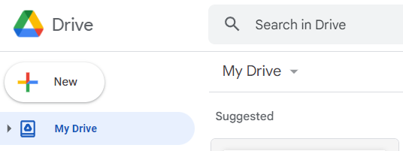

**Step 4:** Click right (or double-click) on the StokesDarcy_Coupling_ML.ipynb file, and choose “Open with Google Colab”

**Step 5:** If successful, this window will be opened

**Step 6:** Click on the two code cells (in black color) to execute them. It is important to note that the copied files should be in “My Drive”, corresponding to the last line of the first code cell (line 9). If you want to place these files in your own folder, such as a folder named “Your_Test”, the last line in the first cell should change to:

%cd /content/drive/MyDrive/Your_Test/

**Step 7:** After several seconds of simulation, this window will appear at the end of the second code cell:

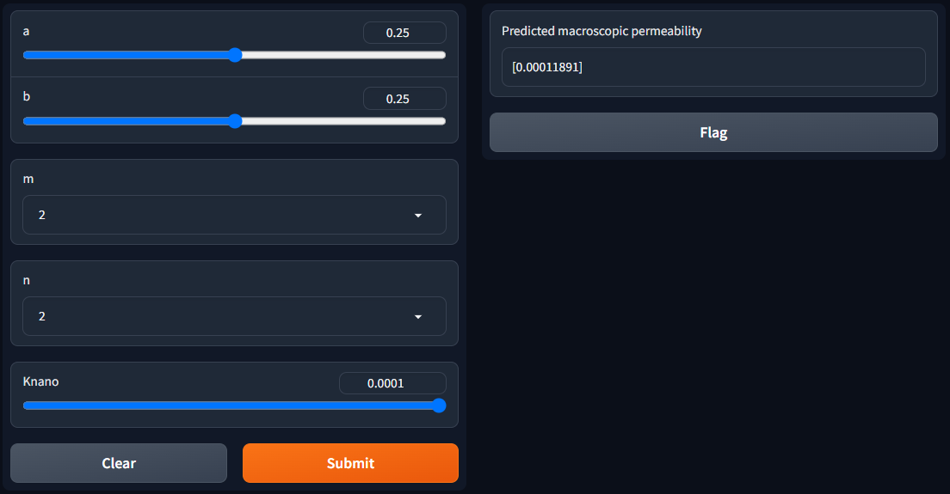

**Step 8:** You can use it directly by scrolling down and choosing the appropriate value you wanted the model to predict, or use the URL provided by the app, which appeared in blue after “Running on public URL”. This link is freely available for 72 hours to share with others in case you want.

**Step 9:** After selecting the desired values of the 5 inputs, click “Submit” to obtain the predicted macroscopic permeability of doubly porous media on the right side of the window.